Aligned to the following standards: AG6; CS.06; FFA.PL-C; FFA.PG-J; FFA.CS-N; FFA.CS-O; FFA.CS-P; CCSS.W.9-10.2; CCSS.MP1; CCSS.MP2; CCSS.MP4; CRP.07; CRP.08; FPP.04
Appendix 5: Popping Off
Part 1
Directions:
Read the article “This SAE Popped Off” in the fall/winter 2024 issue of FFA New Horizons and answer the questions below.

- What initially sparked Grant Deaton’s interest in growing popcorn?

- Grant has increased his production to meet the demand of his community. Answer the following questions about that increase.
  - How many pounds of packaged popcorn did he sell in 2023?

  - How many pounds of packaged popcorn did he sell in the first quarter of 2024?

  - Assuming no increase in demand for the rest of 2024, how many pounds of packaged popcorn would he expect to sell by the end of 2024?

  - Assuming he produces and sells that much, what percent increase would that be from the 2023 totals to the 2024 totals? (Round to the nearest 100).

- What did Grant do when he was not happy with his first crop?

- How does he inspect and test his crop prior to harvest?

- Name three ways that Deaton Popcorn is sold.

- What is one lesson that can be taken from Grant’s SAE that you or other students in your school could implement in your own SAE?

Part 2
Directions:
Use the various resources on the Popcorn Board’s website (https://www.popcorn.org/) to learn more about this treat that is enjoyed by millions of people every year.

Different Types of Corn (https://www.popcorn.org/All-About-Popcorn/Different-Types-of-Corn)
Draw lines to match the descriptions below to the four basic types of corn.
Dent Corn | This corn has its own size, shape, starch level and moisture content. It has a hard exterior shell and a soft starchy center. When heated, the natural moisture inside the kernel turns to steam and builds up enough pressure to eventually explode.
Flint Corn | This corn is almost all soft starch and will never pop. It contains more sugar than other types of corn. Unlike other corns that are picked when the kernels are dry and mature, this corn is picked and eaten while the ears are in the immature milk stage and the kernels are tender.
Popcorn | This corn has a hard outer shell and is distinguished by a wide range of colors. It is grown mostly in Central and South America and used primarily for decoration in North America around harvest time.
Sweet Corn | Also called field corn, this is the most widely grown type of corn in the United States. It is mainly used for livestock feed but is also used in some food products. It contains a mix of hard and soft starches that become indented once the corn is dried.

What Makes Popcorn Pop? (https://www.popcorn.org/All-About-Popcorn/What-Makes-Popcorn-Pop)

- What was the explanation early Native Americans had for why popcorn popped?

- What characteristics actually allow popcorn to pop like it does?

- How much is the pressure inside a kernel of popcorn before it explodes?

Popcorn History and Corny Facts
(https://www.popcorn.org/Kids-Corner/Corny-Facts) (https://www.popcorn.org/All-About-Popcorn/History-of-Popcorn)
Below is a simple flyer your FFA chapter produced for an agricultural literacy event at your school for National Popcorn Day. However, it looks like some of the information was transferred incorrectly, and all the pictures got deleted!
Use the links above to correct the mistakes, and then draw two or three pictures to fix up and complete the flyer.
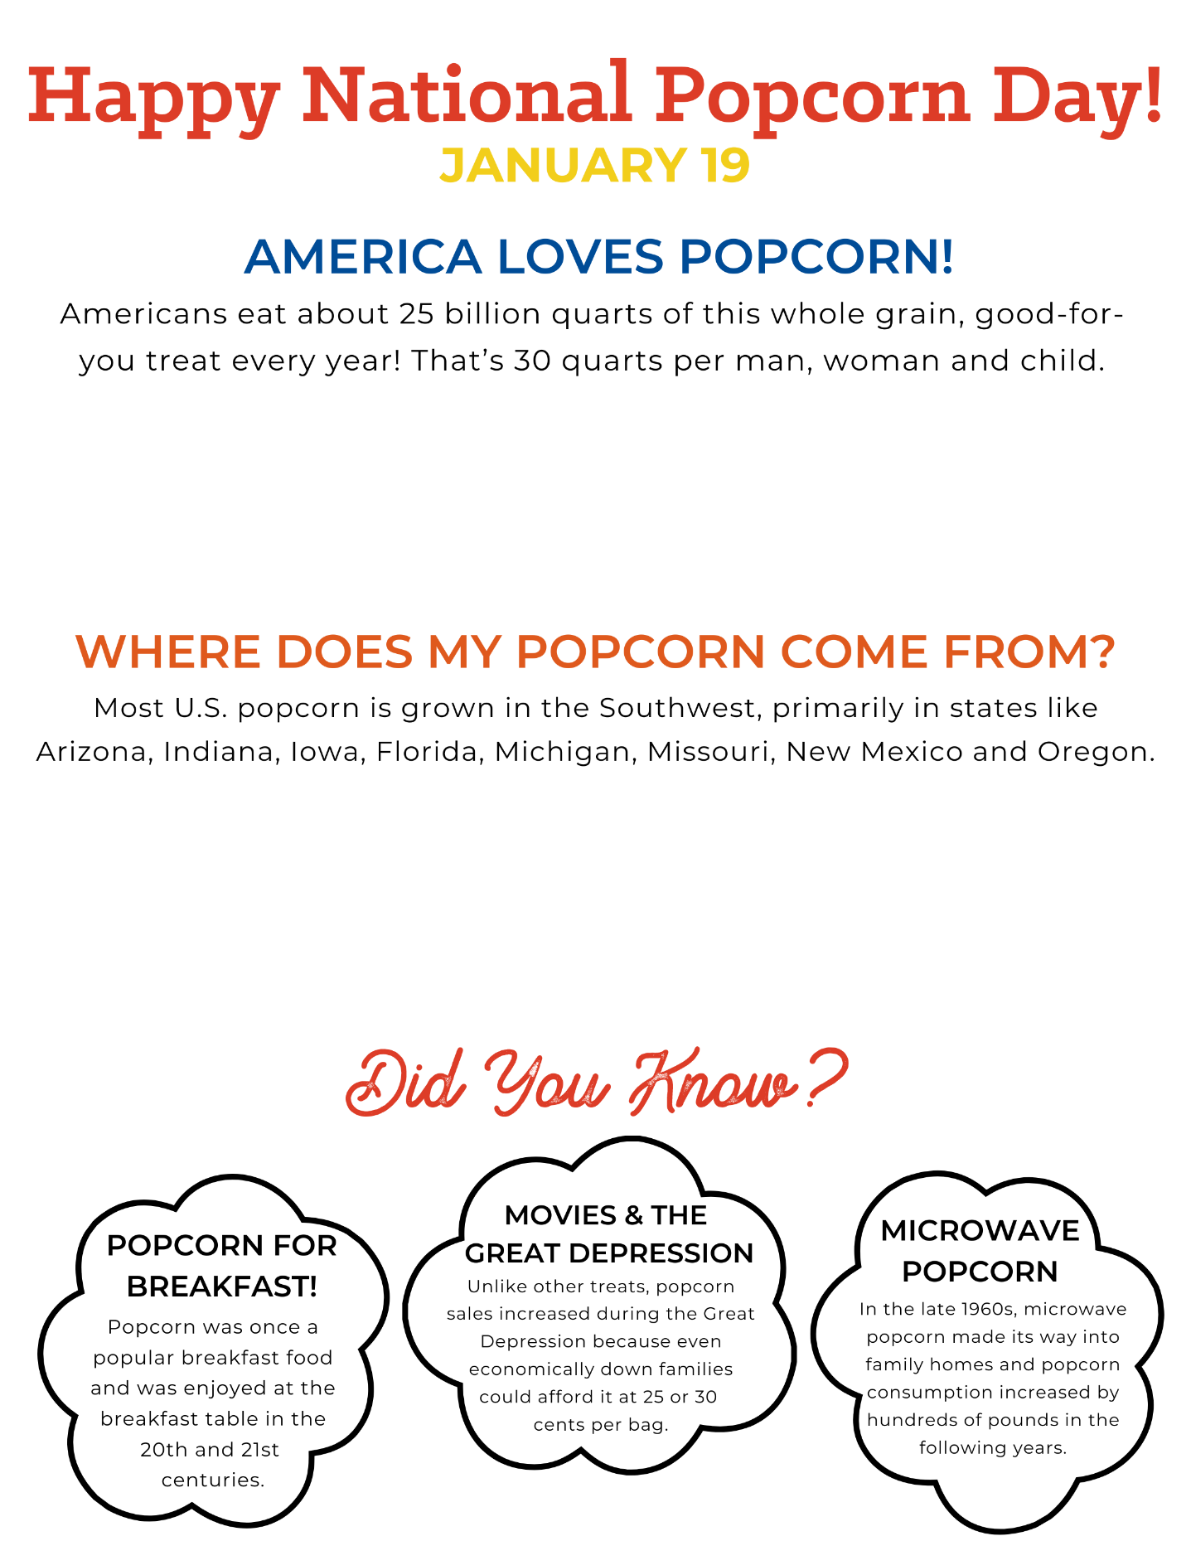
Part 3
Directions:
Popcorn is enjoyed in many different ways. Many people enjoy it with just butter and salt while watching a movie, but there are also many special treats that use popcorn as a base but add things like cheese, chocolate, pretzels or candies. Use your creativity to create a recipe for a new popcorn treat to enjoy. It can be sweet, savory or both — whatever you would most enjoy! Record the recipe on the notecard below and then design a package for your new treat. Be sure to include a name for your new treat as well as a picture and color on your packaging.

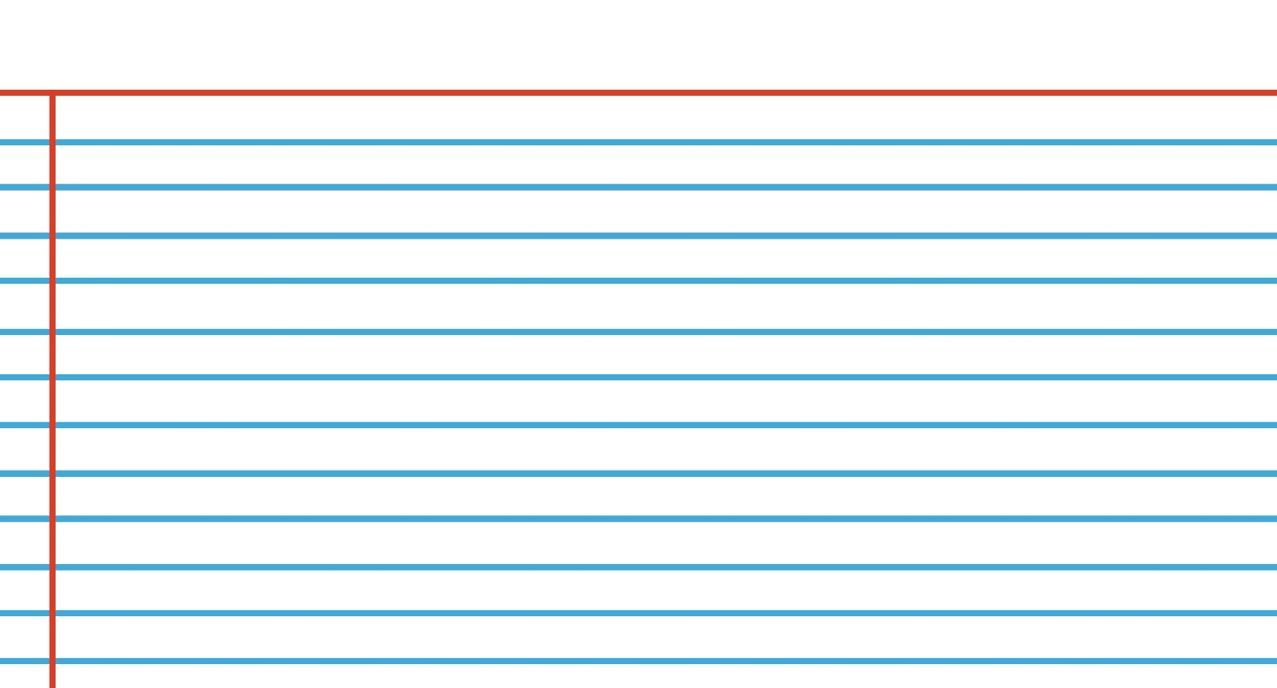

- What is your favorite way to enjoy popcorn? Why is that your favorite?
- How did you decide what to include in your new recipe?

