Aligned to the following standards: FFA.PL-A; FFA.PL-B; FFA.PL-C; FFA.PL-D; CCSS.ELA.RI.9-10.1; CCSS.ELA.W.9-10.3; CCSS.ELZ.W.9-10.8; CRP.04; CRP.05; CRP.06; CRP.08
Appendix 6: More Than a Jacket
Part 1
Directions:
Read the article “More Than a Jacket” in the fall/winter 2024 issue of FFA New Horizons and answer the questions below.

- Explain in your own words why Grace felt a sense of pride when she zipped up her FFA jacket for the first time.

- In the first box, write down how many Greenwood FFA freshmen received a jacket in 2023. In the second box, write down how many freshman FFA members across the whole state received a jacket in 2023.

- Which organization in Pennsylvania began the First-Year Member Jacket Campaign?

- Fill in the blanks.

In the first year, they gave out ______ jackets.
Now, they give out an average of _______ jackets.

- Explain how the Greenwood FFA Chapter initiated their own fundraising efforts.

- Based on what you’ve read, list two benefits of the First-Year Member Jacket Campaign in Pennsylvania.

- Do you feel a program like this would be beneficial in your state? Explain why.

Part 2
Directions:
Visit the Give the Gift of Blue website from National FFA: FFA.org/giveblue/. Watch the three videos and answer the questions below for each video.

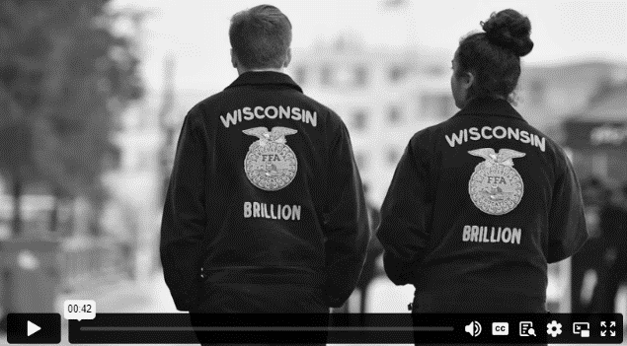
Video 2
Video 1
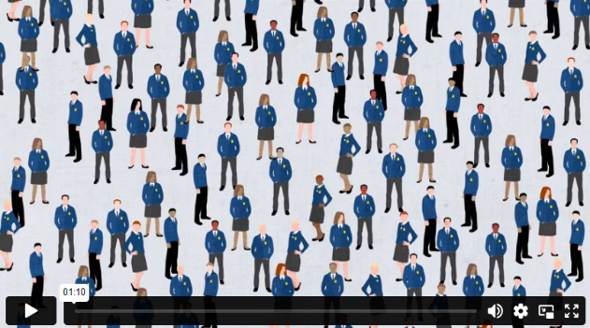
Video 3
1. In FFA, a corduroy jacket is an article of _______________, ______________ and _____________ for millions of FFA members past and present.
2. The FFA jacket remind us __________________
______________________________________________
______________________________________________.

3. What does the Gift of Blue program do?
1. As a member of FFA, you are the most important part of an organization that creates ____________________, ____________________, _______________________, _____________________ and _____________________.
2. How many hours of community service do FFA members give across the country?

3. What unites us all, generation to generation?

4. How many FFA members have a blue jacket?
1. What year did the National FFA Foundation award the 10,000th FFA jacket through Give the Gift of Blue?

2. Only _____ out of ______ FFA members have a jacket with their name stitched on the front.
3. How does a personalized FFA jacket impact the members?
Part 3
Directions:
You and your FFA chapter have been asked to plan a “First-Year Member Jacket Campaign” for your state. Answer the prompts below.

- Fill in the five boxes below with five different requirements for students to receive an FFA jacket.

- Create two Instagram posts to advertise your “First-Year Member Jacket Campaign” for your state.


- List three partners or supporters who could help provide financial support for this project.

- Why do you think this project would benefit members in your state?

- Do you think FFA members would apply? Why or why not?

