Aligned to the following standards: FFA.PL-A; FFA.PL-B; FFA.PL-D; FFA.PL-E; FFA.CS-M; FFA.CS-N; CS.01; CS.02; CS.03; CS.04; CS.06; CCSS.ELA.RI.9-10.1; CCSS.ELA.RI.9-10.7; CCSS.ELA.W.9-10.1; CCSS.ELA.W.9-10.2; CCSS.ELA.W.9-10.8; CCSS.ELA.W.9-10.9; CCSS.ELA.SL.9-10.2; CRP.01; CRP.04; CRP.05; CRP.06; CRP.08; CRP.09; AS.01; AS.02
Appendix 6: Finding Ag in the City
Part 1
Directions:
Read the article “Finding Ag in the City” in the fall 2023 issue of FFA New Horizons and answer the questions below.
- Who is Victoria Tovar?
What FFA chapter is she a member of? | Where is she originally from? | True/False:  Her family was involved in agriculture. | How old was she when her family moved to the US? | What city did they move to?

- What was Victoria Tovar’s reaction to her family dog biting her when she was 7 years old?

- In fifth grade, Tovar told her counselor that she wanted to be a veterinarian. What did her counselor do for her?

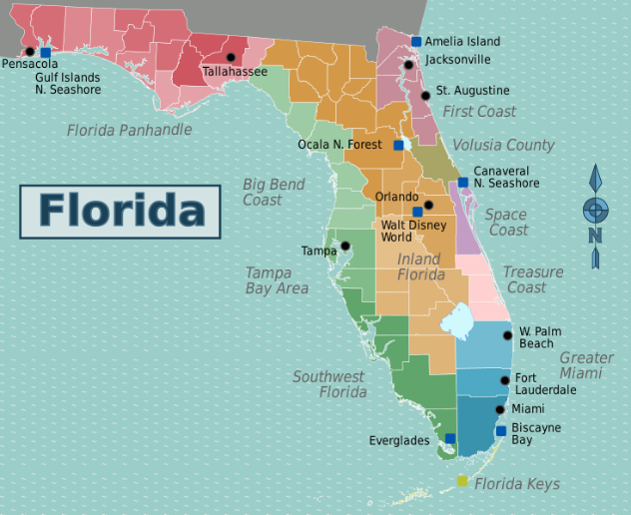
- Which school was at the top of the list? Why?

- If she completed the program at this school, what certification could she earn to assist her in becoming a veterinarian?

- Using the map, locate Miami, Florida, which is identified by the star. Why do you think Miami is not a city that is typically thought to have agriculture?

- William H. Turner Technical Arts High School offers agricultural opportunities on campus for their urban population. What are those opportunities?

- On-campus ______________________________
- Farm with ____________________, hogs, _______________________, goats, lambs, _______________________ and __________________________________________
- Where do students show livestock?

- Describe what Tovar did to earn her FFA advisor’s trust in order to show cattle?

- Which of the following is NOT an environmental condition in Miami that makes raising livestock a challenge?
  - Hot and humid
  - Hot and dry
  - Risk of hurricanes

- Which characteristic does Tovar say is necessary when working with animals?
- Rushing
- Making sudden movements
- Patience

- What breed was her first show steer?

- How much did her steer sell for in her senior year?

- Where is Tovar now? Where does she go to college, and what is she studying?

- Tovar says that, in Miami, animal agriculture is misunderstood. Fill in the blanks below to review her advice when faced with someone being negative about agriculture.

- Keep a ___________________________ mindset.
- _________________________ them.
- Don’t let them ____________________________________________________.
- Find strength in the agriculture __________________________________.

Part 2
Directions:
Watch the video linked below from Louisiana State University on animal rights versus animal welfare and complete the questions below.
Animal Rights and Animal Welfare | Issues in Ag: https://www.youtube.com/watch?v=PydVKdeaix4

- In your own words, define the following:
Animal Rights | Animal Welfare

- What are two examples mentioned in the video that have encouraged animal rights?

- How do animal welfare supporters provide a good point of view for using animals?

- At LSU, what must happen before an experiment can be conducted with animals on campus?

- Which governmental act does LSU follow closely with their animals?

- What are the Five Freedoms from the Farm Welfare Council?

Freedom 1 | Freedom 2 | Freedom 3 | Freedom 4 | Freedom 5
Freedom from … | Freedom from … | Freedom from … | Freedom to … | Freedom from …

- What do you think is a challenge animal agriculturists face from animal rights activists?

- What is something that animal agriculture advocates can do to help animal agriculturists overcome those challenges?

Part 3
Directions:
Using the information that you learned from the video in Part 2 and the information on talking about animal agriculture from the article, create an informational three-panel brochure using a blank sheet of paper. This brochure should cover information that would educate someone on animal agriculture, the difference between animal rights and welfare and the positive impacts of working with animals (such as raising and showing animals).
Use this space to brainstorm your brochure:

