Aligned to the following standards: AG2; AG5; CS.02 CS.05; FFA.PL-A; FFA.PL-C; FFA.PL-D; FFA.PL-E; FFA.PL-F; FFA.PG-G.; FFA.PG-I; FFA.CS-M; FFA.CS-N; FFA.CS-O; FFA.CS-P; CCSS.ELA.RI.9-10.2; CCSS.ELA.RI.9-10.4; CCSS.W.9-10.2; CCSS.W.9-10.4; CCSS.ELA.W.9-10.8; CCSS.SL.9-10.2; CCSS.SL.9-10.4; CRP.02; CRP.04; CRP.08; CRP.09
Appendix 6: Minted a Farmer
Part 1
Directions:
Read the article “Minted a Farmer” in the spring 2023 issue of FFA New Horizons and answer the questions below.

1. In 2017, Brock joined a _____________ farmhand ___________ for high school students at _____________

Farms in __________Wisconsin.

1a. How long has he been there? __________________________________________________________________________
2. How big is the farm?

3. Describe the farm.

4. Brock found his niche with what crop?
a. tomatoes c. watermelon
b. mint d. peppers
5. What awards did he win because of his SAE?
6. Why was he shocked?

7. How did FFA prepare him?
8. What are some tasks, mentioned in the article, that are associated with growing mint?

8a. What have the tasks led to?

9. What is one fact that stood out to you after reading this article?

10. How can you connect this information to what you are learning in your SAE, agriculture class or other classes?

Part 2
Directions:
Complete the activities below to learn about the production of mint. Utilize these websites to complete the activities: https://www.almanac.com/plant/mint, https://www.almanac.com/what-are-plant-hardiness-zones, https://bonnieplants.com/blogs/how-to-grow/growing-mint and https://planthardiness.ars.usda.gov/.

1. What is a plant hardiness zone? __________________________________________________________

2. What zone(s) does mint grow best in? _______________________________________________

On the map, shade in the zones where mint grows best.
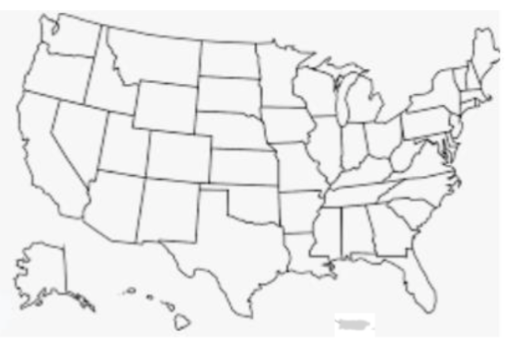

3. In which season is it best to plant mint? Circle the correct answer. Winter Spring Summer Fall
What insects/pests is mint vulnerable to?

According to your area’s USDA planting zone, what crops have similar growth requirements to mint? Use this site to help with your research: https://southernlivingplants.com/find-your-zone/
How to Grow and Plant Mint
Spacing Requirements
Water Requirements
Fertilize Requirements
pH Requirement
When do the flowers on the mint plant typically bloom?

Identify various uses for mint. List at least four.
1.

2.

3.

4.

How do you harvest mint?

How many harvests per season are typical?

What impact does mint production have on you?

Part 3
Directions:
Create (or modify) a recipe! Use the space below to create a recipe using mint OR take one of your favorite recipes and incorporate mint.


Recipe Name:
Directions:
Ingredients:

