Officer Roles and Responsibilities

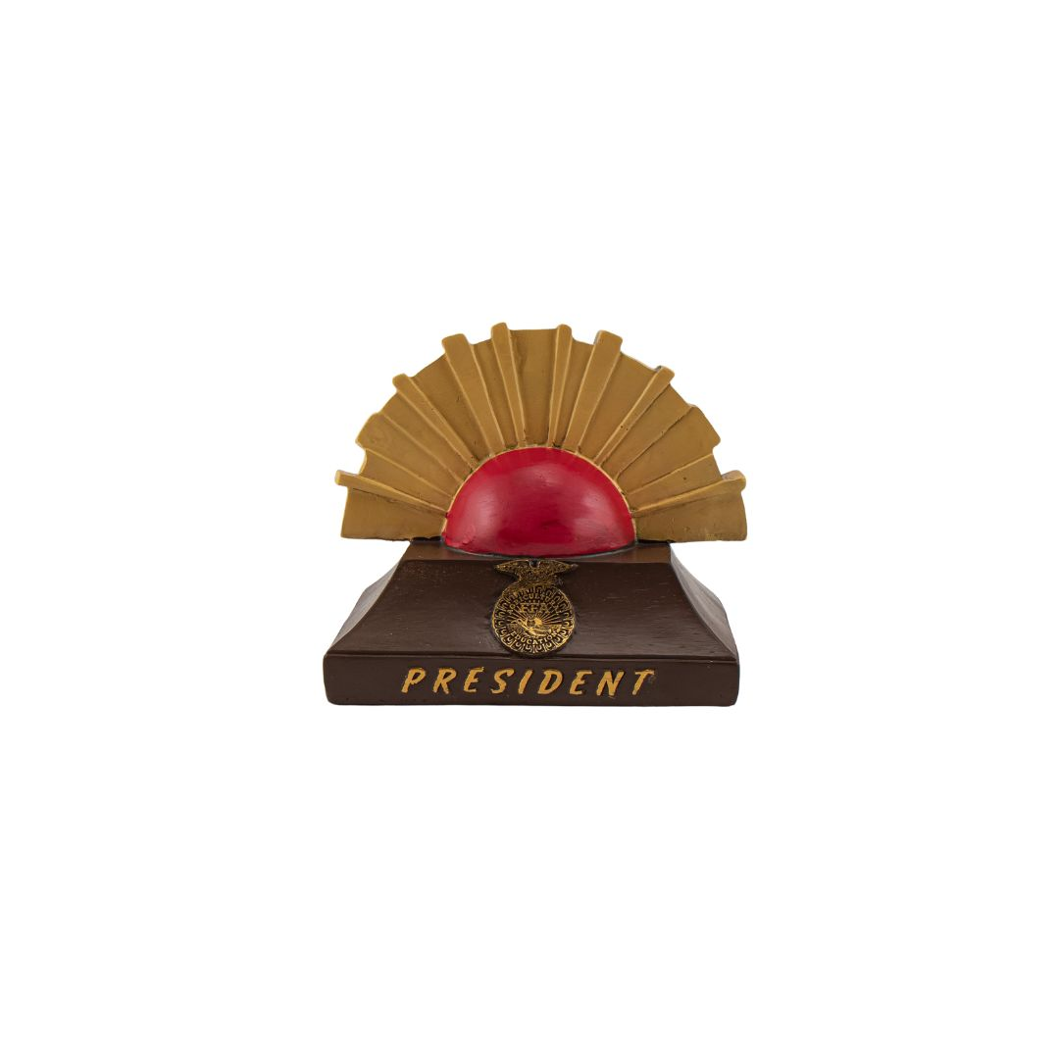
President

“Beneath the Rising Sun”

- Presides over meetings.
- Appoint committees.
- Coordinate activities of the chapter and evaluate the progress of each division of the Program of Activities.
- Represent the chapter in public relations and official functions.

FFA Advisor

“Here by the Owl”

- Supervise chapter activities.
- Inform students and parents about FFA.
- Instruct students in leadership and personal development.
- Build school and community support.
- Encourage involvement of FFA members in activities
- Prepare students for involvement in career and leadership development events.

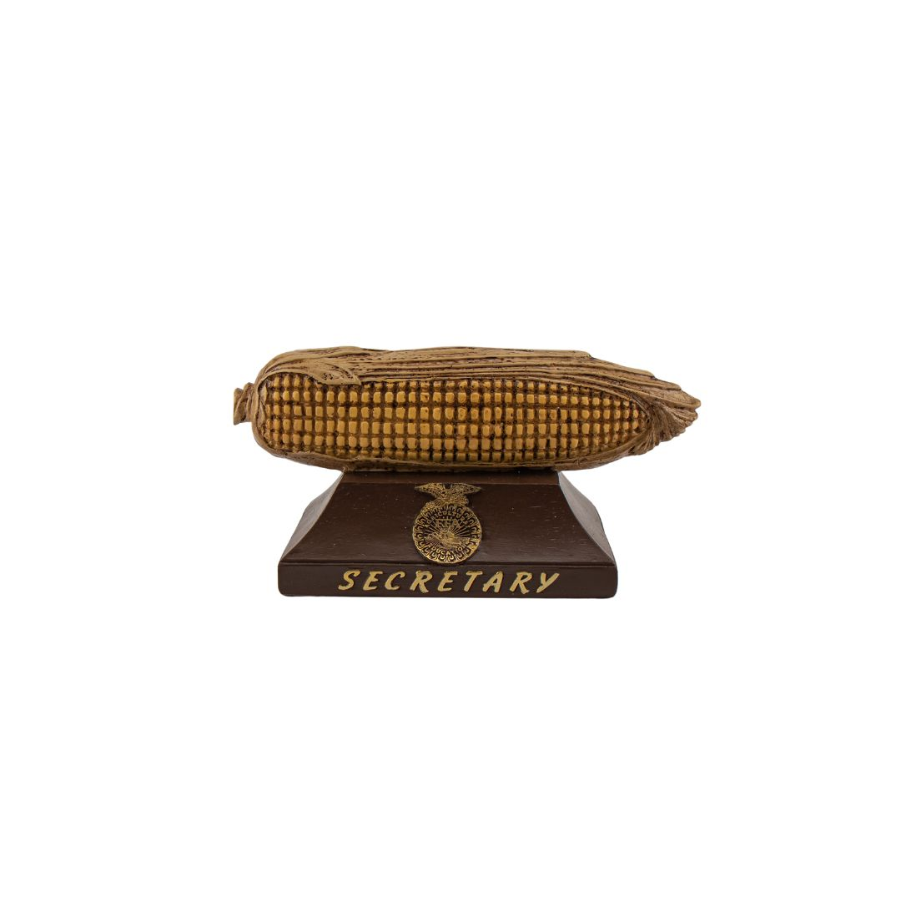
Secretary

“Stationed by the Ear of Corn”

- Prepare and post the agenda for each chapter meeting.
- Prepare and present the minutes of each chapter meeting.
- Place all committee reports in the secretary’s file.
- Maintain chapter correspondence.
- Maintain member attendance and activity records.

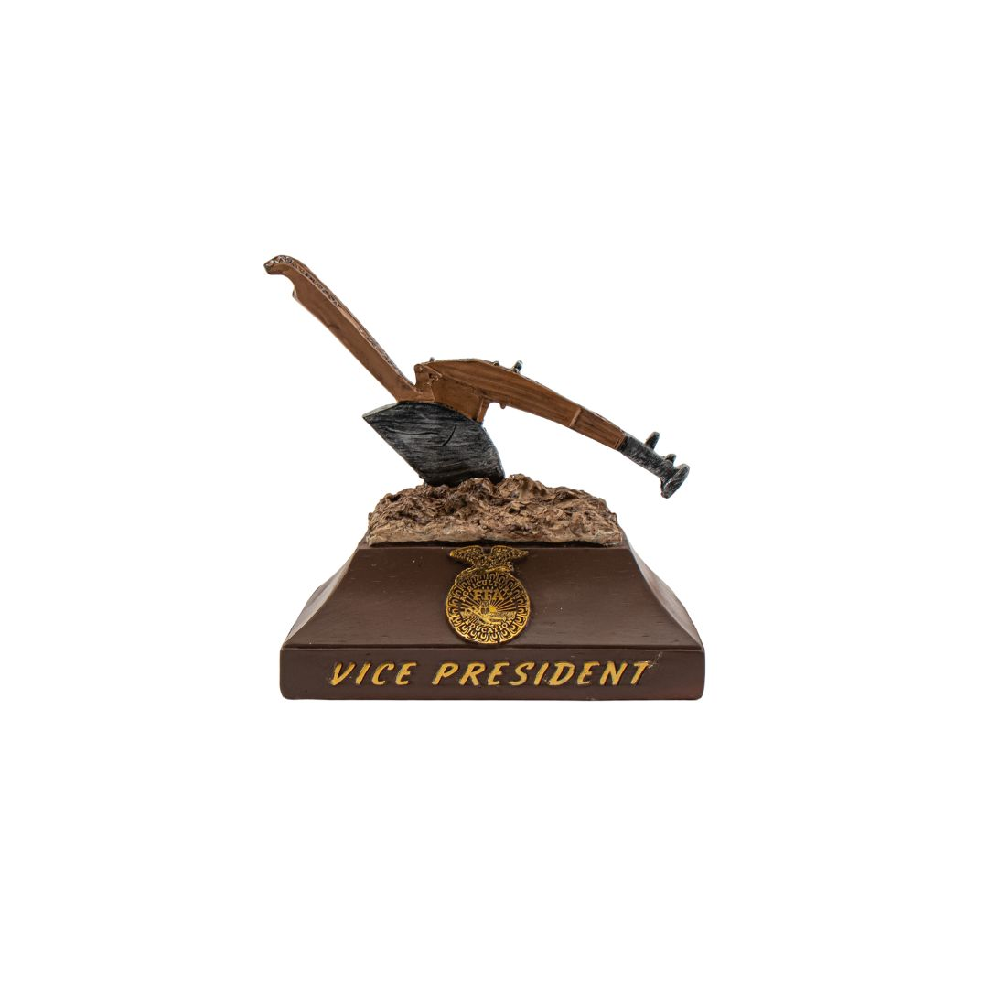
Vice President

“Stationed by the Plow”

- Assume all duties of the president, if necessary.
- Develop the POA and serve on the committees.
- Coordinate all committee work.
- Work closely with the president and advisor to assess progress toward meeting chapter goals.

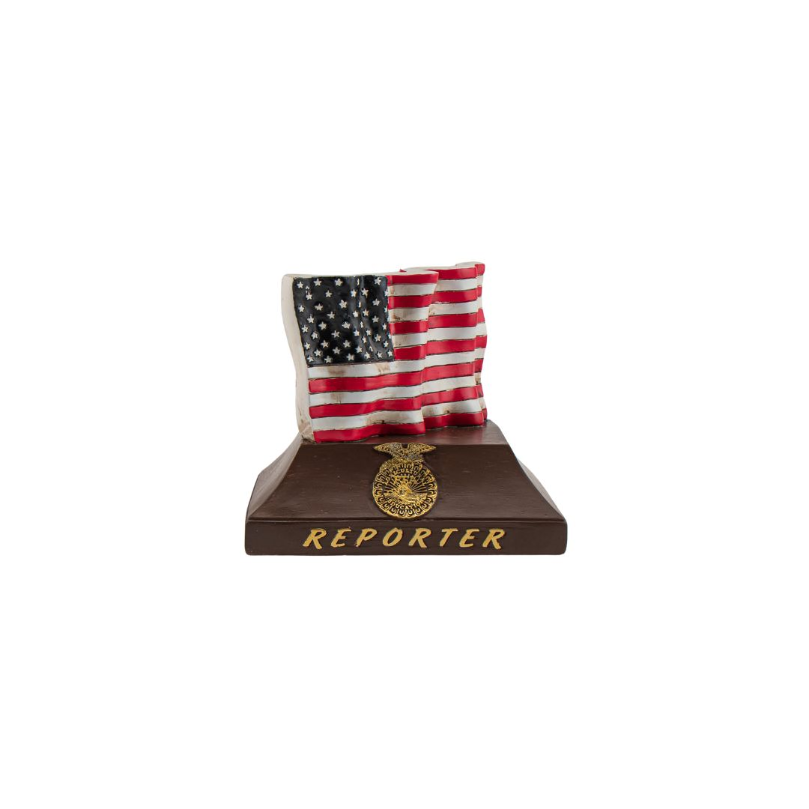
Reporter

“Stationed by the Flag”

- Serves as public relations committee chair.
- Plans public information programs with local radio, television and newspaper.
- Releases news and information to local and regional news media.
- Publishes a chapter newsletter or website.
- Prepares and maintains a chapter scrapbook.
- Sends local stories to news reporters and to any school publications.
- Sends articles and photographs to FFA New Horizons and other national and regional publications.
- Works with local media on radio and television appearances and FFA news.
- Serves as the chapter photographer.

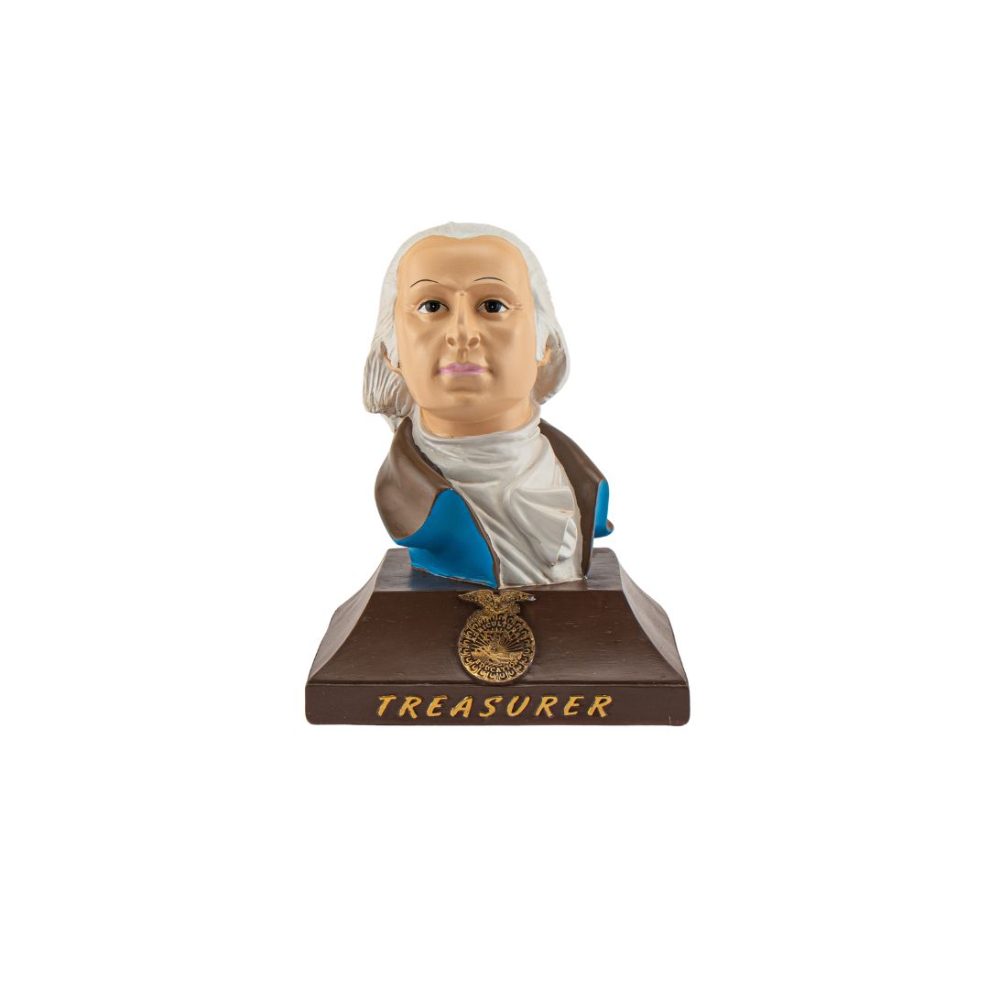
Treasurer

“Stationed at the
Emblem of Washington”

- Receives, records and deposits FFA funds and issues reports.
- Presents monthly treasurer reports at chapter meetings.
- Collects dues.
- Maintains neat and accurate records.
- Prepares and submits the membership roster to the National FFA Organization through the state FFA association.
- Serves as the finance committee chair.

Sentinel

“Stationed by the Door”

- Assists the president in maintaining order.
- Keeps the meeting room, chapter equipment and supplies in order.
- Welcomes guests and visitors.
- Keeps the meeting room comfortable.
- Takes charge of candidates for degree ceremonies.
- Assists with special features and refreshments.
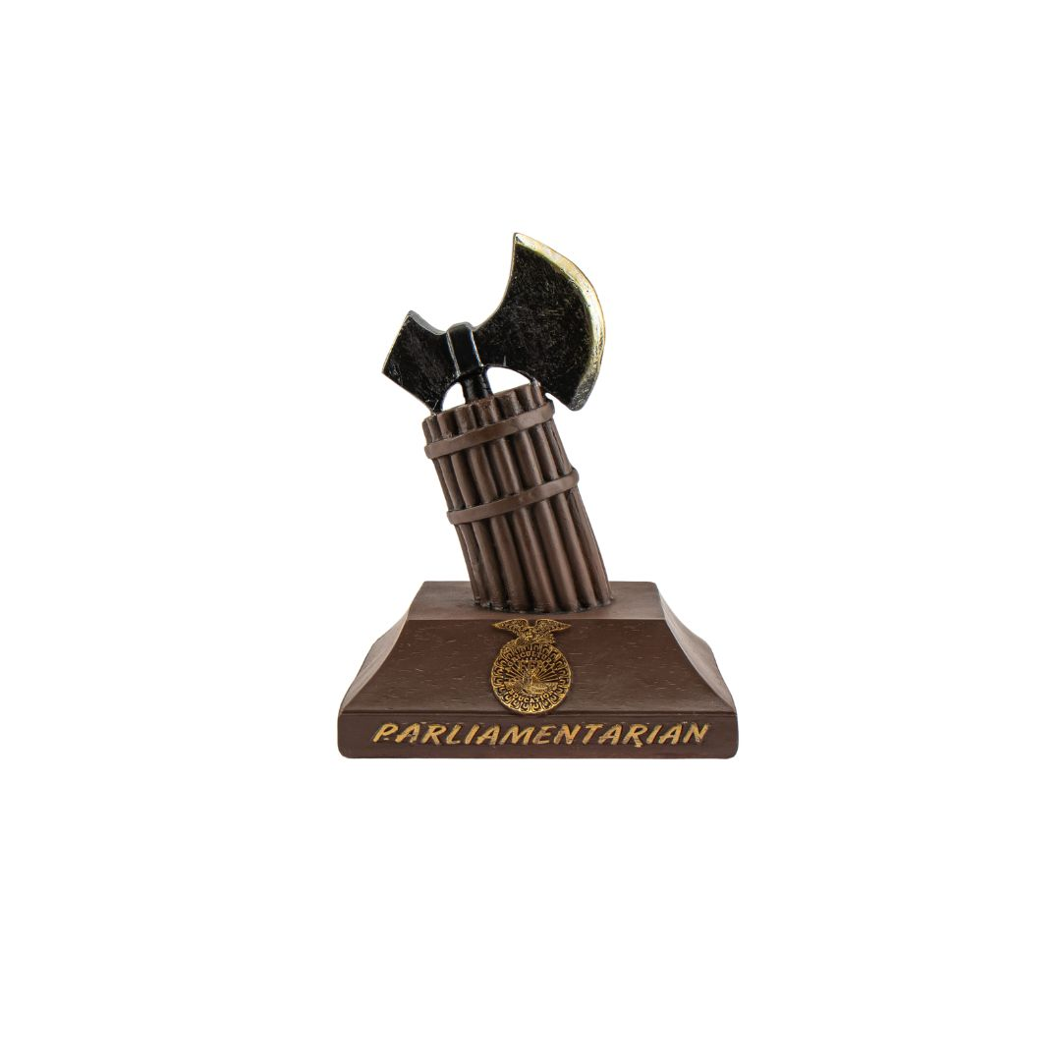
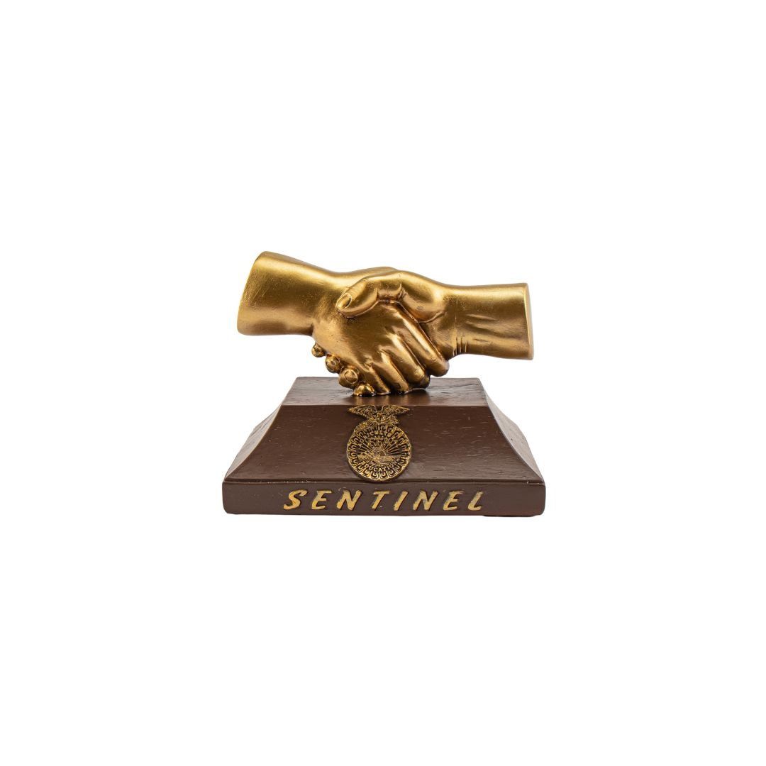
Parliamentarian

“Stationed by
the Fasces”

- Is proficient with parliamentary procedure.
- Rules on all questions of parliamentary conduct at chapter meetings.
- Serves as a participant of the parliamentary procedure team.
- Conducts parliamentary procedure workshops at the chapter level.
- Chairs the committee for the conduct of meetings.

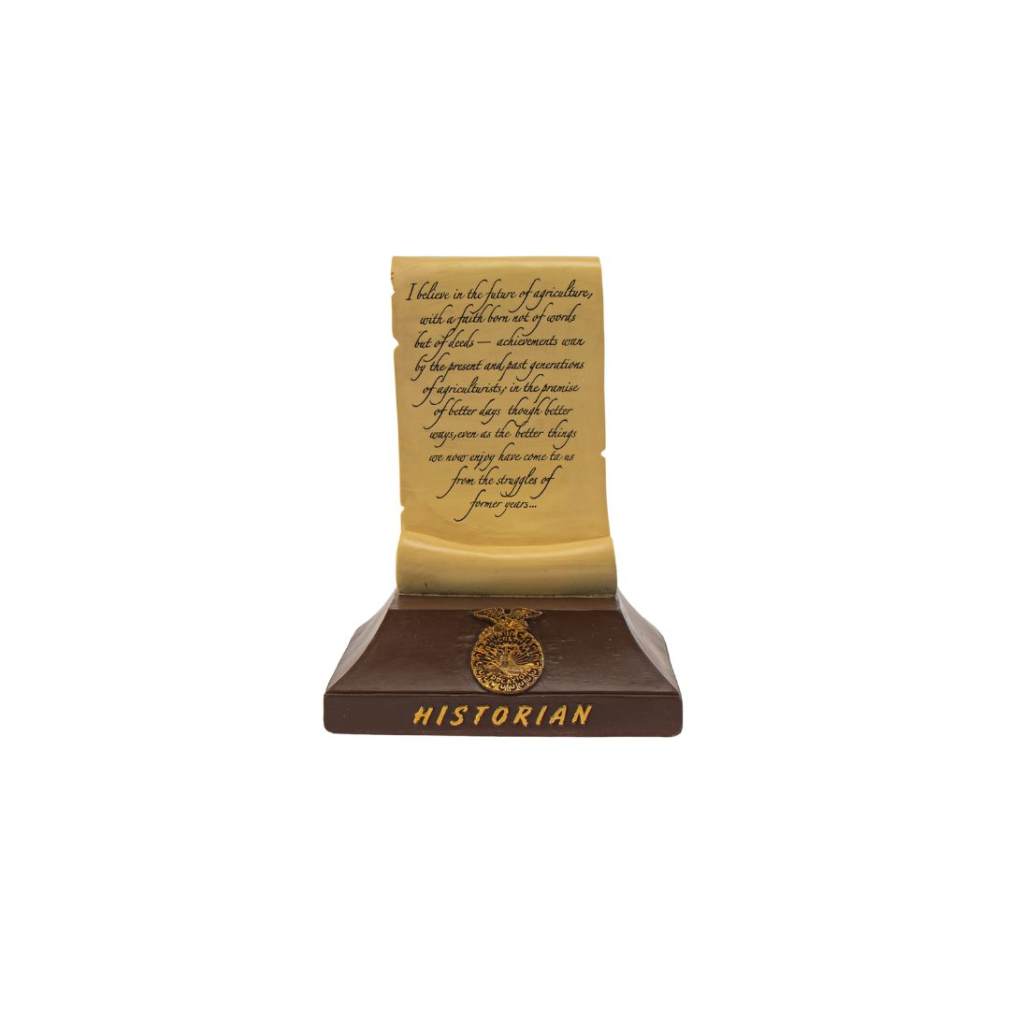
Historian

“Stationed by
the Historical Scroll”

- Develops and maintains a chapter scrapbook to record the chapter’s history.
- Researches and prepares items of significance in the chapter’s history.
- Prepares displays of chapter activities and submits stories of former members to the media.
- Assists the reporter in providing photography for chapter needs.

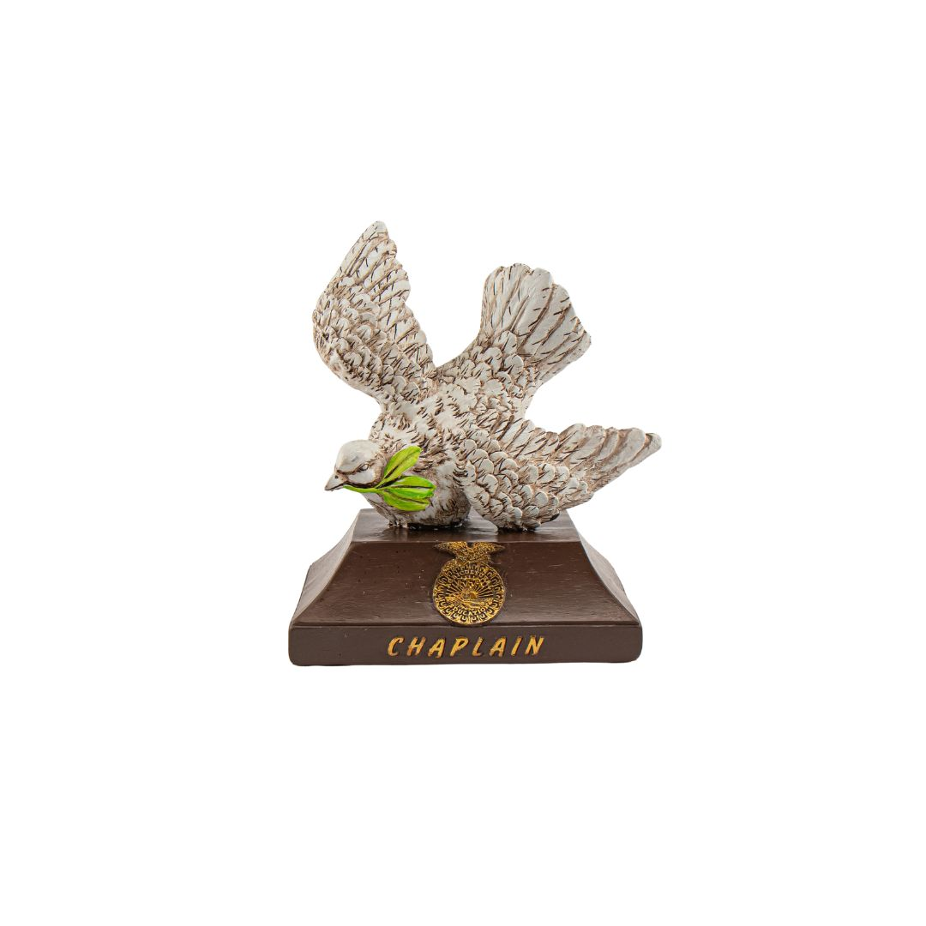
Chaplain

“Stationed by the Dove”

- Presents the reflections at banquets and other functions.
- Conducts reflection services at summer camps and conferences.

