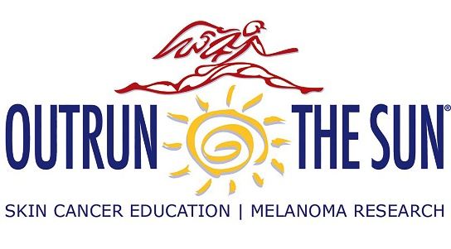
Sun Safety in Agriculture
Created: 04/2026 by the National FFA Organization

Use this outreach guide to assist your agriculture class or FFA chapter in planning a hands-on outreach project to educate others about sun safety in agriculture. These activities are great to use when building a chapter’s program of activities (POA) that meets National Chapter Award standards.

How to Use This Guide:
This outreach guide includes three different project ideas, each with instructions and outlines to help students plan an outreach project on sun safety in agriculture. Two of the projects are geared toward working with local elementary and middle schools. The third project is designed to reach community members.

National Quality Chapter Standards:
The following standards are met with each project:
- Project 1 – Reading for a Sun-Safe Life in Agriculture
  - Strengthening Agriculture: Agricultural Literacy
- Project 2 – Rotating Through Sun Safety in Agriculture
  - Growing Leaders: Healthy Lifestyle
  - Strengthening Agriculture: Safety
  - Strengthening Agriculture: Agricultural Literacy
- Project 3 – Reaching More Sun Safety in Agriculture
  - Strengthening Agriculture: Agricultural Literacy

Resources:
While it is important for FFA members and agriculture students to take ownership over their chosen projects, there are guides and activity sheets included in this resource that can be used. Specific details are omitted to allow planning members/students to be creative and innovative while meeting the specific needs of their audience. FFA members and agriculture students are encouraged to develop their own content based on what they’ve learned from the two lessons connected to this activity guide and further research on sun safety in agriculture. Find the two lesson plans here: https://ffa.box.com/s/o1sgjka9ucu52lkbqiy80bq0ac2ixltu.
The National FFA Organization also has Experience Planning Guides available to help FFA members and agriculture students navigate the planning process for an advocacy event/project. These planning guides can be used in tandem with the project guides in this resource.

Helpful Experience Planning Guides that can be used with the activities include:
- Community: https://FFA.box.com/s/h00vhd4datspx6mmcet2uf2q2jgxew5s
- Peers: https://FFA.box.com/s/4awqoevvdyoi159pco4lxrcfq9bujpf2
- Elementary: https://FFA.box.com/s/rd8oiqiat5ahwnzqkdd28zeor4lc74uv

National FFA has a variety of grants that FFA chapters can apply for to help cover the cost of materials if hosting an agriculture sun safety day. Be sure to check these out!
- Grants for Growing: FFA.org/grants-for-growing/
- Living to Serve: FFA.org/livingtoserve/

Find all handouts and activity instructions pulled out here:
https://ffa.box.com/s/3vqfofmy6m3jfci1i5jmcq1sd62hsr0g (Word | PDF)
https://drive.google.com/drive/folders/1kG00ySF4QP3AVB2NzyBqXw_jBm1rULAo?usp=sharing (Google)
Project 1 – Reading for a Sun-Safe Life in Agriculture
Purpose: | Introduce elementary students to agriculture and sun safety through storytelling, discussion and creativity.
Audience: | Local elementary school; Pre-K classes; Grades K-3
Materials: | - An agricultural-themed picture book to read  - “High Five Sun-Safety Practices” printed to display  - “Sun-Safe Coloring” printed for the number of students being taught (one per student)  - Crayons/markers/colored pencils
Project Outline: | - Select a team of FFA members or agriculture students to manage this project. If you are visiting a local elementary school with several classes, you could create multiple teams of members/students to visit multiple classes.  - Find a local elementary school, pre-K class or other K-3 setting to partner with for this project. Connecting with your local elementary school(s) that feed into your high school is a great way to have FFA introduced to students at a young age.  - Choose an agriculture-related picture book to read to your partnering class. Here are several suggestions from the National Agriculture in the Classroom book list:  - “Outdoor Farm, Indoor Farm” by Lindsay H. Metcalf  - “Right This Very Minute” by Lisl H. Detlefsen  - “Farmer Eva’s Green Garden Life” by Jacqueline Briggs Martin  - “Seasons on the Farm” by Chelsea Tornetto  - Find more book suggestions here: https://www.agfoundation.org/books  - Plan a short discussion to host after reading the story.  - Explain why being safe when working in the sun is important.  - Teach the class about the High Five Sun-Safe Practices.  - High Five Sun-Safe Practices  - Observe and list all items related to the High Five Sun-Safe Practices that were displayed in the picture book.  - Recognize and list anything that was missing from the picture book that could contribute to following sun safety.  - These are suggested, helpful discussion questions:  - Where did the main character work?  - What did the main character do to stay safe in the sun?  - When are you outside in the sun?  - What do you do to stay safe from the sun?  - Coloring and drawing activity:  - Provide each person in the class with the sun safety in agriculture coloring sheet.  - Sun Safe Coloring  - The class can color their sheets, but they will also draw items that relate to sun safety in agriculture that match each of the High Five Sun-Safe Practices.
Why does this project work? | - Low cost  - Easily repeated across multiple classes  - Perfect for National FFA Week, National Agriculture Safety Week, National Teach Ag Day, National Agriculture Day or an Ag Literacy Day

Project 2 – Rotating Through Sun Safety in Agriculture
Purpose: | Host a Sun-Safe Agriculture Day to teach sun safety through movement, hands-on learning and interaction with FFA members/agriculture students in a series of stations.
Audience: | Elementary and middle school-aged students; Grades K-8
Materials: | - Materials are broken down per station.
Project Outline: | - Select a team of FFA members or agriculture students to manage this project. It is recommended that you have three or four members per station to help manage visiting students and lead the activity.  - Find a local elementary school or middle school to partner with for this project. Connecting with your local elementary and middle schools that feed into your high school is a great way to have FFA introduced to students at a young age.  - Secure a location to host the event. This could be at the partnering school, at your own school, at a local park, etc.  - Choose at least three stations from the list to have at your event:  - Sun-Safe Relay – Dress for the Job!  - UV Bead Investigation  - Sunscreen Handprints  - Spectacular Sunglasses  - Being Shady
Rotation Tips | - 8-10 minutes per station  - Groups of 8-10 students
Why does this project work? | - Visiting students are learning through interactive methods.  - Great leadership experience for FFA members/agriculture students  - Perfect for National FFA Week, National Agriculture Safety Week or National Agriculture Day

Project 3 – Reaching More Sun Safety in Agriculture
Purpose: | FFA members educate the community about sun safety in agriculture by creating an informational bulletin board or tri-fold board that can be seen in a public location.
Audience: | Your community
Materials: | - Depends on the board that is planned, but may include:  - Bulletin paper in different colors  - Construction paper  - Printed images  - Letters or materials to make letters  - Typed information  - And more
Project Outline: | - Select a team of FFA members or agriculture students to manage this project.  - Partner with a local organization that is willing to host the bulletin board:  - Farm Bureau or similar business  - Cooperative extension  - Local library  - Community center  - Feed or agriculture supply store  - Town hall building  - Decide what information is most important to share. Ideas include:  - High Five Sun-Safe Practices for agriculture  - Sun-safe tips based on agriculture settings  - Recommended board features:  - “Sun Safety in Agriculture”  - Student-created visuals explaining sun safety  - Real photos or drawings of agriculture work outside  - QR codes linking to sun safety resources
Why does this project work? | - Low cost  - Reaches a broad audience of people of all ages  - Perfect for National FFA Week, National Agriculture Safety Week, National Teach Ag Day, National Agriculture Day or an Ag Literacy Day

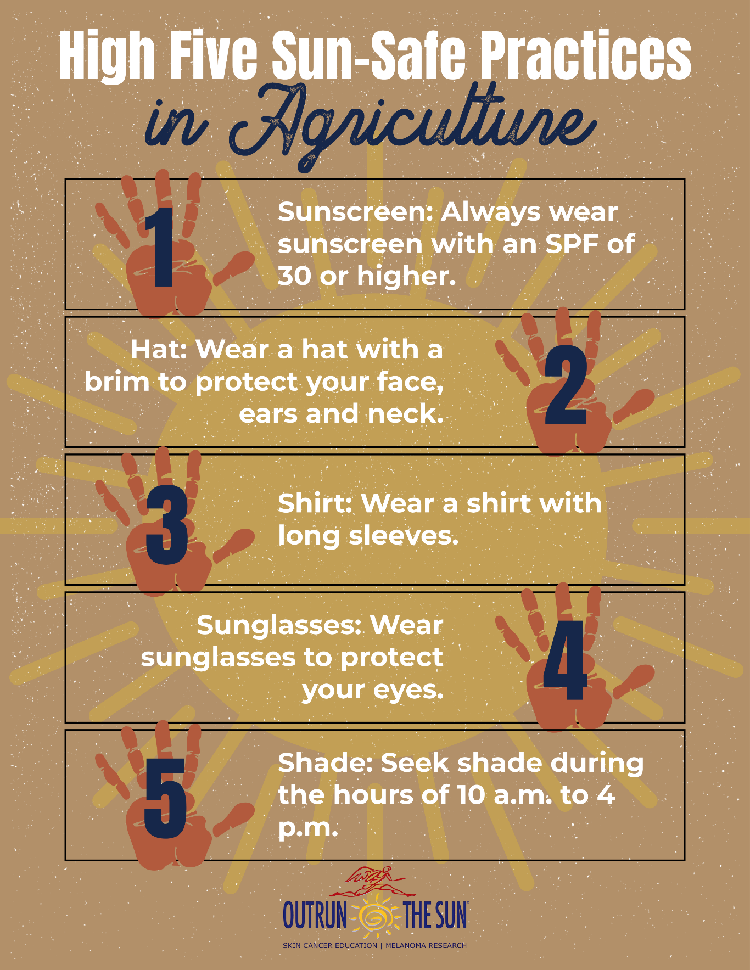
High Five Sun-Safe Practices

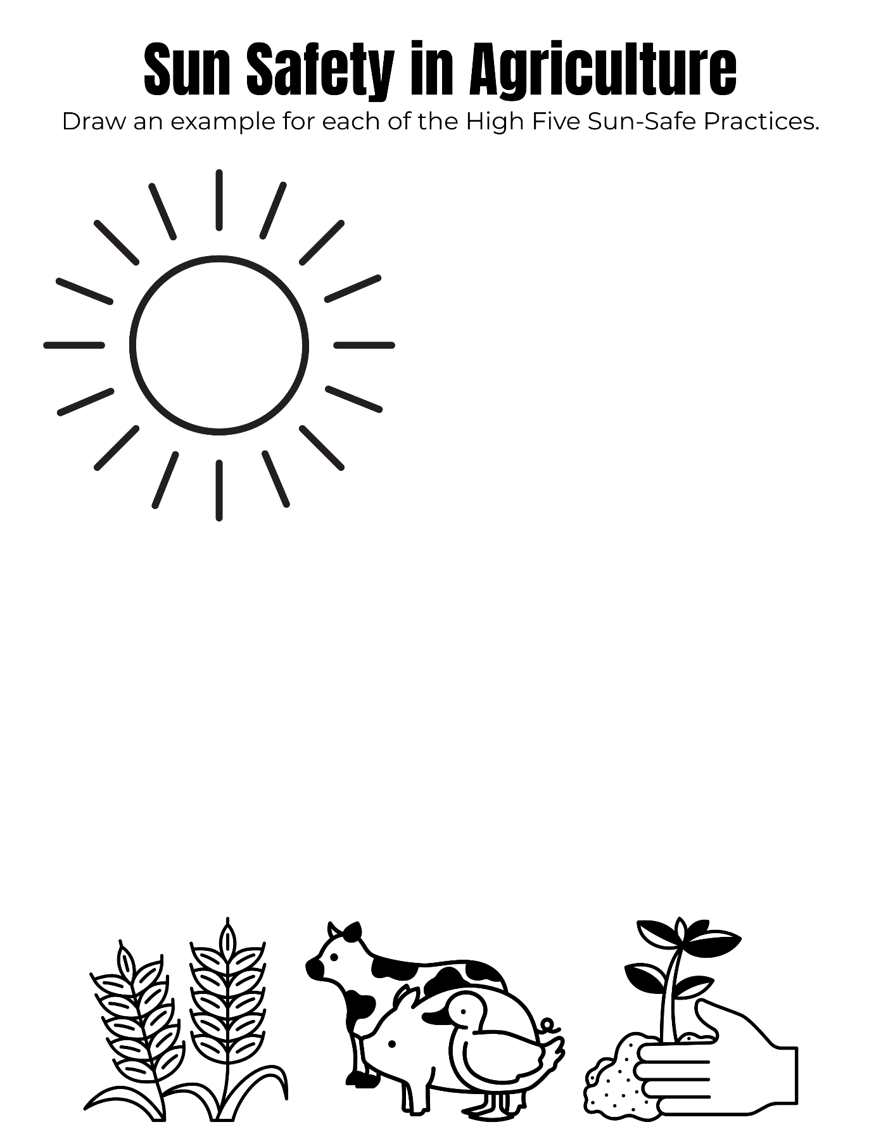
Sun Safe Coloring

Sun Safety Relay – Dress for the Job!

At this station, teams will race to properly “dress” a teammate for outdoor agricultural work.

What you need:
- An educational poster/tri-fold board showing the High Five Sun-Safe Practices
  - Sunscreen – Always wear sunscreen with an SPF of 30 or higher.
  - Hat – Wear a hat with a brim to protect your face, ears and neck.
  - Shirt – Wear a shirt with long sleeves.
  - Sunglasses – Wear sunglasses to protect your eyes.
  - Shade – Seek shade during the hours of 10 a.m. to 4 p.m.
- A starting line or cones to indicate a starting point.
- Mannequins or scarecrows that students will be relaying to dress in sun-safe gear (humans can be used too!).
- Sun safe clothing and accessories such as (but not limited to):
  - Long-sleeve shirts
  - Hats with brims
  - Sunglasses
  - Sunscreen bottles
  - Water bottles
  - Pants
  - Closed-toe shoes
  - Sun shirts
  - Umbrellas
(Be sure to have plenty of options for two teams to play at the same time!)
- NOT sun safe clothing and accessories such as (but not limited to):
  - Tank tops
  - Hats without brims
  - Tiny sunglasses
  - Shorts
  - Flip-Flops
  - Anything else that seems safe, but really doesn’t give protection

How to play:
- Split group into two teams.
- Tell students they are dressing their mannequin/scarecrow/person to be sun safe.
- They have 60 seconds.
- Only one teammate at a time can be dressing the mannequin/scarecrow/person.
- As many of the High Five Sun-Safe Practices as possible need to be met at the end of time.
- When time is called, stop the relay and then go through each dressed mannequin/scarecrow/human together. Be sure to discuss items and why they are right or wrong.

UV Bead Investigation

At this station, students will learn about UV radiation and create a bracelet from UV beads.

What you need:
- An educational poster/tri-fold board teaching about UV radiation and its effects on humans
- Pipe cleaners to make bracelets (each visitor will make one bracelet).
- Wire cutters (might be used to cut pipe cleaners)
- UV beads – about five or six per visitor
  - https://www.amazon.com/INSPIRELLE-Luminous-Changing-Reactive-Bracelets/dp/B09C5FNQL4/

How to play:
- After learning about UV radiation and its effects on humans, visitors will create a UV bead bracelet by stringing five or six UV beads onto a pipe cleaner. This will become a bracelet they can wear.
- Teach about the colors and intensity of colors by showing what the beads look like in a variety of conditions:
  - Direct sunlight
  - Shade
  - Greenhouse (or under glass)
  - Under soil
  - Any other conditions you can think of

Sunscreen Handprints

At this station, students will visually see how sunscreen can protect them from UV exposure.

What you need:
- An educational poster/tri-fold board teaching about the types of sunscreens and what SPF means
  - Be sure to include the following information:
    - Sunscreen lotion and sunscreen sticks are better protection than sunscreen sprays.
    - Sunscreen should be applied 20 minutes before going outside and reapplied every two hours, or after getting out of the pool or sweating.
    - One ounce of sunscreen lotion should be used for each application.
- Sunscreen (a variety of types – kid friendly, sensitive skin, strong SPF, weak SPF, etc.)
- Black construction paper – one sheet per visitor

How to play:
- After learning about sunscreen, allow visitors to pick a sunscreen of their choice.
- Give each visitor a piece of black construction paper.
- Apply the sunscreen to their hand and press it onto the construction paper.
- Place the paper in the direct sun.
- Over time, areas without sunscreen should bleach out, while the handprint from the sunscreen will remain dark. This demonstrates how sunscreen protection works.

Spectacular Sunglasses

At this station, students will learn about the importance of protecting their eyes from UV exposure and what tools are helpful to do so.

What you need:
- An educational poster/tri-fold board teaching about the risks of eye damage from prolonged, unprotected UV exposure
- Fun sunglasses to decorate (regular size, giant size, any fun sunglasses) – one for each visitor
- Items to decorate the sunglasses with such as beads, jewels and other decorations
- Glue gun or strong glue

How to play:
- After learning about the risks of eye damage from prolonged and unprotected UV exposure, teach students how sunglasses can help keep their eyes safe.
- Each visitor will choose a pair of sunglasses to decorate.
- Give them time to decorate their sunglasses so they have something unique and cool they can wear to protect their eyes.

Being Shady

At this station, students will learn about the benefits of shade for humans, equipment, plants and animals while building a shade model.

What do you need:
- An educational poster/tri-fold board teaching about the benefits of shade
- Simple materials such as craft sticks, paper, blocks, fabric, etc.
- Also, materials that are not helpful for providing shade such as clear plastic bags, tissue paper, etc.
- Hot glue or strong glue
- Scissors

How to play:
- After learning about the benefits of shade, explain how shade can protect humans, equipment, plants and animals.
- Visitors will work in pairs to build a shade model for one of the things discussed (humans, equipment, plants or animals).
- They will place their models in the direct sun and see if their structures are providing shade.

