Me: Etiquette
Created: August/2016 by the National FFA Organization

Student Learning Objectives:
After completing these activities, students will…
- Define etiquette.
- Identify rules of etiquette.
- Analyze and practice rules of etiquette.

Time Required: Interest Approach – 5-10 minutes; Lesson and Activities – 50 minutes
Resources: “Official FFA Student Handbook” – one per student, FFA.org and additional resources outlined below.
Equipment and Supplies Needed:
- Etiquette PowerPoint.
- Public writing surface.
- One set of the “Etiquette Scenarios” for the class.
- One copy per student of the “Reflections on Etiquette.”

This quick lesson plan would work well as:
- An accompaniment to any LifeKnowledge unit.

These activities are aligned to the following standards:
FFA Precept
- FFA.PL-F.Continuous Improvement: Accept responsibility for learning and personal growth.
- FFA.PL-G.Professional Growth: Assume responsibility for attaining and improving upon the skills needed for career success.
- FFA.PG-J.Mental Growth: Embrace cognitive and intellectual development relative to reasoning, thinking and coping.
- FFA.CS-M.Communication: Effectively interact with others in personal and professional settings.
- FFA.CS-N.Decision Making: Analyze a situation and execute an appropriate course of action.
Common Core - Speaking and Listening
- CCSS.ELA-Literacy.SL.9-10.1 Initiate and participate effectively in a range of collaborative discussions (one-on-one, in groups, and teacher-led) with diverse partners on grades 9-10 topics, texts, and issues, building on others’ ideas and expressing their own clearly and persuasively.
- CCSS.ELA-Literacy.SL.9-10.4 Present information, findings, and supporting evidence clearly, concisely, and logically such that listeners can follow the line of reasoning and the organization, development, substance, and style are appropriate to purpose, audience, and task.
AFNR Career Ready Practices
- CRP.04. Communicate clearly, effectively, and with reason. Career-ready individuals communicate thoughts, ideas and action plans with clarity, whether using written, verbal and/or visual methods.
Partnership for 21st Century Skills
- Communication
- Critical Thinking and Problem Solving
- Information, Communications, and Technology Literacy
- Initiative and Self-direction
- Leadership and Responsibility
- Think Creatively

Lesson Plan:
- Interest Approach: Using the provided cards ( “Guess Who” worksheet), ask for one volunteer. Give one card to the volunteer. Prep all students that they will be asking the volunteer “yes” and “no” questions in order to figure out the person/character on the volunteer’s card. Provide the choices/answers on a public writing surface or while displaying the corresponding PowerPoint page. The following is a list of the person/character on the provided cards. After completing the short activity, ask students their impressions of these people? What are some words we would use to describe these individuals?
  - Sloppy Sid
  - Late Larry
  - Disorganized Debbie
  - Disrespectful Doug
- Activity: Etiquette Scenarios (25-35 minutes)—Transition from the Interest Approach by asking students to define “etiquette” (conventional requirements as to social behavior; properties of behavior; properties of conduct as established in any class or community or for any occasion). Ask students how we learn proper etiquette. Establish the expectations that sometimes we need to see/evaluate situations, think about appropriate decisions/actions and research what we don’t know. This class period will allow us to do just that.
  - Divide the class into five groups. Use the five provided scenarios; assign one to each group. The task for the group is to evaluate the scenario, discuss what we believe to be appropriate and what may not be appropriate. In all, there should be two characteristics that are appropriate and one that isn’t. If the group doesn’t agree, do some research to come to a group consensus.
  - Once the allotted time has passed, rotate the scenarios and have the group evaluate another scenario. Each group should evaluate two scenarios.
  - On a public writing surface or on posters, put the following headings: “Meeting People,” “Dining,” “The Good Listener,” “Email,” and “Cell Phone.” This will be used to record the tips learned from each group that fit these categories.
  - In turn, one at a time, have a student read a scenario and report out to the class what is and is not believed to be the appropriate behavior. Compare amongst the two groups evaluating the scenario. Discuss with the class if there are any discrepancies.
  - Move on to the next scenario until all have been shared, reported on and discussed.
  - Allow students five minutes, (one minute per poster/topic) to gallery the posters to add comments and questions.
  - Using the PowerPoint, review the key points of appropriate etiquette behaviors. Reference the posters to include additional ideas and questions from the students.
    - Etiquette is used all around us:
      - Meeting people and making a good first impression, http://emilypost.com/advice/tips-on-making-a-good-first-impression/
        - Look them in the eye.
        - Give a firm handshake.
        - Greet them — “How do you do?” or “How do you do, Mr./Ms. ________”.
        - When saying your name, say it slowly and clearly.
        - Smile!
      - Dining, http://emilypost.com/advice/top-table-manners-for-kids/
        - Come to the table with clean hands and face.
        - Put your napkin on your lap.
        - Start eating when everyone else does—or when given the okay to start.
        - Stay seated and sit up straight.
        - Keep elbows (and other body parts) off the table while eating.
        - Chew with your mouth closed and don’t talk until you’ve swallowed.
        - Don’t make bad comments about the food.
        - Say “Please pass the…” instead of reaching.
        - Chat with everyone at the table.
        - Don’t make rude noises like burping or slurping.
        - Ask to be excused when finished.
        - Thank your host or whoever prepared the meal.
        - Offer to help clear the table.
      - The good listener, http://emilypost.com/advice/the-art-of-listening/
        - Be there.
        - Listen carefully.
        - Concentrate.
        - Hear.
        - Reconfirm.
        - Wait.
        - Question.
        - Respond.
        - Keep Still.
      - Using email/internet communication, http://emilypost.com/advice/five-tips-for-email-communication/
        - Let it simmer. Don’t send an email in haste when you are upset.
        - Your subject line is your first impression.
        - Grammar and word choice matter.
        - Be conscious of your voice. Be aware of using all caps, emoticons and text message abbreviations.
        - Use a salutation, closing and signature block.
      - Cell phone, http://emilypost.com/advice/download-for-kids-top-ten-cell-phone-manners/
        - Be in control of your phone—don’t let it control you!
        - Speak softly.
        - Be courteous to those you are with; turn off your phone if it will interrupt a conversation or activity.
        - Watch your language, especially when others can overhear you.
        - Avoid talking about personal problems in a public place.
        - If your phone must be on and it could bother others, use the silent ring mode and move away to talk.
        - Don’t make calls in a library, theater, church or from your table in a restaurant.
        - Don’t text during class or a meeting at your job.
        - Private information can be forwarded, so don‘t text it.
        - NEVER drive and use your phone at the same time.
    - Common etiquette practices include the following:
      - Show respect to others.
      - Remove hats in public buildings.
      - Excuse oneself when leaving an individual or group.
      - Dress appropriately for the occasion.
- Follow Up: Provide students with the “Etiquette Reflections” worksheet to process information about etiquette.
- Leveling Up:
  - Provide students with the opportunity to brainstorm ideas for five to 10 minutes to share these etiquette tips with other students at school. Ideas might include a bulletin board, decorating classroom doors with tips, making commercials, holding afterschool seminars, etc. Allow students to plan their ideas, including needed resources, necessary permissions, etc.
  - FFA.org/resources/educators/lifeknowledge/lessons/high-school
    - Lessons on meeting new people, beginning conversations and first impressions.
Additional resources:

ETIQUETTE SCENARIOS – one copy per class.

REFLECTIONS ON ETIQUETTE – one copy per student.

Guess Who?


Disrespectful Doug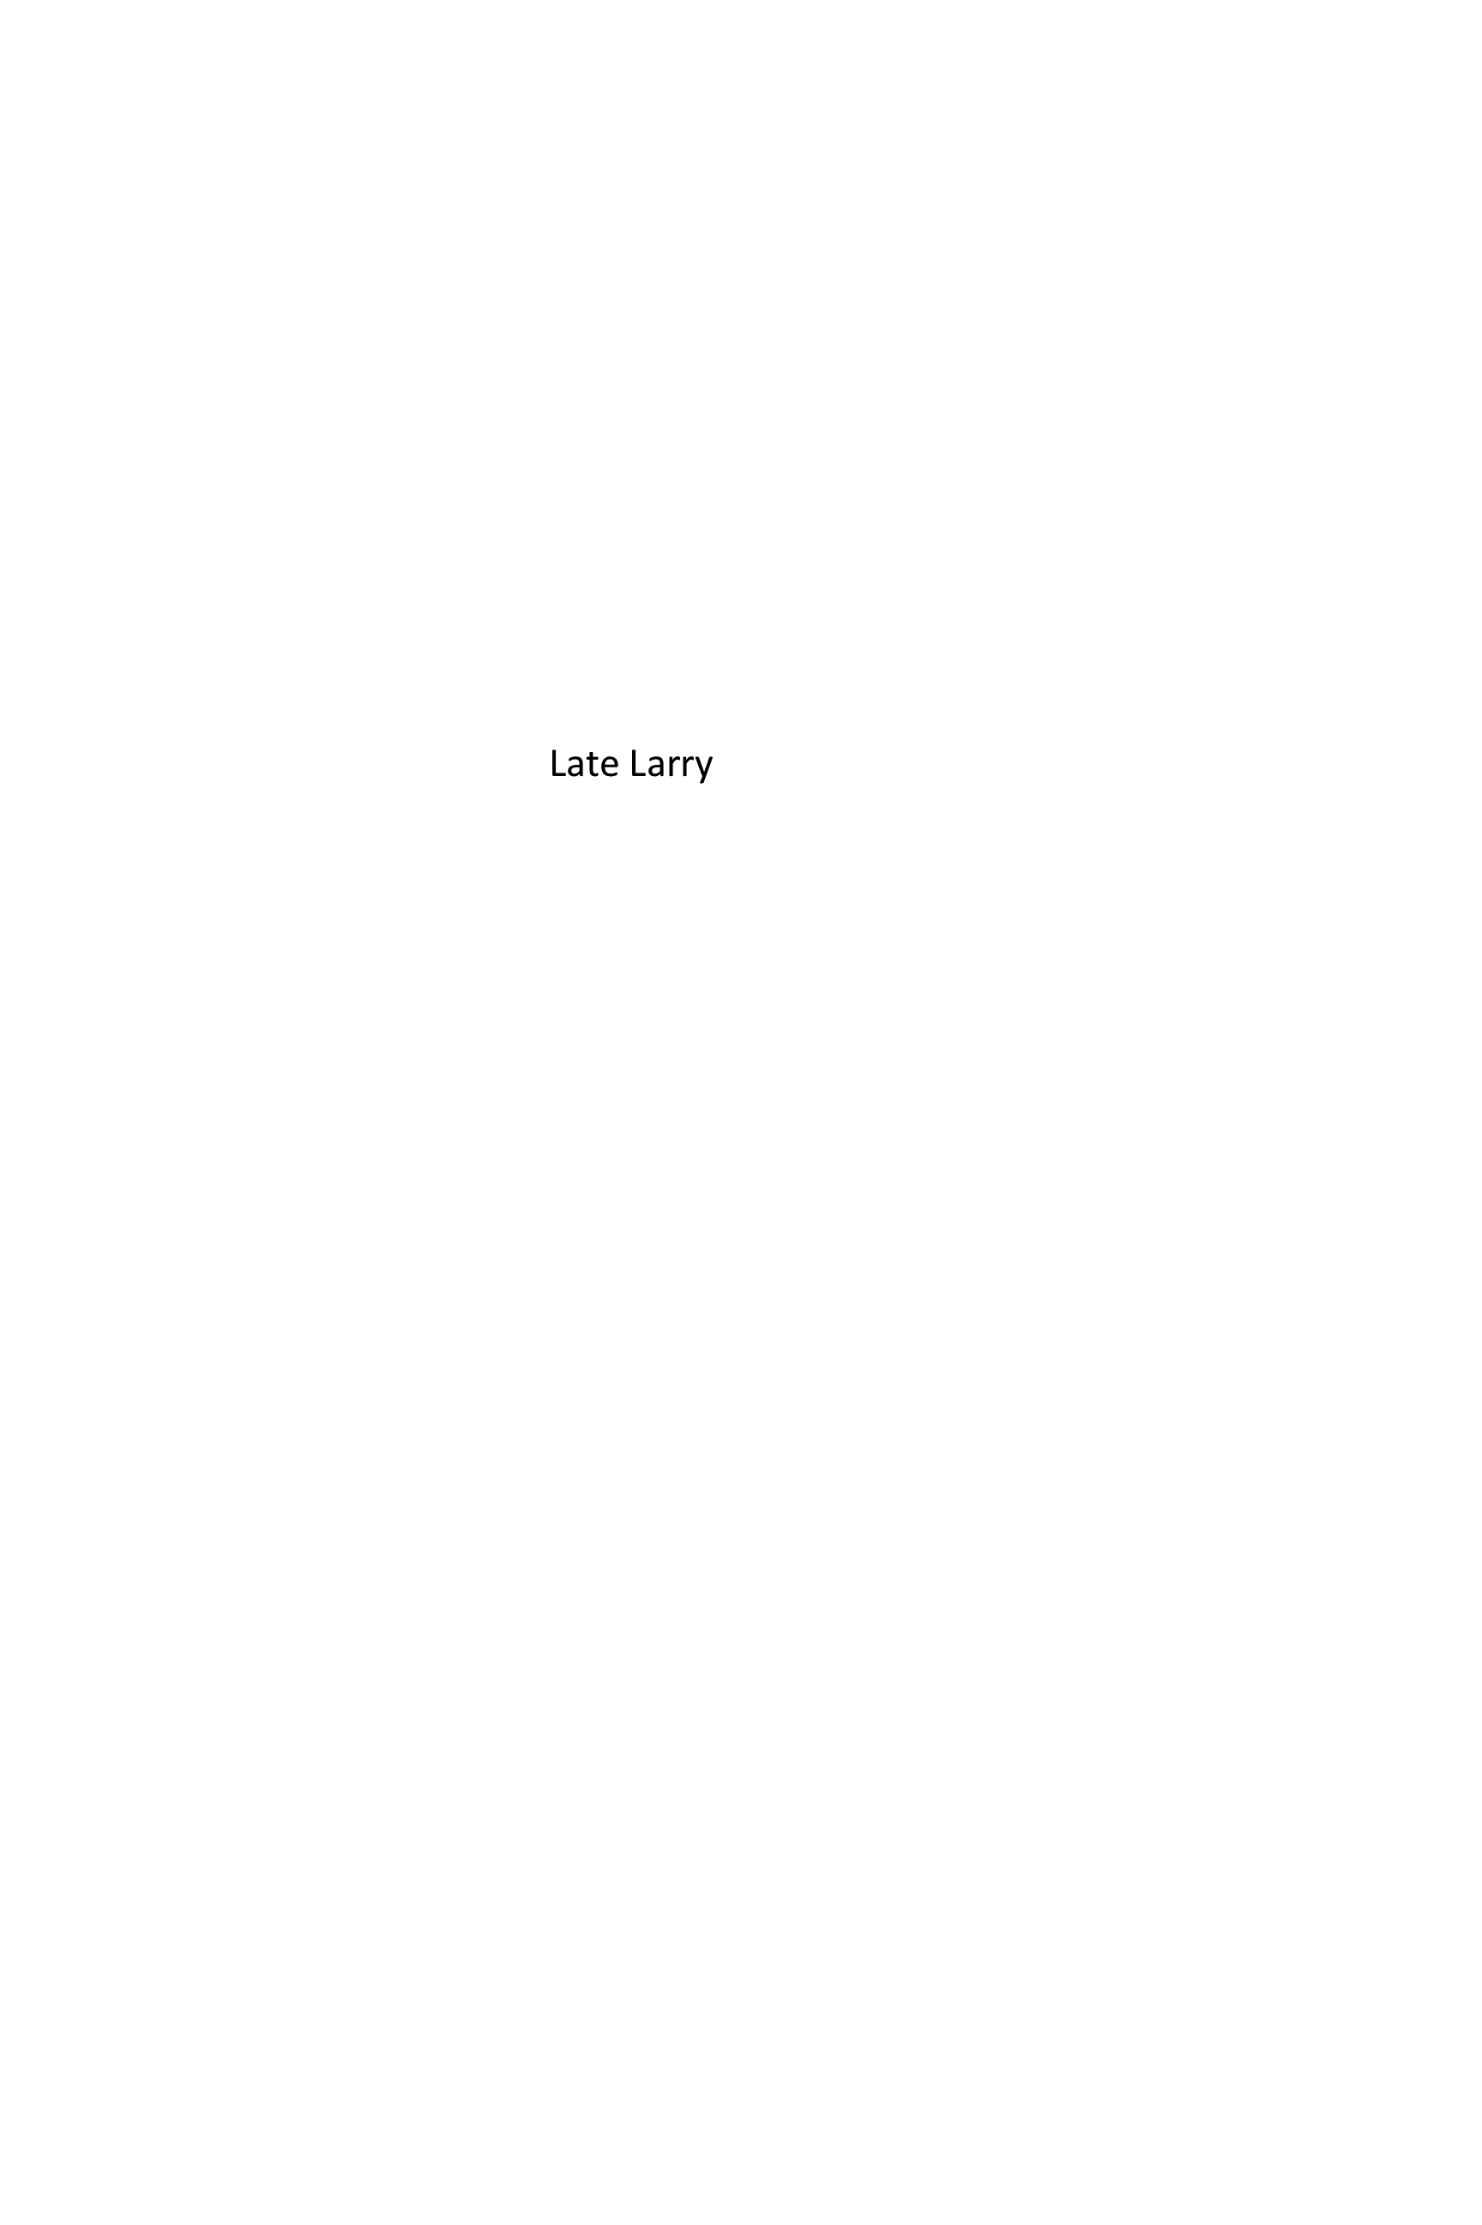

Late Larry

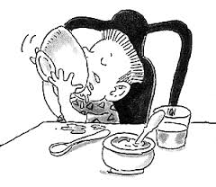
Sloppy Sid
Disorganized Debbie

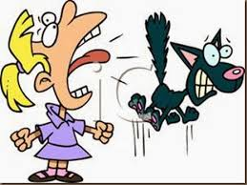
Screaming Sally
Etiquette Scenarios
Meeting People
Bill Brownsburg was excited to get an invite to the neighborhood barbecue. As he arrived at the party, he wanted to meet as many people as possible. He quickly identified a nearby couple and set out to meet them first. He introduced himself by quickly saying his name and stopping to shake hands. Since Bill is new to the neighborhood, he was anxious to meet as many others from the neighborhood as possible. In order to accomplish that, Bill had decided that he did not want to engage in much small talk or simple conversation about how his neighbors’ days may have been or how they were enjoying their evening. Bill was quick to move on to meet another group of people with a big smile on his face.

Group 1 Comments:
Appropriate: | Not appropriate:
Questions/thoughts:
Group 2 Comments:
Appropriate: | Not appropriate:
Questions/thoughts:

Etiquette Scenarios
Dining
Beth Kent was so hungry after finishing soils career development event practice. She had worked extra hard at learning the new material about soil texture and was quite proud of herself for her extra effort. Beth arrived at home to the scent of her favorite dinner, meatloaf and mashed potatoes. She carefully washed up and joined her family at the table. The family began eating together, and Beth excitedly shared about her day while chomping down her favorite dinner, hardly breathing and swallowing in between. Something was slightly different about this meatloaf, and she wasn’t quite sure what it was, so she decided to ask her grandma why the meatloaf tasted “funny.”

Group 1 Comments:
Appropriate: | Not appropriate:
Questions/thoughts:
Group 2 Comments:
Appropriate: | Not appropriate:
Questions/thoughts:

Etiquette Scenarios
The Good Listener
Thinking about yesterday’s meeting was clouding Chad Mackenzie’s concentration. There was a lot of disagreement among the members, and it was a lot to sort through. Sarah walked up to Chad at lunch and asked to sit with him to share some thoughts she had about the FFA meeting yesterday. Sarah had a compromise to present to the officers, but she wanted to run it by Chad first. After hearing Sarah’s idea, Chad had to have her repeat it because of his lack of concentration. Despite his struggles the first time through, Chad listened carefully the second time and was truly present. Chad reconfirmed Sarah’s idea and followed up with a couple of questions.

Group 1 Comments:
Appropriate: | Not appropriate:
Questions/thoughts:
Group 2 Comments:
Appropriate: | Not appropriate:
Questions/thoughts:

Etiquette Scenarios
Email/Internet Communication
As the reporter for the FFA chapter, Christine was tasked with contacting local businesses to invite them to the FFA banquet. Christine and her advisor agreed that email would be a fast and efficient method to communicate. Christine began working on a rough draft email with the subject line, “Banquet Invite.” Further into her email, Christine included information on the date, time and location of the banquet, along with a request to RSVP with guest name(s). She finished by thanking invitees for their support of the chapter and that she hoped to see them in attendance. Signed, TTYL, Christine Roberts, FFA Chapter Reporter.

Group 1 Comments:
Appropriate: | Not appropriate:
Questions/thoughts:
Group 2 Comments:
Appropriate: | Not appropriate:
Questions/thoughts:

Etiquette Scenarios
Cell Phones
Luke Johnson was a busy student and member of the FFA chapter. It took a lot of organization to keep him on top of all his responsibilities. His smartphone is a key tool in his organizational methods. It was almost time for the FFA meeting after school, and Luke was trying to wrap up a phone conversation. He was loudly talking on the phone amongst a group of FFA members discussing the meeting agenda. It was distracting to hear Luke’s conversation while trying to take care of some last-minute planning before the meeting. Finally, his conversation was finished, and the members got the final pieces ready for their meeting. The meeting was well underway when Luke’s phone kept receiving texts and other reminders for Luke’s busy schedule. Luke couldn’t help but peek at each one and occasionally send a text back or write down a note about something. It was difficult to tell if Luke was focused on the meeting, but he always seemed to have his responsibilities well taken care of.

Group 1 Comments:
Appropriate: | Not appropriate:
Questions/thoughts:
Group 2 Comments:
Appropriate: | Not appropriate:
Questions/thoughts:
Reflections on Etiquette
In your own words, what is etiquette? ___________________________________________________

___________________________________________________________________________________

Why is etiquette important? ___________________________________________________________

___________________________________________________________________________________

___________________________________________________________________________________

List three etiquette tips for meeting people.
1. ________________________________________________________________________________
2. _________________________________________________________________________________
3. _________________________________________________________________________________
List three etiquette tips for dining.
1. ________________________________________________________________________________
2. _________________________________________________________________________________
3. _________________________________________________________________________________
List three etiquette tips for being a good listener.
1. ________________________________________________________________________________
2. _________________________________________________________________________________
3. _________________________________________________________________________________
List three etiquette tips for email.
1. ________________________________________________________________________________
2. _________________________________________________________________________________
3. _________________________________________________________________________________
List three etiquette tips for cell phones.
1. ________________________________________________________________________________
2. _________________________________________________________________________________
3. _________________________________________________________________________________
Aligned to the following standards:
FFA.PL-F; FFA:PL-G; FFA.PG-J; FFA.CS-M; FFA.PG-N; CCSS.ELA-Literacy.SL.9-10; CCSS.ELA-Literacy.SL.9-10.4; CRP.04; Communication; Critical Thinking and Problem Solving; Information, Communication, and Technology Literacy; Initiative and Self-Direction; Leadership and Responsibility; Think Creatively

