The Basics: The FFA Emblem and Colors
Created: June/2016 by the National FFA Organization

Student Learning Objectives:
After completing these activities, students will…
- Describe the elements of the FFA emblem and the FFA colors.
- Research and discuss the meanings of key components of the FFA emblem.

Time Required: Interest Approach – 10 minutes; Activity 1 – 20 minutes; Activity 2 – 25 minutes
Resources: “Official FFA Student Handbook,” FFA.org and additional resources outlined below.
Equipment and Supplies Needed:
- FFA Emblem Symbols.
- FFA Emblem Symbols and Meanings.
- FFA Emblem Symbols and Meanings Key.
- FFA Emblem Assessment.
- FFA Emblem Assessment Key.
- NH.Section2.The Basics – PowerPoint Presentation.
- “Official FFA Student Handbook” – one copy per student.
- Internet access for students (optional).

This quick lesson plan would work well as:
- An introduction to FFA/FFA basics.
- An introduction to FFA traditions.

These activities are aligned to the following standards:
FFA Precept
- FFA.PL-B.Relationship. Build relationships, work as a team player and appreciate the talents of others.
- FFA.PL-C.Vision. Visualize the future and how to get there.
- FFA.PL-E.Awareness. Understand personal vision, mission, and goals.
- FFA.CS-M.Communication. Effectively interact with others in personal and professional settings.
Common Core - Reading: Informational Text
- CCSS.ELA-Literacy.RI.9-10.4. Determine the meaning of words and phrases as they are used in a text, including figurative, connotative, and technical meanings; analyze the cumulative impact of specific word choices on meaning and tone (e.g., how the language of a court opinion differs from that of a newspaper).
Common Core - Speaking and Listening
- CCSS.ELA-Literacy.SL.9-10.2. Integrate multiple sources of information presented in diverse media or formats (e.g., visually, quantitatively, orally) evaluating the credibility and accuracy of each source.
AFNR Career Ready Practices
- CRP.04. Communicate clearly, effectively, and with reason. Career-ready individuals communicate thoughts, ideas and action plans with clarity, whether using written, verbal and/or visual methods.
- CRP.06. Demonstrate creativity and innovation. Career-ready individuals regularly think of ideas that solve problems in new and different ways, and they contribute those ideas in a useful and productive manner to improve their organization.
- CRP.07. Employ valid and reliable research strategies. Career-ready individuals are discerning in accepting and using new information to make decisions, change practices or inform strategies.
Partnership for 21st Century Skills
- Civic Literacy
- Communication
- Critical Thinking and Problem Solving
- Global Awareness
- Think Creatively

Lesson Plan:
- Interest Approach: Have students think through what an “emblem” is and what it means to them. Give each student a piece of paper and have them draw a personal emblem that represents their values and their backgrounds. Have students share their emblems with a partner and have a few students share their partner’s emblems with the rest of the class.
  - Optional: If the class has extra time, have students color and decorate their emblems to display on the classroom walls at the end of the lesson.

- Activity 1: Describe the elements in the FFA emblem and FFA colors.
  - Cut symbols from FFA Emblem Symbols and tape the six symbols of the FFA emblem around the room (or in the front of the room): cross section of an ear of corn, rising sun, plow, eagle, owl, and the words “Agricultural Education” and “FFA.”
  - Break the class into groups of three to four students.
  - Have students label the emblem on FFA Emblem Symbols and Meanings with the correct symbols and colors with their correct meanings. Then have students write why they think each meaning matches the symbol or color.
  - Have groups share with the class and then share correct meanings with students found in the FFA Emblem Symbols and Meanings Key. Also, share the meanings behind the FFA colors: national blue and corn gold.
    - Optional: Have students draw the FFA emblem on a big piece of butcher paper and label the meanings of each component of the emblem.
    - Then students can write the description of each meaning on the butcher paper and give an example of how their chapter lives out each meaning. For example, the cross section of the ear of corn represents “unity” so have the students explain how the chapter exhibits “unity.”

- Activity 2: Research and discuss the meanings of key components of the FFA emblem.
  - Regroup students in original groups of three to four students.
  - Assign each group one of the symbols in the emblem to research.
  - Utilizing the internet (if available) or other classroom resources, have each group extensively research the background of each symbol on the emblem and discuss their relationship(s) with American and global agriculture. Ask students to answer:
    - What is the history of the symbol? Where did the symbol get its meaning? What else could the symbol represent? How does it fit into FFA and agricultural education today? How do you see the symbol being relevant in the next 30 or 50 years?

- Follow Up: Give each student a copy of the FFA Emblem Assessment to gauge the understanding of symbols in the FFA emblem and their meanings.

- Leveling Up:
  - Have students use their creativity to build their own FFA emblem. It can be made out of wood or metal, drawn, painted, Papier-mâché, a sand drawing, etc. Allow students to write a report, song lyrics or poem on how the FFA emblem has impacted their lives and global agriculture.
  - When students present their homemade emblems, they will share their statements/songs/poems of what it means to them and global agriculture.

Additional resources:

NH.Section2.The Basics – PowerPoint Presentation.

“Official FFA Student Handbook” – one copy per student.

Internet access for students (optional).

FFA Emblem
Symbols

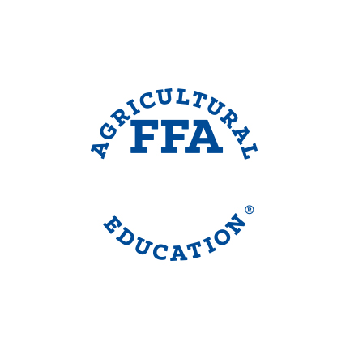

NAME: ____________________________________ DATE: _____________________ CLASS: ___________

FFA Emblem
Symbols and Meanings

Directions: Label the different symbols on the FFA emblem and match each symbol and color with the correct meanings listed below:
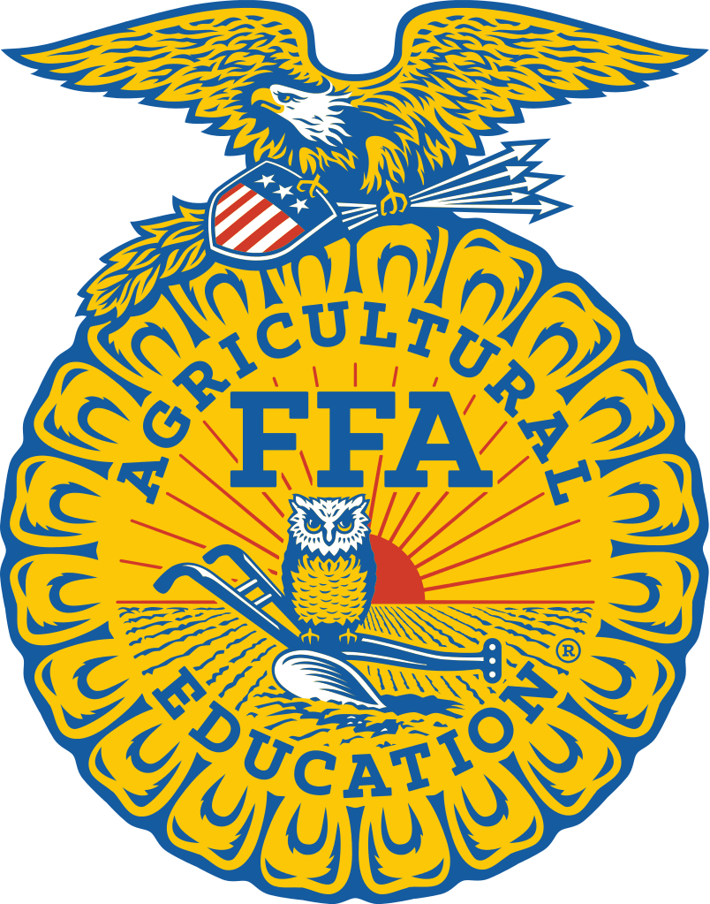

Symbol or Color: Meaning:
Cross Section of the Ear of Corn Learning & Leadership for Progressive
Agriculture
Rising Sun For the Blue Field of Our Nation’s Flag
Plow Freedom
Eagle Unity
Owl Progress
“Agricultural Education and FFA” Labor and Tillage of the Soil
National Blue Knowledge
Corn Gold For the Golden Fields of Ripened Corn

NAME: ____________________________________ DATE: _____________________ CLASS: ___________

FFA Emblem
Symbols and Meanings Key

Directions: Label the different symbols on the FFA emblem and match each symbol and color with the correct meanings listed below:

Symbol or Color: Meaning:
Cross Section of the Ear of Corn Learning & Leadership for Progressive
Agriculture
Rising Sun For the Blue Field of Our Nation’s Flag
Plow Freedom
Eagle Unity
Owl Progress
“Agricultural Education and FFA” Labor and Tillage of the Soil
National Blue Knowledge
Corn Gold For the Golden Fields of Ripened Corn

NAME: ____________________________________ DATE: _____________________ CLASS: ___________

FFA Emblem Assessment
Symbols and Meanings

Directions: Answer the questions below.

- Whether you live in Maine, Hawaii, Alaska, Puerto Rico or one of the states in between, _________________ is grown somewhere in your state. _________________ signifies _________________, and from the first Thanksgiving feast on, it has historically served as the foundation crop of American agriculture. It is appropriate then that the ___________________ of the ear of corn be used as the foundation of the FFA emblem.
- Just as the industry of agriculture has developed new technologies and evolved to meet the next generation of consumer demands, the National FFA Organization has continued to evolve as it looks to the future to meet FFA members’ needs. The _________________ signifies progress and holds the promise that tomorrow will bring a new day, shining with opportunity.
- The National FFA Organization is founded in agriculture, the backbone of our country. The _________________signifies _________________ and _________________ of the soil and the historic foundation of our country’s strength.
- The _________________ is a national symbol that reminds all FFA members of our freedom and our ability to explore new horizons for the future of agriculture.
- Long recognized as a symbol of wisdom and _________________, the _________________ symbolizes the knowledge required to be successful in the industry of agriculture.
- The words _________________ and the letters _________________ are emblazoned in the center of the emblem to signify the combination of _________________ and _________________ necessary for _________________ agriculture.
- Which symbol resonates the most with you? Why?
NAME: ____________________________________ DATE: _____________________ CLASS: ___________

FFA Emblem
Symbols and Meanings Key

Directions: Answer the questions below.

- Whether you live in Maine, Hawaii, Alaska, Puerto Rico or one of the states in between, __CORN__ is grown somewhere in your state. __CORN__ signifies __UNITY__, and from the first Thanksgiving feast on, it has historically served as the foundation crop of American agriculture. It is appropriate then that the __CROSS SECTION__ of the ear of corn be used as the foundation of the FFA emblem.
- Just as the industry of agriculture has developed new technologies and evolved to meet the next generation of consumer demands, the National FFA Organization has continued to evolve as it looks to the future to meet FFA members’ needs. The __RISING SUN__ signifies progress and holds the promise tomorrow will bring a new day, shining with opportunity.
- The National FFA Organization is founded in agriculture, the backbone of our country. The __PLOW__ signifies __LABOR__ and __TILLAGE__ of the soil and the historic foundation of our country’s strength.
- The __EAGLE__ is a national symbol that reminds all FFA members of our freedom and our ability to explore new horizons for the future of agriculture.
- Long recognized as a symbol of wisdom and __KNOWLEDGE__ the __OWL__ symbolizes the knowledge required to be successful in the industry of agriculture.
- The words __AGRICULTURAL EDUCATION__ and the letters __”FFA”__ are emblazoned in the center of the emblem to signify the combination of __LEARNING__ and __LEADERSHIP__ necessary for __PROGRESSIVE__ agriculture.
- Which symbol resonates the most with you? Why?
Aligned to the following standards:
FFA.PL-B.Relationship; FFA.PL-C.Vision; FFA.PL-E.Awareness; FFA.CS-M.Communication; CCSS.ELA-Literacy.RI9-10.4; CCSS.ELA-Literacy.SL.9-10.2; CRP.04; CRP.06; CRP.07; Civic Literacy; Communication; Critical Thinking and Problem Solving; Global Awareness; Think Creatively.

