Supervised Agricultural Experience (SAE) Programs: SAEs Defined
Created: December/2016 by the National FFA Organization

Student Learning Objectives:
After completing these activities, students will…
- Be able to answer the questions, “What is an SAE?” and “What is the purpose for having an SAE?”
- Be able to identify examples of the six types of SAEs and assess the benefits of each type.
- Be able to list current available factors for beginning an SAE project.
- Be able to observe the positive influence that SAE projects can have on community members.

Time Required: 30-37 minutes or 40-55 minutes (with the Leveling Up activity)
Resources: FFA.org
Equipment and Supplies Needed:
$1 bill.
$5 bill.
$100 bill.
Note cards/paper.
Two stickers per student.
Eight envelopes.
Eight examples of SAEs.

These activities are aligned to the following standards:
FFA Precept
- FFA.PL-A.Action: Assume responsibility and take the necessary steps to achieve the desired results, no matter what the goal or task at hand.
- FFA.PL-C.Vision: Visualize the future and how to get there.
- FFA.PL-E.Awareness: Understand personal vision, mission and goals.
- FFA.CS-N.Decision Making: Analyze a situation and execute an appropriate course of action.
- FFA.CS-P.Technical/Function Skills in Agriculture: Obtain knowledge and skills needed for a career in agriculture and related industries.
Common Core - Reading: Informational Text
- CCSS.ELA-LITERACY.RI.9-10.2 Determine a central idea of a text and analyze its development over the course of the text, including how it emerges and is shaped and refined by specific details; provide an objective summary of the text.
Common Core - Writing
- CCSS.ELA-LITERACY.W.9-10.1 Write arguments to support claims in an analysis of substantive topics or texts, using valid reasoning and relevant and sufficient evidence.
- CCSS.ELA-LITERACY.W.9-10.2 Write informative/explanatory texts to examine and convey complex ideas, concepts, and information clearly and accurately through the effective selection, organization, and analysis of content.
Common Core - Speaking and Listening
- CCSS.ELA-LITERACY.SL.9-10.1 Initiate and participate effectively in a range of collaborative discussions (one-on-one, in groups, and teacher-led) with diverse partners on grades 9-10 topics, texts, and issues, building on others' ideas and expressing their own clearly and persuasively.
Common Core - Language
- CCSS.ELA-LITERACY.L.9-10.6 Acquire and use accurately general academic and domain-specific words and phrases, sufficient for reading, writing, speaking, and listening at the college and career readiness level; demonstrate independence in gathering vocabulary knowledge when considering a word or phrase important to comprehension or expression.
AFNR Career Ready Practices
- CRP.02. Apply appropriate academic and technical skills. Career-ready individuals readily access and use the knowledge and skills acquired through experience and education to be more productive.
- CRP.04. Communicate clearly, effectively, and with reason. Career-ready individuals communicate thoughts, ideas and action plans with clarity, whether using written, verbal and/or visual methods.
- CRP.12. Work productively in teams while using cultural/global competence. Career-ready individuals positively contribute to every team, whether formal or informal.
Partnership for 21st Century Skills
- Communication
- Critical Thinking and Problem Solving
- Global Awareness
- Implement Innovations
- Initiative and Self-direction
- Leadership and Responsibility
- Think Creatively
Lesson Plan:
- Optional Bell Ringer:
  - Have students journal and answer the questions, “How important is money in our society today?” and “What are five things that you would like to purchase before you graduate high school?”
- Introduction:
  - Pull out a $1 bill and ask the students, “Who wants this dollar?”
    - Continue to hold it up and ask the question, or variations of the question, until a student comes to the front of the room and takes the dollar.
  - Pull out a $5 bill and ask the students, “Who wants this $5 bill?”
    - Same protocol as with the $1 bill, which will be quick.
  - Pull out a $100 bill and ask the students, “Who wants this $100 bill?”
    - Quickly put it back in your wallet/pocket, and say that I will be keeping this one.
  - Point 1: Establish that it is not enough simply to want something; we have to get up and do something so that we can earn what we want.
  - Point 2: Establish that money can be a great motivator and have a brief discussion about the value of money.
  - Point 3: Establish the objectives/purpose for the lesson and how SAEs help us get what we want and teach us that through hard work, we can achieve what we want.
- Objective 1:
  - Pair up the students.
  - Instruct the pairs that they will be coming up with a definition of an SAE in 25 words or less and that we will share those definitions with the rest of the class.
  - They will write their definitions on a note card/piece of paper.
  - Have the partners read the sections from the “Official FFA Student Handbook” entitled “Supervised Agricultural Experience” and “Parts of an SAE Program.”
  - Have each group post their definitions around the room and have the students vote for their two favorite definitions using stickers that they place on the note card/paper.
  - Establish that students can’t vote for their own definition.
  - Read off the top definition to the class and establish that this will be our starting point for the day.
- Objective 2:
  - Give students two minutes to read the descriptions of the four types of SAEs (Entrepreneurship, Placement, Agriscience or Exploratory).
  - Tell students that around the room there are eight envelopes that contain insights into what an SAE project can be and the value of them.
  - Evenly split up the students between the eight envelopes as a starting place.
  - At each envelope, one student in the group needs to write down:
    - Which type of SAE is the example (Entrepreneurship, Placement, Agriscience or Exploratory)?
    - Two character traits that this SAE built in the student (Example: responsibility, work ethic, etc…).
    - Three career skills that are developed by this SAE.
  - Have students share an example for and what they liked about each one.
- Objective 3:
  - Tell students that we will now start planning to develop each of their SAE projects.
  - If you have AET, use resources for developing a student’s SAE project plan. If you don’t, hand out the worksheet for them to begin and reaffirm that they should put quite a bit of thought into this as it could open many doors both within and outside of FFA.
- Leveling Up:
  - Ask one or more FFA Alumni, senior members, officers or other community members to visit with the students about the value of SAE projects and what they were able to do because of their own projects.
- Review:
  - Revisit the class’s top definition of an SAE.
  - Ask students individually to write down on a note card their definition of an SAE on one side and on the other, the value of having an SAE. If they really like the definition that they came up with, have them just copy it down and remind them that neither can be more than 25 words. Have students put their names on these and turn them, along with the worksheet that we will do more with in the next lesson, into the teacher.

A Logger’s Life for Me
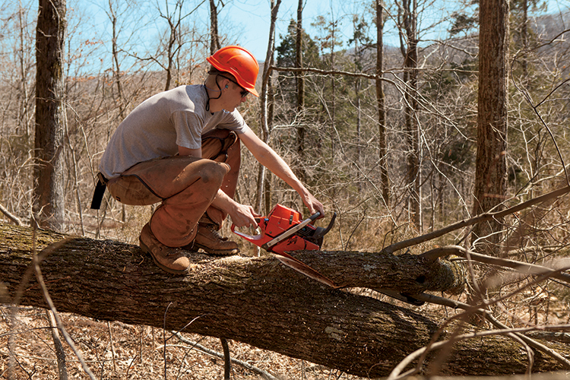
FFA member and master logger Matthew Seals trims off branches from a fallen tree.
For as long as he can remember, Matthew Seals of Tazewell, Tenn., has been logging, or harvesting timber, with his dad.
“My dad has his own logging business, Jimmy Seals Logging, so when I was young I’d always ride along in his logging truck to haul logs to the sawmill,” says Matthew, who graduated from Claiborne High School in May 2013. “When I was 12 or 13, he let me start running the bulldozer a little bit, and over time I progressed in it. Now I can run any piece of equipment we have.”
Logging is a forestry career that’s popular in East Tennessee due to the abundance of timber in the area. Matthew’s dad, grandfather and uncle are all loggers, and other members of the Tazewell FFA Chapter have also gone on to work for local logging businesses.
“It’s a big deal in our area,” says Mike Wilmoth, Claiborne High School agriculture teacher and FFA advisor. “At least 12 to 15 of my former students are working in logging operations like Matthew’s. Landowners will hire loggers to saw and cut trees and pull them to the log yard.”
An agriculture teacher for 31 years, Wilmoth was Matthew’s FFA advisor as well as his dad, Jimmy’s. He now has Matthew’s younger brother Landon as a student.
“Matthew was a model student in every way. He studied hard, worked hard and took all his assignments seriously,” Wilmoth says. “He truly loves logging. That’s all he talked about. It’s kind of in your blood.”
One of the things that sets Jimmy Seals Logging apart, Matthew says, is the extra attention they give to the land.
“Landowners will call us when they want their property logged, and we’ll go in and mark property lines and cut the mature timber into logs to sell to a sawmill,” he says. “But it’s not just going in there and making a mess. Of course there will be a mess, but we clean everything up and get it looking good again so the landowner is happy. We treat their property like it’s our own. Loggers who don’t clean up after themselves give us all a black eye.”
Matthew was named the 2013 Forest Management and Products Proficiency Winner at the National FFA Convention & Expo. The award recognized him for outstanding achievement in gaining hands-on career experience in his field, and came with a plaque and $500.
After high school, Matthew became foreman of the logging crew.
“We have four guys who work for us, and I help them fix any problems and keep things running smoothly,”
Matthew says. “We’re all good buddies, and we enjoy working together. Logging is stressful and dangerous, so there’s no room for arguing.”
One way Matthew prepared for his career was by taking a five-week master logger class his junior year.
At age 17, he became a certified Tennessee master logger.
“The course included things like chainsaw safety, finances, CPR, first aid and how to spot tree diseases,” Matthew says. “Logging is very challenging, so you have to have a heart for it.”
In fact, logging is among the top five most dangerous jobs in the United States, according to statistics. Total logging fatalities in the United States were 59 in 2010 and 65 in 2011. Loggers work with heavy machinery, frequent bad weather and occasional high altitudes.
The fatality rate is 104 per 100,000 workers.
“You’ve got to watch the tops of trees because they can hit you, and dead limbs can also fall on you,”
Matthew says. “We always wear the proper equipment – hard hats, safety glasses and logging chaps. You’ve got to pay attention, because there’s no room for mistakes in the woods.”
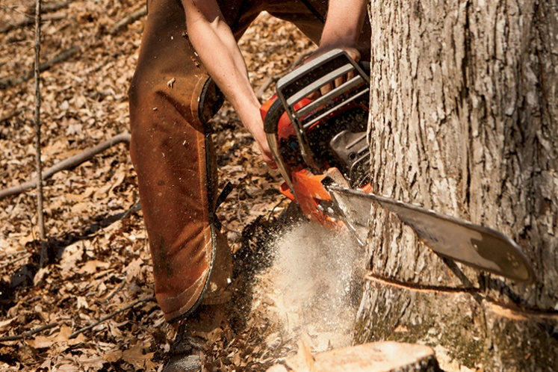
Matthew speaks from experience. In April 2014, he cut into his foot with a chainsaw, slicing a bone in two. He spent a week in the hospital and two months recovering. It taught him a valuable lesson.
“Sometimes when you do things enough, you get comfortable and forget to pay close attention,” he says. “I’m even more cautious on the job now. I don’t ever want to make that mistake again.”
Matthew’s goal is to become a partner in his father’s business.
“Logging has been passed down for several generations in my family, and my two younger brothers are probably going to progress in it, too,” he says. “It’s a great opportunity for me to get to work alongside my dad.”
FFA helped Matthew get where he is today, and he says Wilmoth was “the best teacher I could ever ask for.”
“I started in FFA my freshman year and did several contests, including livestock, land and forestry judging, and parliamentary procedure,” Matthew says. “Those competitions helped me learn to think on my feet and develop my leadership skills.”
Wilmoth says seeing students like Matthew develop their self-confidence and succeed after they graduate is rewarding.
“Everyone loves Matthew at our school, and I’ve used him as an example in class many times,” Wilmoth says. “I feel fortunate to have had him as my student.”
– Jessica Mozo

Towing the Line
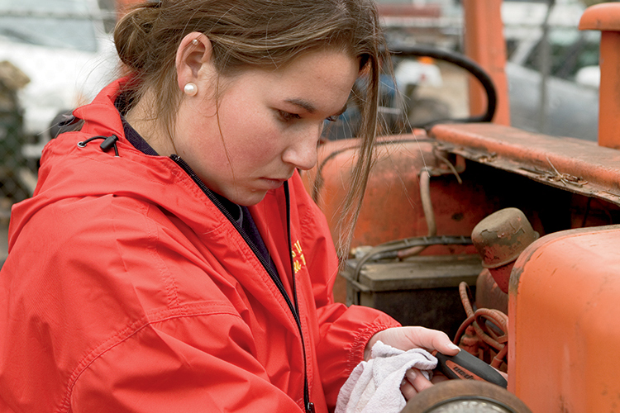
Georgia FFA alumna Chantell Matthews isn’t afraid to get her hands dirty. She’s been helping at her dad’s automotive repair shop and towing service, Matthews Garage Inc., since she was six years old. Today, the 19-year-old Cass High School graduate works there full time.
“I’ve been around the shop all my life. I started by riding in the tow trucks and helping my dad in the shop by handing him tools or holding things for him,” Chantell says. “I began working there part time after school when I was 15 and then full time after I graduated in 2013.”
Located in Cartersville, Ga., Matthews Garage was established by Chantell’s grandfather, Mack, in 1963.
Her dad, Ricky, became owner in 1991, and the business has grown to include three shops – automotive repair, body shop and heavy-duty diesel repair. Chantell’s older brother, Jeremy, also works at the garage.
“We live directly across the street from the shop, so Chantell has always gone with me on towing calls and helped get me things,” Ricky says. “She always had a strong interest in it. She especially enjoys the towing part, and she has the highest level of certification available to operate the recovery part of the wrecker. She was the youngest female in the world to become a level 6/7 WreckMaster.”

FFA Sets The Foundation
During high school, Chantell was president of the Cass FFA Chapter, where she showed cattle and competed in public speaking and tractor driving contests. In 2013, she became a national finalist for the National FFA Agricultural Proficiency Award in agricultural mechanics repair and maintenance.
“FFA was her passion, and it most definitely prepared her for working at the garage,” Ricky says. “As chapter president, she learned how to deal with people. By showing cattle, she learned responsibility. FFA played a huge part of her life in high school.”
Chantell considered going to college, but instead decided to jump into her career immediately after high school.
“Since I know this industry is where I want to be for the rest of my life, I feel I will be better off continuing to work at the shop and going to some business seminars when I get a little older,” she says. “Knowing my grandfather started this business back in the 1960s gives me the drive to continue in this industry and carry on his legacy.”
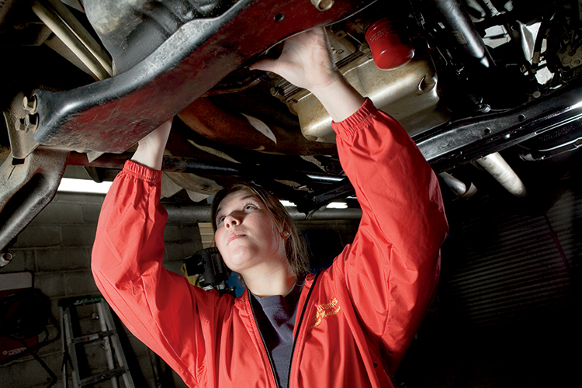
She Can Do It All
At the garage, Chantell works wherever she is needed, whether it’s doing minor vehicle repairs by herself or helping technicians with major repairs.
“I go out on wrecker calls. I dispatch calls. I do estimates and invoices for the work we do at the shop,” she says. “I never know what exactly I will be doing each day when I go into work.”
Some customers are surprised to see Chantell show up for a towing job in an industry typically dominated by men.
“People who don’t know me well are very surprised when I tell them I work at a garage. While I’m at work, quite a few people have been surprised to see me working in the shop or out pulling cable, hooking up a car in the wrecker,” she says. “Most people are proud for me that I’m doing what is considered a man’s job. But then I do have some guys who don’t think I know what I’m doing just because I’m a girl.”

Gaining Industry Recognition
Ricky says many people give Chantell a “thumbs-up” because she started out in the industry so young.
“People in the industry know her because she attends tow shows all over the country, she’s been in tow magazines and she won the first Young Tower’s Achievement Award ever given,” he says. “In the general public, people might raise an eyebrow and think, ‘Why is she out here?’ But then they see what she can do.”
Aside from all the technical skills she’s learned, working at the garage has equipped Chantell with patience and responsibility.
“Working on a vehicle or out in the wrecker, I’ve gained patience to keep trying and never give up even if something isn’t easy,” she says. “I’ve learned to be patient when dealing with the public. I know one day my brother and I will take over our family business, and I’m learning the responsibility of how to run a business.”
Through the years, Matthews Garage has won an impressive number of industry awards for service and performance. Ricky has no doubt that with Chantell and Jeremy in charge, the family business will continue to serve north Georgia long into the future.
“I’ll be involved as long as I’m able. When my dad retired and turned the business over to me, he still came to work every day until the week he died at age 87,” Ricky says. “I’ll probably be the same.”
When they aren’t working, Chantell and her dad enjoy attending antique tractor shows.
“My dad worked on a lot of tractors, so Chantell got interested in tractors when she was little. She has her own antique tractor that we take to shows together,” Ricky says. “I’m very proud of her. I can’t even put it into words.”
– Jessica Mozo

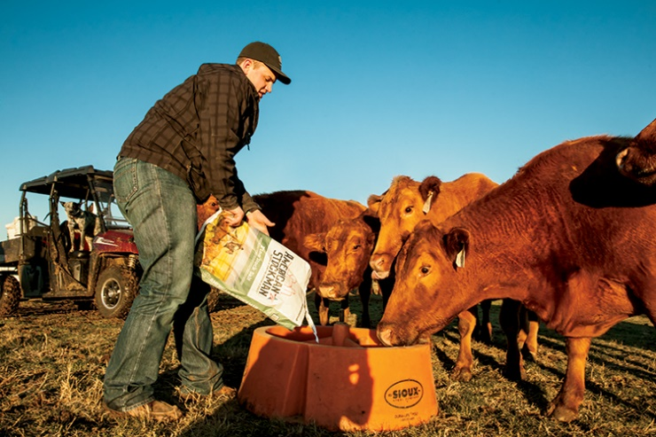
Running the Ranch
Thomas Glascock has always had a natural way with animals. He found his calling at 4 years old as he proudly stood next to his older sister and showed his first calf. By the age of 6 he had joined the American Junior Red Angus Association and the Texas Junior Red Angus Association and officially showed his first registered Red Angus heifer. He’s never looked back.
“I had a special bond with the young calves,” says Thomas, who was the first person to win the Reserve Supreme heifer at the Houston Livestock Show and Rodeo with the Red Angus breed. “I like the cattle, and they like me.”
Today, he has translated that passion and gift into his education and career. He runs a successful cattle and forage business that has won two national FFA proficiency awards, and he is in school at Tarleton State in Stephenville, Texas, studying animal science. Thomas has also served as president of the Texas Red Angus Association and a director of the National Junior Red Angus Association. “Showing cattle is in my genes. This has always been what I want to do,” he says.
A Family Tradition
Growing up in Pilot Point, Texas, Thomas credits his grandfather for getting him started raising cattle. “Pop watched me show the calf at side for my sister and saw the bond between us. A few months later, he bought me a registered Red Angus heifer calf and gave it to me for my birthday.” That would be the first registered heifer of many that Thomas showed, and at just 6 years old, he became an important part of his family’s working cattle ranch.
“After that first show, Thomas was hooked,” says his mother and FFA advisor, Tammy Glascock. “He rode in the truck side by side with his Pop as he tended to his cattle, helping out as much as he could. And he helped us with his sister’s cattle.”
His grandparents continued buying him a heifer or cow for a few years, and with their guidance and the help of his parents – both FFA advisors and agricultural science teachers – Thomas was able to start saving money from the calves he sold and increased his herd size. “Without my family, I would never have been able to achieve my successes,” Thomas says.
FFA at an Early Age
Being the son of two agricultural science teachers and the younger brother of an award-winning FFA member sister had its advantages. “I was always tagging along with my parents, going to shows, meetings, contests and conventions just like the high school FFA members, and always dreaming about the day when I would be old enough to join FFA and participate,” Thomas says.
Following in the footsteps of his sister, Rachel, Thomas developed his supervised agricultural experience (SAE) program as a freshman in high school with the advice and assistance of his parents. He started out with registered Red Angus cattle, a show heifer, market pig, market steer and 60 acres of forage utilized for the production of hay for his cattle. The market pig and steer were used to generate additional revenue to support his beef cattle herd.
As he made money from the sales of cattle, market animals, surplus hay and loans, Thomas had the opportunity to grow and expand his herd. Today, his SAE consists of 109 registered Red Angus cattle and six registered Simmental cattle that he raises on 515 acres, as well as 310 acres of native and improved grass pastures for forage production. “As a sophomore in high school, one day Thomas told me, ‘the harder you work, the luckier you get,’” Tammy says. “I am proud of the young man that he has become in regard to his work ethic, his determination to succeed, his desire to gain knowledge and the fact that he never meets a stranger.”
Ranching Challenges
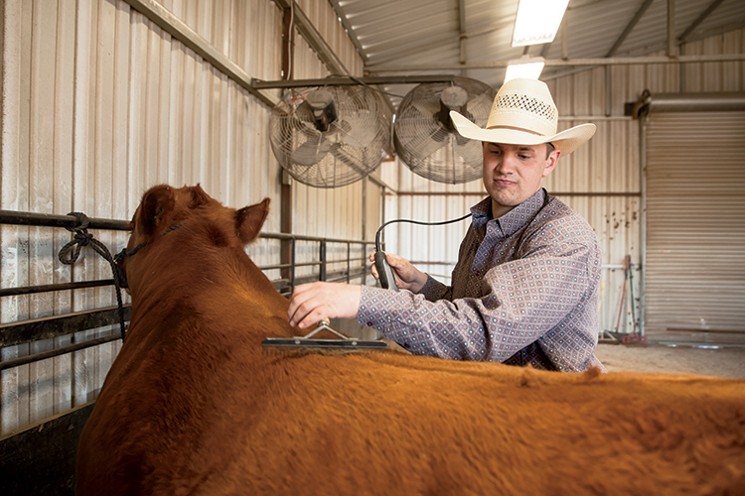
Raising cattle may be in his blood, but maintaining and running a cattle ranch as a busy high school student is no easy feat. “Time management has been one of my greatest challenges,” Thomas says. “Things were especially difficult before I had a driver’s license and had to rely on my family to take me back and forth to my land, which was 45 minutes from my house.”
As a high school student balancing high academic standards, participation in FFA events, his leadership responsibilities on the local and district levels, and other school activities, Thomas had to learn to manage his time wisely in order to stay on top and in control. Now that he attends college two hours from home, he’s had to reevaluate those time constraints and balance his commitment to his cattle operation as well as his classes and part-time work with the Meat Science Lab. To help with daily management, feeding and calving, Thomas has hired a part-time employee while he is in school.
Future Focused
Thomas’s hero and role model has always been his grandfather, who recently passed away. “Pop taught high school agriculture for 10 years and agriculture at the college level for 39 years,” Tammy says. “Before he started kindergarten, Thomas spent many a day with his Pop at college. Having both parents and grandparents as public educators, Thomas has always known the value of education. He knows that his success in the beef cattle industry will depend on his education.”
Thomas aims to earn his American FFA Degree and use his college education to better his herd. “When I first created my SAE, I developed a set of goals that will allow me to grow and expand my operation into a herd of reputable cattle that would be marketable to meet the demands of a purebred breeder, the commercial cattleman and consumer demand,” Thomas says.
He is currently working to improve his herd genetically and phenotypically through artificially inseminated sires, embryo transfer and genetics. He hopes to one day operate a nationally known purebred cattle operation and to serve as a consultant managing and marketing commercial and purebred Red Angus cattle. “The thing that impresses me so much about Thomas is that he has known since the ninth grade what he wants out of life,” Tammy says. “He and his sister both have set goals, and they work diligently to achieve them. It’s impressive to see the wheels turning in his mind.”
Rachel Glascock helps her brother Thomas eartag a calf. Both Rachel and Thomas have been very successful in their beef cattle and FFA experiences.
– Blair Thomas

Call of the Quail
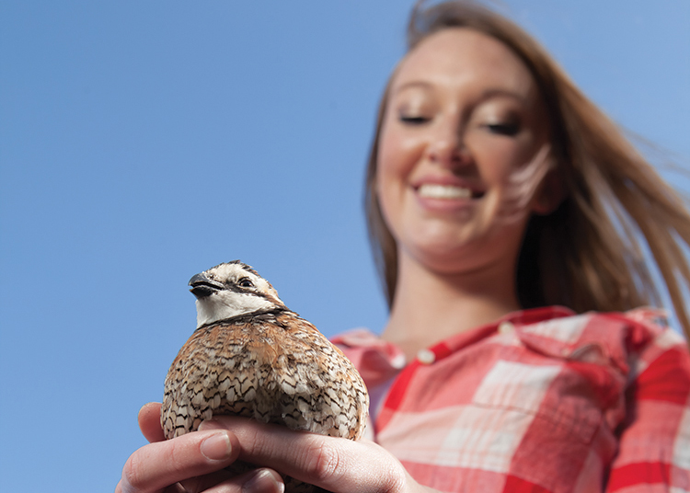
When Kacy Schlesener of Dover, Kan., noticed a decline in the population of bobwhite quail in her area, she made it her mission to help bring back the small, plump birds popular among hunters.
In 2011, when she was a sophomore at Mission Valley High School, Kacy focused her supervised agricultural experience (SAE) project on repopulating her region with quail. She began hatching quail in an incubator at her parents’ home and raising them until they were ready to sell to local hunters and hunting preserves. Once she saw the first quail hatch from its small egg, Kacy was hooked.
“It’s pretty fun to watch,” she says. “I had 250 eggs in my first batch, and it was so cool to see them all hatch.”
Kacy ordered her first batch of quail eggs from Georgia, but was concerned about them being damaged during shipping. She then began ordering the eggs from Sharon, Kan., which is closer to her home. Her dad, Bruce, and mom, Jenni, have helped the project become a family business, as has her 19-year-old brother, Lukas.
“When we first get the eggs, they go in an incubator for 21 days,” she says. “Then we put them in the hatcher, where they hatch over the next 24 to 72 hours. We keep them in my parents’ basement for a while because it’s a constant temperature, and we check on them frequently to see if they are dried off and healthy.”
Next, the baby quail go into a brooder pen, where they are divided up equally so they don’t get too hot or suffocate one another.
“Occasionally we have some eggs that don’t hatch, so my dad and brother use those as trapping bait,” Kacy says.
A few unhatched eggs don’t cause a huge loss since she buys the eggs for 30 cents apiece and is able to sell the adult quail for about $4.50 each.
The quail stay in the brooder pen for eight weeks, and then are transferred to a separate flight pen that has a mesh netting over the top. Kacy and her dad built the brooder pen from an old shed, and she took out a $1,500 loan to build the flight pen.
“It’s neat to watch them grow from the size of a 50-cent piece to a little smaller than a pheasant,” Kacy says. “I enjoy it because it gets me outside, and I get to spend time with my dad and brother.”
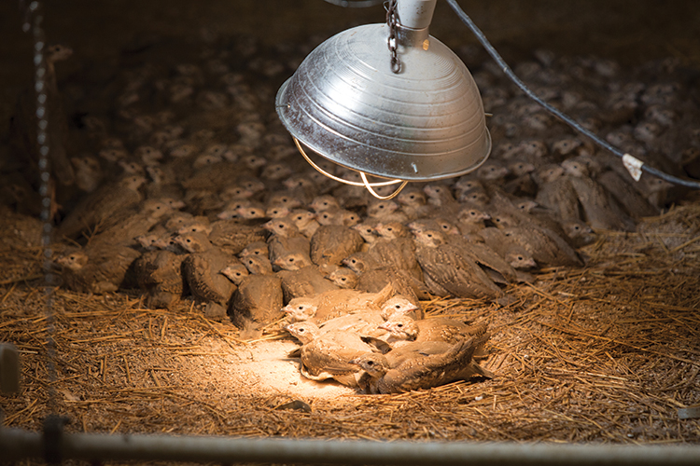
Baby quail inside a pen in the incubation building.
Once the birds reach 16 weeks of age, they are considered adult birds and are ready to sell. Buyers often release them on their own land or use them to train hunting dogs.
“One client buys 25 birds at a time just to keep them near his home because he likes how they sound,” Kacy says. “The biggest client I have likes to band them so he can track them a year later. He has bought 500 birds, 1,000 birds and even 1,500 at a time.”
Kacy has come a long way since 2011, when she started with her first batch of 250 eggs. Today, she and her family hatch batches of 3,000 eggs at a time, with two different batches per season. She won four district FFA awards and two state FFA awards in wildlife preservation management for her quail repopulation project.
Kacy’s FFA advisor, Kelly Hoelting, says since Kacy launched her quail project, three other students have done similar SAEs because of her influence.
“Kacy is such a dynamic young lady who I knew was special,” Hoelting says. “I really encouraged her to try agricultural education as she was unsure coming into her freshman year. I saw a spark in her that I knew would help not only grow herself but our entire chapter.”
Kacy served in numerous offices and as committee chairs throughout high school and will receive her American FFA Degree at the 2016 National FFA Convention & Expo.
“I am lucky to have taught her all of her years in high school and have had her as a student in my program,” Hoelting says.
Kacy is studying dental hygiene at Flint Hills Technical College in Emporia, Kan., and will graduate in 2017. She also works part-time in an orthodontics office. Kacy hopes to continue the quail business with her family on a part-time basis after she graduates.
“Family is big to me, so I plan to stay close to home,” she says.
– Jessica Mozo

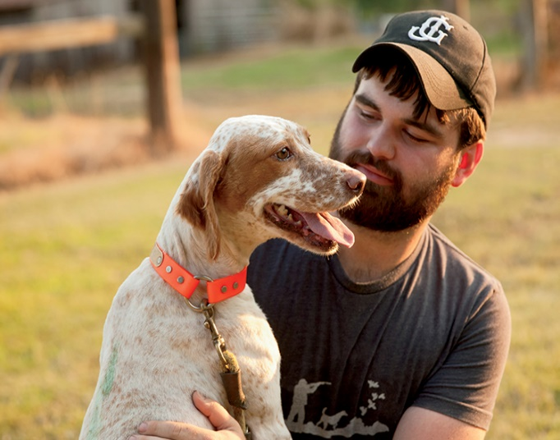
FFA Member’s Dog Training is on Point
At the tender age of 6, one of Chris Mullins’ favorite pastimes was watching his grandfather Bill Moore interact with his English Setter dogs, which he has raised and trained since 1979. Now 20, the former FFA member from McNairy Central High School in Selmer, Tenn. has 35 of his own English Setters, and he raises and trains them to compete in national shoot-to-retrieve field trials like his grandfather.
“My granddad has taught me everything I know about the dogs. He has won 12 national championships, and three were in the same year,” says Chris, who works part-time as a video editor for a news channel in Jackson, Tenn. when he isn’t working with his dogs. “Nobody has won as many times as he has.”
Each of Chris’ dogs has a name, though he admits he confuses them with one another “every now and again.” His favorite is Lou, an 8-year-old female who won the National Shoot To Retrieve Association’s (NSTRA) championship title “Dog of the Year” in 2010.
Mullins and Moore travel to national competitions at least twice a year. Moore has been called the “Babe Ruth of the NSTRA” by others in the industry for his many championship wins.
“I’ve raised all the dogs I’ve competed with, and the dogs and I are a team – you can’t win otherwise,” Moore says. “A dog also has to be in condition, and I’m a fanatic on condition. We swim the dogs in the summer when it’s too hot to run. Otherwise I exercise the dogs five to six miles a day, six dogs at a time.”
In his heyday, Moore raised and trained legendary champion bloodline dogs and built a successful breeding business. One of his puppies would sell for between $500 and $1,000.
“I’ve been around my granddad’s dogs all my life, but I got more involved in high school when he was diagnosed with cancer,” Chris says. “The dogs have been a great way for me and him to bond. He’s had two rounds of cancer, but he’s beat it both times. He’s cancer-free now.”
The grandfather/grandson duo start training the dogs when they are just puppies.
“We get a bird wing tied to a string and throw it out, and we’ll get the pups chasing it,” Chris says. “Once they’re 6 months old, we’ll let them chase pigeons in a fenced-in area to get them interested in birds. Later we ease them into quail, and they’ll start pointing.”
The term “pointing” refers to the dog’s tendency to stop when they smell a bird and raise their head and tail in the direction of the bird.
“Almost always the bird will be five to 10 feet directly in front of them,” Chris explains. “Once you shoot it, they’ll retrieve it.”
In competition, dogs are judged on how well they point and retrieve, how obedient they are and how stylish they look when they point.
“The more stylish they are as they do it, the more points you get,” Chris says. “A lot of it has to do with breeding, but also training. When they’re young and start pointing, we set them up by hand so they’ll do it by themselves when they get older.”
Like people, no two dogs have the same personality.
“You’ve got to be able to read the animals and really pay attention to what each dog needs,” Moore says. “Some dogs require more intense training and others want to please more.”
Several years ago, Moore was offered $60,000 for two of his championship dogs by Japanese breeders, but he wouldn’t sell them.
“I love the competition, and I love to win. I’m just boneheaded,” he says with a laugh. “All I’ve done since I had cancer is play with dogs.”
At 69, Moore continues to compete with – and against – his grandson at nationals.
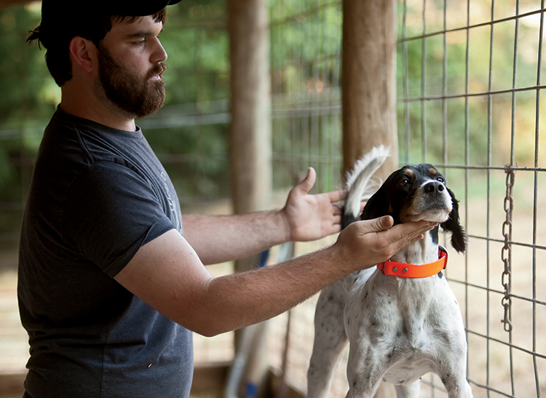
“Chris and I compete hard, and I’ve taught him to do that,” he says.
Chris plans to continue raising and training English Setters and is talking with outdoor cable channels about launching a TV show about the dogs.
“We’ve already filmed promos for the show, and we’re getting sponsorships,” he says. “We are hoping to have it on-air by early 2015.”
For Chris, making connections with his dogs is one of the best rewards.
“Nothing excites me more than seeing a dog smelling a bird and working up to hunting it,” he says.
As an FFA member, Chris competed on soil and land judging teams, received his American FFA Degree in 2013 and was a national proficiency finalist in 2012.
“I also got to go to Costa Rica on the national proficiency trip, which was by far my favorite FFA memory,” he says. “But I enjoyed the friendships what were developed while learning valuable skills. FFA taught me that with hard work and determination, you can achieve any goal you set your mind to.”

– Jessica Mozo

Fast Talking Man
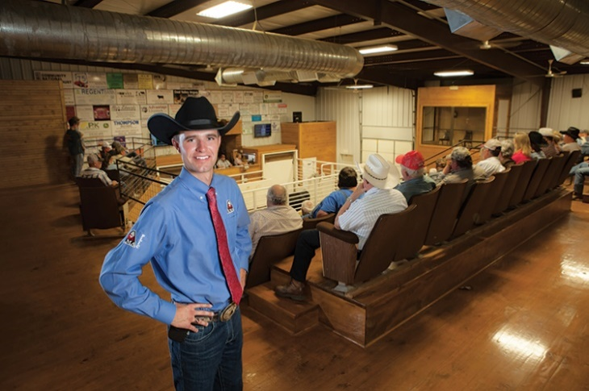
Third-generation auctioneer Blaine Lotz of Edna, Kan., was almost born on an auction block. His mom, Carla, is an auctioneer and went into labor with Blaine 45 minutes after finishing an auction.
“She auctioneered to me instead of singing lullabies,” says Lotz, now 22. “I learned to count by counting cattle.”
Lotz’s grandfather was also an auctioneer, and his dad, Mike, is a professional cattle order buyer who buys cattle for ranchers and farmers on commission. So it’s not surprising Blaine grew up to be an auctioneer.

World Livestock Auctioneer Champion
What is surprising to many is that the former president of the Labette County FFA Chapter won the Livestock Marketing Association’s (LMA) World Livestock Auctioneer Championship in June 2014 at the young age of 20, proving he has some world-class talent. He competed against 30 other auctioneers from around the U.S. and Canada whose average age was between 35 and 40. The contest was held in Knoxville, Iowa.
“I had watched the World Livestock Auctioneer Championship on TV growing up. It is to auctioneering as the Super Bowl is to the NFL – there’s no greater championship,” Lotz says. “It was my goal to win it someday. I won seventh place when I was 19, which was a huge accomplishment. Magically, I ended up winning first place at age 20.”
Along with the championship title, Lotz won a customized 2014 Ford F-150 pickup, $5,000 cash, a world champion Gist belt buckle, briefcase and ring, and a gavel, among other prizes. He also spent a year traveling to represent the LMA, making more than 50 livestock market appearances.
Lotz’s former FFA advisors, Dustin Wiley and John Frazier, weren’t surprised at his success. During his four years in FFA, Lotz was a state champion FFA Creed speaker and won his way to several national contests for which he had to qualify as top in the state.
“The first time I heard Blaine give the FFA Creed, I about fell out of my chair,” Frazier says. “He’s very gifted. When you listen to him speak, it’s incredible – he’s a tremendous auctioneer and role model. I tell him he needs to start singing country music. He just laughs.”
Wiley says he feels “super fortunate” to have had Lotz as a student.
“When he came in as a freshman, he was a man in a 14-year-old’s body. He was touched by God with the ability to speak and communicate,” Wiley says. “He’s a leader by example in the way he carries himself and a self-starter from day one.”
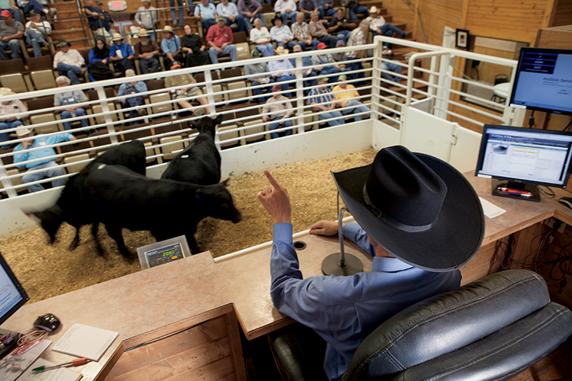
Blaine Lotz of Edna, Kan., sells a lot (or grouping) of cattle at a local Kansas market.

Becoming An Auctioneer
At age 15, Lotz attended the Western College of Auctioneering in Billings, Mont. One month after finishing the two-week program, Lotz performed his first auction. Today, he makes a living as an auctioneer, performing four live auctions per week in Kansas and Oklahoma markets.
“I’m a person who has to be doing something all the time, and auctioneering is fast-paced, so it gets me in my zone and makes me happy,” Lotz says. “It’s exciting because you never know what animal will walk through that gate that I get to sell. I interact with both buyers and sellers. For some sellers, that may be their only paycheck for the entire year, so my job is to sell it for them at the best price I can.”
What makes a good auctioneer, you may ask? It’s not just about talking fast – you also have to be pleasurable to listen to and know the livestock business – what you’re selling, and what it’s worth – so you can make the most money possible for a seller.
In competition, contestants are judged on voice quality, the clarity of their auction chant, and their ability to catch bids and keep the sale flowing. But most importantly is an auctioneer’s honesty, character and integrity.
“Blaine never put himself on a pedestal. He never looked down on anybody,” Wiley says. “Life can be hard for kids who are ultra-successful, because people get jealous of them. But if you were the kid with a rough home life and shabby clothes, Blaine was your friend. If you were the star athlete, he was your friend too. He’s a person of tremendous character.”
Lotz credits his experience in FFA as one reason for his success.
“Labette County FFA is an outstanding program. It benefited me more than any other high school class,” Lotz says. “To this day, I still love all my ag teachers. They’re like family.”
Wiley says Lotz is “a living example of what FFA is all about.”
“He’s supportive of others, a strong competitor, and he cherished his teammates and his advisors,” Wiley says. “We’re very blessed to have him.”
– Jessica Mozo

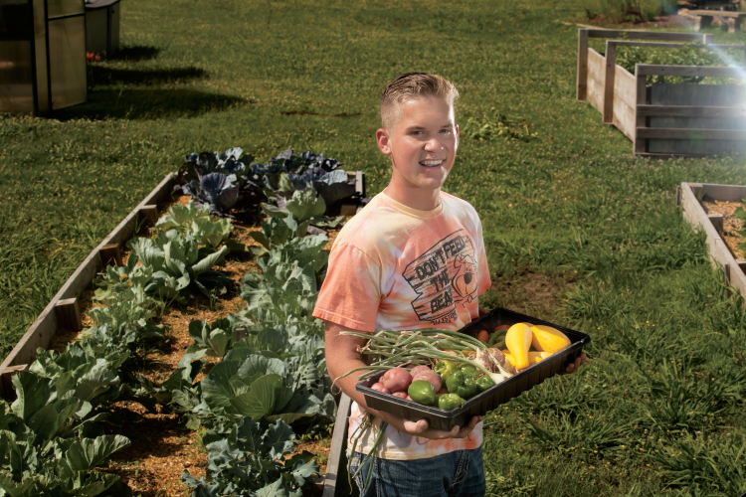
Oklahoma Member Leaves a Legacy of Service
Many high school students spend their weekends at the movies, the mall or cruising town in their first car. But Ridge Howell of Checotah, Okla., spent his high school weekends mowing lawns for senior citizens (for free) and working in his FFA chapter’s community garden, which also benefited the elderly.
“Ridge put in over 500 hours of community service working on our FFA senior citizens lawn mowing program and our FFA community garden, which was sponsored by a grant from the National FFA Organization and the Howard G. Buffet Foundation,” says Jason McPeak, Checotah FFA advisor. “Ridge has outstanding moral fiber and is one of the most kindhearted people you will meet.”
Native American Heritage
Now in his freshman year at Oklahoma State University, Ridge was FFA president, student body president and valedictorian of the class of 2013 at Checotah High School. He is also a member of the Muscogee Creek Nation, one of five civilized Native American tribes relocated by the government from their homes in the Mississippi River basin to Oklahoma on the Trail of Tears in the 1830s.
“My Native American heritage is my past, present and future,” Ridge says. “My dad’s side of the family are Muscogee Creek Nation, and my grandfather always told me lots of stories about my family’s history. Checotah High School has one of the highest Native American populations in the state.”
Ridge joined FFA in the ninth grade, but he was no stranger to agriculture. He had been showing animals through 4-H since age 9.
“When I joined FFA, I didn’t realize the impact it would have on my life,” he says. “I understood later it wasn’t just about agriculture – it teaches you leadership skills you will use the rest of your life.”
Washington, D.C., Bound
In November 2011, Ridge was invited by the USDA’s Office of Tribal Relations to serve on a board called Native Voices in Washington, D.C. He was one of 10 students invited from different states and tribes.
“I got involved with USDA Tribal Relations at the national FFA convention, when different Indian tribes across the country presented blankets to the national officers,” he says. “Later, I got a call saying they wanted my advisor Jason and I to come serve on the Native Voices board in D.C. A lot of schools throughout the country, especially on Indian reservations, don’t have FFA or ag programs. We’re trying to get it in more schools, and they asked me to come talk about my FFA experience.” Ridge was there when President Obama met with chiefs of different tribes. “It was surreal. I was very proud and happy,” he says. “I kept thinking, ‘How on earth did I get to do this?’ No one expects to get called to serve in D.C.”
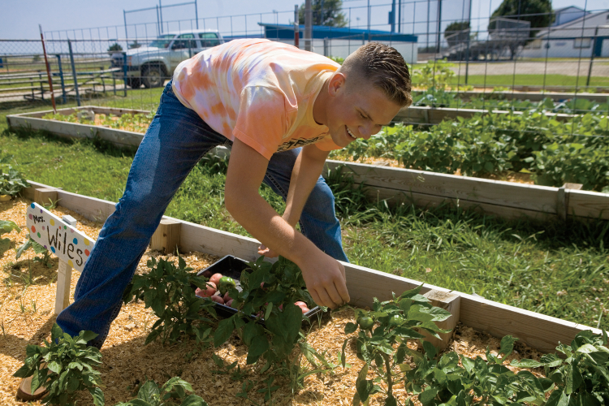
White House Champion of Change
In October 2012, Ridge returned to D.C. after being named a White House Champion of Change. He spoke on a panel with 11 other Champions of Change chosen from across the nation about current issues, including diversity, education and agriculture.
“We spoke in front of about 100 people with moderators asking us questions, and it streamed live online,” Ridge says. “My whole FFA chapter was involved and was watching. It was one of the best experiences I’ve ever had. I met so many influential people, including a member of the president’s cabinet.”
Ridge was nominated for the honor by his ag teachers, including McPeak, who went with him to D.C. He was selected for his outstanding community service efforts.
“As a freshman, Ridge helped with our FFA senior citizens lawn mowing program, and by the time he was a senior, he was running that program,” McPeak says. “Ridge was also on the ground level of a vital fruit and vegetable nutrition program made possible through our FFA community garden. Both programs are still successfully operating today.” Ridge says even though he worked hard, he gained much more than he gave by helping the elderly.
“There are stereotypes between teenagers and seniors – the two groups don’t really associate with one another,” he says. “I wanted to break down those barriers, because there are no better people to learn from than the elders of your community.” After mowing, Ridge says many seniors would sit and talk with him over lemonade and cookies. He also enjoyed delivering produce from his chapter’s community garden to the Checotah Senior Center each week.
“That’s where the real fun began. I never thought I’d see two 90-year-old women fight over the last zucchini, but I did,” he says, laughing. “One lady would always meet us outside in the parking lot so she could get first pick of the watermelons. It really bridged the gap between seniors and teens.” Ridge is majoring in English at OSU and hopes to go to law school before returning to Checotah to serve his neighbors.
“Small towns often get a bad rap, but it was extremely beneficial to grow up in Checotah,” he says. “I want my future family to have the privilege of living there as well. There is a network of people who will be there for you in a second if you need them.” Ridge’s dedication to service helped him become a Coca-Cola Scholar, which is helping him pay for college. He was one of 50 recipients selected nationwide. Ridge plans to visit his senior citizen friends back at home on his college breaks.
“There’s Betty and Dora … I can name them all,” he says, chuckling. “I learned a lot from serving them, and I’m much happier because of it. I’m very blessed.”
– Jessica Mozo

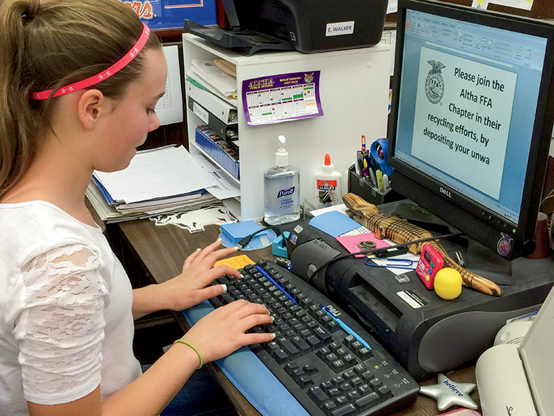
Altha Middle FFA Starts a Recycling Revolution
Homework, fliers, binder paper, hall passes. What happens to all that paper once the notes are taken, class is over and the grades are in?
Members of the Altha Middle FFA chapter from Florida were shocked to discover how much paper waste their school produced, and that none of it was being recycled. In the spirit of serving their community, the chapter decided to cut down on their waste and start a recycling revolution.
“After some of our members, and even our FFA advisors, started noticing how much used paper our school produced, it sparked an interest,” says FFA member Graham Bruner. “We did some research and learned that we were not recycling any of it.”
The chapter placed boxes throughout the school where teachers and students could deposit their paper products. A few times a week, members would empty the boxes, sort the contents and transport it to the local recycling facility.
“The recycling project benefited our environment by reducing the amount of waste in our local landfill,” says FFA member Max Scott. “We were really amazed at how much paper we were able to recycle in a short amount of time.”
These efforts, along with their overall excellence in student, chapter and community activities, led to the chapter being named National FFA Organization’s Outstanding Middle School in 2014 during the National FFA Convention & Expo. The award is sponsored by John Deere as a special project of the FFA Foundation.
But the rewards went beyond national recognition.
“Our chapter members learned a great deal about the importance of the environment, and why it doesn’t take an army to make a difference,” says member Morgan Raper. “We also learned how much paper, even in a very small school, is sent to the trash on a daily basis.”
FFA members who want to start a similar community service project are encouraged to identify a need in their own community, whether it be reducing pollution, fighting hunger, or fundraising for a good cause.
“A chapter can learn about the needs of its community by speaking with local churches, and even the local government,” Bruner says. “Good communication with your community is key to being informed on the need of the members of that community. “
When it comes to service, every little bit helps. No matter if you are picking up trash on the side of the road, or raising money for a charity, your efforts will gain momentum, and are capable of making a huge impact.
“The most beneficial advice that we can offer is to start small,” says chapter advisor Erin Walker. “A project does not have to change the world to make a difference. Begin with small achievable goals or projects and then slowly begin to set bigger goals.”

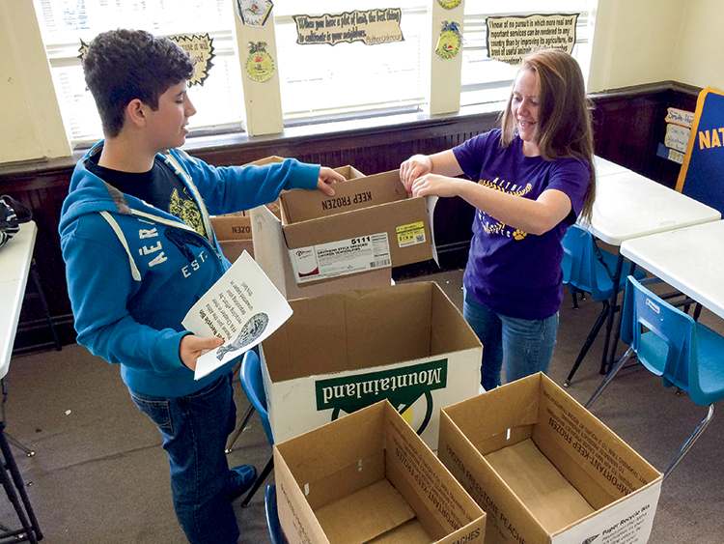
Start Your Own Revolution
Altha Middle FFA advisor Erin Walker says, “The big thing that really helped us was to begin looking for a need. Then figure out ways that you can help. Once we saw the need for a paper-recycling program at our school, we contacted those that worked in that area. Identify the need and then work backward.” The process she and her FFA members followed:
1. Identify
What is a major need or issue facing your community? Ask community leaders, teachers, and local groups what issues they would like to see addressed.
2. Plan
Decide how you want to address this issue. Do you want to organize an event, fundraiser or introduce a new initiative?
3. Start Small
Decide how to apply your plan in your community. Can you begin making changes in your school?
4 . Expand
Enlist your family, friends, neighbors, teachers and other members of the community to achieve your goal on wider scale. Can you expand your efforts to affect a larger group
– Hannah Patterson

Planning a Supervised Agricultural Experience (SAE)
Requirements:
- At least 10 hours per quarter agriculture class (15, if a semester class).
- Complete work contract.
- Keep accurate records on www.theaet.com (rubric attached).
- Create a poster with at least three pictures of the project and present it to the class at the end of the quarter.
Benefits of SAE:

- Aid students in making career choices.
- Develop thinking and decision-making skills.
- Use lessons from agriculture class.
- Gain self-confidence.
- Develop human-relations skills.
- Explore career opportunities.
- Gain practical experience, money and knowledge.
- Apply record-keeping and money management skills.
- Develop personal responsibility.
- Develop good work ethics that are valuable to employers.

Selecting an SAE:
Consider the following:
- Your experience and background.
- Your personal interests.
- Your ability to finance the activities.
- Your career interests.
- Your parental/guardian support.
- Facilities available to you.

Types of SAEs:

- Foundational—
- Includes four components:
  - Career exploration and planning
  - Personal financial management and planning
  - Workplace safety
  - Agricultural literacy
- These are meant to allow students to lead to one of the other SAE types.

- Ownership/Entrepreneurship—
  - Student owns and uses materials.
  - Student plans, implements, operates and assumes financial risks.
  - Student develops skills to establish own business or gain future employment.
  - Student shows improvement over time.
  - Student must keep accurate financial records.

- Placement/Internship—
  - Student works on a farm, in an agricultural business.
  - Student gains practical experience.
  - Paid employment or unpaid internships.

- Research-Based—
  - Student may conduct experiments and research information.
    - Experimental – involves the application of the scientific method to control certain variables while manipulating others to observe the outcome.
    - Analytical – analyze the data, facts and information to determine the answer to the posed question.
    - Invention – apply the engineering design process to create a new product.

- School-Based Enterprise—
  - Work with other students to create a business on school grounds.

- Service-Learning Experience—
  - By yourself or with fellow members, plan, conduct and evaluate a project(s) to provide a service to your school, a public entity or the community as a whole.

SAE Examples
- Create a lawn-mowing business.
- Take care of pets/livestock.
- Work at an agricultural or food-related business.
- Help a neighbor with harvest.
- Job shadow a person in an agricultural career you are interested in.
- Build birdhouses to sell.

SAEs can be just about anything within agriculture, food or natural resources. Pick something you enjoy doing or in which you can see yourself excelling. Many people find careers after completing an SAE.

Goals:
What are three goals for your SAE project during this class?

1.

2.

3.

SAE Work Contract
Name: _____________________________

Grade: _____________________________

Class/Block: _________________________

Circle the type of SAE you will be completing?

Placement/Internship Ownership/Entrepreneurship Foundational

Research-Based School-Based Enterprise Service-Learning Experience

In which category does your SAE fit (see list attached)? ______________________

Describe your SAE in your own words:

I pledge to make appropriate progress on my SAE project and complete it to the best of my ability.

Student Signature: _____________________________________

I pledge to assist the student with their SAE project whenever possible and help them progress throughout the program.

Teacher Signature: ____________________________________
Aligned to the following standards:
NRS.01; AGPE01.01; CCSS.ELA-Literacy.RI.9-10.3; CCSS.ELA-Literacy.SL.9-10.1; RST.9.10.1; RST.9.10.2; RST.9.10.4; RST.9.10.5; RST.9.10.6; RST.9.10.8; RST.9.10.9; WHST.9.10.7; WHST.9.10.9; MP3; MP6; AG-NR2; HS-LS2-6; HS-LS2-7

