Your Path
Created: 12/2021 by the National FFA Organization
Description of Lesson: Finding your path in life is important, but it is also important to know that your path may look different from others. In this retiring address, 2020-21 National FFA Central Region Vice President Paxton Dahmer discusses how it is OK to have a different path than your peers.
Student Learning Objectives:
After completing these activities, students will…
- Describe the importance of following their own path, regardless of what peers are doing.
- Create a timeline to outline major milestones in life.

Suggested Grade Level:
Grades 9 and 10 (This lesson is written so instructors can scale up or down based on class needs.)

Suggested Time: 45 minutes (*Time requirements may vary based upon student understanding and class schedule.)
Resources/References:
- Video: “Paxton Dahmer Retiring Address,” https://vimeo.com/640688862

Related Resources:
- Retiring Addresses and Keynotes, FFA.org/ffa-video-center/convention-keynotes-and-retiring-addresses/

Equipment and Supplies Needed:
- A copy of the “Your Path” worksheet for each student
- Internet access to play the video in real time or embed it in a PowerPoint ahead of time

Vocabulary:
- Dive
- Trust

Cross-Curricular Connections:
English/Language Arts | Social Studies
Create a timeline to depict a path. | Locate Ukraine on a map.

Virtual Instruction Ideas:
Have students download and then watch the video on a device of their choice and complete the worksheet.

Student Activity Sheets:
Direct access to student activity sheets without lesson plan or answer key for easy upload to a learning management system or printing for classwork.

https://ffa.box.com/s/40n5810delyq1l2tda7wav23k7e356gm (Word)
https://ffa.box.com/s/ntfvuxnru2kprv2gks1nmaoe37avvs9q (Non-Designed)
https://ffa.box.com/s/i8ev35xug6t4d4hz4536mjo20k9u6egk (PDF)
https://docs.google.com/document/d/18YkZCKGJYo3imhxsPwLmpIV3uAgUe3rLfCb6_PNOGms/copy (Google)

These Activities are Aligned to the Following Standards:
FFA Precept
- FFA.PL-A.Action: Assume responsibility and take the necessary steps to achieve the desired results, no matter what the goal or task at hand.
- FFA.PL-C.Vision: Visualize the future and how to get there.
- FFA.PL-E.Awareness: Understand personal vision, mission and goals.
- FFA.PG-J.Mental Growth: Embrace cognitive and intellectual development relative to reasoning, thinking and coping.
- FFA.CS-N.Decision Making: Analyze a situation and execute an appropriate course of action.
Common Core – Writing
- CCSS.ELA-Literacy.W.9-10.4: Produce clear and coherent writing in which the development, organization, and style are appropriate to task, purpose, and audience.
AFNR Career Ready Practices
- CRP.02: Apply appropriate academic and technical skills. Career-ready individuals readily access and use the knowledge and skills acquired through experience and education to be more productive.
- CRP.04: Communicate clearly, effectively, and with reason. Career-ready individuals communicate thoughts, ideas and action plans with clarity, whether using written, verbal and/or visual methods.
- CRP.06: Demonstrate creativity and innovation. Career-ready individuals regularly think of ideas that solve problems in new and different ways, and they contribute those ideas in a useful and productive manner to improve their organization.
- CRP.08: Utilize critical thinking to make sense of problems and persevere in solving them. Career-ready individuals readily recognize problems in the workplace, understand the nature of the problem, and devise effective plans to solve the problem.
Partnership for 21st Century Skills
- Critical Thinking and Problem Solving
- Flexibility and Adaptability
- Initiative and Self-Direction
- Leadership and Responsibility
Lesson Plan:
- Bell Ringer: When was the last time you compared yourself to others? Why did you?

- Introduction: Finding your path in life and knowing it is not the same as everyone else is important. Today we are going to watch a retiring address from the 94th National FFA Convention & Expo. This retiring address was given by 2020-21 National FFA Central Region Vice President Paxton Dahmer. In his speech, he discusses the importance of understanding that not everyone’s path is the same, and that is OK.

- Activity: Each student needs a copy of the worksheet “Your Path.”
  - Part 1: Students will watch the retiring address of 2020-21 National FFA Central Region Vice President Paxton Dahmer and complete the activities. The video URL is https://vimeo.com/640688862.
  - Part 2: After listening to Paxton, we know that we need to follow our own paths no matter where that path takes us. Using the timeline, have students map out the next five years to the best of their abilities. Students should be sure to consider special-interest milestones (ex. football, FFA, choir, 4-H, FCCLA, etc.), education milestones (ex. graduation, certifications, etc.) and personal milestones (ex. first trip outside their state, first National FFA Convention, etc.). Students should include (1) a small picture to represent each item on their timelines, (2) a minimum of 10 milestones with an approximate timeframe and (3) an explanation of why each milestone is important to them. Note: Remind students that these can always change as their lives change!

- Follow-up: Have students share milestones and their importance with the class.

- Exit Ticket: Why is following your own path, regardless of what your peers are doing, important?

Your Path
Aligned to the following standards:
FFA.PL-A; FFA.PL-C; FFA.PL-E; FFA.PG-J; FFA.CS-N; CCSS.ELA.W.9-10.4; CRP.02; CRP.04; CRP.06; CRP.08
Part 1
Directions:
Complete the following activities while watching the retiring address of 2020-21 National FFA Central Region Vice President Paxton Dahmer. The video is available at https://vimeo.com/640688862.

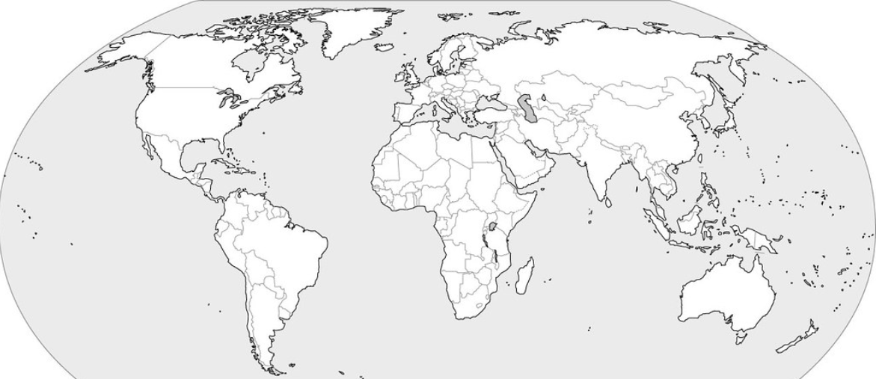
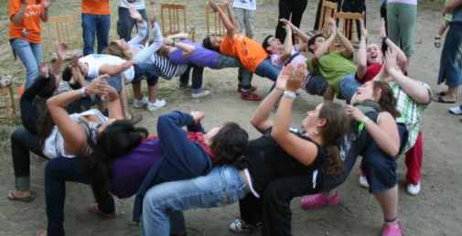
Color in Ukraine. In the space to the right of the map, draw the Ukrainian flag.
According to Paxton, why are challenges important?

1.

2.

3.
What is a challenge that you have faced, and what importance has it had in your life?
“Know that not __________________________________ path is the ____________, and that is ________.” — Paxton Dahmer
What is a trust circle?
What is a reason you would move?
Part 2
Directions:
After listening to Paxton, we know that we need to follow our own path no matter where that path takes us. Using the timeline below, map out the next five years to the best of your ability. Be sure to consider special-interest milestones (ex. football, FFA, choir, 4-H, FCCLA, etc.), education milestones (ex. graduation, certifications, etc.) and personal milestones (ex. first trip outside your state, first National FFA Convention, etc.). Be sure to include (1) a small picture to represent each item on your timeline, (2) a minimum of 10 milestones with an approximate timeframe and (3) an explanation of why each milestone is important to you. Note: These can always change as your life changes!
Example: earn my American FFA Degree
Summarize what you have learned in one sentence.
KEY: Your Path
Aligned to the following standards:
FFA.PL-A; FFA.PL-C; FFA.PL-E; FFA.PG-J; FFA.CS-N; CCSS.ELA.W.9-10.4; CRP.02; CRP.04; CRP.06; CRP.08
Part 1
Directions:
Complete the following activities while watching the retiring address of 2020-21 National FFA Central Region Vice President Paxton Dahmer. The video is available at https://vimeo.com/640688862.


Color in Ukraine. In the space to the right of the map, draw the Ukrainian flag.
According to Paxton, why are challenges important?

- Make you who you are

2. Set you apart from others

- Drive your development
What is a challenge that you have faced, and what importance has it had in your life? Answers will vary.
“Know that not everyone’s path is the same, and that is OK.” — Paxton Dahmer
What is a trust circle?
A space where we share with others
What is a reason you would move?
Answers will vary.
Part 2
Directions:
After listening to Paxton, we know that we need to follow our own paths no matter where that path takes us. Using the timeline below, map out the next five years to the best of your ability. Be sure to consider special-interest milestones (ex. football, FFA, choir, 4-H, FCCLA, etc.), education milestones (ex. graduation, certifications, etc.) and personal milestones (ex. first trip outside your state, first National FFA Convention, etc.). Be sure to include (1) a small picture to represent each item on your timeline, (2) a minimum of 10 milestones with an approximate timeframe and (3) an explanation of why each milestone is important to you. Note: These can always change as your life changes!
Example: earn my American FFA Degree
Answers will vary.
Summarize what you have learned in one sentence.
Answers will vary.

