Your Path
Aligned to the following standards:
FFA.PL-A; FFA.PL-C; FFA.PL-E; FFA.PG-J; FFA.CS-N; CCSS.ELA.W.9-10.4; CRP.02; CRP.04; CRP.06; CRP.08
Part 1
Directions:
Complete the following activities while watching the retiring address of 2020-21 National FFA Central Region Vice President Paxton Dahmer. The video is available at https://vimeo.com/640688862.

- What is a trust circle?

- What is a reason you would move?

- “Know that not __________________________________ path is the ____________, and that is ________.” — Paxton Dahmer
- According to Paxton, why are challenges important?

1.

2.

3.

- What is a challenge that you have faced, and what importance has it had in your life?

- Color in Ukraine. In the space to the right of the map, draw the Ukrainian flag.
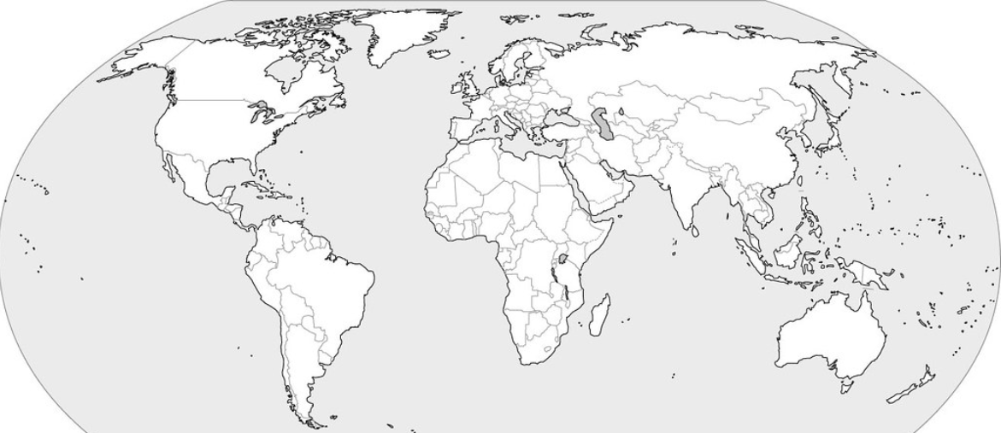

Part 2
Directions:
After listening to Paxton, we know that we need to follow our own path no matter where that path takes us. Using the timeline below, map out the next five years to the best of your ability. Be sure to consider special-interest milestones (ex. football, FFA, choir, 4-H, FCCLA, etc.), education milestones (ex. graduation, certifications, etc.) and personal milestones (ex. first trip outside your state, first National FFA Convention, etc.). Be sure to include (1) a small picture to represent each item on your timeline, (2) a minimum of 10 milestones with an approximate timeframe and (3) an explanation of why each milestone is important to you. Note: These can always change as your life changes!
Example: earn my American FFA Degree

- Summarize what you have learned in one sentence.

