Personal Goals Activity 
MY SMART GOALS
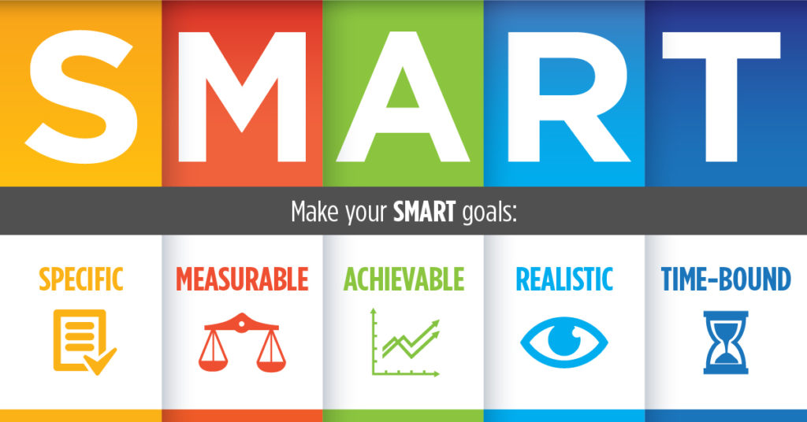
Personal goals are important because each of you have dreams of what you would like to achieve within this chapter. Now that you have committed to one word and a personal mission statement, create two goals, detailing how you are going to work toward these goals and when you want to achieve them.
When making your SMART goals for this year, make sure to follow the format below:
WHAT: What are you trying to achieve? WHY: Why is this goal important?
WHO: Who will help with achieving the goal?
WHEN: When will this goal be achieved by? HOW: How are you going to achieve this goal?

SMART Goal 2

SMART Goal 1

