Learning
Created: 05/2019 by the National FFA Organization

Retiring Address Video Summary: Many believe that learning stops once you graduate from your last step in the world of academia, whether that is a high school diploma or a doctorate. However, to truly succeed, we must strive to be lifelong learners. In this retiring address, 2017-18 National FFA Central Region Vice President Piper Merritt discusses the importance of becoming a forever learner.
Student Learning Objectives:
After completing these activities, students will …
- Describe a forever learner.
- Examine their lives to determine how to become a forever learner.

Time Required: 45 minutes
Resources:
- Video: “The Forever Learner, Piper Merritt Retiring Address,” https://vimeo.com/297323619
- “What Famous Lifelong Learner Are You?,” https://www.proprofs.com/quiz-school/story.php?title=mtixnjkxoqz7qr

Equipment and Supplies Needed:
- A copy of the “When Does Learning End?” worksheet for each student
- Internet access to play the video in real time or embed it in a PowerPoint ahead of time

This quick lesson plan would work well as A:
- Leadership lesson.
- Personal growth lesson.

Student Activity Sheets:
Direct access to student activity sheets without lesson plan or answer key for easy upload to learning management systems or printing for classwork.
https://ffa.box.com/s/lhrqioajcc9ths9qniom8qrtk2075w6n (Word)
https://ffa.box.com/s/7b45e2ei7hq49jz5zeam3evpz8e9afel (Non-Designed)
https://ffa.box.com/s/16afm3lpbhhoezntp751oc94sbysvh0j (PDF)
These activities are aligned to the following standards:

FFA Precept
- FFA.PL-A.Action: Assume responsibility and take the necessary steps to achieve the desired results, no matter what the goal or task at hand.
- FFA.PL-C.Vision: Visualize the future and how to get there.
- FFA.PL-E.Awareness: Understand personal vision, mission and goals.
- FFA.PG-J.Mental Growth: Embrace cognitive and intellectual development relative to reasoning, thinking and coping.
- FFA.CS-N.Decision Making: Analyze a situation and execute an appropriate course of action.
Common Core – Literacy in Science & Technical Subjects: Writing
- CCSS.ELA-Literacy.WHST.9.10.4: Produce clear and coherent writing in which the development, organization, and style are appropriate to task, purpose, and audience.
Common Core – Math Practices
- CCSS.MP1: Make sense of problems and persevere in solving them.
- CCSS.MP5: Use appropriate tools strategically.
- CCSS.MP6: Attend to precision.
AFNR Career Ready Practices
- CRP.02: Apply appropriate academic and technical skills. Career-ready individuals readily access and use the knowledge and skills acquired through experience and education to be more productive.
- CRP.04: Communicate clearly, effectively, and with reason. Career-ready individuals communicate thoughts, ideas and action plans with clarity, whether using written, verbal and/or visual methods.
- CRP.06: Demonstrate creativity and innovation. Career-ready individuals regularly think of ideas that solve problems in new and different ways, and they contribute those ideas in a useful and productive manner to improve their organization.
- CRP.08: Utilize critical thinking to make sense of problems and persevere in solving them. Career-ready individuals readily recognize problems in the workplace, understand the nature of the problem, and devise effective plans to solve the problem.
Partnership for 21st Century Skills
- Communication
- Critical Thinking and Problem Solving
- Flexibility and Adaptability
- Initiative and Self-Direction
- Leadership and Responsibility

Lesson Plan:
- Bell Ringer: When does learning new things end?

- Introduction: Many people talk about being a lifelong learner, but what is the value and what does this phrase actually mean? Today, we are going to watch a retiring address from the 91st National FFA Convention & Expo. This retiring address was given by 2017-18 National FFA Central Region Vice President Piper Merritt. In her speech, she discusses the importance of being a forever learner.

- Activity: Each student needs a copy of the worksheet “When Does Learning End?” Students will watch the retiring address of 2017-18 National FFA Central Region Vice President Piper Merritt and complete the activities. The video URL is https://vimeo.com/297323619.

- Follow-up: Have students journal about reaching/achieving the short-term goals they set.

- Leveling Up: Have students create long-term goals for becoming forever learners.

- Exit Ticket: Why is it important to become a forever learner?

When Does Learning End?
Aligned to the following standards:
FFA.PL-A; FFA.PL-C; FFA.PL-E; FFA.PG-J; FFA.CS-N; CCSS.ELA.WHST.9.10.4; MP1; MP5; MP6; CRP.02; CRP.04; CRP.06; CRP.08
Directions:
Fill in the blanks and answer the questions below while watching “The Forever Learner,” the retiring address of 2017-18 National FFA Central Region Vice President Piper Merritt, available at https://vimeo.com/297323619.


Find, label, and color Japan on the map.
What last piece of advice did the farmer from Japan share with the National FFA Officers?

- Life is a journey.
- Work hard, stay happy.
- Learning will pave your path.
- Have pride.
According to Piper, what are four positive outcomes of being a forever learner?


To be a forever learner, we must set

_______________ aside.

Describe three specific ways becoming a forever learner will impact your life.

To be a forever learner, we must find __________ in learning.


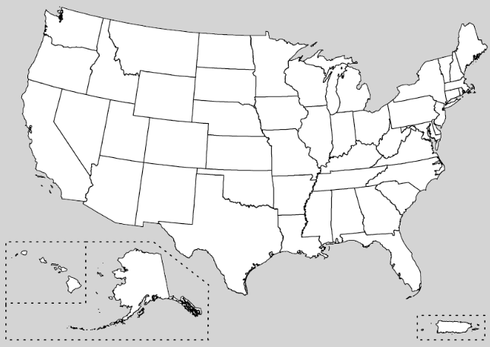
What can you do today to find joy in learning?
Write two short-term goals to help you start being a forever learner.

1.

2.
Find, label and color five states Piper visited that had an impact on her need to continue as a forever learner.
Using this link, https://www.proprofs.com/quiz-school/story.php?title=mtixnjkxoqz7qr, take the quiz to find out “What Famous Lifelong Learner Are You?” Record your answer here.

________________________________________________
Do you feel the person you got in the quiz is an accurate reflection of you? Why or why not?



KEY: When Does Learning End?
Aligned to the following standards:
FFA.PL-A; FFA.PL-C; FFA.PL-E; FFA.PG-J; FFA.CS-N; CCSS.ELA.WHST.9.10.4; MP1; MP5; MP6; CRP.02; CRP.04; CRP.06; CRP.08
Directions:
Fill in the blanks and answer the questions below while watching “The Forever Learner,” the retiring address of 2017-18 National FFA Central Region Vice President Piper Merritt, available at https://vimeo.com/297323619.

According to Piper, what are four positive outcomes of being a forever learner?

Joy

Happiness

Humility

Success
Find, label and color Japan on the map.
What last piece of advice did the farmer from Japan share with the National FFA Officers?

- Life is a journey.
- Work hard, stay happy.
- Learning will pave your path.
- Have pride.
To be a forever learner, we must find joy in learning.

Describe three specific ways becoming a forever learner will impact your life.
Answers will vary.

Japan
To be a forever learner, we must set pride aside.

What can you do today to find joy in learning?
Answers will vary.
Write two short-term goals to help you start being a forever learner.
Answers will vary.

1.

2.
Find, label and color five states that Piper visited that had an impact on her need to continue as a forever learner.
Using this link, https://www.proprofs.com/quiz-school/story.php?title=mtixnjkxoqz7qr, take the quiz to find out “What Famous Lifelong Learner Are You?” Record your answer here. Answers will vary.

________________________________________________
Do you feel the person you got in the quiz is an accurate reflection of you? Why or why not?
Answers will vary.

Florida
Alabama
Kentucky
Ohio
New York
Oklahoma
Oregon

