When Does Learning End?
Aligned to the following standards:
FFA.PL-A; FFA.PL-C; FFA.PL-E; FFA.PG-J; FFA.CS-N; CCSS.ELA.WHST.9.10.4; MP1; MP5; MP6; CRP.02; CRP.04; CRP.06; CRP.08
Directions:
Fill in the blanks and answer the questions below while watching “The Forever Learner,” the retiring address of 2017-18 National FFA Central Region Vice President Piper Merritt, available at https://vimeo.com/297323619.


Find, label, and color Japan on the map.
What last piece of advice did the farmer from Japan share with the National FFA Officers?

- Life is a journey.
- Work hard, stay happy.
- Learning will pave your path.
- Have pride.
According to Piper, what are four positive outcomes of being a forever learner?


To be a forever learner, we must set

_______________ aside.

Describe three specific ways becoming a forever learner will impact your life.

To be a forever learner, we must find __________ in learning.


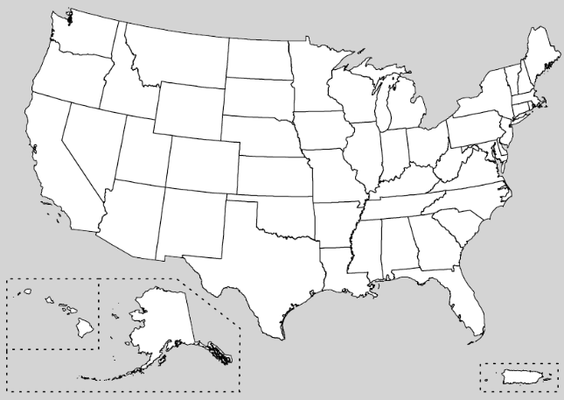
What can you do today to find joy in learning?
Write two short-term goals to help you start being a forever learner.

1.

2.
Find, label and color five states Piper visited that had an impact on her need to continue as a forever learner.
Using this link, https://www.proprofs.com/quiz-school/story.php?title=mtixnjkxoqz7qr, take the quiz to find out “What Famous Lifelong Learner Are You?” Record your answer here.

________________________________________________
Do you feel the person you got in the quiz is an accurate reflection of you? Why or why not?

