Pizza Anyone?
Created: 06/2017 by the National FFA Organization

Student Learning Objectives:
After completing these activities students will…
- Describe the role of Domino’s Pizza in the agriculture industry.
- Understand the relationship between American agriculture and the global economy.

Time Required: 30 minutes
Resources:
- FFA.org
- Website — Domino’s International Fun Facts: https://biz.dominos.com/web/public/international/fun-facts
- Video — Domino’s Supply Chain

Equipment and Supplies Needed:
- A copy of the “Around the World” worksheet for each student
- Internet access for the website for each student

This quick lesson plan would work well as Part of An:
- Agriculture innovators and/or companies unit.
- Agriculture advances unit.
- Agriculture business or marketing course/unit.
- International agriculture course/unit.

These activities are aligned to the following standards:
FFA Precept
- FFA.PL-A.Action: Assume responsibility and take the necessary steps to achieve the desired results, no matter what the goal or task at hand.
- FFA.PG-I.Professional Growth: Assume responsibility for attaining and improving upon the skills needed for career success.
- FFA.PG-J.Mental Growth: Embrace cognitive and intellectual development relative to reasoning, thinking and coping.
- FFA.CS-M.Communication: Effectively interact with others in personal and professional settings.
AFNR Cluster Skills
- CS.01. Analyze how issues, trends, technologies and public policies impact systems in the Agriculture, Food & Natural Resources Career Cluster.
Common Core- Writing
- CCSS.ELA-LITERACY.W.9-10.1 Write arguments to support claims in an analysis of substantive topics or texts, using valid reasoning and relevant and sufficient evidence.
- CCSS.ELA-LITERACY.W.9-10.2 Write informative/explanatory texts to examine and convey complex ideas, concepts, and information clearly and accurately through the effective selection, organization, and analysis of content.
- CCSS.ELA-LITERACY.W.9-10.4 Produce clear and coherent writing the development, organization, and style are appropriate to task, purpose, and audience.
Common Core- Speaking and Listening
- CCSS.ELA-LITERACY.SL.9-10.1 Initiate and participate effectively in a range of collaborative discussions (one-on-one, in groups, and teacher-led) with diverse partners on grades 9-10 topics, texts, and issues, building on others' ideas and expressing their own clearly and persuasively.
- CCSS.ELA-LITERACY.SL.9-10.4 Present information, findings, and supporting evidence clearly, concisely, and logically such that listeners can follow the line of reasoning and the organization, development, substance, and style are appropriate to purpose, audience, and task.
Common Core- Language
- CCSS.ELA-LITERACY.L.9-10.6 Acquire and use accurately general academic and domain-specific words and phrases, sufficient for reading, writing, speaking, and listening at the college and career readiness level; demonstrate independence in gathering vocabulary knowledge when considering a word or phrase important to comprehension or expression.
Common Core- Math Practices
- CCSS.MP3: Construct viable arguments and critique the reasoning of others.
- CCSS.MP6: Attend to precision.
- CCSS.MP7: Look for and make use of structure.
AFNR Career Ready Practices
- CRP.02. Apply appropriate academic and technical skills. Career-ready individuals readily access and use the knowledge and skills acquired through experience and education to be more productive.
- CRP.04. Communicate clearly, effectively, and with reason. Career-ready individuals communicate thoughts, ideas and action plans with clarity, whether using written, verbal and/or visual methods.
- CRP.05. Consider the environmental, social and economic impact of decisions. Career-ready individuals understand the interrelated nature of their actions and regularly make decisions that positively impact and/or mitigate negative impact on other people, organizations and the environment.
- CRP.06. Demonstrate creativity and innovation. Career-ready individuals regularly think of ideas that solve problems in new and different ways, and they contribute those ideas in a useful and productive manner to improve their organization.
- CRP.08. Utilize critical thinking to make sense of problems and persevere in solving them. Career-ready individuals readily recognize problems in the workplace, understand the nature of the problem, and devise effective plans to solve the problem.
Partnership for 21st Century Skills
- Civic Literacy
- Communication
- Critical Thinking and Problem Solving
- Information Literacy
- Information, Communications, and Technology Literacy
- Initiative and Self-direction
- Media Literacy
- Productivity and Accountability

LESSON PLAN:
- Introduction: American agriculture is part of a bigger picture of the global economy. To increase sales and production, many companies have expanded globally to meet consumer demands. Individually, have students brainstorm what countries they think the United States exports to the most. To add to that list, have students brainstorm what countries they think would be most beneficial for companies to have a presence in.

- Video: Show students the video “Domino’s Supply Chain," https://www.youtube.com/watch?v=KDB6Cf5b7Rw. Have students write down three interesting facts and three questions they have from the video.

- Activity: Each student (or they can work in pairs) should have access to a computer and the website Domino’s International Fun Facts: https://biz.dominos.com/web/public/international/fun-facts
  - Students should work through the worksheet titled “Around the World” by identifying Domino’s global presence.
  - As a class, identify these places on a large map and discuss each location.

4. Follow-up: Conduct a class discussion about why Domino’s may have selected those locations. Do you think other food companies have a presence in those countries? Why or why not?

5. Leveling Up: Have students select one location where Domino’s is present. They should research that location, including things such as education level, agricultural production, language, population, etc. How does this information relate to Domino’s, or any food company, choosing to have a presence there?

Around the World
Aligned to the following standards:
FFA.PL-A; FFA.PG-I; FFA.PG-J; FFA.CS-M; CS.01; CCSS.W.9-10.1; CCSS.W.9-10.2; CCSS.W.9-10.4; CCSS.SL.9-10.1; CCSS.SL.9-10.4; CCSS.L.9-10.6; CCSS.MP3; CCSS.MP6; CCSS.MP7; CRP.02; CRP.04; CRP.05; CRP.06; CRP.08
Directions:
Using the Domino’s International Fun Facts website, answer the questions below. The direct URL is: https://biz.dominos.com/web/public/international/fun-facts.

- On the map below, put a mark by every location that Domino’s has around the world.
- Next to each location marked, write one fun fact about that location.
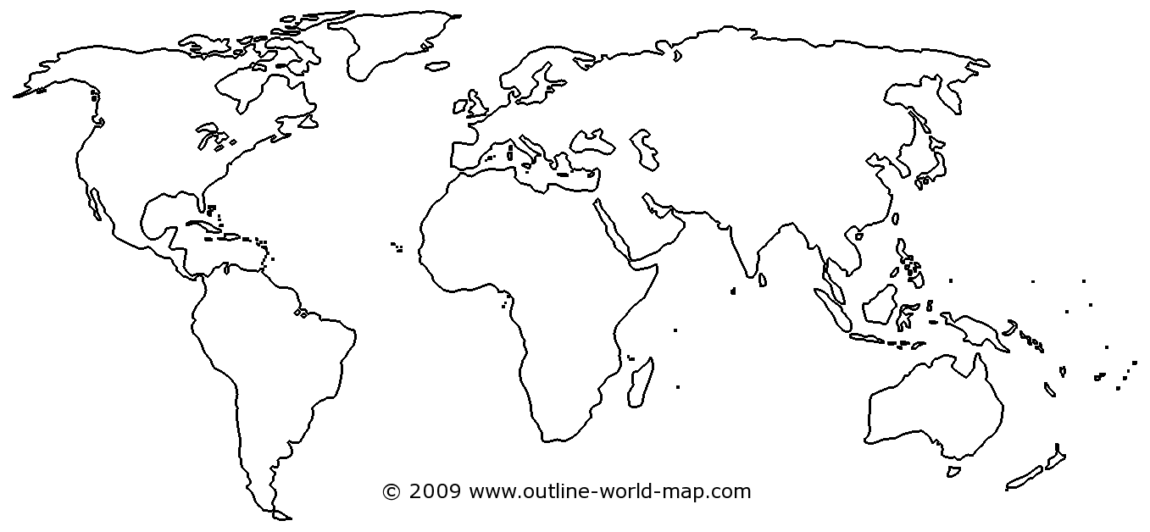

- Describe the importance of Domino’s having a global presence and the effect it has on American agriculture.

