Planning for Advocacy
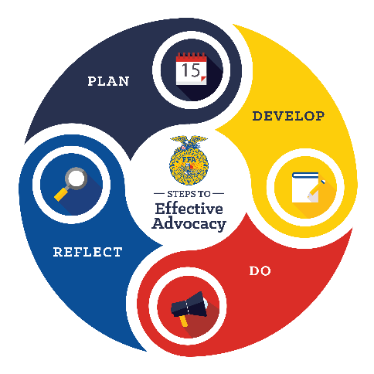
Advocating is an important and essential role needed in agriculture. And what better week to advocate for agriculture, agricultural education and FFA then FFA Week!
The Agricultural Literacy and Advocacy Model consists of four steps: plan, develop, do and reflect. This model can be used to complete advocacy experiences with different audiences, including those encountered during FFA week: elected officials, peers, community members and elementary students.
As your chapter plans activities, encourage students to plan an advocacy activity. With each potential audience, think about the following steps.
- Plan — Establish the overall question you want to investigate in this step. Each guiding question below will help determine the main question.
  - Define your issue:
What is the challenge we are facing?

Example: Idea that brown cows give chocolate milk
What is the vital information we need to know, and where can we find it?
  - Analyze:
Example: What age group has the greatest misunderstanding?

  - Understand the audience:
Who are we trying to influence?
Example: Elementary children aged K-3rd grade

- Develop — Now that you have analyzed the situation and identified the target audience, it’s time to develop materials, messages and resources. The following questions help guide you.
  - Write objectives:
What do we want to accomplish?
Example: Educate students about agriculture

  - Identify SMART goals:
How are we going to accomplish this goal?
Example: We will increase knowledge about agriculture for 20 elementary school students. We will do this by hosting an ag day. This will be accomplished in one month.
  - Determine key messages:
What are our important talking points for our defined audience?
Example: Agriculture is present in all areas of our lives.

  - Develop a plan:
What are the steps we need to take to achieve our objectives?
Example: Identify school, animals and a lesson

- Do — Once students have successfully planned and developed resources, it’s time to take action. What are the next steps? Collaborate, execute and raise awareness! Use the following guiding questions to assist in the activity completion.
  - Collaborate:
How can we partner with others to strengthen our advocacy efforts?
Example: Find area experts that can provide animals or lessons.
How are we using what we know?
  - Execute:
Example: What did we learn in our agriculture classes that we can share?

  - Raise awareness:
How do we promote our advocacy efforts and gain support?
Example: Reach out to the newspaper to highlight the activity.

- Reflect — Once the activity is over, it’s time to reflect on what happened and what can be changed and/or improved. Use these questions to reflect on what you just accomplished.
What information can we collect that will demonstrate impact?
  - Monitor:
Example: What are the students’ perceptions before and after our activity?
How well did we achieve our objectives?
  - Review:
Example: Share how you met, exceeded or did not meet your expectations during this event.
What changes can we make to improve?
  - Adapt:
Example: Change lesson we provided to be more relatable for age.
NOW, HAVE STUDENTS STEP UP AND PUT ONE OF YOUR PLANNED ACTIVITIES INTO ACTION AND CONSIDER SHARING THROUGH THE CHALLENGE!

