Post-Convention Reflection
Directions: Reflect on your experiences during the 95th National FFA Convention & Expo by completing the activities below.
- Five-minute free write: Use the space below to share your thoughts and feelings about your convention experience

- Choose one word that represents your convention experience and create an acrostic poem using your chosen word.
Example:
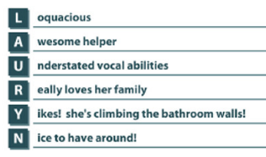

- What is one thing from your convention experience that you can apply in your personal life and in school?
School
Personal

- What was your most interesting discovery during this experience?

