“Power Up” Your Future with John Deere
Created: 04/2018 by the National FFA Organization

Student Learning Objectives:
After completing these activities, students will …
- Describe career preparation programs offered through John Deere and affiliated colleges.
- Identify skills, qualifications and requirements needed in a Power, Structural and Technical career.

Time Required: 45 minutes
Resources:
- FFA.org
- Video: “Power Up Your Career as a John Deere Technician” and additional resources, https://www.deere.com/en/our-company/john-deere-careers/dealer-technician-training/ag-turf-technicians/
- AgExplorer, AgExplorer.ffa.org

Equipment and Supplies Needed:
- A copy of the “Power Up Your Future as a John Deere Agriculture/Turf Technician” worksheet for each student
- A copy of the “Advertising to Power Up Our Future” worksheet for each student
- Internet access for student exploration
- Internet access to play the video in real time or embed it in a PowerPoint ahead of time

This quick lesson plan would work well as:
- Part of a careers lesson.
- A lesson/unit about agricultural companies.

These activities are aligned to the following standards:
AFNR Performance Element
- CS.02. Evaluate the nature and scope of the Agriculture, Food & Natural Resources Career Cluster and the role of agriculture, food and natural resources (AFNR) in society and the economy.
- CS.05. Describe career opportunities and means to achieve those opportunities in each of the Agriculture, Food & Natural Resources career pathways.
FFA Precept
- FFA.PL-A.Action: Assume responsibility and take the necessary steps to achieve the desired results, no matter the goal or task at hand.
- FFA.PL-C.Vision: Visualize the future and how to get there.
- FFA.PL-E.Awareness: Understand personal vision, mission and goals.
- FFA.PL-F.Continuous Improvement: Accept responsibility for learning and personal growth.
- FFA.PG-J.Mental Growth: Embrace cognitive and intellectual development relative to reasoning, thinking and coping.
- FFA.CS-M.Communication: Effectively interact with others in personal and professional settings.
- FFA.CS-N. Decision Making: Analyze a situation and execute an appropriate course of action.
Common Career Technical Core
- AG2: Evaluate the nature and scope of the Agriculture, Food & Natural Resources Career Cluster and the role of agriculture, food and natural resources (AFNR) in society and the economy.
- AG3: Describe career opportunities and means to achieve those opportunities in each of the Agriculture, Food & Natural Resources career pathways.
NASDCTEc
- AGC09.02: Select, research and examine critical aspects of career opportunities in one or more AFNR career pathways in order to gain an understanding of the breadth of occupations within this cluster.
Common Core - Reading: Informational Text
- CCSS.ELA-Literacy.RI.9-10.2: Determine a central idea of a text and analyze its development over the course of the text, including how it emerges and is shaped and refined by specific details; provide an objective summary of the text.

Common Core - Speaking and Listening
- CCSS.ELA-Literacy.SL.9-10.1: Initiate and participate effectively in a range of collaborative discussions (one-on-one, in groups, and teacher-led) with diverse partners on grades 9-10 topics, texts, and issues, building on others’ ideas and expressing their own clearly and persuasively.
- CCSS.ELA-Literacy.SL-10.2: Integrate multiple sources of information presented in diverse media or formats (e.g., visually, quantitatively, orally) evaluating the credibility and accuracy of each source.
- CCSS.ELA-Literacy.SL.9-10.4: Present information, findings, and supporting evidence clearly, concisely, and logically such that listeners can follow the line of reasoning and the organization, development, substance, and style are appropriate to purpose, audience, and task.
Common Core - Literacy in Science & Technical Subjects: Writing
- CCSS.ELA-Literacy.WHST.9.10.4: Produce clear and coherent writing in which the development, organization, and style are appropriate to task, purpose, and audience.
- CCSS.ELA-Literacy.WHST.9.10.6: Use technology, including the Internet, to produce, publish, and update individual writing products, taking advantage of technology’s capacity to link to other information and to display information flexibly and dynamically.
AFNR Career Ready Practices
- CRP.04: Communicate clearly, effectively, and with reason. Career-ready individuals communicate thoughts, ideas, and action plans with clarity, whether using written, verbal and/or visual methods.
- CRP.05: Consider the environmental, social and economic impact of decisions. Career-ready individuals understand the interrelated nature of their actions and regularly make decisions that positively impact and/or mitigate negative impact on other people, organizations and the environment.
- CRP.07: Employ valid and reliable research strategies. Career-ready individuals are discerning in accepting and using new information to make decisions, change practices, or inform strategies.
Partnership for 21st Century Skills
- Information, Communications, and Technology Literacy
- Think Creatively
- Initiative and Self-direction
- Leadership and Responsibility

Lesson Plan:
- Bell Ringer: Using your own paper, you have two minutes to list as many careers as you can think of in the Power, Structural and Technical Systems career focus area. After the time has run out, give students one minute to think-pair-share and create a joint list of careers. Then, have students share with the class. Record responses on the board. Follow with a group discussion.

- Introduction: Show the video “Power Up Your Career as a John Deere Technician.” The direct URL is https://www.deere.com/en/our-company/john-deere-careers/dealer-technician-training/jd-tech/.

- Activity 1: Each student needs a copy of the worksheet “Power Up Your Future as a John Deere Agriculture/Turf Technician” as well as access to the John Deere website at https://www.deere.com/en/our-company/john-deere-careers/dealer-technician-training/jd-tech/. The worksheet has three parts: (1) program purpose, (2) mapping out opportunities, and (3) program components.
- Activity 2: Each student needs a copy of the worksheet “Advertising to “Power Up” Your Future as a John Deere Agriculture/Turf Technician” as well as access to the John Deere website, https://www.deere.com/en/our-company/john-deere-careers/dealer-technician-training/ag-turf-technicians/. Students will create an advertisement that could be utilized to advertise the “Power Up” program to other students that have potential interest in this type of career/programming. **Students may need access to the video again. However, it is not required to complete the activities.
- Follow Up: Once students have completed Activity 2: “Advertising to “Power Up” Your Future, have students share their advertisement with the class.
- Leveling Up:
  - Have students develop a PowerPoint presentation based on the advertisement they created in Activity 2 and present this career opportunity to an Introductory Agriculture course at your school.
  - Have students go on a college visit or have a “Power Up” program representative speak to the class. An alternative would be to have a current technician speak to the class about career requirements and opportunities.
- Exit Ticket: Have students write the bell ringer on a separate sheet of paper. Based upon what you learned today, what career opportunities exist in the Power, Structural and Technical Systems career focus area? How does the John Deere “Power Up” program relate to those careers?
“Power Up” Your Future as a John Deere Agriculture/Turf Technician
Aligned to the following standards:
CS.02; CS.05; FFA.PL-A; FFA.PL-E; FFA.PG-J; FFA.CS-M; FFA.CS-N; FFA.PL-C; FFA.PL-F; AG2; AG3; AGC09.02; CCSS.RI.9-10.2; CCSS.SL.9-10.1; CCSS.SL.9-10.2; CCSS.SL.9-10.4; CCSS.WHST.9.10.4; CCSS.WHST.9.10.6; CRP.04; CRP.05; CRP.07
Directions:
Watch the video “Power Up Your Career as a John Deere Technician.” The direct URL is https://www.deere.com/en/our-company/john-deere-careers/dealer-technician-training/jd-tech/.

What is the purpose of this program?



DIRECTIONS:
Mapping out the opportunity: Utilize the “Power Up Your Career” as a John Deere Technician website (https://www.deere.com/en/our-company/john-deere-careers/dealer-technician-training/ag-turf-technicians/) for the next set of activities.

- Using the map below, color your state in blue.
- Using the Ag Turf/Technician page on Deere.com, select 3 schools of interest that offer the John Deere Tech program.
  - Place a on the map where each program is located.

  - Label each with the school’s name.

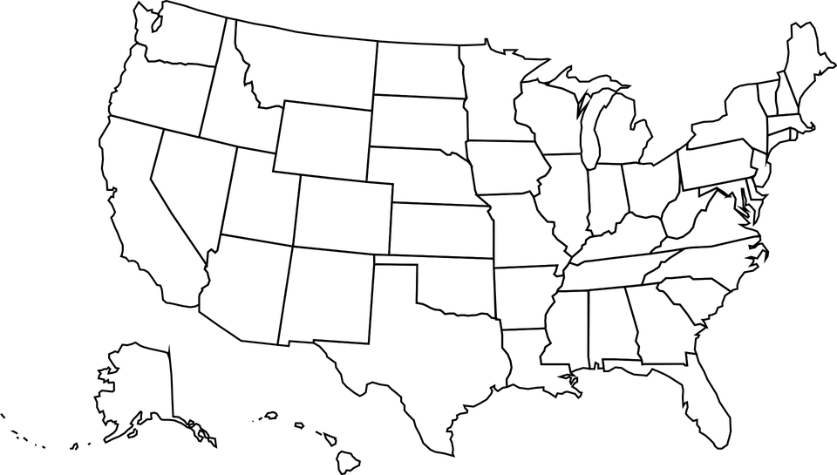

“Power Up” Your Future as a John Deere Agriculture/Turf Technician, continued
Aligned to the following standards:
CS.02; CS.05; FFA.PL-A; FFA.PL-E; FFA.PG-J; FFA.CS-M; FFA.CS-N; FFA.PL-C; FFA.PL-F; AG2; AG3; AGC09.02; CCSS.RI.9-10.2; CCSS.SL.9-10.1; CCSS.SL.9-10.2; CCSS.SL.9-10.4; CCSS.WHST.9.10.4; CCSS.WHST.9.10.6; CRP.04; CRP.05; CRP.07

“Power Up” Program Components

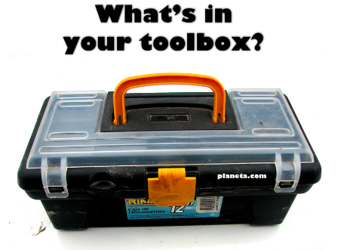
Gradebook

Identify 3 specific courses you would be engaged in through this program.
- ______________________________

- ______________________________

- ______________________________
If the program is completed successfully, what type of degree do you receive?

_____________
How long is the program?
____________

What master tools do you need for this program?

- _________________
- _________________
- _________________
- _________________
- _________________

End Result?

John Deere Career!

- Using AgExplorer.ffa.org, identify 3 careers in the Power, Structural and Technical Systems career focus area that would utilize the same skill sets learned within the “Power Up” program offered by John Deere.

- _______________________
- _________________________________
- _________________________________

Advertising to “Power Up” Your Future
Aligned to the following standards:
CS.02; CS.05; FFA.PL-A; FFA.PL-E; FFA.PG-J; FFA.CS-M; FFA.CS-N; FFA.PL-C; FFA.PL-F; AG2; AG3; AGC09.02; CCSS.RI.9-10.2; CCSS.SL.9-10.1; CCSS.SL.9-10.2; CCSS.SL.9-10.4; CCSS.WHST.9.10.4; CCSS.WHST.9.10.6; CRP.04; CRP.05; CRP.07

DIRECTIONS:
On a separate sheet of paper, create an eye-catching advertisement that would attract other students to explore the Agriculture/Turf Technician program offered through John Deere. Include the following:

- What is the purpose of the program and career?
- Schools that offer the program
- Master tools utilized within the program
- Courses required for the program
- The degree that is earned upon successful completion of the program
- Why is this an interesting program/why should someone enter the program?
- Color
- Pictures

**Remember that advertisements are meant to attract other students and get them excited about a product, program or opportunity!

Criteria | Excellent  (10–7 points) | Good  (6–4 points) | Needs Improvement  (3–0 points) | Point Total
Content | All information was included (numbers 1 to 6 above) in a short and concise format. | Only half of the content was included and/or the information was not concise. It was not plagiarized. | Less than half of the content was included and/or the information was not concise. Some content was plagiarized.
Color | Student adds color to the entire advertisement where necessary. | Some color was utilized. | No color
Pictures | Student thoroughly incorporates 3 or more pictures and visuals to convey the message in an appealing manner. | 3 images/visuals utilized. | Less than 3 images were included.
Overall Impact of the Advertisement | Grabs attention and meets the needs of an advertisement | Somewhat impactful | Very little impact/effort provided

Final Score: _______/40

KEY: “Power Up” Your Future as a John Deere Agriculture/Turf Technician
Aligned to the following standards:
CS.02; CS.05; FFA.PL-A; FFA.PL-E; FFA.PG-J; FFA.CS-M; FFA.CS-N; FFA.PL-C; FFA.PL-F; AG2; AG3; AGC09.02; CCSS.RI.9-10.2; CCSS.SL.9-10.1; CCSS.SL.9-10.2; CCSS.SL.9-10.4; CCSS.WHST.9.10.4; CCSS.WHST.9.10.6; CRP.04; CRP.05; CRP.07

Directions:
Watch the video “Power Up Your Career as a John Deere Technician.” The direct URL is https://www.deere.com/en/our-company/john-deere-careers/dealer-technician-training/jd-tech/.

What is the purpose of this program?

Students are placed into a hands-on program to learn to work on diesel engines, hydraulics, machine systems, power trains and computer diagnostics. Students will also gain the soft skills needed to work within a John Deere dealership atmosphere.

DIRECTIONS:
Mapping out the opportunity: Utilize the “Power Up Your Career” as a John Deere Technician website (https://www.deere.com/en/our-company/john-deere-careers/dealer-technician-training/ag-turf-technicians/) for the next set of activities.

- Using the map below, color your state in blue.
- Using the Ag Turf/Technician page on Deere.com, select 3 schools of interest that offer the John Deere Tech program.
  - Place a on the map where each program is located.

  - Label each with the school’s name.

Answers will vary.

KEY: “Power Up” Your Future as a John Deere Agriculture/Turf Technician, continued
Aligned to the following standards:
CS.02; CS.05; FFA.PL-A; FFA.PL-E; FFA.PG-J; FFA.CS-M; FFA.CS-N; FFA.PL-C; FFA.PL-F; AG2; AG3; AGC09.02; CCSS.RI.9-10.2; CCSS.SL.9-10.1; CCSS.SL.9-10.2; CCSS.SL.9-10.4; CCSS.WHST.9.10.4; CCSS.WHST.9.10.6; CRP.04; CRP.05; CRP.07

“Power Up” Program Components

Gradebook

Identify 3 specific courses you would be engaged in through this program. Answers will vary.
- ______________________________

- ______________________________

- ______________________________
How long is the program?
2 years
If the program is completed successfully, what type of degree do you receive?

Associates

What master tools do you need for this program? Answers will vary.

- _________________
- _________________
- _________________
- _________________
- _________________

End Result??

John Deere Career!

- Using Agexplorer.ffa.org, identify 3 careers in the Power, Structural and Technical career focus area that would utilize the same skill sets learned within the “Power Up” program offered by John Deere. Answers will vary.

- _______________________
- _________________________________
- _________________________________

KEY: “Power Up” Your Future as a John Deere Agriculture/Turf Technician, continued
Aligned to the following standards:
CS.02; CS.05; FFA.PL-A; FFA.PL-E; FFA.PG-J; FFA.CS-M; FFA.CS-N; FFA.PL-C; FFA.PL-F; AG2; AG3; AGC09.02; CCSS.RI.9-10.2; CCSS.SL.9-10.1; CCSS.SL.9-10.2; CCSS.SL.9-10.4; CCSS.WHST.9.10.4; CCSS.WHST.9.10.6; CRP.04; CRP.05; CRP.07

Grading rubric for the “Leveling Up” activity listed in the lesson plan.

Criteria | Excellent  (10–7 points) | Good  (6–4 points) | Needs Improvement  (3-0 points) | Point Total
Content | All information was included in a short and concise format. | Only half of the content was included and/or the information was not concise. It was not plagiarized. | Less than half of the content was included and/or the information was not concise. Some content was plagiarized.
Presentation Skills | Student stands tall and speaks fluently and clearly (rehearsed/practiced). Makes eye contact | Student knows the material but leans heavily on reading from the presentation and makes little eye contact. | Student read the presentation and did not make eye contact.
Pictures | Student thoroughly incorporates pictures and visuals to convey the message in an appealing manner. | 3 images/visuals utilized. | Less than 3 images were included.
Questions | Able to answer all questions clearly and concisely. | Presenters stumbled when trying to answer questions. | Unable to answer questions or refused.

Total: _______/40 points

