(Chapter Name) FFA (Event)
Providing the Next Generation of Leaders Who Will Change the World
Date


(Student Name) walked into (his/her/their) first agricultural education class not knowing what to think. (He was/She was/They were) shy and didn’t grow up on a farm. Four years later, (student first name) says agriculture classes and (Chapter Name) FFA helped (him/her/them) grow into a leader in the school and community.

As part of (his/her/their) FFA experience, (student's first name) learned (hands-on skill). (He/She/They) also learned about the food insecurity needs in our community. (Student first name) and (his/her/their) classmates developed a program to supply food to the local food pantry to help those in need. In (month), (student first name) and (# of students) presented their project to the city council and encouraged local leaders to find more ways to address food insecurity in our community.

This fall, (student first name) plans to enroll at (college) as a freshman studying (major). (He credits/She credits/They credit) (his/her/their) involvement with FFA for helping (him/her/them) realize that everyone can be a part of agriculture and feeding the world. (Student first name) now has the confidence and passion to help others and make a difference.
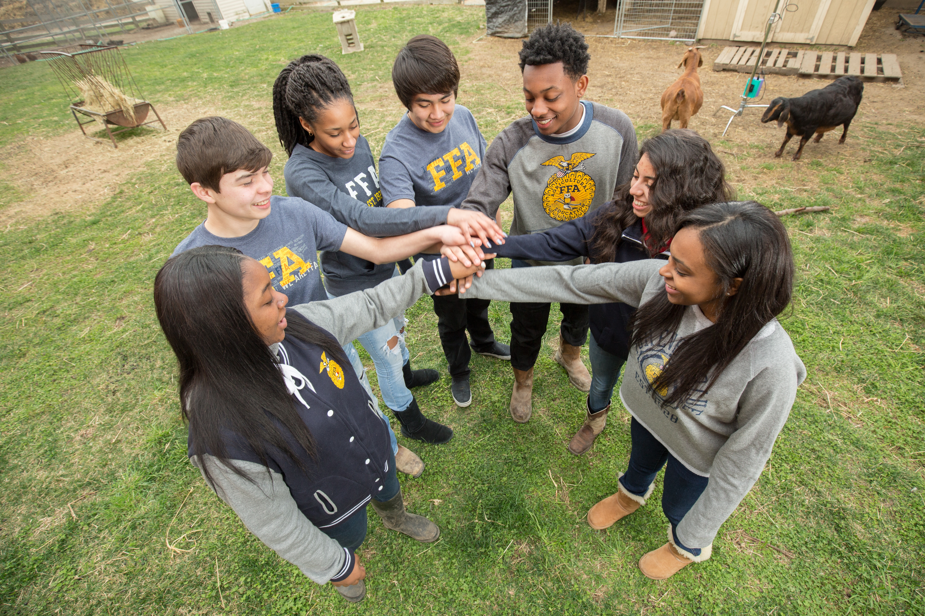
The (FFA Alumni and Supporters) is proud of (student first name) and all the local agricultural education students. We’re thrilled to play a small role in helping them become student leaders on a path to personal and career success.

Join us in supporting the next generation of leaders who will change the world! Become a sponsor of FFA.
Your sponsorship dollars will:
- Help fund FFA activities to give teachers more time to focus on the classroom.
- Promote agricultural literacy.
- Develop student leadership skills.
- Prepare students for a wide variety of career opportunities.
A range of sponsorship options means you can choose the level of support that meets your budget and impact goals. Please commit today to the sponsorship level that is right for you and see the attached form for more sponsorship details.

Forever Blue,

Name of Alumni Member
Alumni and Supporters Chapter Name

