Quail Management SAE — Trace Ward
Created: 03/2024 by the National FFA Organization
Description of Lesson: Learn about Trace Ward’s SAE in hatching and raising quail. Then, learn more about one of the five most common types of quail in the United States.
Student Learning Objectives:
After completing these activities, students will …
- Explore a unique quail management SAE.
- Investigate facts about a specific type of quail.

Suggested Grade Level:
Grades 9 and 10 (This lesson is written so instructors can scale up or down based on class needs.)

Suggested Time: 60 minutes (*Time requirements may vary based upon student understanding and class schedule.)

Resources/References:
- Video: “Quail Management SAE – Trace Ward,” https://vimeo.com/857657901

Equipment and Supplies Needed:
- A copy of the “All About Quail” worksheet for each student
- Internet access to play the video in real-time or embed it in a PowerPoint ahead of time

Vocabulary:
- Incubation
- Management
- Quail

Cross-Curricular Connections:
Science
Research one type of quail and create an informational graphic showcasing facts such as habitat, food, life expectancy, etc.

Virtual Instruction Ideas:
This entire lesson can be taught virtually. All student handouts can be sent or posted electronically.

Student Activity Sheets:
Direct access to student activity sheets without lesson plan or answer key for easy upload to a learning management system or printing for classwork.

https://ffa.box.com/s/rystuhhtkx0cytcc67cdrlsawyp7639k (Word)
https://ffa.box.com/s/vct00xyyexxh0e9s4oadwl380nn2l9ws (Non Designed Word)
https://ffa.box.com/s/mbpe45bjlx1lgmbcslf4wt0jz7pybakt (PDF)
https://docs.google.com/document/d/1aAiN7vjdKQhsmwWVSyNERnP_GOCByjhfvYPQTwxw6eU/copy (Google)

These Activities Are Aligned to the Following Standards:
AFNR Performance Element
- CS.04. Demonstrate stewardship of natural resources in AFNR activities.
- CS.05. Describe career opportunities and means to achieve those opportunities in each of the Agriculture, Food & Natural Resources career pathways.
- CS.06. Analyze the interaction among AFNR systems in the production, processing and management of food, fiber and fuel and the sustainable use of natural resources.
FFA Precept
- FFA.PL-A.Action: Assume responsibility and take the necessary steps to achieve the desired results, no matter what the goal or task at hand.
- FFA.PL-C.Vision: Visualize the future and how to get there.
- FFA.PG-I.Professional Growth: Assume responsibility for attaining and improving upon the skills needed for career success.
Common Core – Writing
- CCSS.ELA-LITERACY.W.9-10.6 Use technology, including the Internet, to produce, publish, and update individual or shared writing products, taking advantage of technology’s capacity to link to other information and to display information flexibility and dynamically.
- CCSS.ELA-LITERACY.W.9-10.8 Gather relevant information from multiple authoritative print and digital sources, using advanced searches effectively; assess the usefulness of each source in answering the research question; integrate information into the text selectively to maintain the flow of ideas, avoiding plagiarism and following a standard format for citation.
Common Core – Speaking and Listening
- CCSS.ELA-LITERACY.SL.9-10.2 Integrate multiple sources of information presented in diverse media or formats (e.g., visually, quantitatively, orally) evaluating the credibility and accuracy of each source.
- CCSS.ELA-LITERACY.SL.9-10.5 Make strategic use of digital media (e.g., textual, graphical, audio, visual, and interactive elements) in presentations to enhance understanding of findings, reasoning, and evidence and to add interest.
AFNR Career Ready Practices
- CRP.02. Apply appropriate academic and technical skills. Career-ready individuals readily access and use the knowledge and skills acquired through experience and education to be more productive.
- CRP.04. Communicate clearly, effectively, and with reason. Career-ready individuals communicate thoughts, ideas and action plans with clarity, whether using written, verbal and/or visual methods.
- CRP.06. Demonstrate creativity and innovation. Career-ready individuals regularly think of ideas that solve problems in new and different ways, and they contribute those ideas in a useful and productive manner to improve their organization.
- CRP.07. Employ valid and reliable research strategies. Career-ready individuals are discerning in accepting and using new information to make decisions, change practices or inform strategies.
- CRP.11. Use technology to enhance productivity. Career-ready individuals find and maximize the productive value of existing and new technology to accomplish workplace tasks and solve workplace problems.
Partnership for 21st Century Skills
- Critical Thinking and Problem Solving
- Information Literacy
- Initiative and Self-direction
- Media Literacy
- Productivity and Accountability
- Think Creatively

Lesson Plan:
- Bell Ringer: What do you already know about quail? What would you like to know about quail?

- Introduction: Quail are often only thought of as wild animals. Many do not realize that quail can be farmed for different reasons, including egg production, meat production and to replenish hunting preserves. Learn more from FFA member Trace Ward about his SAE in quail management. After the video, you will choose one of the five most commonly raised quail on farms to learn more about.

- Activity: Each student needs a copy of the worksheet “All About Quail.”
  - Part 1: Show the SAE video about quail management in class. Students will complete Part 1 as they watch the video to learn more about this SAE.
Video: “Quail Management SAE – Trace Ward,” https://vimeo.com/857657901
  - Part 2: Students will choose one of the five most common types of quail raised on farms. They will use their preferred research method (Google, etc.) to research the information listed in Part 2. Students will create an informational poster (hand-drawn or digital — it is the teacher’s preference) about the type of quail they selected.

- Follow-up: Post informational posters in the classroom or in the hallway for students to learn about all the different types of quail. Give students a sticky note. Have them visit each poster and pick one new fact about quail and write it on the sticky note to turn in.

- Optional – Extended Learning Opportunities (Not factored into time requirement):
  - Request a visit from your state’s wildlife resources commission to teach your students about quail or other wildlife animals in your state.
  - Let students research other animals that can be raised on a farm and used to help repopulate hunting preservations.

- Exit Ticket: What is one new fact you learned about quail from this lesson?

All About Quail
Aligned to the following standards:
CS.04; CS.05; CS.06; FFA.PL.A; FFA.PL.C; FFA.PG.I; CCSS.W.9-10.6; CCSS.W.9-10.8; CCSS.SL.9-10.2; CCSS.SL.9-10.5; CRP.02; CRP.04; CRP.06; CRP.07; CRP.11
Part 1
Directions:
Watch the SAE video “Quail Management SAE | Trace Ward,” https://vimeo.com/857657901, and answer the questions below.

- Which state is Trace Ward from?
  - South Carolina
  - Mississippi
  - Georgia
  - Alabama

- Describe what Coturnix quail look like.

- Create a to-do list for Trace based on the daily tasks he says are involved with caring for his quail.
Quail SAE Daily Task To-Do List:

- Circle the safety items he wears when cleaning the tray.
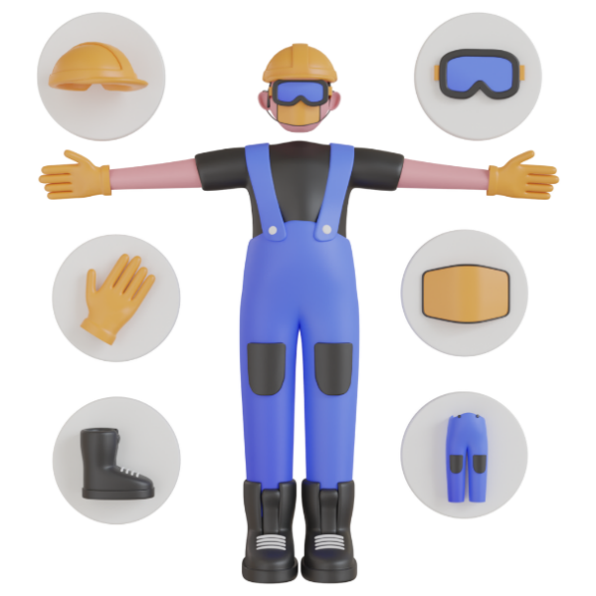

- Define the word “incubation.”

- How many days does it take for quail eggs to hatch?
  - 21 days
  - 12-14 days
  - 23-26 days
  - 17-19 days

- What does Trace say his favorite part of his SAE is?

- What advice does Trace give for students looking to start an SAE?

- After hearing Trace’s SAE story, how do you think raising quail connects with agriculture?

Part 2
Directions:
Five of the most common types of quail are Coturnix, bobwhite, California, button and blue scale. You will be assigned one of these types. You will be creating an informational poster about the type you are assigned. This poster can be hand drawn on a blank sheet of paper or digitally created on a platform such as Google Slides or Canva.

Please include the following information on your quail:
- Name of the type of quail
- Where this type can be found in the U.S.
- Description of its preferred habitat
- Average size it grows to
- List of food that it eats
- Description of its behavior
- Life expectancy
- A picture of what the type looks like (drawn in full color or photo found in full color)
- Two interesting facts you learned about the type of quail

The following rubric will be used to grade your poster:

Name of the type of quail selected | /5
Home: location within the U.S. where this type is found and a description of its preferred habitat | /10
Information: average size this type grows to, list of food this type eats, description of the behavior and life expectancy | /15
Two interesting facts learned about this type | /10
A picture of the type, showing all characteristics (drawn or digital) | /10
Neatness and appealing to look at | /5
Source list attached | /5
TOTAL | /60

KEY: All About Quail
Part 1
Directions:
Watch the SAE video “Quail Management SAE | Trace Ward,” https://vimeo.com/857657901, and answer the questions below.

- Which state is Trace Ward from?
  - South Carolina
  - Mississippi
  - Georgia
  - Alabama

- Describe what Coturnix quail look like.
Small and brown with white specks

- Create a to-do list for Trace based on the daily tasks he says are involved with caring for his quail.
Quail SAE Daily Task To-Do List:
- Clean the litter tray.
- Water
- Feed
- Put sand in the coop.

- Circle the safety items he wears when cleaning the tray.
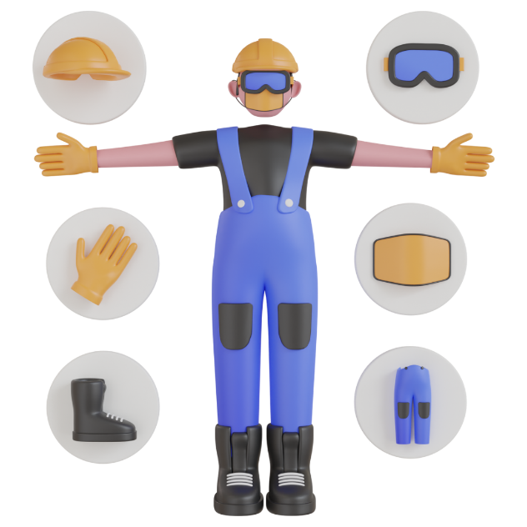

- Define the word “incubation.”
When you take eggs from the birds that lay them and put them in a warm box that keeps them warm until they hatch

- How many days does it take for quail eggs to hatch?
  - 21 days
  - 12-14 days
  - 23-26 days
  - 17-19 days

- What does Trace say his favorite part of his SAE is?
Watching the quail hatch and the process it takes to get there

- What advice does Trace give for students looking to start an SAE?
Do what you want to do.

- After hearing Trace’s SAE story, how do you think raising quail connects with agriculture?
Answers will vary.

