Recycling
Created: 03/2019 by the National FFA Organization

Raymond’s supervised agricultural experience (SAE) program is collecting all the recyclables at his school and making sure they are recycled properly. Follow along as he shares how he became interested in recycling and why he thinks it is so important.

Student Learning Objectives:
After completing these activities, students will …
- List recycling best practices.
- Explain what agricultural plastics are and how they are used.
- Identify barriers to recycling agricultural plastics and possible solutions.

Time Required: 90 minutes
Resources/References:
- Video: “Recycling SAE | Raymond Pan,” https://vimeo.com/328425306
- Website: “Tips to Recycle Right,” https://www.recycleacrossamerica.org/tips-to-recycle-right
- Article: “Agricultural Plastics — Boon or Bane?” http://cwmi.css.cornell.edu/WastRed/AgWaste.html
- PDF: “Agricultural Plastics: What Are They? Why Are They 'Hard Stuff'? Can the Challenges be Surmounted?” https://ecommons.cornell.edu/bitstream/handle/1813/36402/Levitan-PlasticRecycling2014Mar11.pdf?sequence=2&isAllowed=y
- Article: “Farmers Test New Equipment to Collect, Recycle Field Plastic,” https://deq.nc.gov/blog/2019-10-17/johnston-county-farmers-test-new-equipment-collect-recycle-field-plastic

Equipment and Supplies Needed:
- A copy of the “Stepping Up” worksheet for each student
- A copy of the “The Agricultural Plastic Problem” worksheet for each student
- Internet access to play the video in real time or embed it in a PowerPoint ahead of time
- Technology access for students to read articles and conduct research

Student activity sheets:
Direct access to student activity sheets without lesson plan or answer key for easy upload to learning management systems or printing for classwork.
https://ffa.box.com/s/dxtc4u060egjg0mzkvnawkmgb0xeea5w (Word)
https://ffa.box.com/s/wqumemlj8vnm4k7y36gti3oh62b76cab (PDF)

Cross-Curricular Connections:
English/Language Arts
Reading multiple articles, evaluating content and compiling information

These activities are aligned to the following standards:
AFNR Performance Element
- ESS.02. Evaluate the impact of public policies and regulations on environmental service system operations.
FFA Precept
- FFA.PL-A.Action: Assume responsibility and take the necessary steps to achieve the desired results, no matter what the goal or task at hand.
- FFA.PL-C.Vision: Visualize the future and how to get there.
- FFA.PG-J.Mental Growth: Embrace cognitive and intellectual development relative to reasoning, thinking, and coping.
- FFA.CS-N.Decision Making: Analyze a situation and execute an appropriate course of action.
Common Career Technical Core
- AG-ENV2 Evaluate the impact of public policies and regulations on environmental service system operations.
NASDCTEc
- AGPF01.02 Examine and interpret public policies and regulations impacting environmental services to determine their effect on facility operations.
AFNR Cluster Skills
- CS.01. Analyze how issues, trends, technologies and public policies impact systems in the Agriculture, Food & Natural Resources Career Cluster.
Common Core – Reading: Informational Text
- CCSS.ELA-Literacy.RI.9-10.3 Analyze how the author unfolds an analysis or series of ideas or events, including the order in which the points are made, how they are introduced and developed, and the connections that are drawn between them.
- CCSS.ELA-Literacy.RI.9-10.6 Determine an author's point of view or purpose in a text and analyze how an author uses rhetoric to advance that point of view or purpose.
Common Core – Speaking and Listening
- CCSS.ELA-Literacy.SL.9-10.1.D Respond thoughtfully to diverse perspectives, summarize points of agreement and disagreement, and, when warranted, qualify or justify their own views and understanding and make new connections in light of the evidence and reasoning presented.
Common Core – Science & Technical Subjects
- CCSS.ELA-Literacy.RST.9-10.1 Cite specific textual evidence to support analysis of science and technical texts, attending to the precise details of explanations or descriptions.
- CCSS.ELA-Literacy.RST.9-10.2 Determine the central ideas or conclusions of a text; trace the text's explanation or depiction of a complex process, phenomenon, or concept; provide an accurate summary of the text.
- CCSS.ELA-Literacy.RST.9-10.4 Determine the meaning of symbols, key terms, and other domain-specific words and phrases as they are used in a specific scientific or technical context relevant to grades 9-10 texts and topics.
Green/Sustainability Knowledge and Skill Statements
- AFNR Career Cluster, Statement 2 Analyze community practice or policy development related to sustainability in AFNR.
AFNR Career Ready Practices
- CRP.02. Apply appropriate academic and technical skills. Career-ready individuals readily access and use the knowledge and skills acquired through experience and education to be more productive.
- CRP.04. Communicate clearly, effectively, and with reason. Career-ready individuals communicate thoughts, ideas and action plans with clarity, whether using written, verbal and/or visual methods.
- CRP.05. Consider the environmental, social and economic impact of decisions. Career-ready individuals understand the interrelated nature of their actions and regularly make decisions that positively impact and/or mitigate negative impact on other people, organizations and the environment.
- CRP.07. Employ valid and reliable research strategies. Career-ready individuals are discerning in accepting and using new information to make decisions, change practices or inform strategies.
- CRP.08. Utilize critical thinking to make sense of problems and persevere in solving them. Career-ready individuals readily recognize problems in the workplace, understand the nature of the problem, and devise effective plans to solve the problem.
- CRP.11 Use technology to enhance productivity. Career-ready individuals find and maximize the productive value of existing and new technology to accomplish workplace tasks and solve workplace problems.
Partnership for 21st Century Skills
- Civic Literacy
- Environmental Literacy
- Information Literacy

Lesson Plan:
- Bell Ringer: Have students respond to this prompt: Do you recycle? Why or why not?

- Introduction: With seven billion people on the planet, we produce a lot of trash and that trash is piling up in landfills. Today, we’ll learn how one student recognized that this was a problem and took steps to make a difference.

- Activity:
  - Each student needs a copy of the worksheet “Stepping Up.” Have students watch the video “Recycling SAE | Raymond Pan,” available at https://vimeo.com/328425306, and then answer the following questions. There is one question that does require students to go to the website “Tips to Recycle Right” (https://www.recycleacrossamerica.org/tips-to-recycle-right), so completing the worksheet as they watch the video won’t be possible. When students are done with the worksheet, ask them “Have you ever wondered about recycling on the farm?” Have a brief class discussion about products used by production agriculturists that are and are not recyclable or reusable. The goal of this discussion is to help students realize that there are many products used in agriculture that are not easily recycled, such as plastics. This discussion could also help student identify ways to safely reuse items by sharing ideas.
    - Many plastic products used in agriculture are not recyclable, though many agriculture producers do find ways to reuse plastic film, plant pots, plant carriers, etc. Refer to the websites listed in the Resources section for more examples.
  - Handout the worksheet “The Agricultural Plastic Problem.” You can have students complete this individually or students could do this in pairs or small groups. The worksheet provides three suggested resources that will helps students learn about agricultural plastics — what they are, their uses, the problems with them and possible solutions to the increasing amount of agricultural plastics. The worksheet has guided questions that will help them highlight the important information.

- Follow-up: Have a class discussion about the agricultural plastics problem. Have students share what they learned, including anything that surprised them or that they hadn’t ever considered before.

- Optional — Extended Learning Opportunities (Not factored into time requirement):
  - Have students do additional research, beyond the sources provided in the worksheets, about potential solutions for reusing and recycling agricultural plastics. Then, either have students write a short speech to give to the class or have a structured class debate.

- Exit Ticket: Have you ever considered what happens to plastic wrapping and tubing after it’s used on the farm? After learning about some of the issues, what do you think should be done?

Stepping Up
Aligned to the following standards:
ESS.02; FFA.PL-A; FFA.PL-C; FFA.PG-J; FFA.CS-N; AG-ENV2; AGPF01.02; CS.01; CCSS.RI.9-10.3; CCSS.RI.9-10.6; CCSS.SL.9-10.1.D; CCSS.RST.9-10.1; CCSS.RST.9-10.2; CCSS.RST.9-10.4; CCSS.MP3; CCSS.MP6; CRP.02; CRP.04; CRP.05; CRP.07; CRP.08; CRP.11
Directions:
Watch the video “Recycling SAE | Raymond Pan,” available at https://vimeo.com/328425306, and then answer the following questions.

What is Raymond’s SAE?

What are Raymond’s responsibilities?



What motivated him to start this SAE?

What does Raymond enjoy the most about his SAE?
Why did he join the FFA?

List 10 tips for recycling best practices. Suggested resource: https://www.recycleacrossamerica.org/tips-to-recycle-right


The Agricultural Plastic Problem
Aligned to the following standards:
ESS.02; FFA.PL-A; FFA.PL-C; FFA.PG-J; FFA.CS-N; AG-ENV2; AGPF01.02; CS.01; CCSS.RI.9-10.3; CCSS.RI.9-10.6; CCSS.SL.9-10.1.D; CCSS.RST.9-10.1; CCSS.RST.9-10.2; CCSS.RST.9-10.4; CCSS.MP3; CCSS.MP6; CRP.02; CRP.04; CRP.05; CRP.07; CRP.08; CRP.11
Directions:
We often hear about recycling in our homes and schools, but what about recycling on the farm? Use the suggested resources and answer the questions below to find out about the agricultural plastic problem and the efforts being made to reduce and recycle.
Suggested Resources:
- “Agricultural Plastics — Boon or Bane?” http://cwmi.css.cornell.edu/WastRed/AgWaste.html
- “Agricultural Plastics: What Are They? Why Are They 'Hard Stuff'? Can the Challenges be Surmounted?” https://ecommons.cornell.edu/bitstream/handle/1813/36402/Levitan-PlasticRecycling2014Mar11.pdf?sequence=2&isAllowed=y
- “Farmers Test New Equipment to Collect, Recycle Field Plastic,” https://deq.nc.gov/blog/2019-10-17/johnston-county-farmers-test-new-equipment-collect-recycle-field-plastic

- What are agricultural plastics?

- List six examples of agricultural plastics.



- Why are agricultural plastics so popular in production agriculture?

- Why are agricultural plastics so difficult to recycle? (Give five reasons.)

- List three possible solutions for using old agricultural plastic.
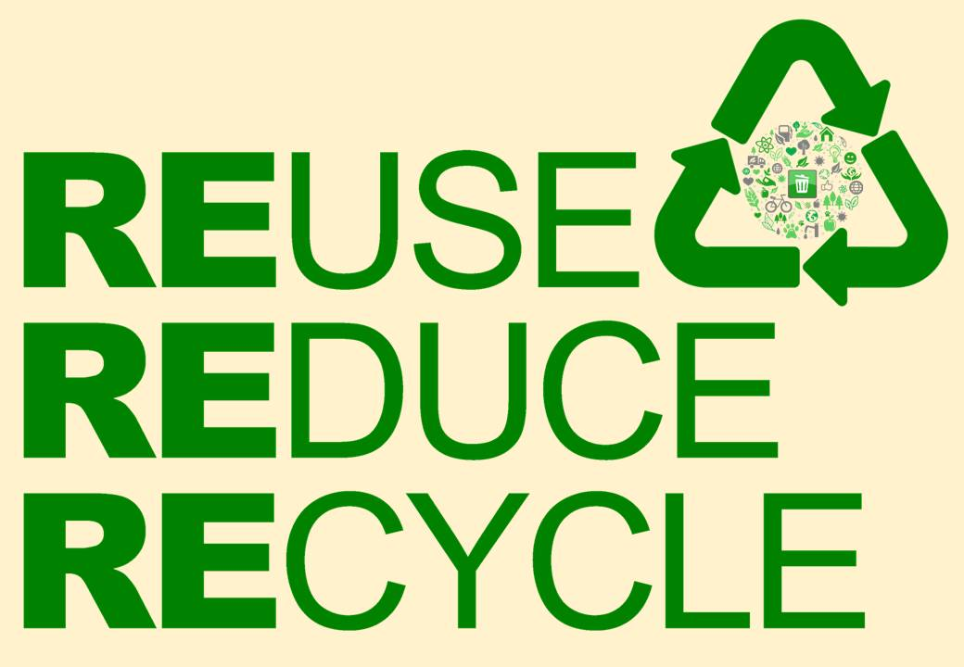


KEY: Stepping Up
Aligned to the following standards:
ESS.02; FFA.PL-A; FFA.PL-C; FFA.PG-J; FFA.CS-N; AG-ENV2; AGPF01.02; CS.01; CCSS.RI.9-10.3; CCSS.RI.9-10.6; CCSS.SL.9-10.1.D; CCSS.RST.9-10.1; CCSS.RST.9-10.2; CCSS.RST.9-10.4; CCSS.MP3; CCSS.MP6; CRP.02; CRP.04; CRP.05; CRP.07; CRP.08; CRP.11
Directions:
Watch the video “Recycling SAE | Raymond Pan,” available at https://vimeo.com/328425306, and then answer the following questions.

What is Raymond’s SAE?
Collecting recyclables around the school and making sure
they get recycled

What are Raymond’s responsibilities?
Collect recyclables from bins around the school
Transfer the materials to the correct bag
Transport the materials to the recyclables’ dumpster

What motivated him to start this SAE?

During state convention, they picked up trash on the side
of the road. He realized the world is facing a trash problem,
and it is important to decrease what goes into the landfill.

What does Raymond enjoy the most about his SAE?

Seeing the recycling dumpster fill up because he knows he has accomplished something to help
Why did he join the FFA?

He is from China, and agriculture was a big part of his life. He wanted to continue that in the US.
List 10 recycling best practices. Suggested resource: https://www.recycleacrossamerica.org/tips-to-recycle-right

Answers will vary. Some possible answers include:
Follow the directions on the bin.

NO food, NO liquids, NO straws, NO plastic cups and NO plastic dishware in the recycling bin.

Avoid single-use items as much as possible.

Do not put cheesy, oily pizza boxes in your recycling bin.

NO NEED TO WASH, however, please empty and scrape out the food or material

Plastic bottles and jugs with 1 or 2 on the bottom are recyclable. Check on all other plastics.

Recycle all clean paper and all clean and flattened cardboard boxes.

Do not throw compostable plastics in recycling bins.

Take all electronics to a SERI-certified electronics recycling facility.

Never put drinking glasses, cups or dishware in the recycling bin.

KEY: The Agricultural Plastic Problem
Aligned to the following standards:
ESS.02; FFA.PL-A; FFA.PL-C; FFA.PG-J; FFA.CS-N; AG-ENV2; AGPF01.02; CS.01; CCSS.RI.9-10.3; CCSS.RI.9-10.6; CCSS.SL.9-10.1.D; CCSS.RST.9-10.1; CCSS.RST.9-10.2; CCSS.RST.9-10.4; CCSS.MP3; CCSS.MP6; CRP.02; CRP.04; CRP.05; CRP.07; CRP.08; CRP.11
Directions:
We often hear about recycling in our homes and schools, but what about recycling on the farm? Use the suggested resources and answer the questions below to find out about the agricultural plastic problem and the efforts being made to reduce and recycle.
Suggested Resources:
- “Agricultural Plastics — Boon or Bane?” http://cwmi.css.cornell.edu/WastRed/AgWaste.html
- “Agricultural Plastics: What Are They? Why Are They 'Hard Stuff'? Can the Challenges be Surmounted?” https://ecommons.cornell.edu/bitstream/handle/1813/36402/Levitan-PlasticRecycling2014Mar11.pdf?sequence=2&isAllowed=y
- “Farmers Test New Equipment to Collect, Recycle Field Plastic,” https://deq.nc.gov/blog/2019-10-17/johnston-county-farmers-test-new-equipment-collect-recycle-field-plastic

- What are agricultural plastics?
Agricultural plastics include the many different film and rigid products now used in all sectors of agriculture, such as low density polyethylene (LDPE) agricultural plastic film.

- List six examples of agricultural plastics.

Answers will vary, but should include the following:
Mulch film

Bale wrap

Drip tape and irrigation pipe

Silo covers

Fumigation film

Maple sap tubing

Greenhouse covers

- Why are agricultural plastics so popular in production agriculture?
The upside of using this lightweight plastic agricultural film is that it can be more convenient and economical for farmers with short-term storage requirements. Plastic bale wrapping is also ideal for farmers who harvest more than they can store in existing structures but do not want to invest more capital in additional buildings. Using plastic film (a process called plasticulture), allows farmers to grow high-yield fruit and vegetable crops with less water use and herbicides.

- Why are agricultural plastics so difficult to recycle? (Give five reasons.)
Answers will vary but should include some of the following:
Dirty
Because the materials are dispersed across rural areas, collection and transportation is difficult and expensive.
Bulky
Dark colors
Possible or perceived pesticide residue
Unidentified mix of resins and additives
Soil pathogens

- List three possible solutions for using old agricultural plastic.
Answers will vary, but should include some of the following:
Plastics-to-oil, converting waste plastics to clean fuel;
cleaning and baling; cleaning and reusing; grinding

