Advertising Signs
Created: 03/2024 by the National FFA Organization
Description of Lesson: This advertising signs SAE introduces students to the basics of marketing through signage.
Student Learning Objectives:
After completing these activities, students will …
- Define advertising.
- Create an original poster, billboard or digital advertisement that will effectively communicate a message.

Suggested Grade Level:
Grades 9 and 10 (This lesson is written so instructors can scale up or down based on class needs.)

Suggested Time: 60 minutes (*Time requirements may vary based upon student understanding and class schedule.)

Resources/References:
- Website: Advertising Signs SAE | Rylah Hager, https://vimeo.com/901202137

Equipment and Supplies Needed:
- A copy of the “Advertisings Signs” worksheet for each student
- Internet access to play the video in real-time or embed it in a PowerPoint ahead of time
- Markers
- Colored pencils
- Crayons

Vocabulary:
- Advertising
- Agricultural Communications
- Call to Action
- Marketing

Cross-Curricular Connections:
English/Language Arts | Technology
- Create an advertisement that uses clear and concise communication. | - Create a digital advertisement.

Virtual Instruction Ideas:
Have students download and watch the video on a device of their choice and complete the worksheet.

Student Activity Sheets:
Direct access to student activity sheets without lesson plan or answer key for easy upload to a learning management system or printing for classwork.

Word: https://ffa.box.com/s/19ov0wk4ypb9zs6gqagojtdoow6w0vsr
Non- Designed: https://ffa.box.com/s/19ov0wk4ypb9zs6gqagojtdoow6w0vsr
PDF: https://ffa.box.com/s/3p1amaphdt3sloywp89qolrsx0di97zq
Google Docs: https://docs.google.com/document/d/1qAwqvPcLRYXLzycq4zT34drUvATc5xJXb10d82oauIw/copy

These Activities Are Aligned to the Following Standards:
FFA Precept
- FFA.PL-A.Action: Assume responsibility and take the necessary steps to achieve the desired results, no matter what the goal or task at hand.
- FFA.PL-F.Continuous Improvement: Accept responsibility for learning and personal growth.
- FFA.PG-I.Professional Growth: Assume responsibility for attaining and improving upon the skills needed for career success.
- FFA.CS-M.Communication: Effectively interact with others in personal and professional settings.
Common Core – Speaking and Listening
- CCSS.ELA-LITERACY.SL.9-10.1 Initiate and participate effectively in a range of collaborative discussions (one-on-one, in groups, and teacher-led) with diverse partners on grades 9-10 topics, texts, and issues, building on others’ ideas and expressing their own clearly and persuasively.
- CCSS.ELA-LITERACY.SL.9-10.2 Integrate multiple sources of information presented in diverse media or formats (e.g., visually, quantitatively, orally) evaluating the credibility and accuracy of each source.
- CCSS.ELA-LITERACY.SL.9-10.5 Make strategic use of digital media (e.g., textual, graphical, audio, visual, and interactive elements) in presentations to enhance understanding of findings, reasoning, and evidence and to add interest.
Common Core – Language
- CCSS.ELA-LITERACY.L.9-10.6 Acquire and use accurately general academic and domain-specific words and phrases, sufficient for reading, writing, speaking, and listening at the college and career readiness level; demonstrate independence in gathering vocabulary knowledge when considering a word or phrase important to comprehension or expression.
AFNR Career Ready Practices
- CRP.02. Apply appropriate academic and technical skills. Career-ready individuals readily access and use the knowledge and skills acquired through experience and education to be more productive.
- CRP.04. Communicate clearly, effectively, and with reason. Career-ready individuals communicate thoughts, ideas and action plans with clarity, whether using written, verbal and/or visual methods.
- CRP.06. Demonstrate creativity and innovation. Career-ready individuals regularly think of ideas that solve problems in new and different ways, and they contribute those ideas in a useful and productive manner to improve their organization.
- CRP.11. Use technology to enhance productivity. Career-ready individuals find and maximize the productive value of existing and new technology to accomplish workplace tasks and solve workplace problems.
Partnership for 21st Century Skills
- Communication
- Global Awareness
- Information Literacy
- Information, Communications, and Technology Literacy
- Initiative and Self-direction
- Leadership and Responsibility
- Media Literacy
- Productivity and Accountability
- Think Creatively

Lesson Plan:
- Bell Ringer: List as many places where you can find advertisements.
  - Examples: television, radio, magazines, newspapers, billboards, buses, product placements in TV/movies, internet ads, social media, etc.
- Introduction: Today, we will dive into the world of agricultural communication through the lens of advertisements. Advertisements can be found through television, radio, magazines, newspapers, billboards, buses, product placements in TV or movies, internet ads, social media, etc. We’ll be watching an example of sign advertisements to understand the strategy and purpose behind them, particularly within the realm of agriculture.

- Activity: Each student needs a copy of the worksheet “Advertising Signs.”
  - Part 1: Students will watch the video “Advertising Signs SAE | Rylah Hager,” https://vimeo.com/901202137, and complete the questions.
  - Part 2: Students will answer questions related to creating an advertising sign and then choose a scenario to create an original advertisement.

- Optional – Extended Learning Opportunities (Not factored into time requirement):
  - Have students display and present their advertisements to their peers. Students can share feedback and thoughts. Some guiding questions you could include: Where was your eye drawn to first, next and last? What elements stood out? What was the overall message?

- Exit Ticket: What do you think is the most effective form of advertising today and why?

Advertising Signs
Aligned to the following standards:
FFA.PL-A; FFA.PL-F; FFA.PG-I; FFA.CS-M; CCSS.ELA-LITERACY.SL.9-10.1; CCSS.ELA-LITERACY.SL.9-10.2; CCSS.ELA-LITERACY.SL.9-10.5; CCSS.ELA-LITERACY.L.9-10.6; CRP.02.; CRP.04; CRP.06.

Part 1
Directions:
Watch the SAE video “Advertising Signs SAE | Rylah Hager,” https://vimeo.com/901202137, and answer the questions below.

- Where is Rylah from, and what chapter does she represent?

- What is Rylah’s SAE?


- What pathway does this SAE align with?

- What areas does Rylah service?

- What do businesses usually ask Rylah to display?

- After a businessperson calls, what are the next steps in her process?

- How has Creed speaking helped Rylah?

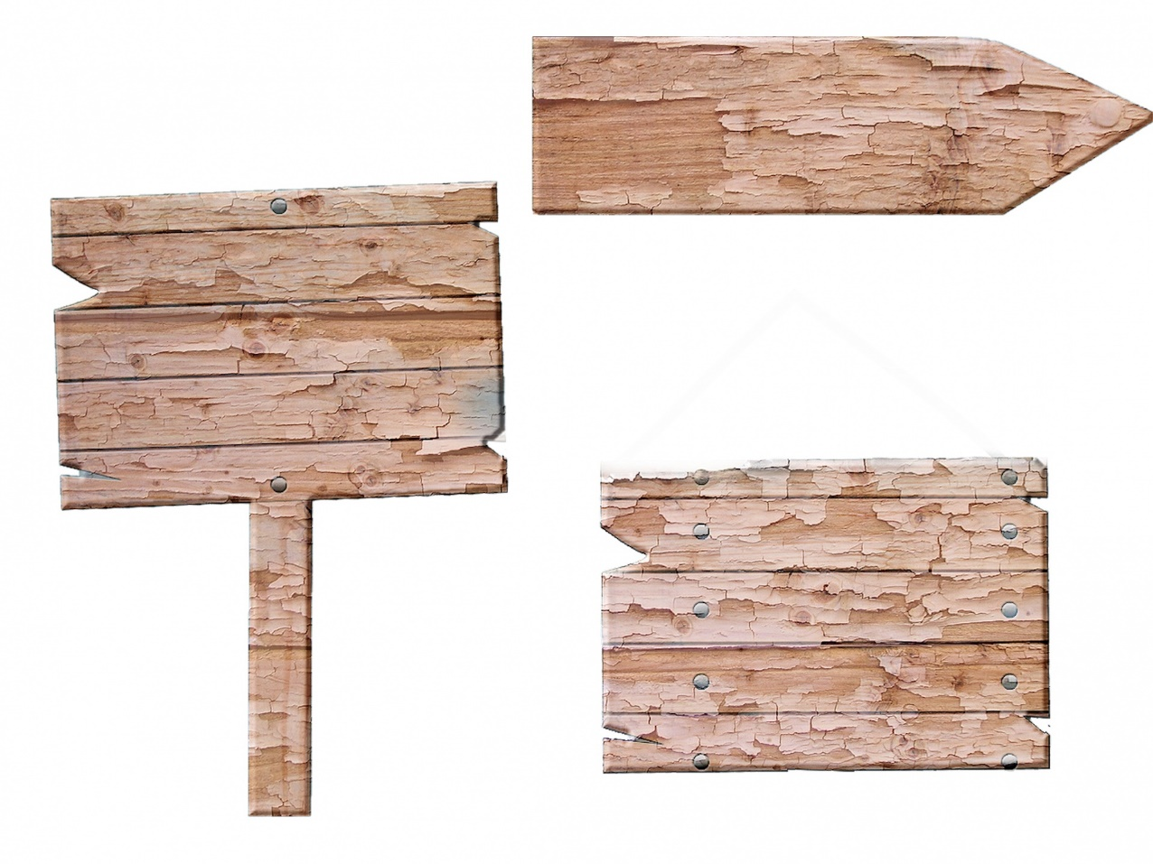
- List two things Rylah has learned from her SAE.

- Why should other students join the FFA?

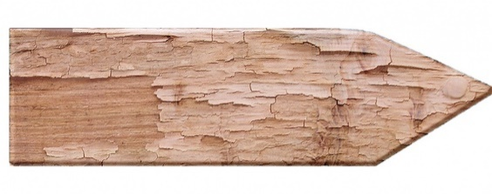

Part 2
Directions:
Answer the questions below. These questions lead up to creating an advertisement for a scenario of your choice. Use the rubric below to help guide your answers.

- In your own words, define advertising.

- Why do you think advertising signs are important?

- List at least three important elements to include in an advertisement. (Think about advertisements you’ve seen. What do you remember?)

Choose one scenario/option below by highlighting it, and create an original advertisement using a variety of art materials. This can be a poster, billboard or digital advertisement. Be sure to include details, use clear and concise communication and be creative!

- This year’s National FFA Convention & Expo
- Something you want to advocate for related to agriculture
- Promote your SAE.
- An upcoming school event

Use the space below to brainstorm, and when you are ready, use the next page for your final design. Things to consider:
What is your message/call to action?

What colors are you including?
Who is your target audience?

What is the brand or organization’s logo?
Are there specific dates?
Other ideas:

Chosen Scenario:

Advertisement Rubric

Criteria | 0 Points | 1 Point | 2 Points | Score
Message/Call to Action | No clear message or call to action | Message or call to action is somewhat clear. | Clear and compelling message with a strong call to action
Brand/Organization’s Logo | Logo is missing or not recognizable. | Logo is present but not clear or recognizable. | Logo is prominently displayed and clearly recognizable.
Image | No relevant or impactful image is included. | Image is somewhat relevant or impactful. | Relevant and impactful image that enhances the advertisement
Creativity | Advertisement lacks creativity and originality. | Advertisement demonstrates some creativity and originality. | Advertisement is highly creative and original, standing out effectively.
Overall Effectiveness | Advertisement does not effectively communicate the intended message. | Advertisement somewhat effectively communicates the intended message. | Advertisement effectively communicates the intended message and persuades the target audience.
Additional Comments |  |  |  | Total Score:  /10

KEY: Advertising Signs
Aligned to the following standards:
FFA.PL-A; FFA.PL-F; FFA.PG-I; FFA.CS-M; CCSS.ELA-LITERACY.SL.9-10.1; CCSS.ELA-LITERACY.SL.9-10.2; CCSS.ELA-LITERACY.SL.9-10.5; CCSS.ELA-LITERACY.L.9-10.6; CRP.02.; CRP.04; CRP.06.

Part 1
Directions:
Watch the SAE video “Advertising Signs SAE | Rylah Hager,” https://vimeo.com/901202137, and answer the questions below.

- Where is Rylah from, and what chapter does she represent?
Rugby North Dakota and Rugby FFA Chapter

- What is Rylah’s SAE?
Advertising signs

- What pathway does this SAE align with?
Agribusiness Systems

- What areas does Rylah service?
Rugby, Towner and Harvey area

- What do businesses usually ask Rylah to display?
A product or an event they will be hosting

- After a businessperson calls, what are the next steps in her process?
Go to her shed, get her sign out and start working on the arrangement, colors and sizes of letters she wants to display.

- How has Creed speaking helped Rylah?
It helped her learn how to be more comfortable speaking with adults and clients.

- List two things Rylah has learned from her SAE.
Answers many vary but should include two of the following:
how to talk to adults, how to negotiate with customers or learned to work on a time schedule.

- Why should other students join the FFA?
FFA is a large community, and you will be able to find your group. You’ll find something that you enjoy doing in it. There is also something for everyone.

Part 2
Directions:
Answer the questions below. These questions lead up to creating an advertisement for a scenario of your choice.

- In your own words, define advertising.
Answers will vary.

- Why do you think advertising signs are important?
Answers will vary.

- List at least three important elements to include on an advertisement. (Think about advertisements you’ve seen. What do you remember?)
Answers will vary.

Choose one scenario/option below by highlighting it, and create an original advertisement using a variety of art materials. This can be a poster, billboard or digital advertisement. Be sure to include details, use clear and concise communication and be creative!

- This year’s National FFA Convention & Expo
- Something you want to advocate for related to agriculture
- Promote your SAE.
- An upcoming school event

Use the space below to brainstorm, and when you are ready, use the next page for your final design. Things to consider:

What colors are you including?
Answers will vary.

What is your message/call to action?
Answers will vary.
Who is your target audience?
Answers will vary.

What is the brand or organization’s logo?
Answers will vary.

Are there specific dates?
Answers will vary.

Other ideas:
Answers will vary.

Chosen Scenario:
Answers will vary.

