Chicken Little: Agricultural Education
Created: 03/2024 by the National FFA Organization
Description of Lesson: Through Kristyn Bauer’s SAE, she helps others experience chicken egg incubation and hatching.
Student Learning Objectives:
After completing these activities, students will …
- Explain the functionality of an egg.
- Describe the different developmental stages of a chick.
- Write a story about the development of a chick.

Suggested Grade Level:
Grades 9 and 10 (This lesson is written so instructors can scale up or down based on class needs.)

Suggested Time: 120 minutes (*Time requirements may vary based upon student understanding and class schedule.)

Resources/References:
- Video: Ag Education SAE | Kristyn Bauer, https://vimeo.com/901201926
- Website: Mississippi State University Extension, https://extension.msstate.edu/content/stages-chick-embryo-development
- Website: Hincubate, Chicken Embryonic Development, https://hincubate.com/chicken-embryonic-development
- Website: The Poultry Site, Embryonic Development Day by Day, https://www.thepoultrysite.com/articles/embryonic-development-day-by-day
- Website: Alabama A&M and Auburn Universities Extension, Chicken Embryo Development, https://www.aces.edu/blog/topics/poultry/chicken-embryo-development/

Related Resources:
- U.S. Poultry and Egg Curriculum: https://FFA.box.com/v/uspoultryandegg

Equipment and Supplies Needed:
- A copy of the “Chicken Little” worksheet for each student
- Internet access to play the video in real-time or embed it in a PowerPoint ahead of time

Vocabulary:
- Air Cell
- Allantois
- Development
- Embryo
- Incubation
- Yolk Sac

Cross-Curricular Connections:
English/Language Arts
- Read an article and use it to understand the stages of chicken embryo development.
- Write a fictional story about the development of a chick.

Virtual Instruction Ideas:
Have students download and watch the video on a device of their choice and complete the worksheet.

Student Activity Sheets:
Direct access to student activity sheets without lesson plan or answer key for easy upload to a learning management system or printing for classwork.

Word: https://ffa.box.com/s/plrxdkhb7f0w2yuhrh5jprwtf7tnji5w
Non-Designed: https://ffa.box.com/s/5sw1bpunlutl2zr2xbqqo1epbzrlwm06
PDF: https://ffa.box.com/s/5sw1bpunlutl2zr2xbqqo1epbzrlwm06
Google Doc: https://docs.google.com/document/d/1VUTVjt6cCsOkOjfCHkXUhckF7DGUWaIyWw78R5IIy9A/copy

These Activities Are Aligned to the Following Standards:
FFA Precept
- FFA.PL-A. Action: Assume responsibility and take the necessary steps to achieve the desired results, no matter what the goal or task at hand.
- FFA.PG-I. Professional Growth: Assume responsibility for attaining and improving upon the skills needed for
- career success.
- FFA.PL-F. Continuous Improvement: Accept responsibility for learning and personal growth.
Common Core – Writing
- CCSS.ELA-LITERACY.W.9-10.2 Write informative/explanatory texts to examine and convey complex ideas, concepts, and information clearly and accurately through the effective selection, organization, and analysis of content.
- CCSS.ELA-LITERACY.W.9-10.4 Produce clear and coherent writing in which the development, organization, and style are appropriate to task, purpose, and audience.
Common Core – Language
- CCSS.ELA-LITERACY.L.9-10.6 Acquire and use accurately general academic and domain-specific words and phrases, sufficient for reading, writing, speaking, and listening at the college and career readiness level; demonstrate independence in gathering vocabulary knowledge when considering a word or phrase important to comprehension or expression.
AFNR Career Ready Practices
- CRP.02. Apply appropriate academic and technical skills. Career-ready individuals readily access and use the knowledge and skills acquired through experience and education to be more productive.
- CRP.04. Communicate clearly, effectively, and with reason. Career-ready individuals communicate thoughts, ideas and action plans with clarity, whether using written, verbal and/or visual methods.
Partnership for 21st Century Skills
- Communication
- Global Awareness
- Information Literacy
- Information, Communications, and Technology Literacy
- Initiative and Self-direction
- Leadership and Responsibility
- Productivity and Accountability
- Think Creatively

Lesson Plan:
- Bell Ringer: How do you think chicks develop? What part do you think develops first and why?

- Introduction: Today, we are going to learn about the development of chicken embryos through the hatching stage by watching Kristyn Bauer share her SAE. You will have the opportunity to further your understanding of the developmental stages of a chick.

- Activity: Each student needs a copy of the worksheet “Chicken Little.”
  - Part 1: Students will watch the video “Ag Education SAE | Kristyn Bauer,” https://vimeo.com/901201926, and complete the questions.
  - Part 2: Students will read an article from the Mississippi State University Extension Department titled “Stages in Chick Embryo Development,” https://extension.msstate.edu/content/stages-chick-embryo-development. Students will answer questions related to the article.
  - Part 3: Students will write a fictional story related to the developmental stages of a chick embryo.

- Optional – Extended Learning Opportunities (Not factored into time requirement):
  - Have students create their own chicken embryonic development diagram for Days 1 to 21. They can either research their own sources or use the ones linked below:
    - https://hincubate.com/chicken-embryonic-development
    - https://www.thepoultrysite.com/articles/embryonic-development-day-by-day
    - https://www.aces.edu/blog/topics/poultry/chicken-embryo-development/
  - Have students incubate, candle and hatch eggs to see development firsthand.

- Exit Ticket: In three sentences or less, summarize what you learned about embryo development.


Chicken Little
Aligned to the following standards:
FFA.PL-A.; FFA.PG-I; FFA.PL-F; CCSS.ELA-LITERACY.W.9-10; CCSS.ELA-LITERACY.W.9-10.4; CCSS.ELA-LITERACY.L.9-10.6; CRP.02; CRP.04.
Part 1
Directions:
Watch the SAE video “Ag Education SAE | Kristyn Bauer,” https://vimeo.com/901201926, and answer the questions below.

- What chapter does Kristyn represent?
  - Beulah FFA
  - National FFA
  - Berry FFA
  - Beauregard FFA

- What is the name of Kristyn’s SAE?

- Circle the pathway that aligns best with her SAE.

Biotechnology
Natural Resources
Agricultural Education
Plant Science

- What does she make for her SAE?

- How long does she rent her kits out for?
  - 2 weeks
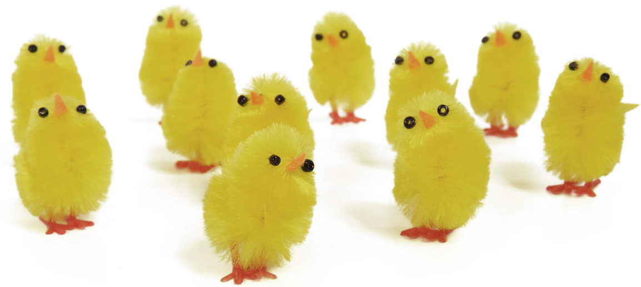
  - 3 weeks
  - 1 month
  - 2 months

- What are students experiencing in the first three weeks?

- What happens in the last week?

- Why did she want to start a chicken kit of her own?

Chicken Little
Part 2
Directions:
Read the article from Mississippi State University Extension Department titled “Stages in Chick Embryo Development.” The article can be found here: https://extension.msstate.edu/content/stages-chick-embryo-development. Once completed, answer the questions below.


- What may some cells become?

- What is the caudal?

- What develops from the primitive streak?

- Summarize what happens on the second day (44th hour) of incubation.

- By the end of the fourth day of incubation what happens?

- Claws form and the embryo moves into position for hatching on which day?

- After 21 days of incubation, how does the chick escape from the shell?

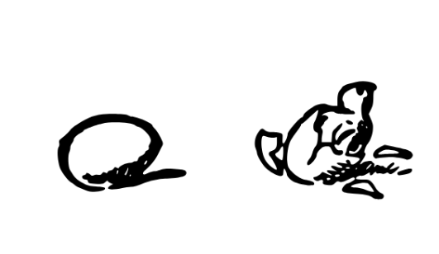

- In the section labeled “Events in Embryonic Development,” choose six out of the 15 days listed and create a drawing of what the chick embryo would look like. Be sure to label each egg with the appropriate day and what is included in the drawing. Days 5, 10, 15 and 20 are shown as examples in the article.

- What did you find most interesting or surprising as you learned about chick embryonic development?
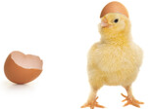
Chicken Little
Part 3
Directions:
Now that you are familiar with the developmental stages of a chick embryo, write a letter to the chick. Pretend this chick is your baby and will one day read about how they developed, hatched and lived. Be sure to mention their importance to the agriculture industry. Use complete sentences, reference the vocabulary words, share details and be creative!



Letter Rubric
Criteria | 0 Points | 1 Point | 2 Points | Score
Understanding of Developmental Stages | Shows lack of understanding of the chick embryo’s developmental stages | Provides some basic information about the chick embryo’s developmental stages, but lacks depth or detail | Shows a strong understanding of the chick embryo’s developmental stages  It provides detailed information about key milestones and transitions.
Connection to Agriculture Industry | There is no reference to how chick development relates to agriculture or the significance of chicks in food production. | Letter acknowledges chick’s importance to the agriculture industry to some extent, but the connection is not elaborated upon or emphasized strongly. | Letter provides a detailed explanation of how chick development contributes to agriculture, emphasizing the critical role of chicks in food production and the economy.
Grammar | Contains numerous grammatical errors and language usage issues | Demonstrates generally correct grammar and language usage with occasional errors or inconsistencies | Minimal to no grammar errors  Language is clear, precise, and effectively communicates the intended message.
Creativity | Lacks creativity and originality | Demonstrates some creativity and originality | Highly creative and original, standing out effectively
Vocabulary | Does not contain any vocabulary words | Contains at least one vocabulary word relevant to chick embryo development and agriculture | Incorporates more than one vocabulary word relevant to chick embryo development and agriculture
Additional Comments |  |  |  | Total Score:  /10

KEY: Chicken Little
Aligned to the following standards:
FFA.PL-A.; FFA.PG-I; FFA.PL-F; CCSS.ELA-LITERACY.W.9-10; CCSS.ELA-LITERACY.W.9-10.4; CCSS.ELA-LITERACY.L.9-10.6; CRP.02; CRP.04.

Part 1
Directions:
Watch the SAE video “Ag Education SAE | Kristyn Bauer,” https://vimeo.com/901201926, and answer the questions below.

- What chapter does Kristyn represent?
  - Beulah FFA
  - National FFA
  - Berry FFA
  - Beauregard FFA

- What is the name of Kristyn’s SAE?
Farm chicks to go

- Circle the pathway that aligns best with her SAE.
Agricultural Education
Biotechnology
Natural Resources
Plant Science

- What does she make for her SAE?
Incubator rental kits

- How long does she rent her kits out for?
  - 2 weeks
  - 3 weeks
  - 1 month
  - 2 months

- What are students experiencing in the first three weeks?
Incubating the chicks, the chicks developing

- What happens in the last week?
Students get to experience the chicks hatching and raising the chicks.

- Why did she want to start a chicken kit of her own?
She was already hatching her own chicks, and she wanted to share this experience with as many people as possible.

Chicken Little
Part 2
Directions:
Read the article from Mississippi State University Extension Department titled “Stages in Chick Embryo Development.” The article can be found here: https://extension.msstate.edu/content/stages-chick-embryo-development. Once completed, answer the questions below.


- What may some cells become?
vital organs or wing/leg

- What is the caudal?
Tail end of the embryo

- What develops from the primitive streak?
The head and backbone of the embryo develop

- Summarize what happens on the second day (44th) hour of incubation.
By the 44th hour of incubation, the heart and vascular systems join, and the heart begins beating. Two distinct circulatory systems are established: an embryonic system for the embryo and a vitelline system extending into the egg.

- By the end of the fourth day of incubation what happens?
By the end of the fourth day of incubation, the embryo has all organs needed to sustain life after hatching, and most of the embryo's parts can be identified.

- Claws form and the embryo moves into position for hatching on which day?
Day 14

- After 21 days of incubation, how does the chick escape from the shell?
The chick begins by pushing its beak through the air cell. The allantois, which has served as its lungs, begins to dry up as the chick uses its own lungs. The chick continues to push its head outward. The sharp horny structure on the upper beak (egg tooth) and the muscle on the back of the neck help cut the shell. The chick rests, changes position and keeps cutting until its head falls free of the opened shell. It then kicks free of the bottom portion of the shell. The chick is exhausted and rests while the navel openings heal and its down dries. Gradually, it regains strength and walks. The incubation and hatching is complete. The horny cap will fall off the beak within days after the chick hatches.

- In the section labeled “Events in Embryonic Development,” choose six out of the 15 days listed and create a drawing of what the chick embryo would look like. Be sure to label each egg with the appropriate day and what is included in the drawing. Days 5, 10, 15 and 20 are shown as examples in the article.

Answers will vary but should include a drawing, a date and labels.
Answers will vary but should include a drawing, a date and labels.
Answers will vary but should include a drawing, a date and labels.
Answers will vary but should include a drawing, a date and labels.
Answers will vary but should include a drawing, a date and labels.
Answers will vary but should include a drawing, a date and labels.

- What did you find most interesting or surprising as you learned about chick embryonic development?
Answers will vary.
Chicken Little
Part 3
Directions:
Now that you are familiar with the developmental stages of a chick embryo, write a letter to the chick. Pretend this chick is your baby and will one day read about how they developed, hatched and lived. Be sure to mention their importance to the agriculture industry. Use complete sentences, reference the vocabulary words, share details and be creative!
Answers will vary. See Letter Rubric.

