Just Peachy: Fruit Production
Created: 03/2024 by the National FFA Organization
Description of Lesson: This fruit production SAE introduces students to the basics of cultivating and managing fruit crops.
Student Learning Objectives:
After completing these activities, students will …
- Describe the optimal conditions for a fruit tree.
- Research information about orchard farms.
- Understand a plant hardiness map.

Suggested Grade Level:
Grades 9 and 10 (This lesson is written so instructors can scale up or down based on class needs.)

Suggested Time: 60-120 minutes (*Time requirements may vary based upon student understanding and class schedule.)
Resources/References:
- Video: Fruit Production SAE | William Martin, https://vimeo.com/857649991
- Website: 2023 USDA Plant Hardiness Zone Map, https://planthardiness.ars.usda.gov/

Related Resources:
- The Functions of a Plant: https://FFA.box.com/s/7tr09dp45o6m3nzullz036lox7doj8id

Equipment and Supplies Needed:
- A copy of the “Just Peachy” worksheet for each student
- Internet access to play the video in real-time or embed it in a PowerPoint ahead of time

Vocabulary:
- Hardiness
- Personal Protective Equipment
- Production

Cross-Curricular Connections:
English/Language Arts | Mathematics | Social Studies
- Research and write about the optimal conditions for growth and production. | - Solve a division problem. | - Identify four states.

Virtual Instruction Ideas:
Have students download and watch the video on a device of their choice and complete the worksheet.

Student Activity Sheets:
Direct access to student activity sheets without lesson plan or answer key for easy upload to a learning management system or printing for classwork.

Word: https://ffa.box.com/s/tc5u1izh49mq59s4b5p32or3px1lu6cn
Non-Designed: https://ffa.box.com/s/8fr17p5nlqoh3jbcas1ih2aadoqwnpjo
PDF: https://ffa.box.com/s/rwq65r031cbbdw0uovvm0ydq9w6919px
Google Docs: https://docs.google.com/document/d/1YGxkgBTyzhPPqc7RP4DcjjWOxnbqCeNh-gJAOO3wyNE/copy

These Activities Are Aligned to the Following Standards:
FFA Precept
- FFA.PL-A.Action: Assume responsibility and take the necessary steps to achieve the desired results, no matter what the goal or task at hand.
- FFA.PL-F.Continuous Improvement: Accept responsibility for learning and personal growth.
Common Career Technical Core
- AG3 Examine and summarize the importance of health, safety, and environmental management systems in AFNR businesses.
AFNR Cluster Skills
- CS.03. Examine and summarize the importance of health, safety and environmental management systems in AFNR workplaces.
Common Core – Reading: Informational Text
- CCSS.ELA-LITERACY.RI.9-10.1 Cite strong and thorough textual evidence to support analysis of what the text says explicitly as well as inferences drawn from the text.
Common Core – Writing
- CCSS.ELA-LITERACY.W.9-10.2 Write informative/explanatory texts to examine and convey complex ideas, concepts, and information clearly and accurately through the effective selection, organization, and analysis of content.
Common Core – Math Practices
- CCSS.MATH.PRACTICE.MP1 Make sense of problems and persevere in solving them.
AFNR Career Ready Practices
- CRP.02. Apply appropriate academic and technical skills. Career-ready individuals readily access and use the knowledge and skills acquired through experience and education to be more productive.
- CRP.04. Communicate clearly, effectively, and with reason. Career-ready individuals communicate thoughts, ideas and action plans with clarity, whether using written, verbal and/or visual methods.
- CRP.06. Demonstrate creativity and innovation. Career-ready individuals regularly think of ideas that solve problems in new and different ways, and they contribute those ideas in a useful and productive manner to
improve their organization.
- CRP.07. Employ valid and reliable research strategies. Career-ready individuals are discerning in accepting and using new information to make decisions, change practices or inform strategies.
- CRP.08. Utilize critical thinking to make sense of problems and persevere in solving them. Career-ready individuals readily recognize problems in the workplace, understand the nature of the problem, and devise effective plans to solve the problem.
- CRP.11. Use technology to enhance productivity. Career-ready individuals find and maximize the productive value of existing and new technology to accomplish workplace tasks and solve workplace problems.
Partnership for 21st Century Skills
- Communication
- Critical Thinking and Problem Solving
- Information Literacy
- Initiative and Self-Direction
- Productivity and Responsibility

Lesson Plan:
- Bell Ringer: Create a list of all the steps you think it takes to start an orchard.

- Introduction: Do you know what goes into the production process of fruit trees? Today, we will explore peach tree production by watching Tennessee native William Martin share his experience. You will have the opportunity to brainstorm, research and plan for your own orchard.

- Activity: Each student needs a copy of the worksheet “Just Peachy.”
  - Part 1: Students will watch the video “Fruit Production SAE,” https://vimeo.com/857649991, and complete the questions by following along.

  - Part 2: Students will research how to start an orchard. They will utilize the United States Department of Agriculture’s Plant Hardiness Zone Map (https://planthardiness.ars.usda.gov/) as well as other sources to understand optimal conditions for the growth and production of fruit trees.

- Optional – Extended Learning Opportunities (Not factored into time requirement):
  - If students are interested in learning more about landscape design Nursery and Landscape Unit 2: Skills are lessons specifically made for preparation of the nursery/landscape career development event. The URL is https://FFA.box.com/s/wlhniuwmsfrof8ri7eqag5uuwzsamr0r.
- Exit Ticket: What is one thing that you learned about fruit production that you did not previously know?

Just Peachy
Aligned to the following standards:
FFA.PL-A; FFA.PL-F; AG3; CS.03; CCSS.ELA-LITERACY.RI.9-10.1; CCSS.ELA-LITERACY.W.9-10.2; CCSS.MATH.PRACTICE.MP1; CRP.02; CRP.04; CRP.06; CRP.07; CRP.08; CRP.11
Part 1
Directions:
Watch the SAE video “Fruit Production SAE | William Martin,” https://vimeo.com/857649991, and answer the questions below.
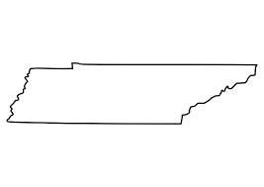
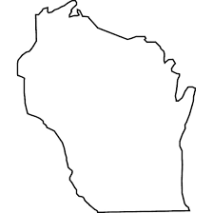
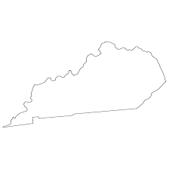

- Label each state and then circle the one William is from.

- How many peach trees does William have?

- How much time does it take from planting to producing a “considerable” amount of peaches?
  - 1 year
  - 2 years
  - 3 years
  - 4 years

- List one skill that he learned in his SAE.

- What does PPE stand for?

- Using the figure below, draw and label three examples of PPE.


- What has he learned the most?

- What advice does he give to students starting their SAE?

- After watching the SAE video, share one thing you learned and one thing you still have questions about.

Just Peachy
Part 2
Directions:
Let’s create a plan to start your own orchard. Answer each question below.
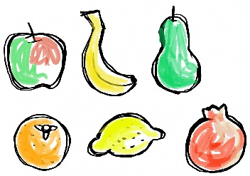
- Create a list of your favorite fruits that you would want to plant in your orchard:
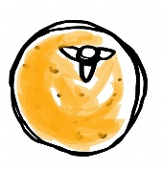
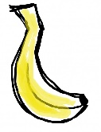

- According to the United States Department of Agriculture, a Plant Hardiness Zone Map is the standard by which gardeners and growers can determine which perennial plants are most likely to thrive at a location. Examine the map available at https://planthardiness.ars.usda.gov/. What is the hardiness zone of where you live?

- Which of your favorite fruits identified above could you grow in your zone? If none are applicable, list the types that can.

- Select one tree from your zone and research the optimal conditions for growth and production. Writing in complete sentences, describe how much sun and water the tree should receive, ideal soil conditions and how far the trees should be spaced apart. Be sure to cite your sources.

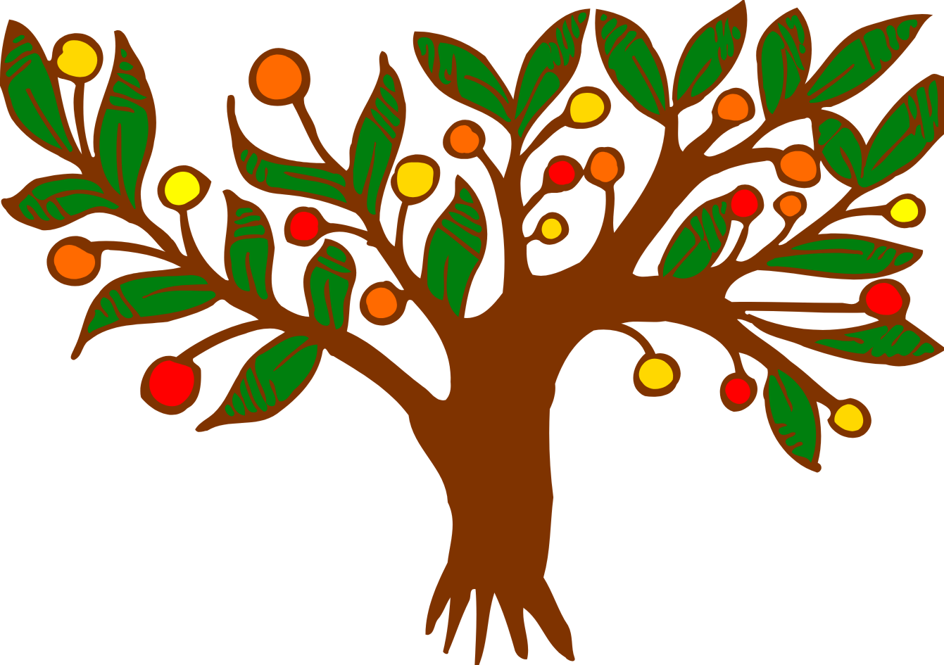

- Imagine you have a rectangular orchard where you want to plant peach trees. The length of the orchard is 120 meters, and the width is 80 meters. You decide to plant peach trees in rows with equal spacing between them. If each peach tree needs to be planted 5 meters apart in each row, how many peach trees can you plant in each row along the length of the orchard?

- How can you apply what you learned today in a real-life scenario?

Aligned to the following standards:
FFA.PL-A; FFA.PL-F; AG3; CS.03; CCSS.ELA-LITERACY.RI.9-10.1; CCSS.ELA-LITERACY.W.9-10.2; CCSS.MATH.PRACTICE.MP1; CRP.02; CRP.04; CRP.06; CRP.07; CRP.08; CRP.11

KEY: Just Peachy
Part 1
Directions:
Watch the SAE video “Fruit Production SAE | William Martin,” https://vimeo.com/857649991, and answer the questions below.
- Label each state and then circle the one William is from.

Tennessee Wisconsin Kentucky California

- How many peach trees does William have?
132

- How much time does it take from planting to producing a “considerable” amount of peaches?
  - 1 year
  - 2 years
  - 3 years
  - 4 years

- List one skill he learned in his SAE.
How to spray chemicals, how to be safe when spraying

- What does PPE stand for?
Personal protective equipment

- Using the figure below, draw and label three examples of PPE.
Answers will vary but may include gloves, gowns, shoe covers, head covers, masks, respirators, eye protection, face shields and goggles.

- What has he learned the most?
How to accept failure

- What advice does he give for students starting their SAE?
Find something you are really passionate about.

- After watching the SAE video, share one thing you learned and one thing you still have questions about.
Answers will vary.

Part 2
Directions:
Let’s create a plan to start your own orchard. Answer each question below.
- Create a list of your favorite fruits that you would want to plant in your orchard:
  - Answers will vary.

- According to the United States Department of Agriculture, a Plant Hardiness Zone Map is the standard by which gardeners and growers can determine which perennial plants are most likely to thrive at a location. Examine the map available at https://planthardiness.ars.usda.gov/. What is the hardiness zone of where you live?
Answers will vary.

- Which of your favorite fruits identified above could you grow in your zone? If none are applicable, list the types that can.
Answers will vary.

- Select one tree from your zone and research the optimal conditions for growth and production. Writing in complete sentences, describe how much sun and water the tree should receive, ideal soil conditions and how far the trees should be spaced apart. Be sure to cite your sources.
Answers will vary.

- Imagine you have a rectangular orchard where you want to plant peach trees. The length of the orchard is 120 meters, and the width is 80 meters. You decide to plant peach trees in rows with equal spacing between them. If each peach tree needs to be planted 5 meters apart in each row, how many peach trees can you plant in each row along the length of the orchard?
If each peach tree needs to be planted 5 meters apart in each row along the length, the number of peach trees in each row is the length divided by the spacing between trees​. Therefore, the number of peach trees in each row along the length is 120/5=24 trees.

- How can you apply what you learned today in a real-life scenario?
Answers will vary.

