SAE for All Resources
Created: 11/2024
National FFA and SAE for All provide free SAE for All resources for teachers. This document will provide a comprehensive list of all resources available.

TABLE OF CONTENTS:
- SAE Companion Resources
- SAE Guides
- SAE Videos
- Full SAE Lesson Plans

SAE Companion Resources
Title | Description | Image
2023 Fall New Horizons Teaching Guide  Appendix 4: Go for an SAE Grant | A companion resource for the article “Go for an SAE Grant” in the 2023 issue of FFA New Horizons | 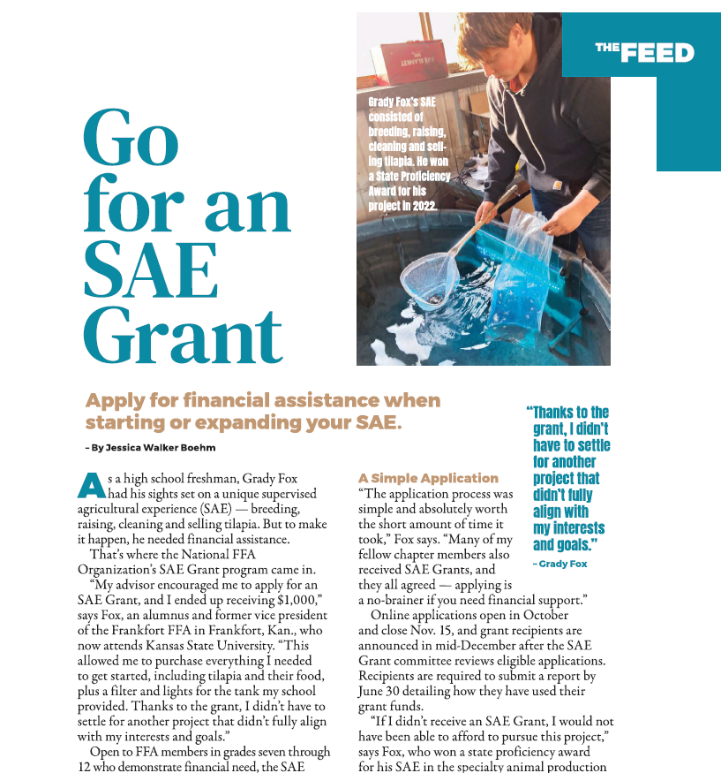
2024 Fall-Winter New Horizons Teaching Guide  Appendix 5: This SAE Popped Off | A kernel of an idea led this National Trail FFA member to a creative (and delicious!) supervised agricultural experience. | 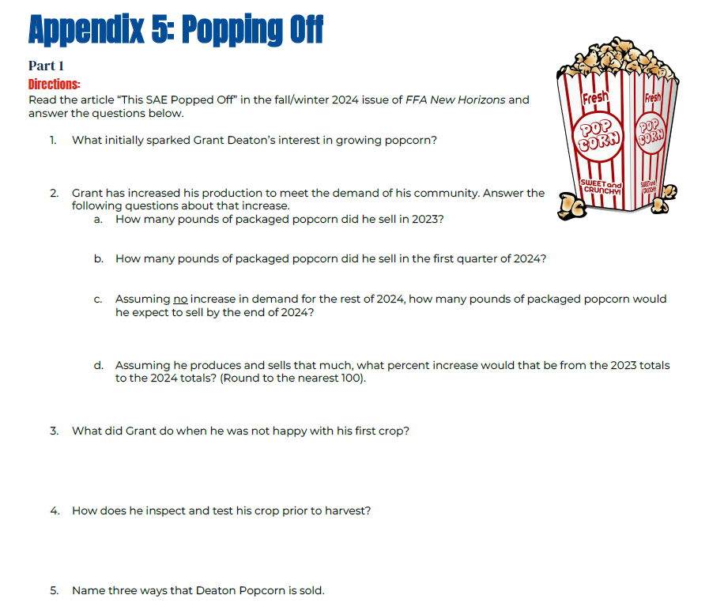
2024 Spring-Summer New Horizons Teaching Guide  Appendix 1: Try Something New With Your SAE | A companion resource for the “Try Something New With Your SAE” article in the 2024 issue of FFA New Horizons | 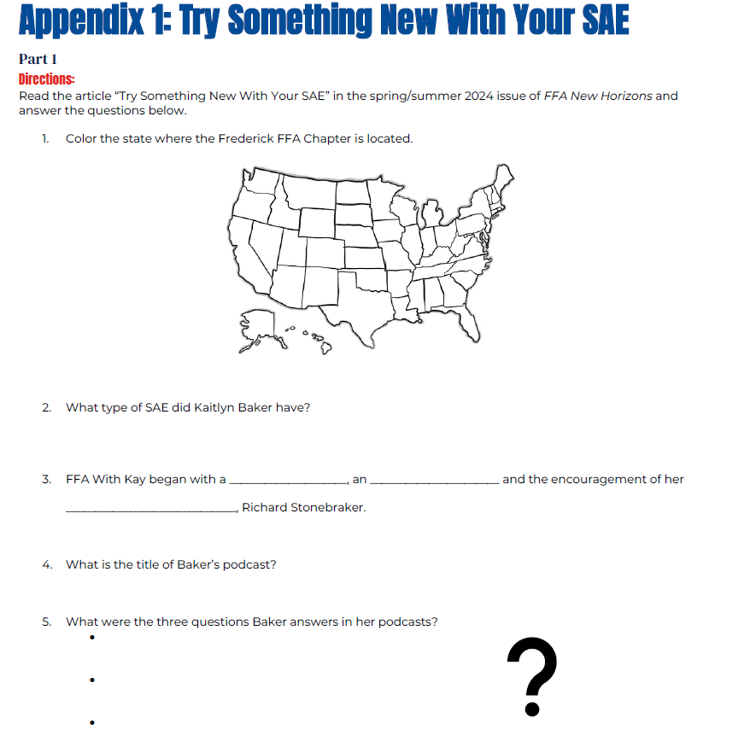
SAE for All | This site provides information on SAE opportunities based on exploring passions and career interests. Students start with a Foundational SAE and then expand to include one or more Immersion SAEs. Find activity guides and more that make it easy for all students to have an SAE.  *E-learning modules are available on the Educator and Student pages. | 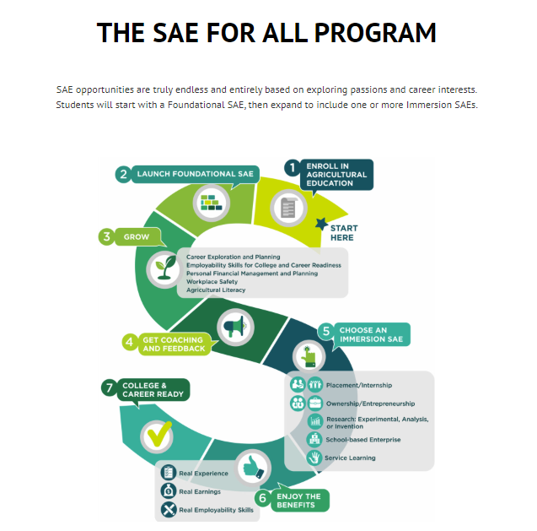
SAE for All Information Sheets | These information sheets are designed to introduce SAEs to key stakeholders such as parents and administrators. | 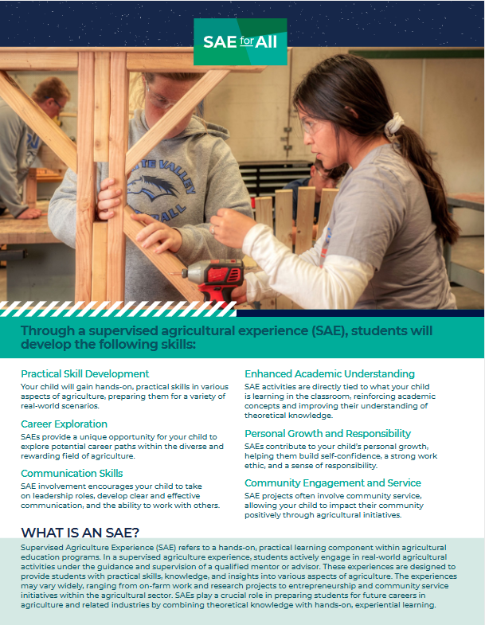
SAE Idea Cards | PDF versions of SAE Idea Cards divided by career focus areas (similar to Agriculture Food and Natural Resources [AFNR] pathways)  The purpose of the SAE Idea Cards is to assist students with developing ideas for SAEs. There are 360 SAE ideas in nine different focus areas that can be downloaded or used online. | 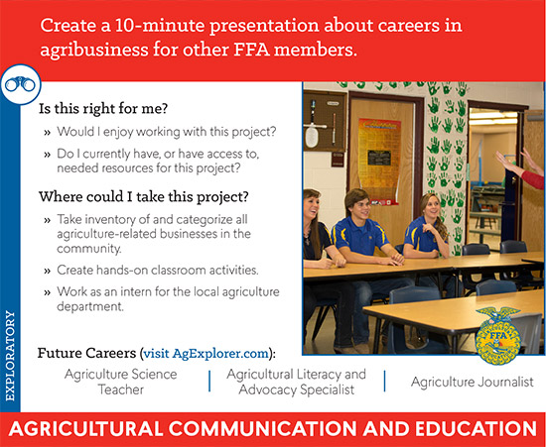
SAE Management Documents (LPS) | SAE Resources and worksheets to help advisors and students determine and manage supervised agricultural experiences. | 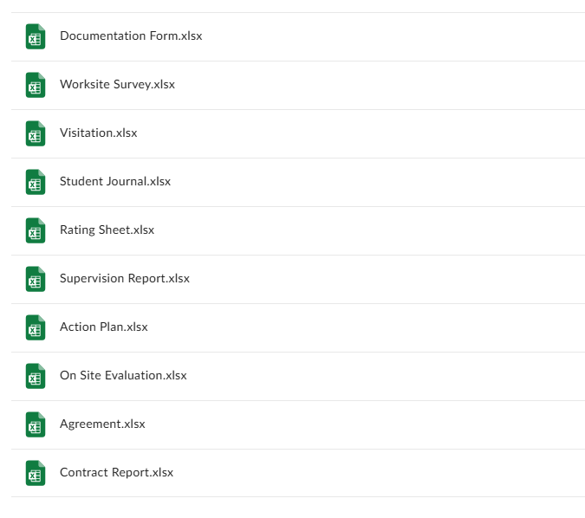

SAE Guides
Auction Industry Guide: Student Guide | The auction industry SAE student guide will help students explore auctioneering as a career and  as an SAE. | 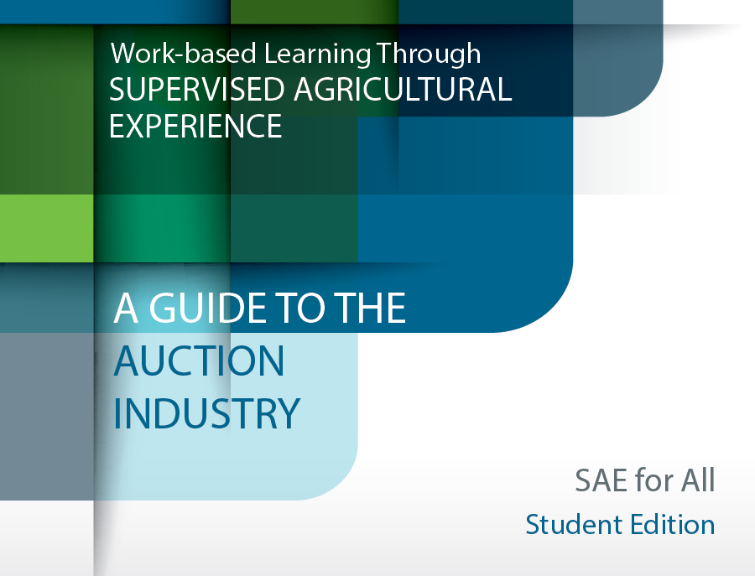
Auction Industry Guide: Teacher Guide | The auction industry SAE teacher guide will help you determine how auctioneering  content can fit into your curriculum and will explain how to guide students who are interested in an auction industry SAE. | 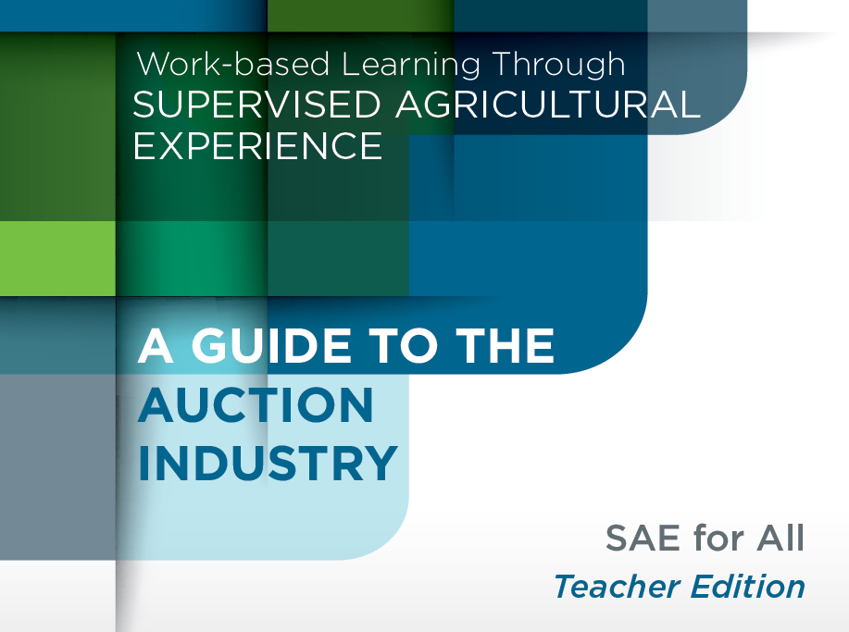
Data Science Kit | The data science SAE student guide will help students explore the world of data science through an SAE. The data science SAE teacher guide will help you determine how data science topics can fit into your curriculum and will explain how to guide students  who are interested in data science. | 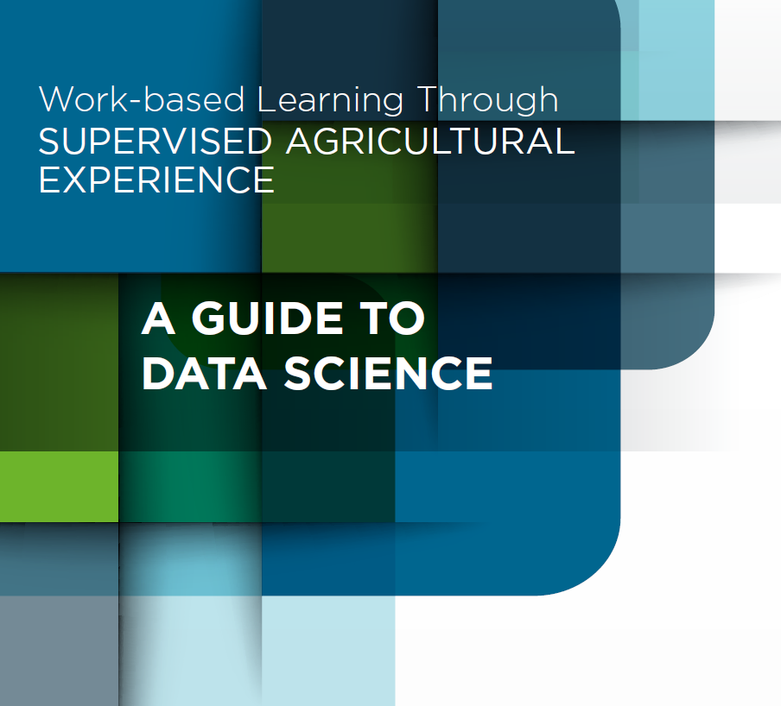
Drone SAE Kit | The drone technology SAE student guide will help students explore the world of drone technology through an SAE. The drone technology SAE teacher guide will help you determine how drone technology topics can fit into your curriculum and will explain how to guide students who are interested in drone technology. | 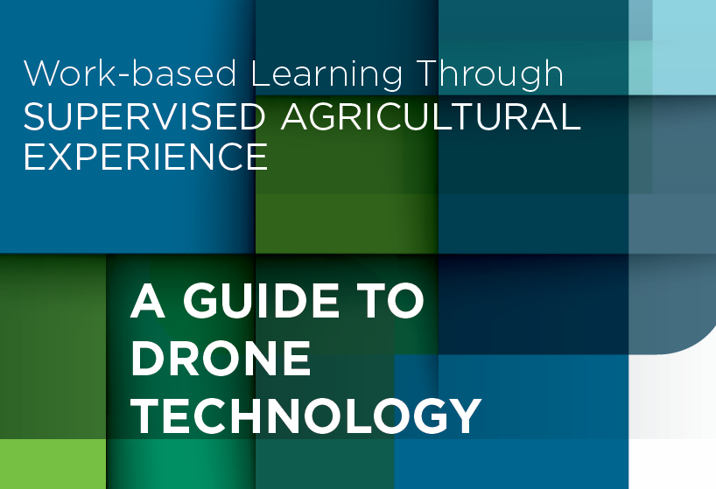
Foundational SAE Independent Learning Guide: Advanced | This guide breaks down a Foundational SAE for students in grades 11 and 12 at the advanced level. | 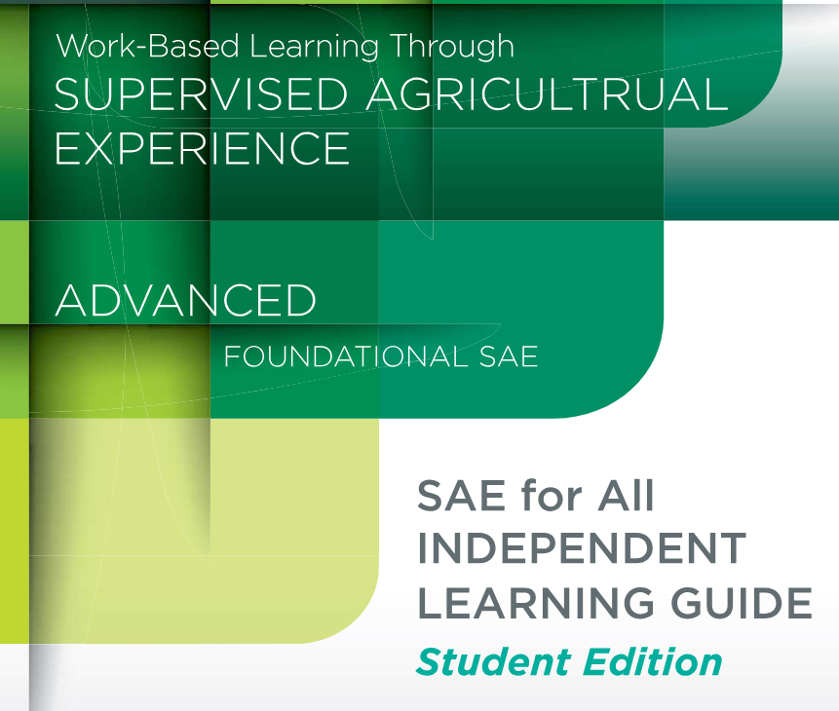
Foundational SAE Independent Learning Guide: Awareness | This guide breaks down a Foundational SAE for students in grades 6 through 9 at the awareness level. | 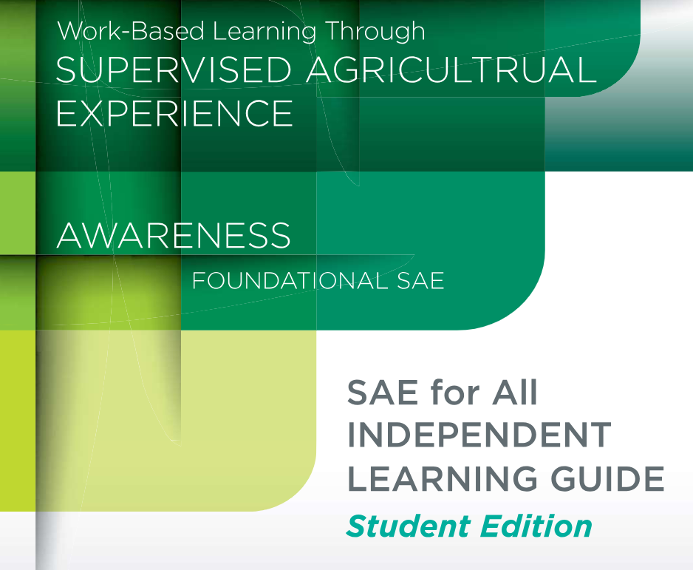
Foundational SAE Independent Learning Guide: Intermediate | This guide breaks down a Foundational SAE for students in grades 11 and 12 at the intermediate level. | 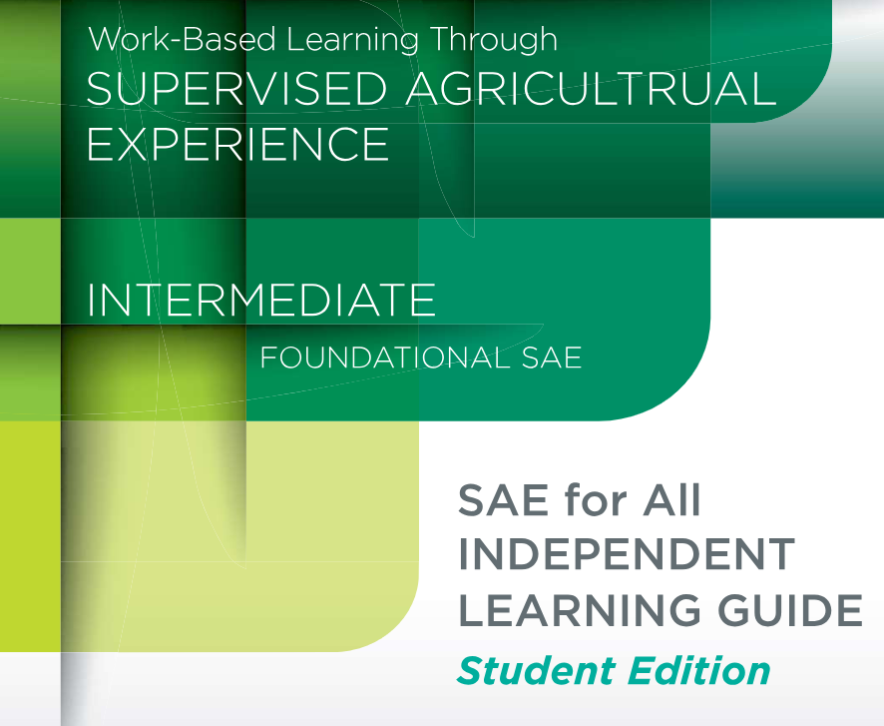
Foundational SAE Independent Learning Guide: Teacher Edition | The Foundational SAE is a critical experience for all students in an agricultural education program. This includes students that are on a four-year sequence and those who enroll just for a semester. The Foundational SAE Independent Learning Guides are an easy way to get your students started  on their SAE journeys. | 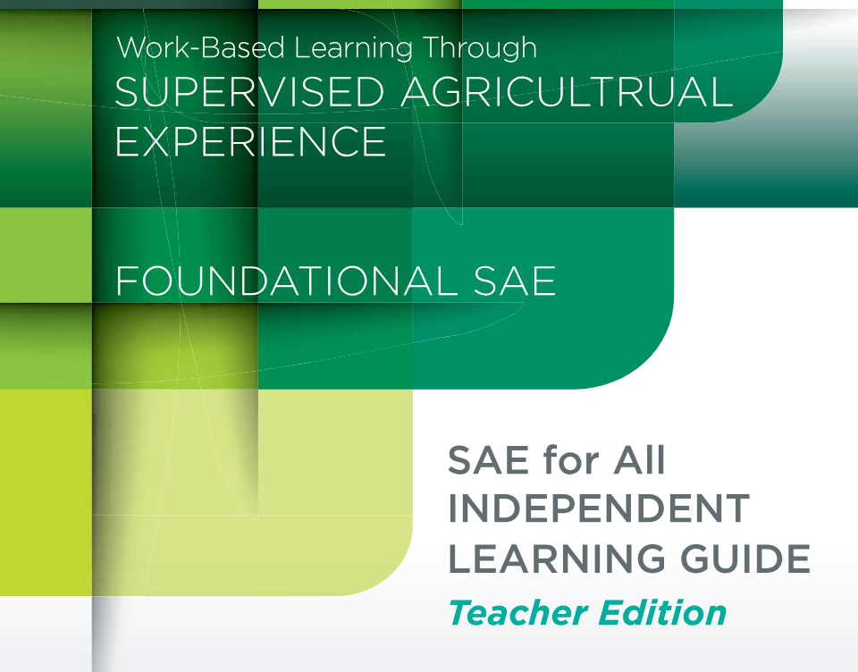
Immersion SAE Ownership/Entrepreneurship Independent Learning Guide: Student Edition | This guide will allow students to complete activities to prepare them for ownership and entrepreneurship SAEs. | 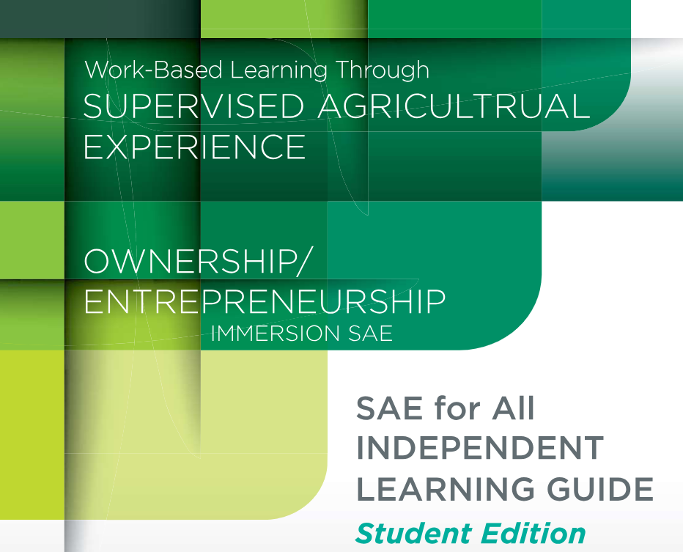
Immersion SAE Ownership/Entrepreneurship Independent Learning Guide: Teacher Edition | This guide will help teachers introduce students to the immersion SAE categories of ownership and entrepreneurship. | 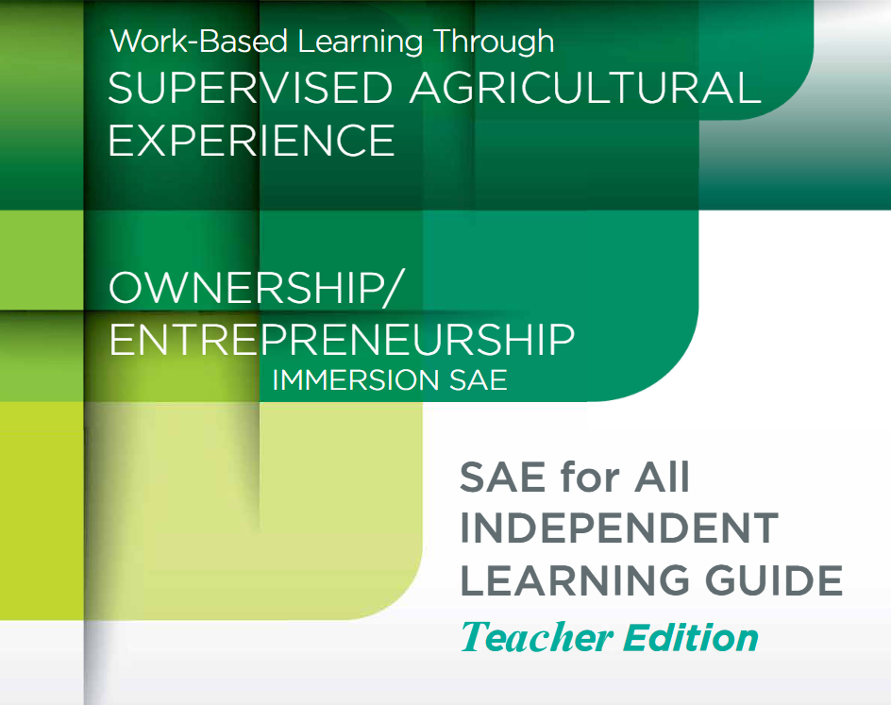
Immersion SAE Placement/Internship Independent Learning Guide: Student Edition | This guide will allow students to complete activities to prepare them for placement and internship SAEs. | 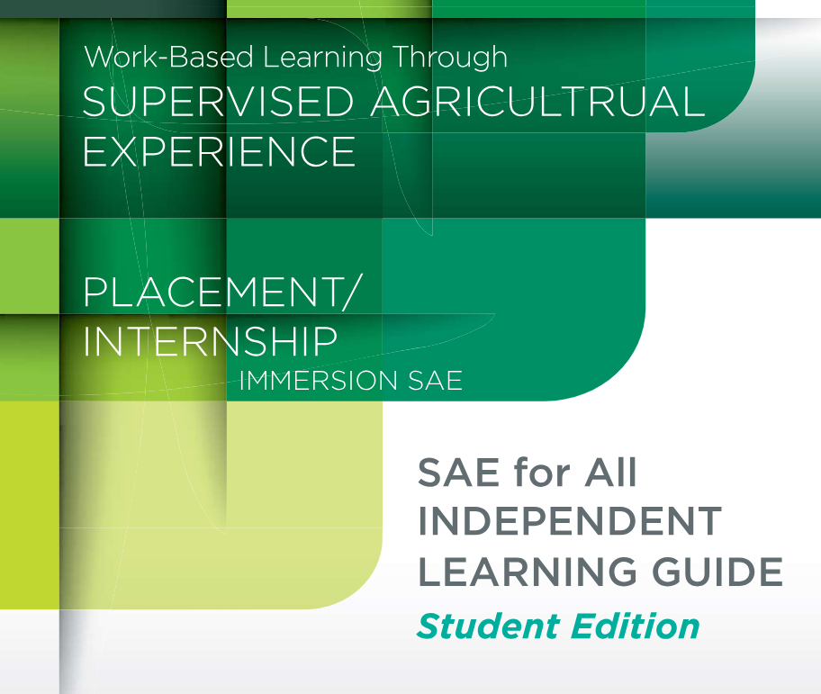
Immersion SAE Placement/Internship Independent Learning Guide: Teacher Edition | This guide will help teachers introduce students to the immersion SAE categories of placement and internship. | 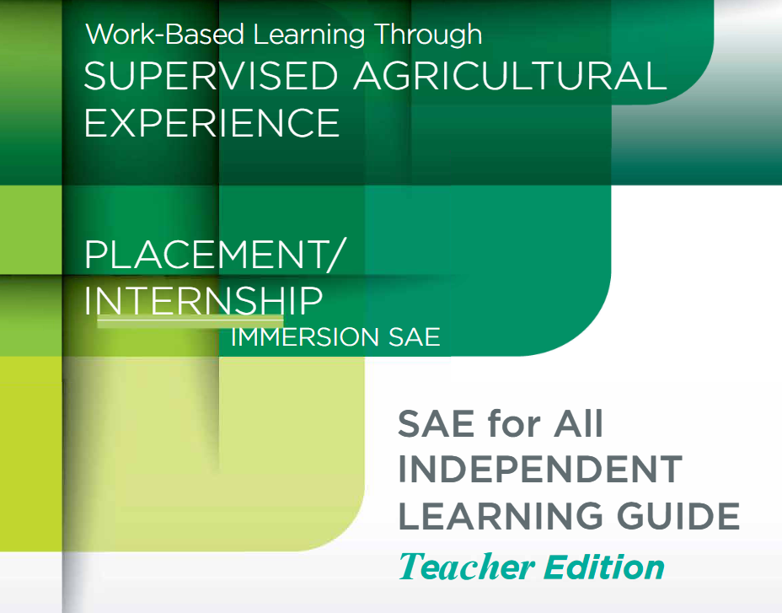
Immersion SAE Research Independent Learning Guide: Student Edition | This guide will allow students to complete activities to prepare them for research SAEs. | 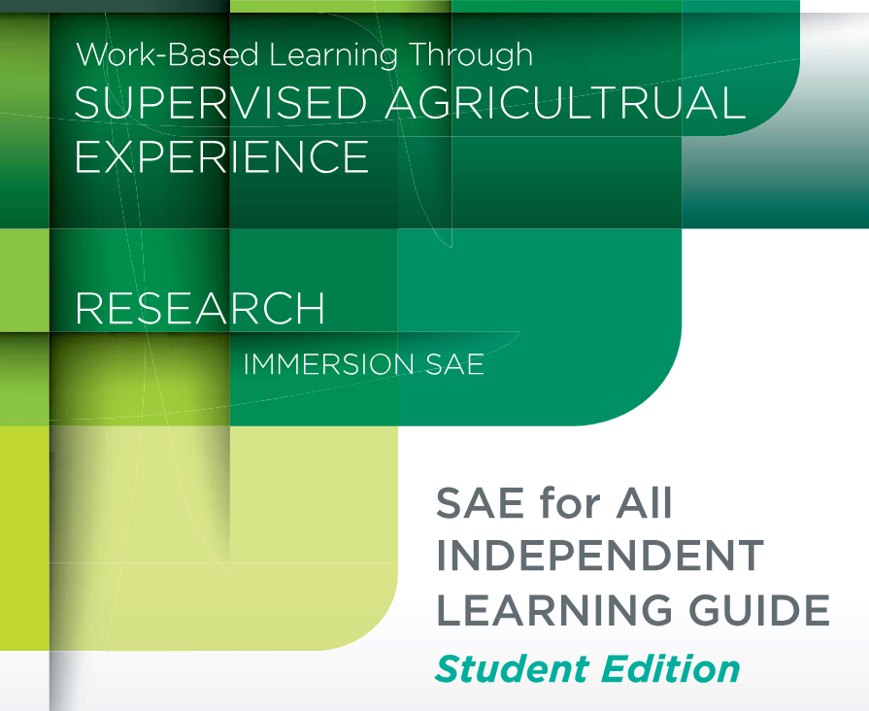
Immersion SAE Research Independent Learning Guide: Teacher Edition | This guide will help teachers introduce students to the immersion SAE category of research. | 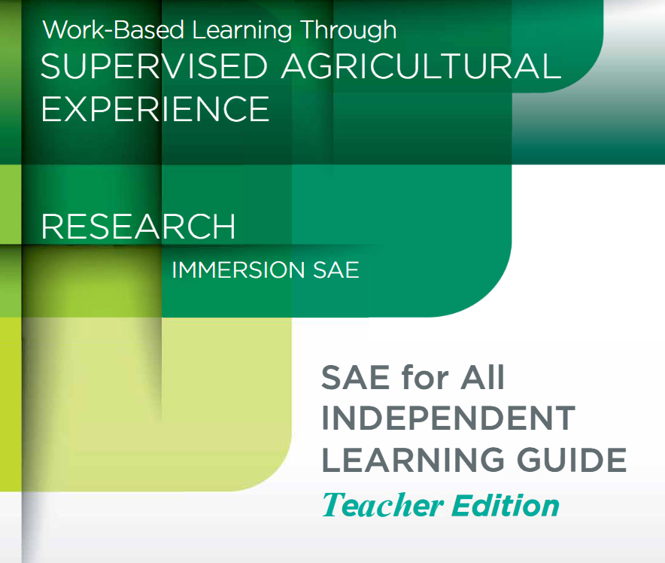
Immersion SAE School-Based Enterprise Independent Learning Guide: Student Edition | This guide will allow students to complete activities to prepare them for school-based enterprise SAEs. | 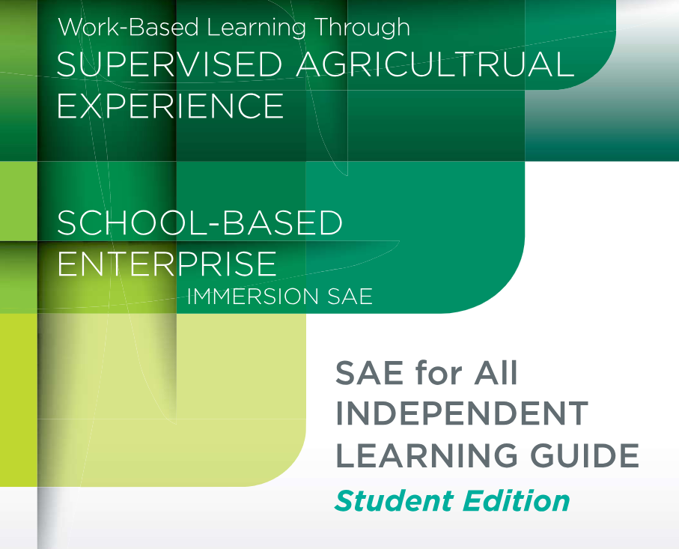
Immersion SAE School-Based Enterprise Independent Learning Guide: Teacher Edition | This guide will help teachers introduce students to the immersion SAE category of school-based enterprise. | 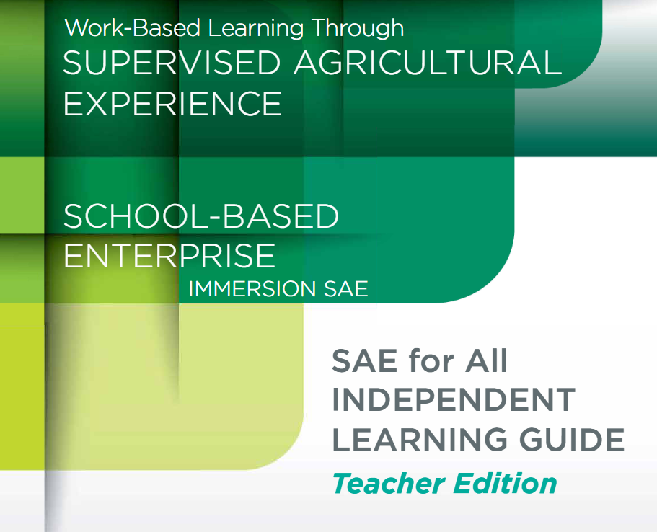
Immersion SAE Service-Learning Independent Learning Guide: Student Edition | This guide will allow students to complete activities to prepare them for service-learning SAEs. | 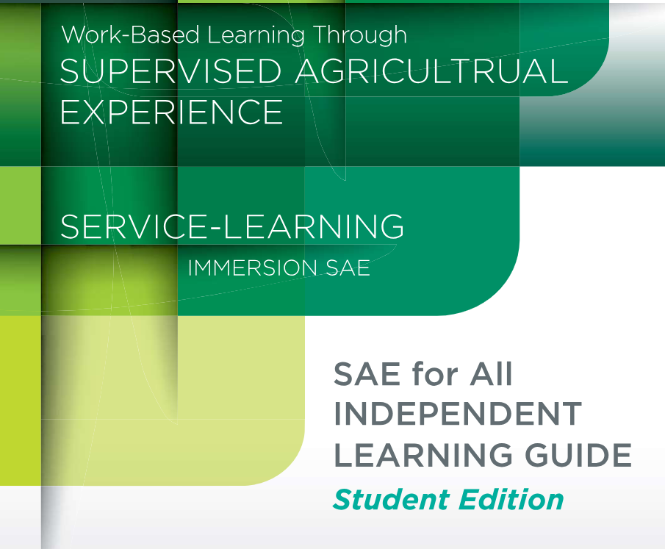
Immersion SAE Service-Learning Independent Learning Guide: Teacher Edition | This guide will help teachers introduce students to the immersion SAE category of service-learning. | 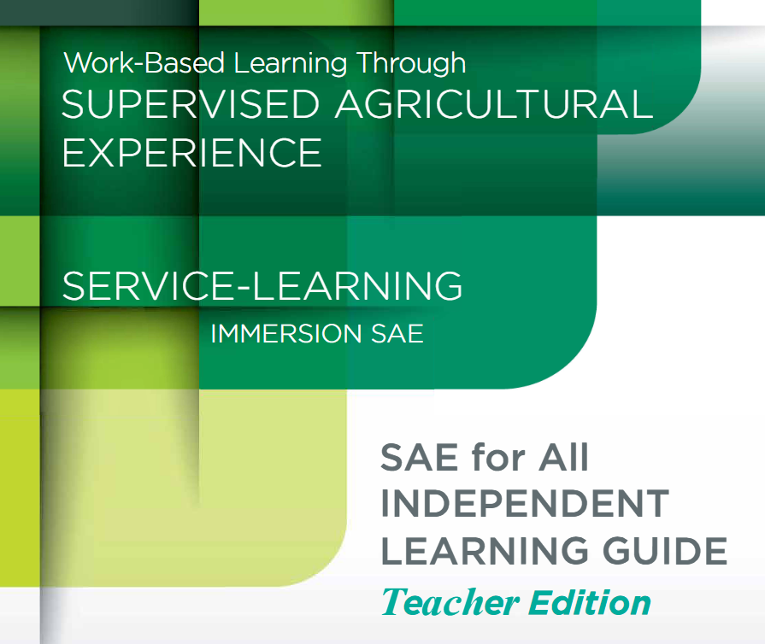
International Agricultural Development Guide: Student Guide | This guide takes students through the activities to complete a Foundational SAE and gives them the tools to begin an Immersion SAE. | 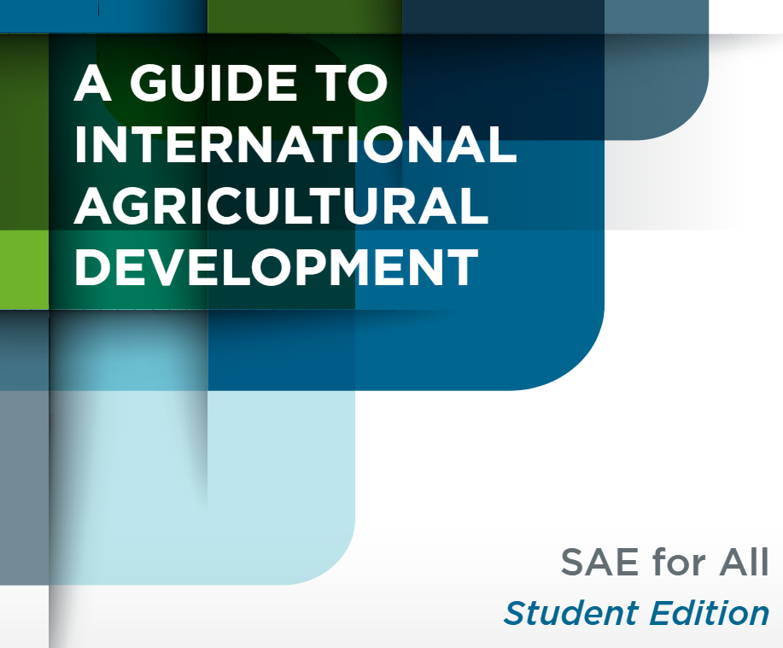
International Agricultural Development Guide: Teacher Guide | The international agricultural development SAE guide is designed to help teachers introduce students to careers in IAD and help them start their own SAEs in international agricultural development. | 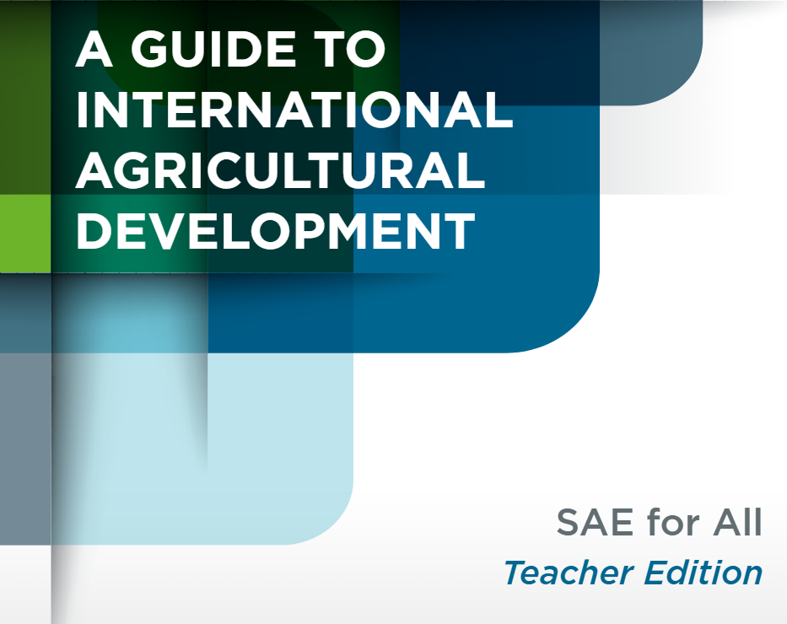
SAE for All Student Guide | The SAE for All program is designed to provide meaningful career preparation experiences for all students through the SAE component of an agricultural education program. It enables every student, regardless of their time in ag ed, to benefit from the SAE involvement by aligning the effort with their career interests. | 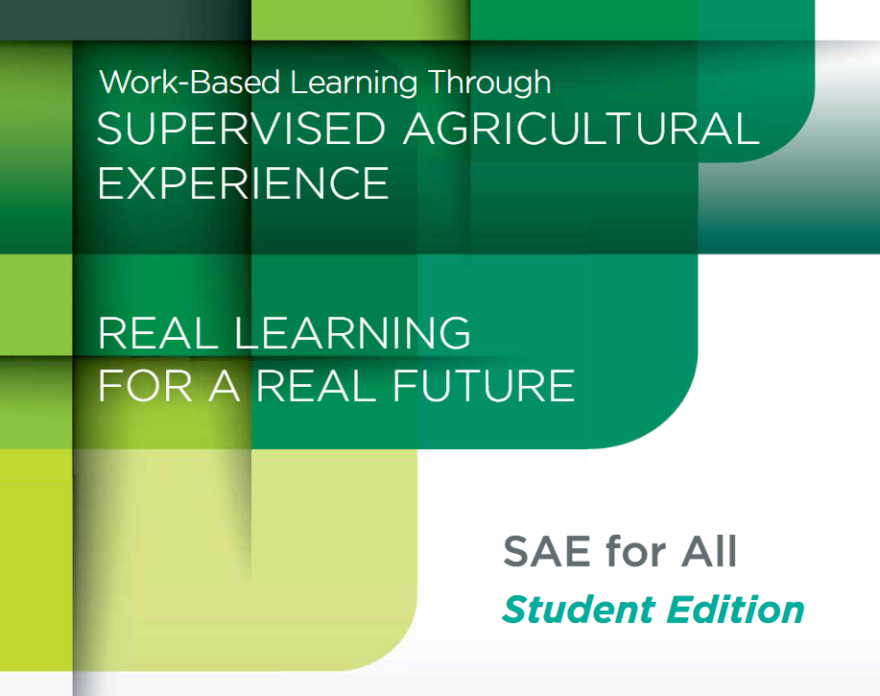
SAE for All Teacher Guide | The SAE for All program is designed to provide meaningful career preparation experiences for all students through the SAE component of an agricultural education program. It enables every student, regardless of their time in ag ed, to benefit from the SAE involvement by aligning the effort with their career interests. | 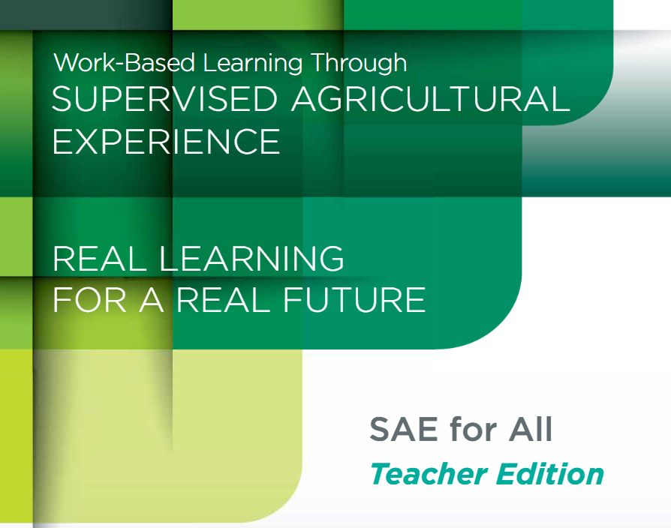
SAE Resources Guide | This guide is designed to help teachers and advisors incorporate supervised agricultural experiences (SAEs) into their courses in the classroom and at a distance. | 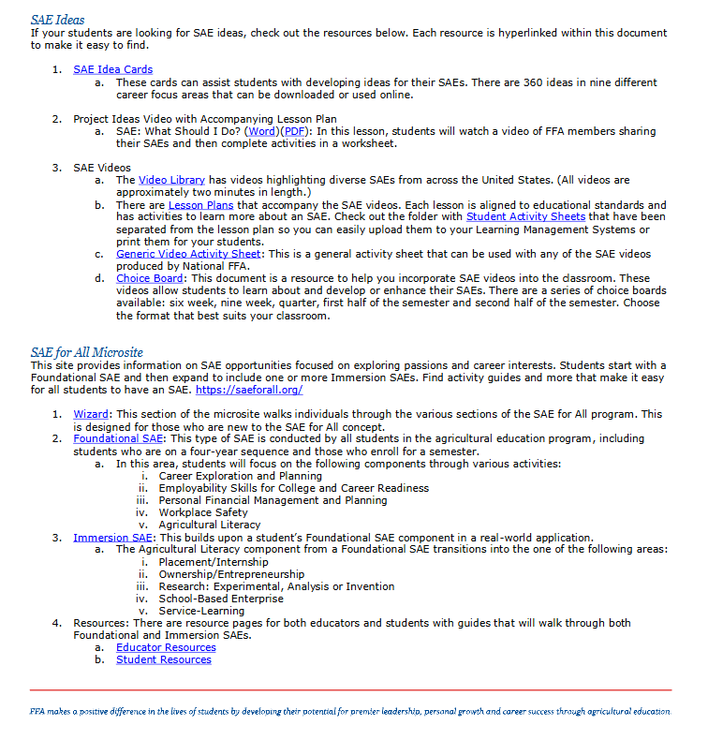

SAE Videos
Abbey Rinker – SAE – Horse Showing Lesson Plan | Abbey Rinker’s SAE is showing horses. Abbey’s grandmother is the inspiration for her SAE, and her whole family has helped her be successful. | 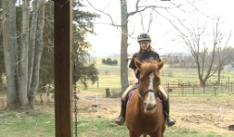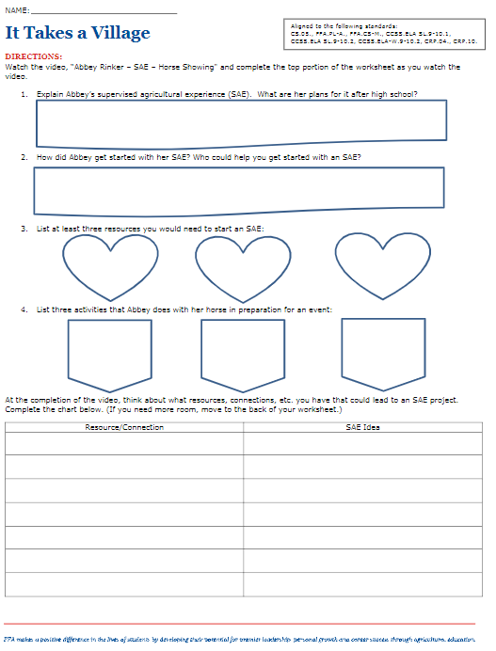
Abiggail Lozon – SAE – Micro Algae | Abigail’s SAE is growing four different types of micro algae. The algae are different sizes and are fed to a variety of species in the lab. Some of her beginning steps were completing extensive research on algae and going through a training process with one of her teachers. | 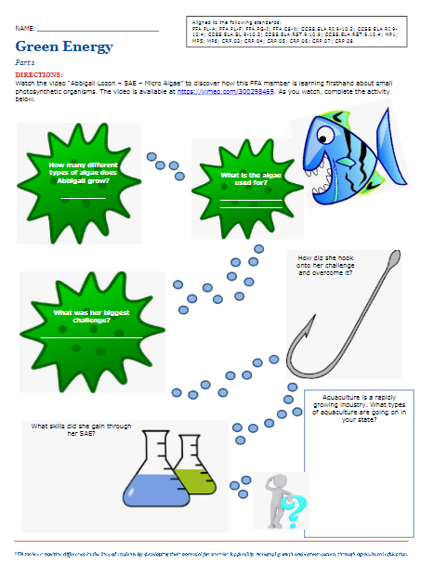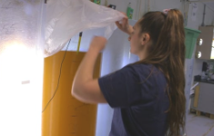
Ashley Yanego – SAE – Floral Shop Lesson | Ashley Yanego’s SAE involves working at a floral shop. She enjoys working with the people in the shop where she learns something new every day. | 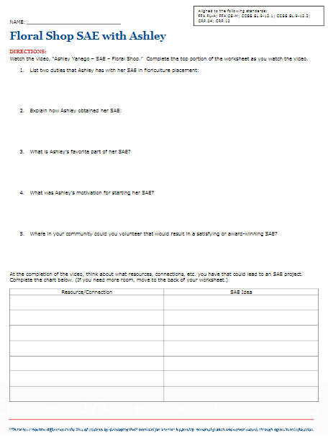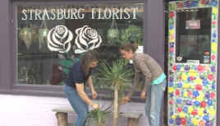
Bailey Morrell – SAE – Organic Oat Hay | Bailey’s SAE is 74.5 acres of certified organic oat hay. Having grown up on a cattle ranch and having a lot of experience in the animal industry, Bailey wanted to learn more about the plant science side of agriculture. One of the beginning steps for her SAE was learning about and going through the process to become organically certified. | 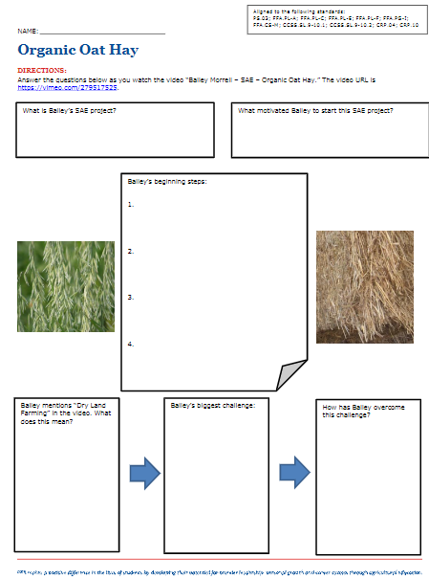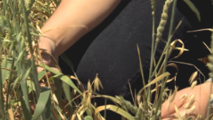
Ben Walker – SAE – Marina | Ben’s SAE is working at a local marina, where he helps with some of the day-to-day tasks associated with operating a marina. | 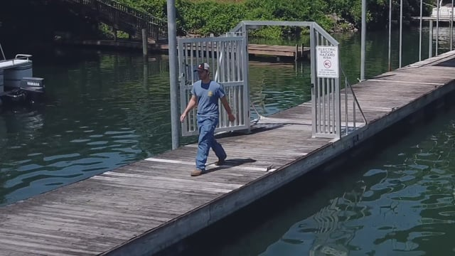
Caleb Wilkerson – Tractor Restoration SAE | Caleb Wilkerson’s SAE is tractor restoration. Students will watch a video on the process Caleb went through to restore a 1948 tractor and then will brainstorm and consider what items they could restore or repurpose in their own lives for a potential SAE. | 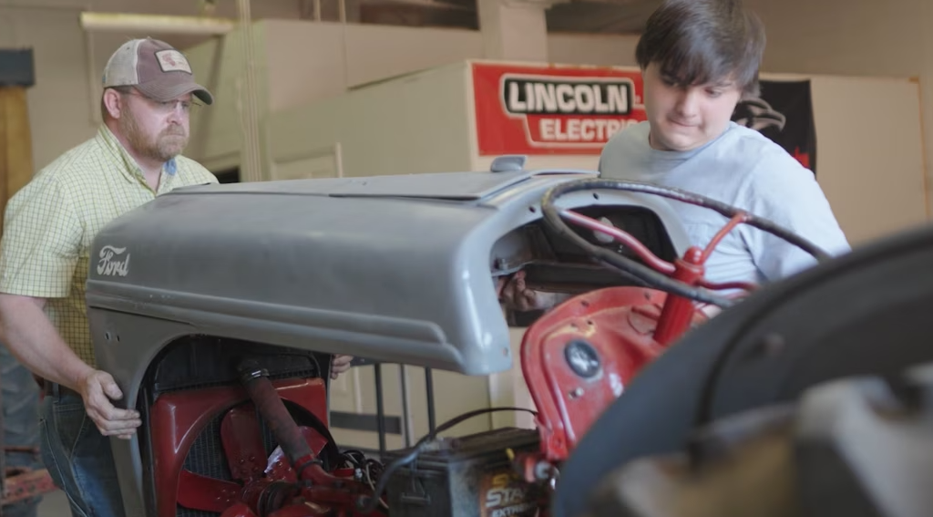
Carlos Garcia – SAE – Young Urban Farmers Program | For Carlos’ supervised agricultural experience (SAE) program, he works in the Young Urban Farmers Program in his hometown. | 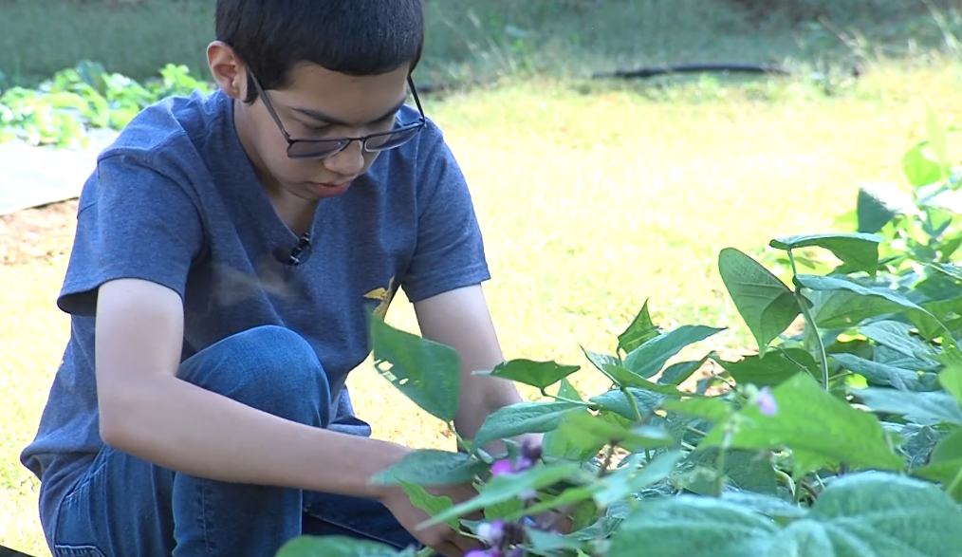
Cayla Miller – SAE – National Forest | Cayla’s SAE is working in the Cherokee National Forest where she performs a variety of tasks such as checking the pH balance of various waterways. | 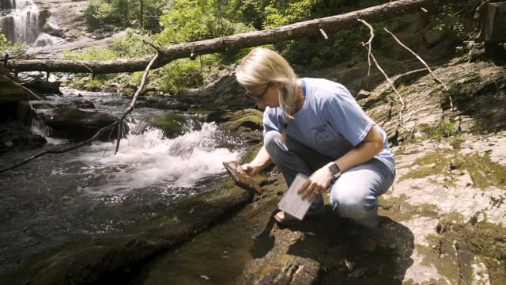
Cheyenne Young – SAE – Vet Clinic | Cheyenne’s SAE is working at the VCA Fairleigh Animal Hospital as a veterinary assistant. In this role, she helps the veterinarians and the veterinary technicians in the treatment room with surgeries, etc. She also helps care for the animals by cleaning cages and making sure they are comfortable. | 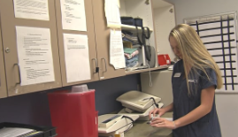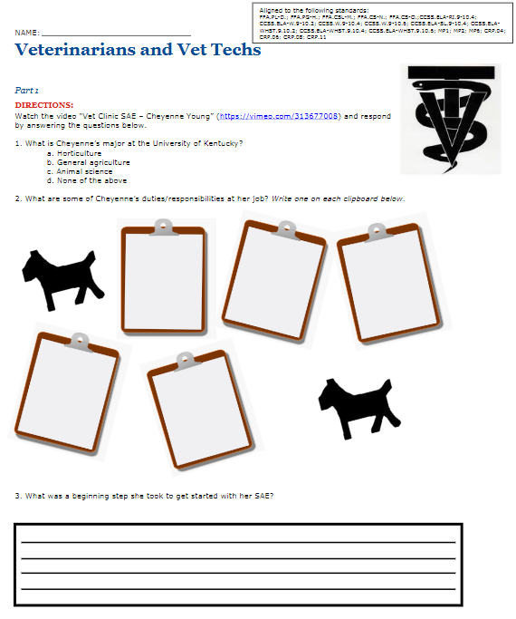
Chloe Jones – SAE – Grapevine Wreaths | Chloe’s SAE is making grapevine wreaths from start to finish. Through this SAE, she learned not only the process of making a wreath but also about grapevine production. | 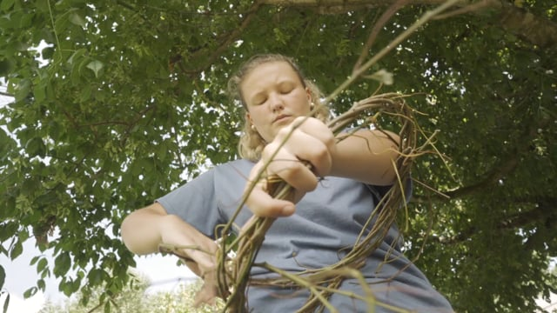
Cole Hanson – SAE – Lawn Care | Cole’s SAE is lawn care and landscape management through his family’s business. Some of the beginning steps Cole had to take were learning the overall business, knowing how to properly operate the mower, etc. Watch the video to learn more about this SAE. | 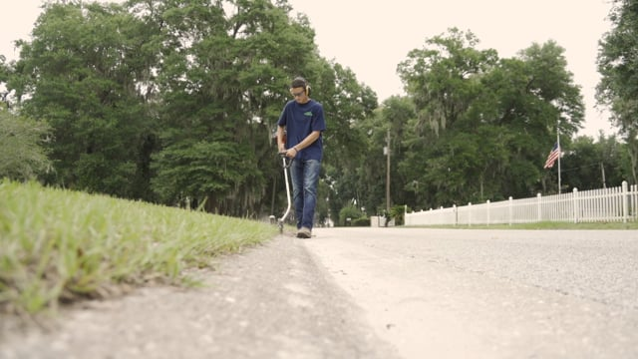
Denisha Washington – SAE – Pet Store | Denisha’s SAE is working at a local pet store, Pet’s Palace in Louisville, Ky. Some of her main responsibilities include cleaning cages, prepping feed, and feeding and watering the animals. | 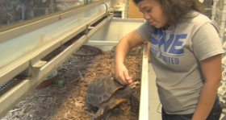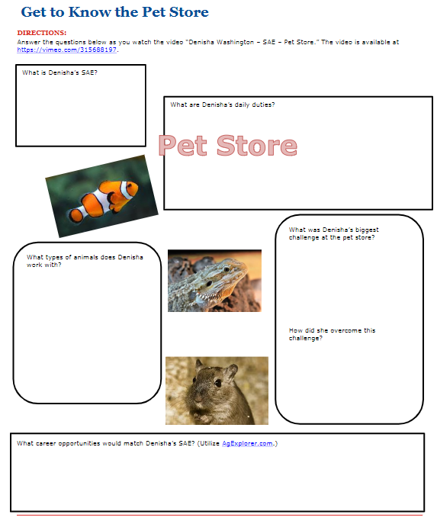
Emily Seifert – SAE – Agricultural Communications | Emily’s SAE is in agricultural communications. She writes blog posts for the agriculture blog Raised in a Barn. Her blog posts are also featured on her chapter’s website. | 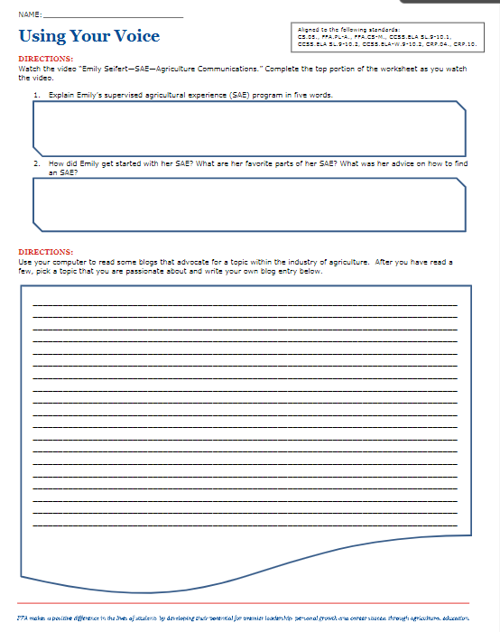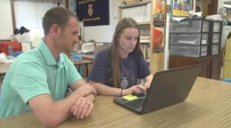
Eric Moen – Wildlife Production and Management SAE | Eric Moen’s SAE combines his passions of wildlife, educating others and trapping. Learn more about how Eric uses dermestid beetles to clean wildlife skulls and educate students in his school. | 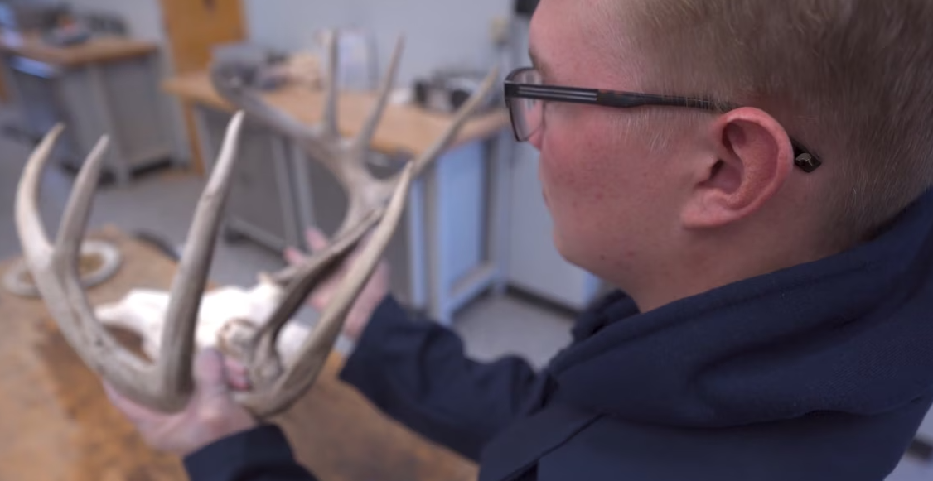
Ethan Sheldon – Vermicomposting | Ethan’s SAE is vermicomposting or composting with worms. With this SAE, he tests a variety of factors such as soil pH and the temperature and moisture content of the soil. | 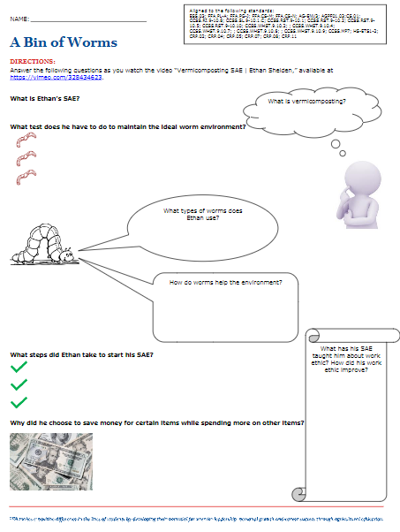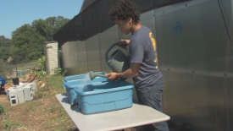
Fiona Haggerty – SAE – Mapping of River | Fiona’s SAE is mapping the Quinnipiac River and trail and helping the Quinnipiac River and Trail Committee. She was motivated to start this particular SAE because the river was close and she wanted to help the community. She has learned different paddling techniques and about Arc GIS technology. | 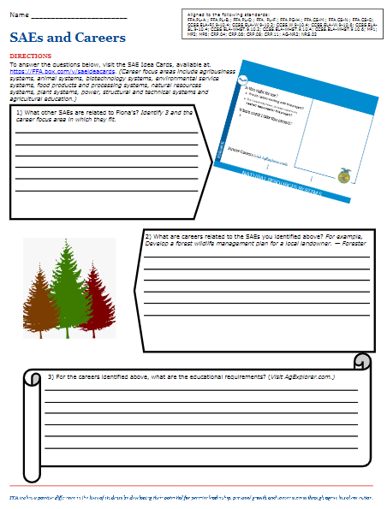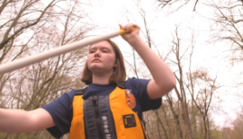
Generic SAE Video Activity Sheet | Use this generic SAE video activity sheet with any SAE video. | 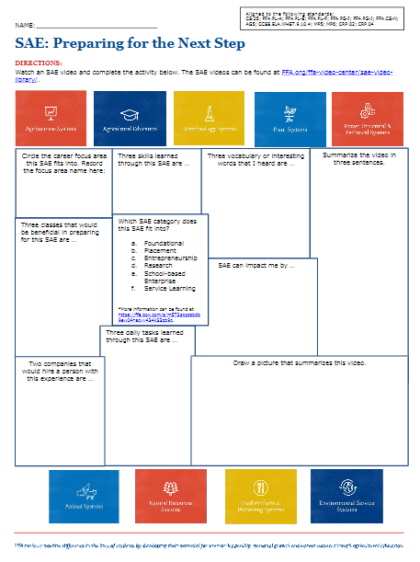
Giancarlo Lomanto – SAE – Pallet Planter | Giancarlo’s SAE is repurposing pallets into pallet planters. When working at a summer job, he noticed some old pallet planters that needed repairs. This sparked his interest to make improvements to the old ones and build new ones as well. He first had to determine what materials he would need for the job. | 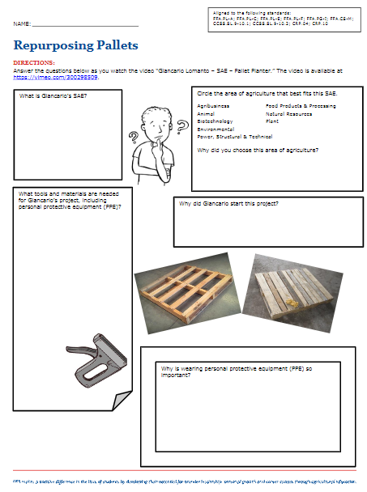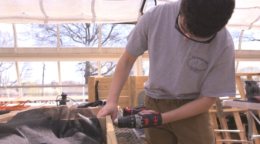
Giovanni and Luke – SAE – Olive Oil | Giovanni and Luke’s SAE is a school-based enterprise working on the school farm where they fertilize, label and harvest the olive oil. Some skills they have learned through this SAE are hard work and communication. | 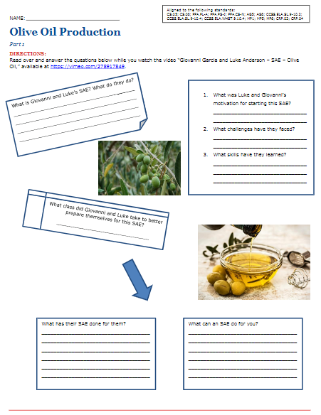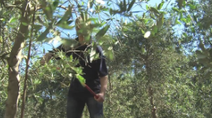
Hannah and Grace – SAE – Ctenophores | Grace and Hannah’s SAE is culturing mnemiopsis leidyi to study the bio-luminescence of the organism, also called ctenophore, which may be used in humans to trace the brain patterns of patients with PTSD. | 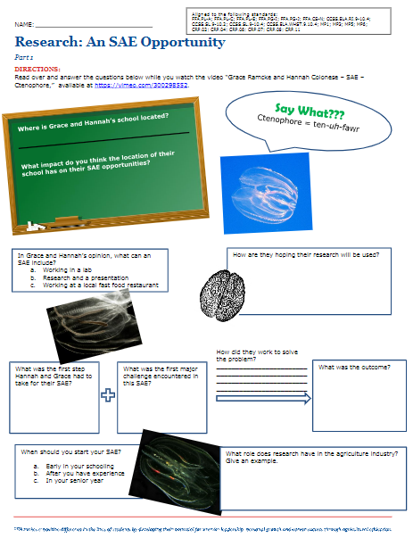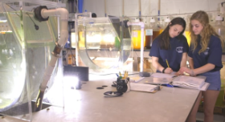
Jackson Brossart – Fishing Lure SAE | Jackson Brossart’s SAE has taught him how to take a hobby and turn it into an SAE. Learn how you can take a hobby and turn it into an SAE and, ultimately, a future career. | 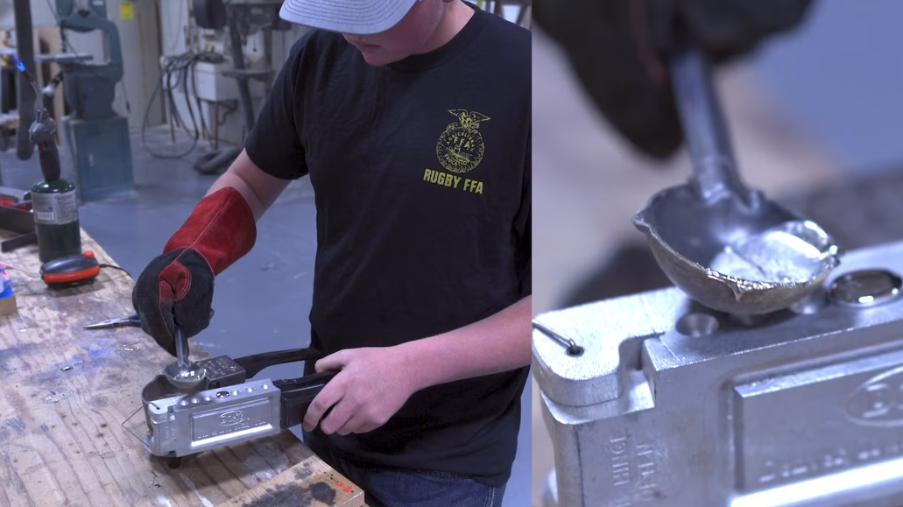
Jacob Reed – SAE – Drones in Agriculture | Jacobs’ SAE is drones in agriculture and is in the agricultural business career focus area. When Jacob was younger, he was interested in radio control technology and helping people. With this SAE, he can combine both interests. Check his video out to learn more about his SAE and some of his daily responsibilities. | 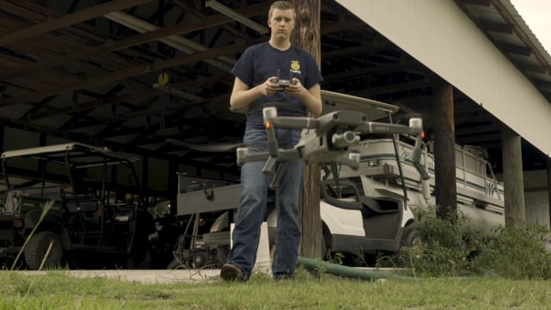
Ja’Kolboe Jones – SAE – Backyard Chickens | Ja’Kobi’s SAE is raising chickens in his backyard. He has thirteen chickens and a chicken coop as part of his SAE. He made modifications to his chicken coop to make it fit in his backyard and to have enough room for the chickens. Other duties include collecting eggs and feeding and watering the chickens. | 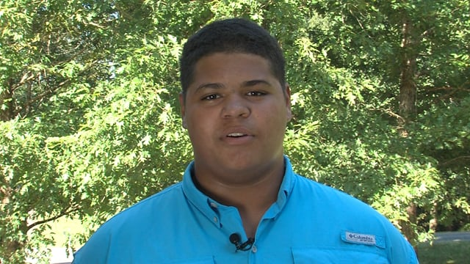
Jared Mudd – SAE – Ranch Foreman | Jared’s SAE is serving as a ranch foreman for an orchard. He works on planting trees, checking trees, irrigating, etc. He grew up in the area and saw that a lot of people were getting into the orchard business, and he wanted to learn more. | 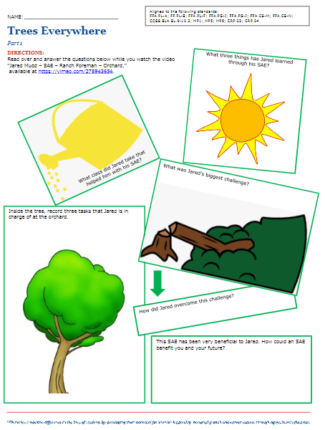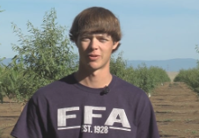
Jared Poldervaart – SAE – Dairy Farm | Jared’s SAE is working on his family dairy farm where they farm 270 acres and have 850 dairy cattle. Some of the beginning steps he had to take for his SAE were getting more involved with the dairy and learning about genomic testing and how it is applied to the herd. | 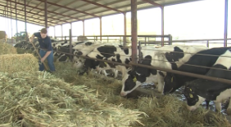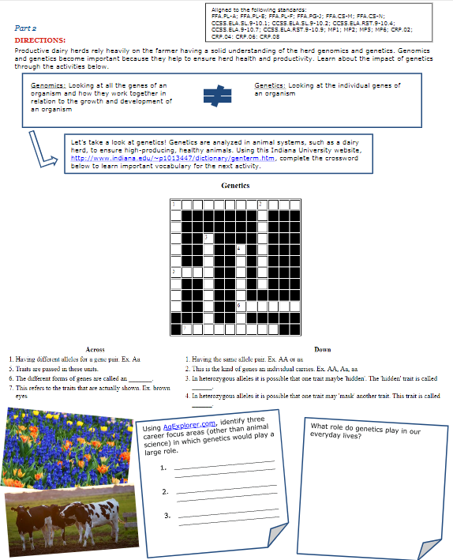
Jeremiah Hager – SAE – Agricultural Mechanics | Jeremiah’s SAE is agricultural mechanics where he works on a variety of equipment such as tractors, skid steers, trucks, trailers, etc. | 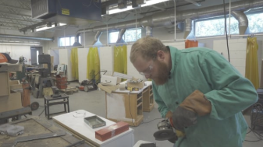
Joe Lindberg – Minnow Trapping SAE | Follow Joe Lindberg as he explains his minnow trapping SAE. Then dive deep into the various aspects of the aquaculture and fishery industries and careers within those industries. | 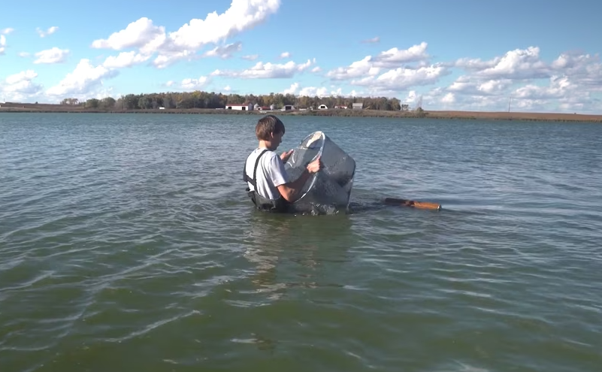
John Zuppan – SAE Prune Orchard | John’s SAE is working in his family’s prune orchard. He performs various tasks through his prune orchard SAE, such as pruning, painting the trees to prevent sunburn, mowing, etc. Through his SAE, one thing he has learned is the true meaning of hard work. | 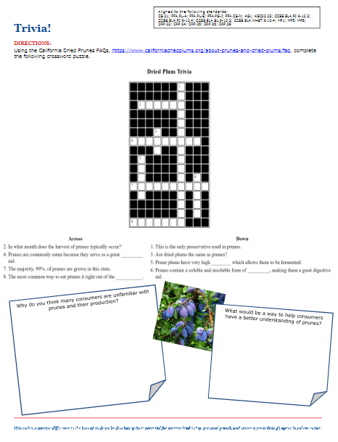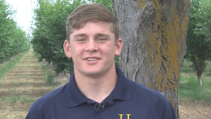
Jordan Butler and Amari Manago – SAE – Research Composting | Jordan and Amari’s SAE is research-based, researching the barriers to urban composting. They wanted to determine ways to reduce solid waste. Additionally, they wanted to help others learn to compost. | 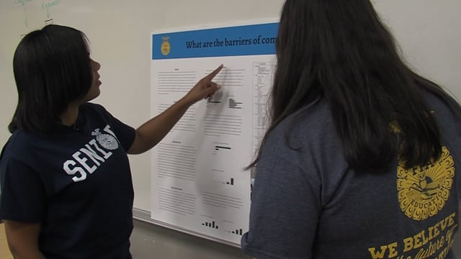
Josh Greene – SAE – Urban Rabbits | Josh’s SAE is breeding and selling rabbits. Josh has three breeds of rabbits that he works with and shows. His SAE is unique in that he conducts his SAE in the backyard of his house that is in an urban setting. | 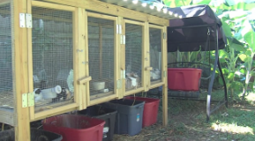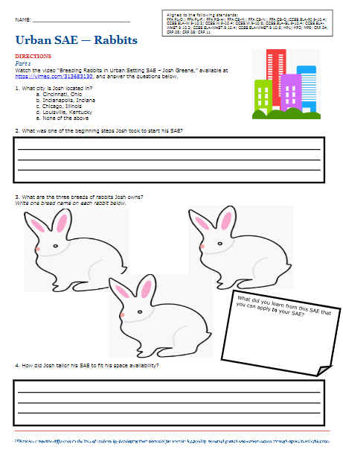
Kami Harmon – SAE – Sheep | Kami’s SAE is caring for and working with her lambs to get them show ready. | 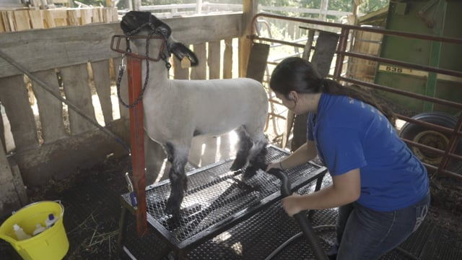
Katelynn Merrifield – SAE – Pet Grooming | Katelynn’s SAE is in pet grooming, working at Hounds Tooth and Cats Meow in Louisville, Ky. Some of her daily responsibilities are cleaning kennels, shaping the dogs’ fur, bathing and cutting the dogs’ nails. One of her favorite things about her SAE is seeing the dogs each day. | 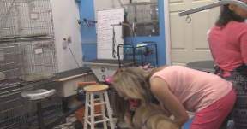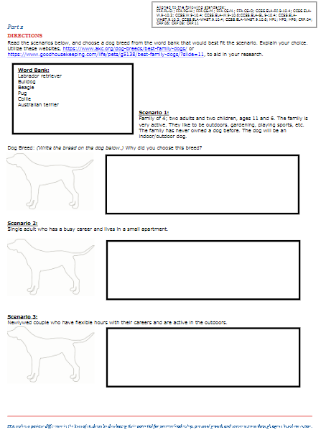
Kayley Pennington and Cheyenne Bolender – SAE – Composting | Kayley and Cheyenne’s composting SAE consists of taking the food waste from their school cafeteria to their compost bin located on their land lab. They use the compost to create healthy soil for the agriculture department. | 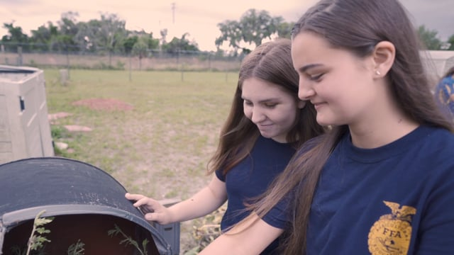
Keegan Humm – SAE – Placement – Implement Dealership | Keegan has a placement SAE working at a local implement dealership. Some favorite aspects of his SAE are seeing coworkers every day and seeing behind the scenes of the business. He has learned valuable skills such as teamwork and communication. | 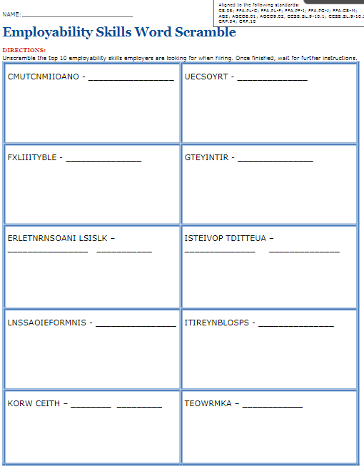  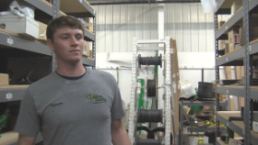
Kent Sloan – SAE – Specialty Animal Production – Seafood | Kent’s SAE is working in the family business at Sloan’s Seafood. Watch this video to learn the details about clam production from harvesting to processing. | 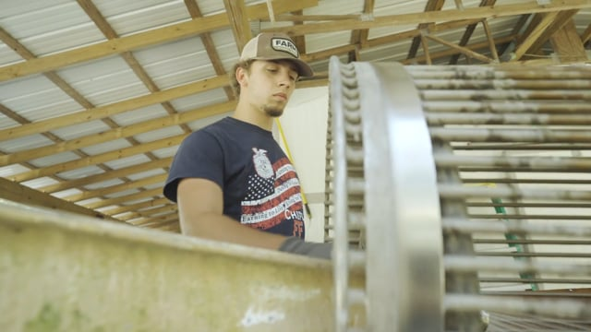
Kristina Budris – SAE –Broadhead Arrowhead | Kristina’s supervised agricultural experience (SAE) program is in agricultural sales working with broadhead arrow tips. | 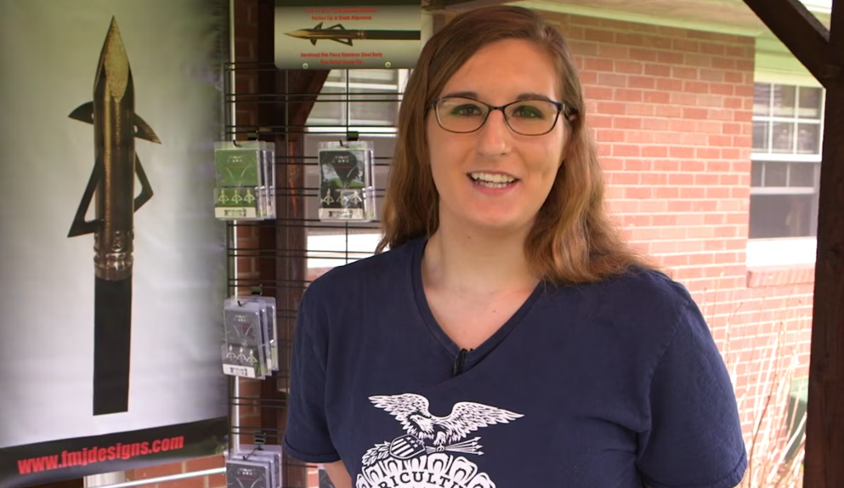
Kristyn Bauer – Ag Education SAE | Through Kristyn Bauer’s SAE, she helps others experience chicken egg incubation and hatching. | 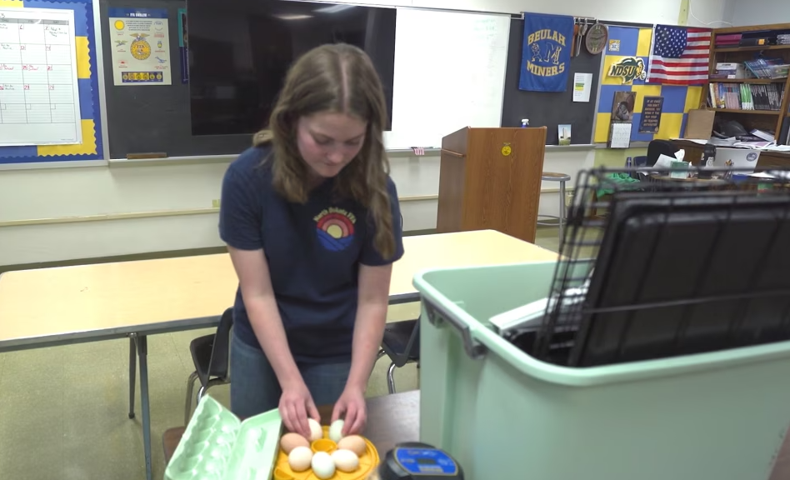
Kyle Tintzman – SAE – Forage and Grain Crop Production Lesson Plan | Learn about Kyle’s SAE in forage and grain crop production through this video and activity. | 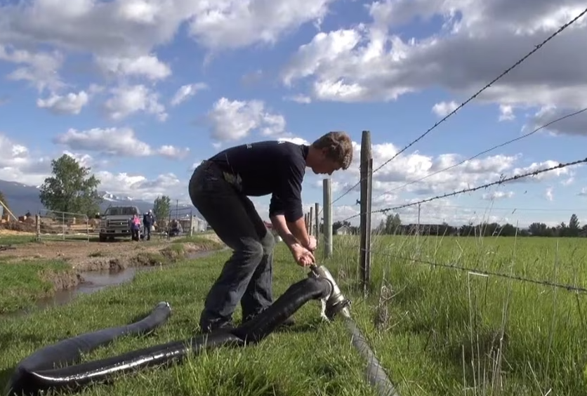
Kylie Skadberg – Meat Processing SAE | Meat processing is a unique SAE and career path. In this lesson, learn how Kylie Skadberg got started in her SAE. Students will also learn what part of the animal different cuts of beef, pork and lamb come from. Finally, they’ll explore the everyday products we use that come from animal products. | 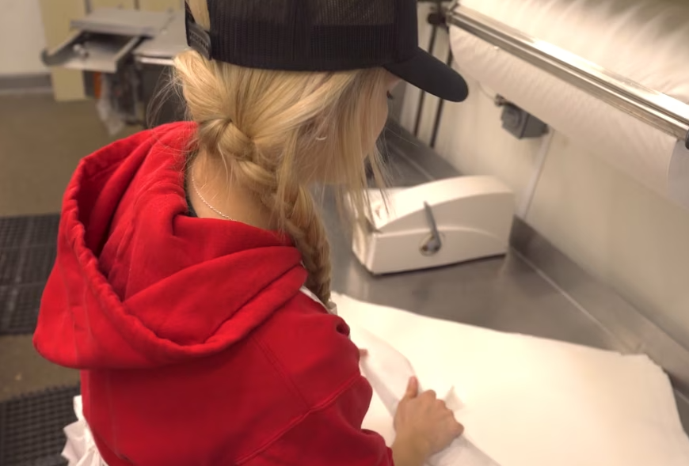
Lane Drewery – Farm and Research Associate SAE | Learn about Lane Drewery’s agricultural research SAE. Explore what happens at the agricultural research company he works at and then discover the agricultural research sites in your own state from land-grant universities. | 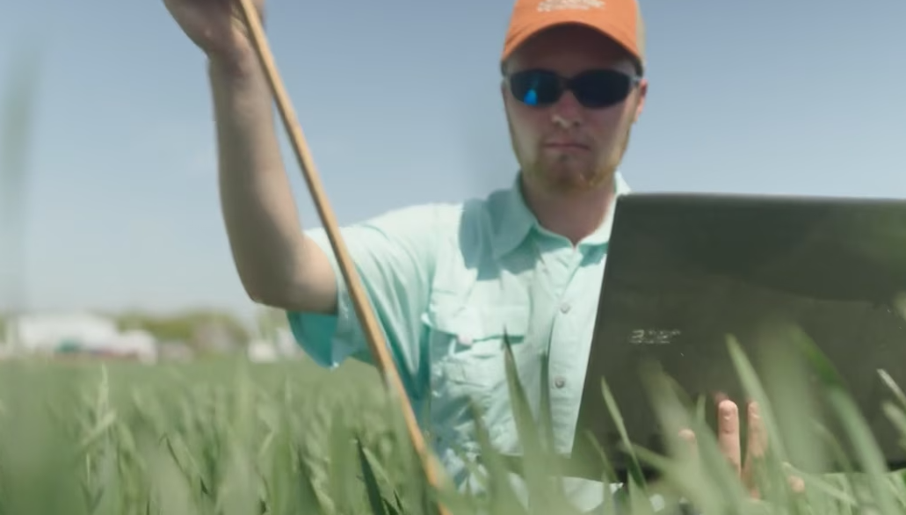
Lilly Richello – SAE – Blue Lobster | Follow Lilly as she walks us through her supervised  agricultural experience (SAE) program working in the lab with blue lobsters. She shows us her daily tasks and responsibilities as well as the challenges with the lobsters. | 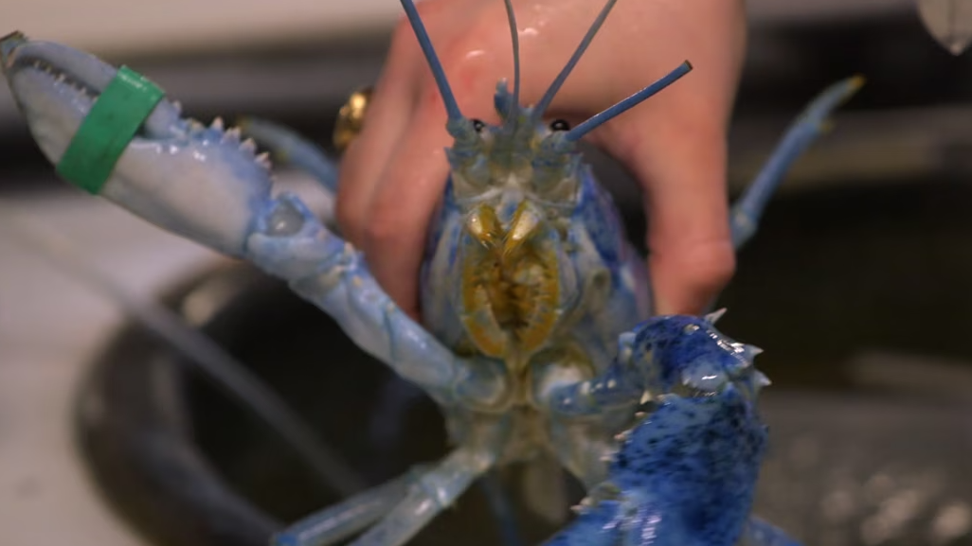
Lindsay, Eric, Kailey Lipka –SAE – School Garden and Food Dishes | These siblings’ SAE is working in the school garden to grow various crops, which they then use to make food dishes such as salsa. They got started with this SAE because they wanted to do something together. Their teacher helped them to plan the garden and create a schedule of crops. | 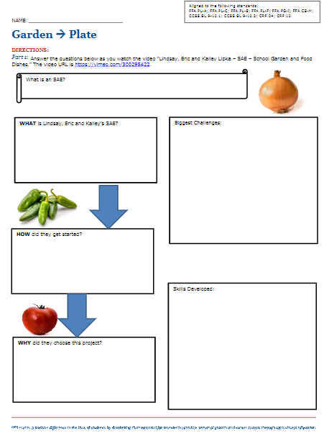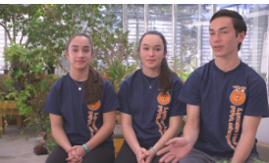
Maci Amaro – SAE – Goat Program | Maci’s SAE is managing and organizing the Mighty Honker Goat program. This program is for students with disabilities so they can raise, show and sell a goat at the county fair. The students inspired Maci to start this program, and she wanted to make sure they felt included in the FFA chapter. | 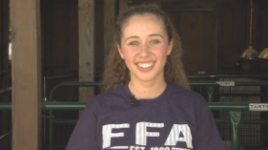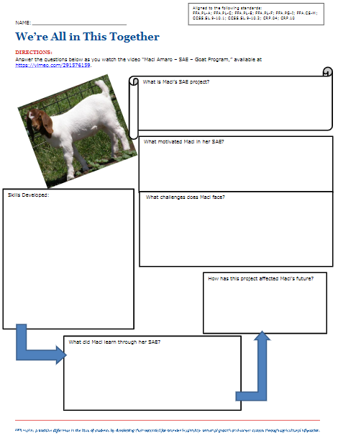
Madalyn Nissen – SAE – Bucke’s Feed and Grain | Madalyn’s SAE is working at her family’s feed and grain store, Bucke’s Feed and Grain. Madalyn’s SAE has grown from being given small tasks to taking on more responsibility, such as working the cash register by herself. | 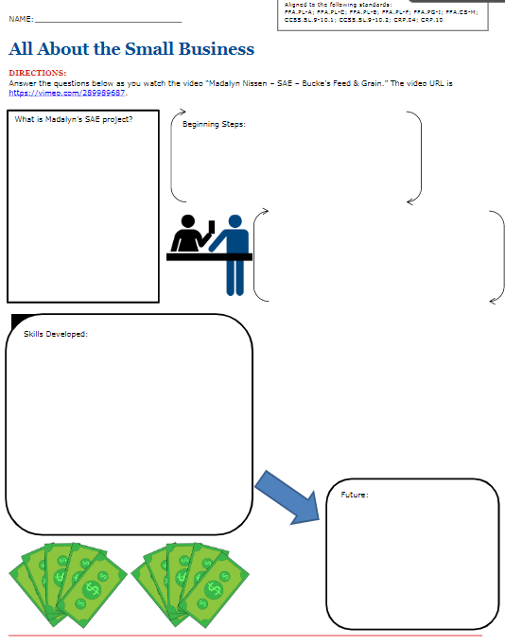  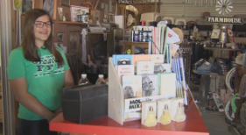
Maisie Jane Hurtado – SAE – Owner | Maisie Jane is an alumna of FFA and is the founder and owner of Maisie Jane’s California Sunshine products. Her SAE when she was in FFA was raising a flock of registered sheep. Later, she decided she wanted to get into the almond industry. She sold the registered sheep and used the money to buy her first 2,000 pounds of almonds, developed recipes for various food products and started selling locally. | 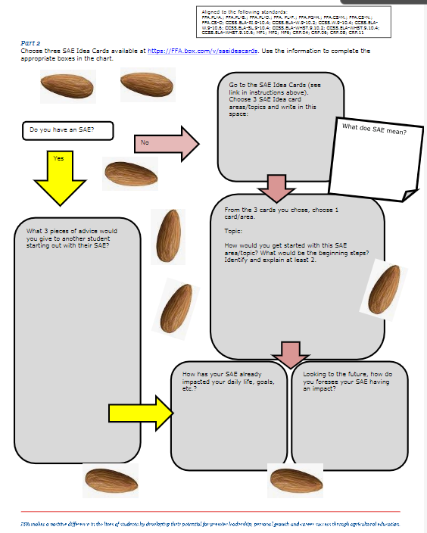
Kaylie Wilson – Market Swine SAE | Learn to step out of your comfort zone and start a new SAE raising market swine for show and food purposes. Kaylie’s SAE has taught her how to care for other living creatures and will help her with her future career as a nurse. | 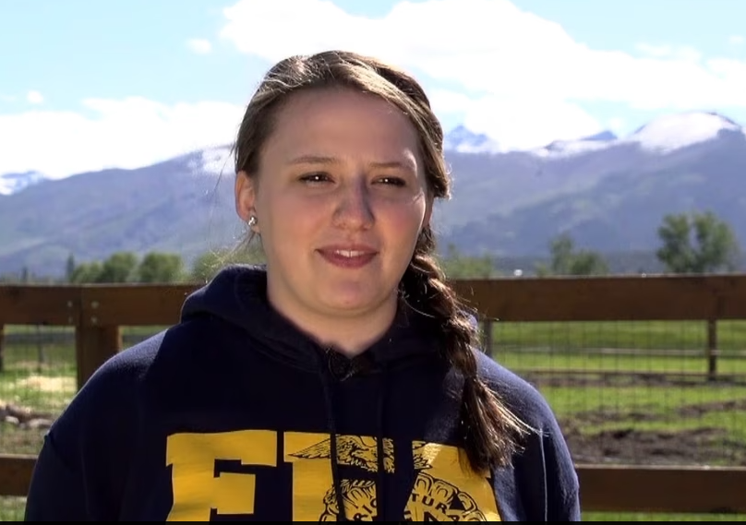
McKenzie Kline – SAE – Rabbits | McKenzie Kline’s SAE is raising rabbits. Her favorite part of her SAE is attending shows, which gives her the chance to travel and meet new people. | 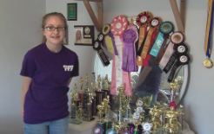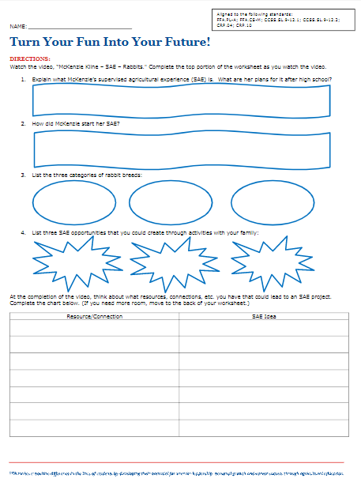
Michael Netherton – SAE – Sports Turf | Michael’s SAE is in sports turf management working at the Louisville Bats stadium on the grounds crew in Louisville, Ky. One of his favorite things about his SAE is being around baseball. | 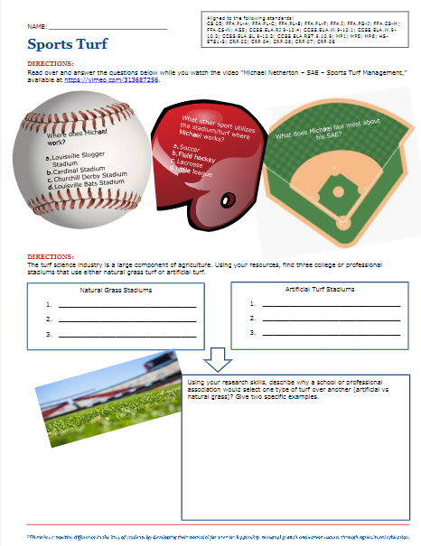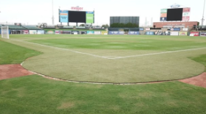
Michaela Carmichael – SAE – Mycelium | Michaela started her SAE when she noticed the effects pig waste was having on the environment. She wanted to determine a cost-effective way to help her pig’s health and the surrounding environment. That is when she turned to mycelium. | 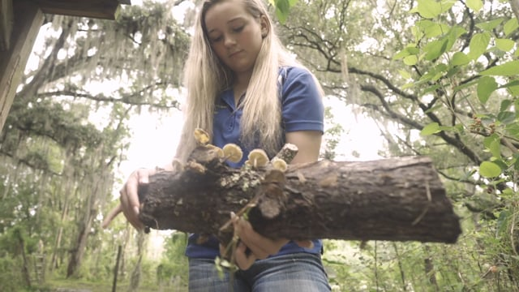
Mitch Hopkins – Fiber and Oil Crop Production SAE | Learn about Mitch Hopkins’s fiber and oil crop production SAE. Research a variety of topics focused on cotton by completing a choice board. | 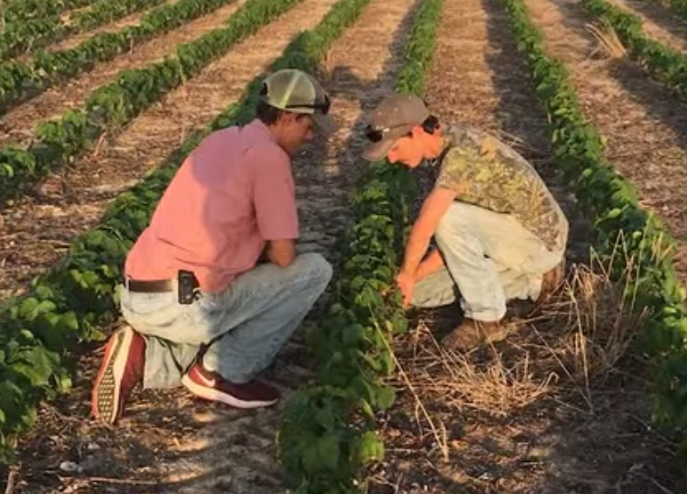
Morgan Weidow – SAE – Biomedical Research | Morgan’s SAE is in biomedical research with an internship at Rocky Mountain Laboratories, a biomedical research facility. Part of her responsibilities include assisting with laboratory procedures and experiments while also maintaining laboratory safety equipment. | 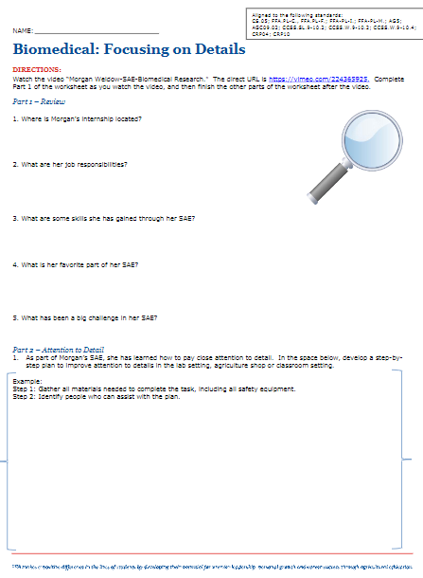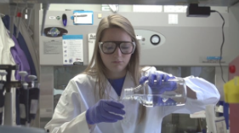
Natalie Massa – SAE – Cooperative | Natalie is an alumna of Willows FFA. While in FFA, her SAE was 12.8 acres of rice, 3.5 acres of olives and showing market sheep at the county fair. FFA, her SAEs and her agriculture teacher had a huge impact on her future and where she is today in her career as an agricultural loan officer. Her SAE showed her that she really enjoyed agriculture and talking with farmers and people within the agriculture industry. | 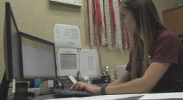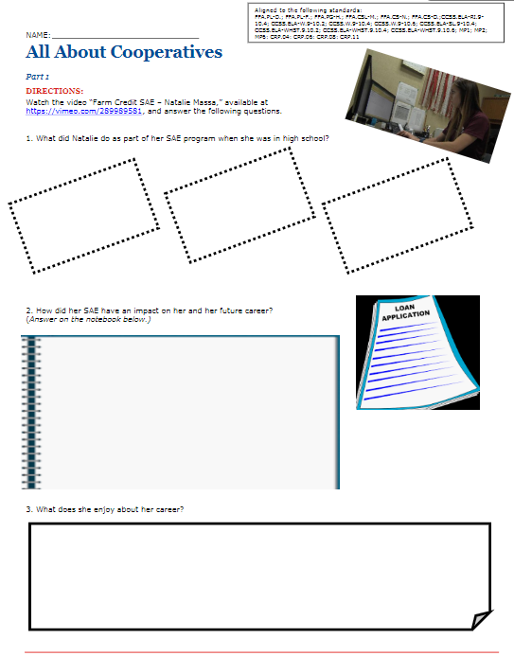
Nathan Gore – SAE – Mushroom Farming | Watch this video to learn about Nathan’s SAE of mushroom farming. Learn the process of growing, harvesting and producing mushrooms! | 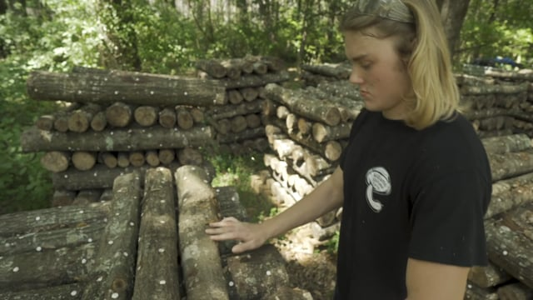
Nathan Laurenz – SAE –Beekeeping Lesson Plan | Learn about Nathan’s SAE of beekeeping through this video and lesson. | 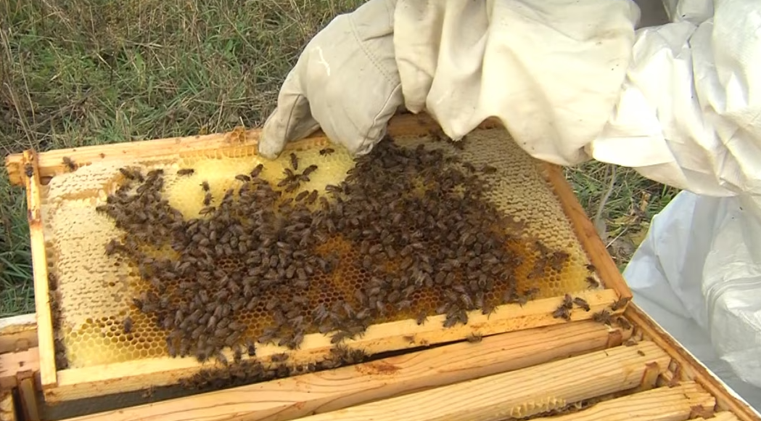
Nick Wulfekule – Outdoor Recreation SAE | Nick Wulfekuhle has used two different SAEs to continue to expand his knowledge and skills. Encourage your students to do the same with the activities in this lesson. | 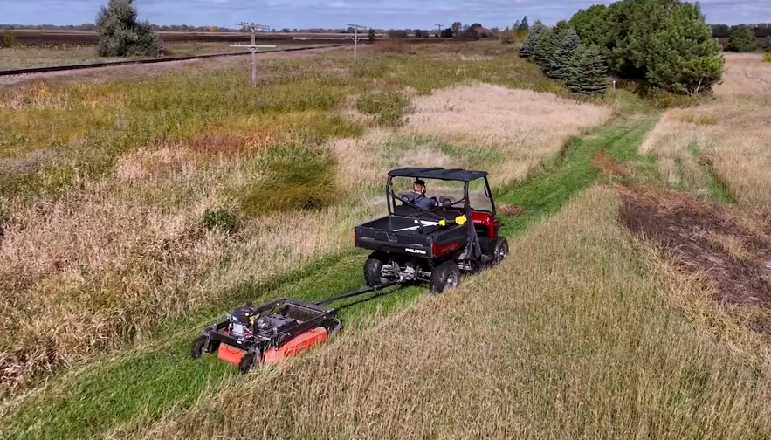
Nicole Ford – SAE – Louisville Zoo | Nicole’s SAE involves working at the Humane Society in Louisville, Ky., and at the Louisville Zoo. At the zoo, Nicole volunteers in the Meta Zoo (education center). Some of her daily responsibilities include cleaning the glass, cleaning cages, checking on the animals and showing visitors the animals. | 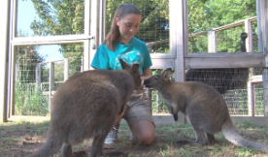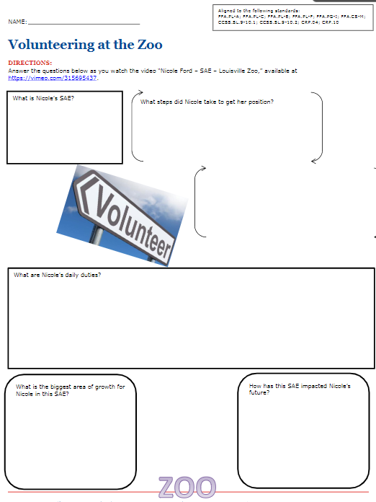
Payden Criswell – Catawba Worm Farming SAE | Follow Payden Criswell as he walks through a typical day in his Catawba worm farming SAE. Then, explore the world of integrated pest management. | 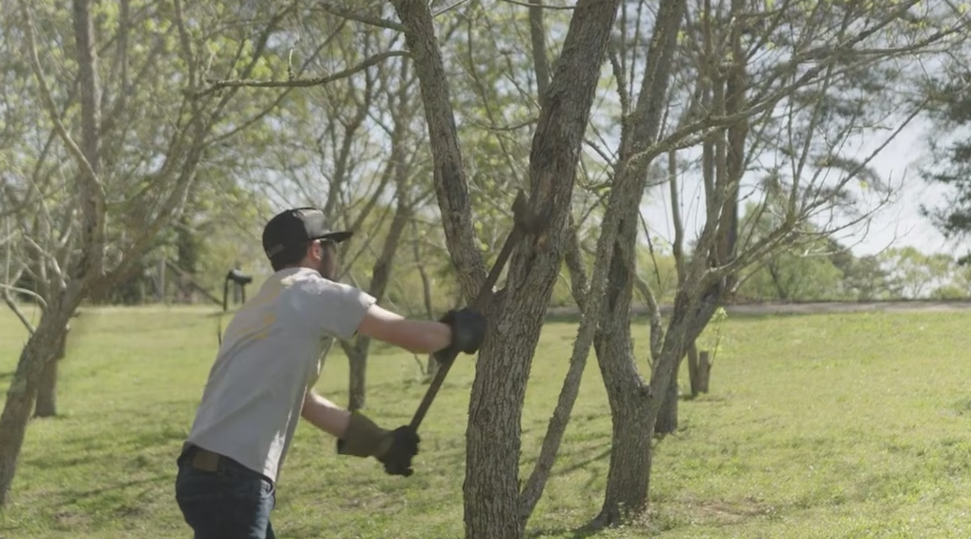
Peyton Moore – SAE – Agritourism | Peyton’s SAE is in agritourism. She works on her family’s pumpkin patch. On fall weekends, people can pick their own pumpkins, and Peyton helps to educate them about how pumpkins are grown and about agriculture in general. | 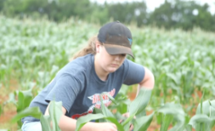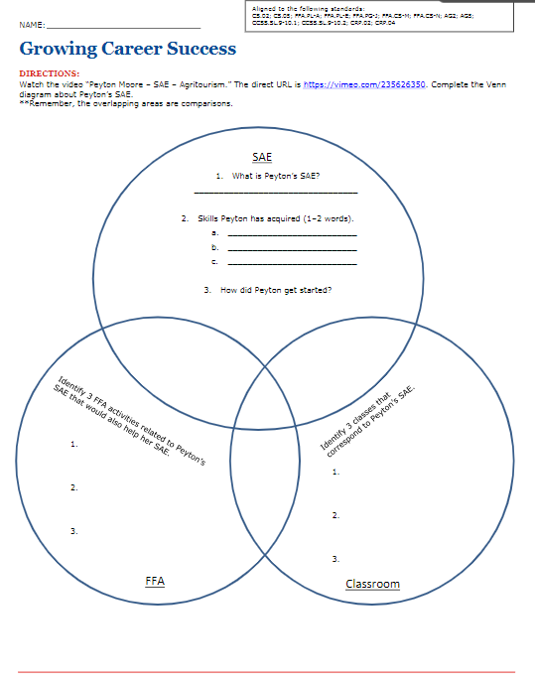
Raymond Pan – Recycling | Raymond’s SAE is recycling. His SAE involves collecting all the recyclables around his school and making sure they get recycled properly. He got interested through a similar activity at the Georgia state convention where they had to pick up trash. He realized there are a lot of waste issues and how important it is to recycle. | 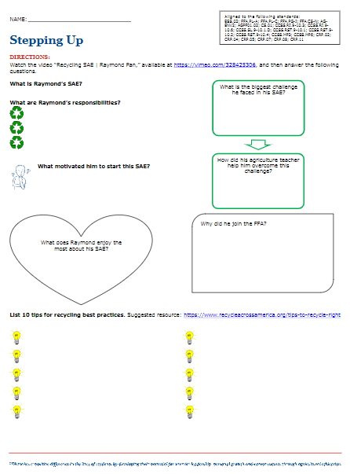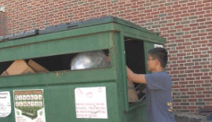
Rogelio Ceja – SAE – Poultry Lesson Plan | Rogelio helps manage the chapter’s poultry, which includes feeding and watering on the weekends. He raises the chickens for the Michigan broiler contest, and one of his favorite aspects of his SAE is seeing the growth progression of the chickens. | 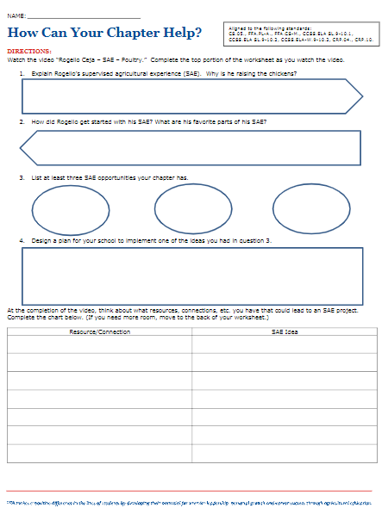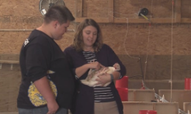
Rylah Hager – Advertising Signs SAE | This advertising signs SAE introduces students to the basics of marketing through signage. | 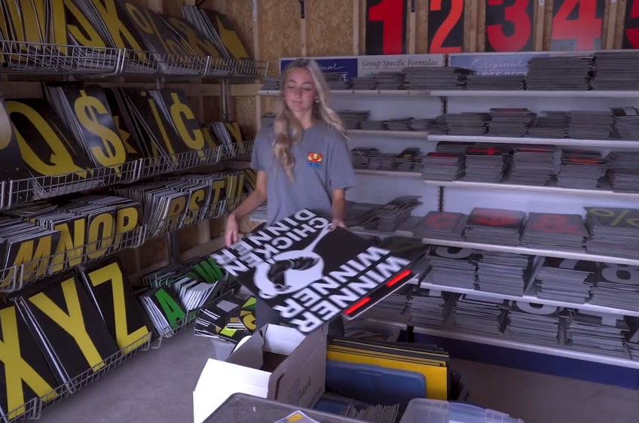
SAEs Inspiring Careers Videos | These videos have been recorded of industry representatives to showcase the impact that SAEs can and do have on future careers. | 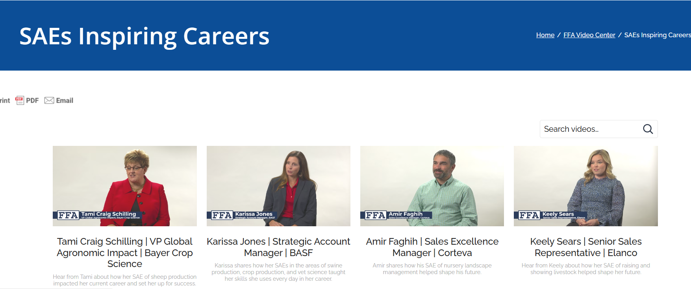
SAEs Inspiring Careers Video Activity | This activity is a generic worksheet to accompany the SAEs Inspiring Careers Videos. | 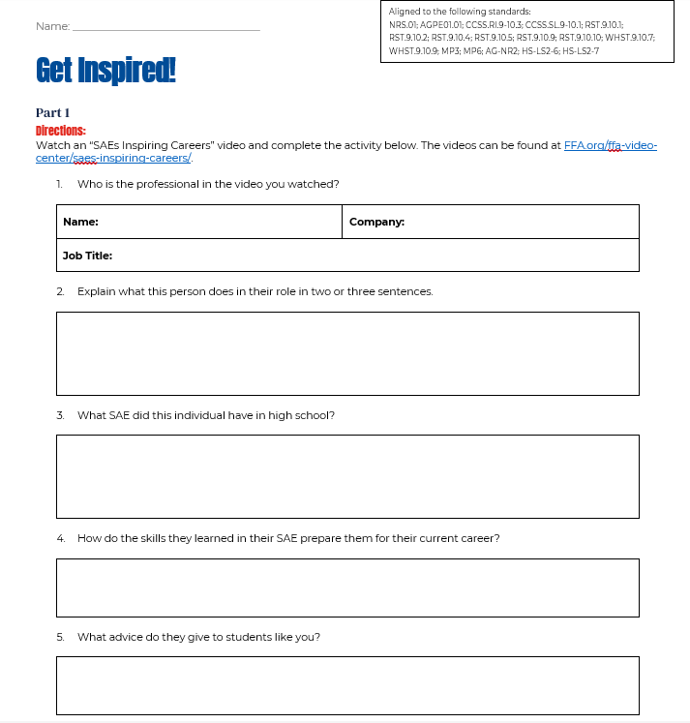
SAE Video Choice Board | This document serves as a resource to incorporate SAE videos into the classroom. These videos allow students to learn about and develop/enhance their SAEs. There are a series of choice boards available: six-week, nine-week, quarter, first-half of the semester and second-half of the semester. Choose the format that best suits your classroom. | 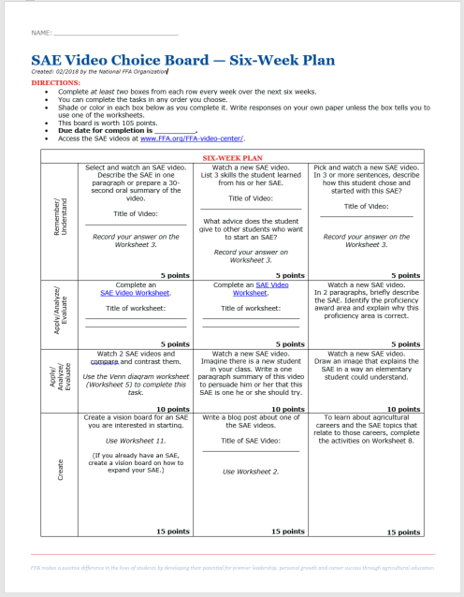
Sam Mills – SAE – Pine Straw | Sam’s SAE is baled pine straw through his family’s business. His daily tasks vary from season to season, but can include spraying, mowing, baling, raking, etc. | 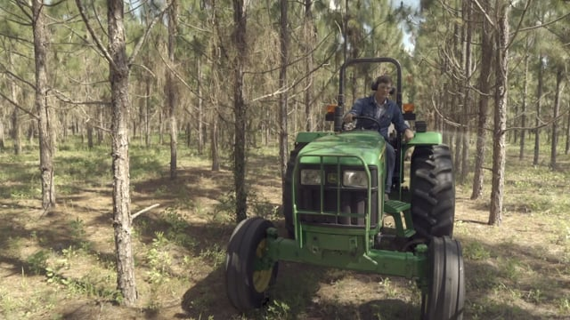
Silvio Barnes – SAE – Succulents | Silvio’s SAE involves working in the school greenhouse where he grows and propagates succulents. His SAE has grown from first having 15 plants to now having over 100. | 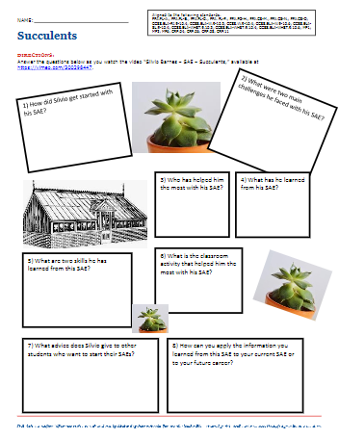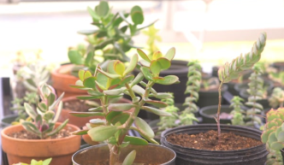
Sydnee Weintraut and Raelyn Butler – SAE – School Garden | Sydnee and Raelyn’s SAE is the school garden. Watch their video to learn about the planning process, what they do with the produce once harvested and how they have overcome challenges with their SAE. | 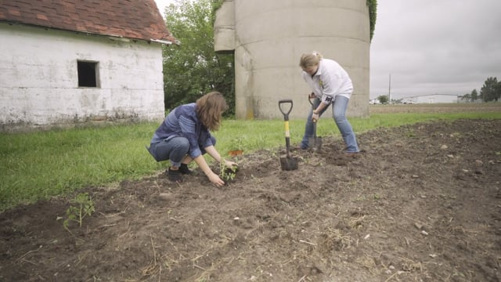
Taylor and Keegan Smith – SAE – Happy Souls Sock Ministry – Service Learning | Taylor and Keegan Smith’s SAE is “Happy Souls Sock Ministry” and is in the service-learning area. They got the idea for this SAE because they wanted to do something positive in the community and came up with the idea of donating socks to those in need. Watch this video to learn about the responsibilities of their SAE and how they work together as brother and sister. | 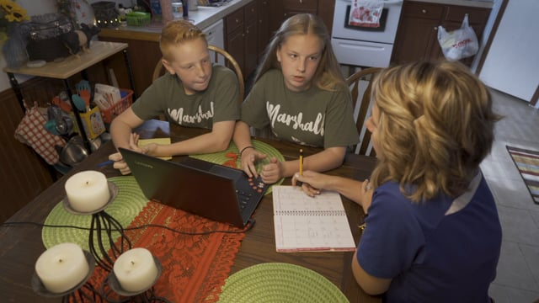
Tiffany Heishman – SAE – Goats Lesson Plan | Tiffany Heishman’s SAE is raising goats to sell for other young people to show. Her favorite part of her SAE is selling her goats to other kids that fall in love with them. | 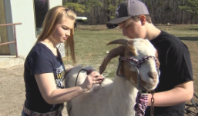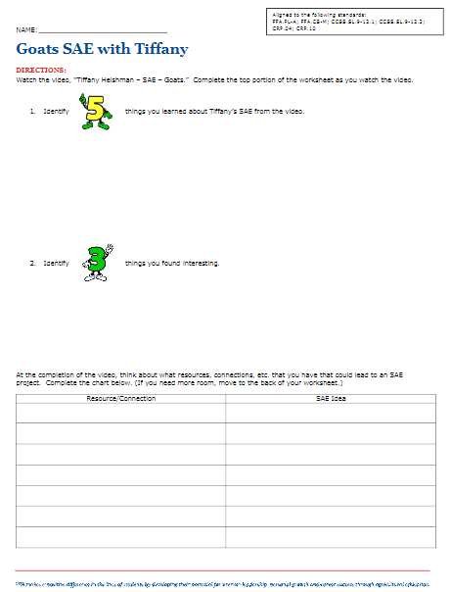
Trace Ward – Quail Management SAE | Learn about Trace Ward’s SAE in hatching and raising quail. Then, learn more about one of the five most common types of quail in the United States. | 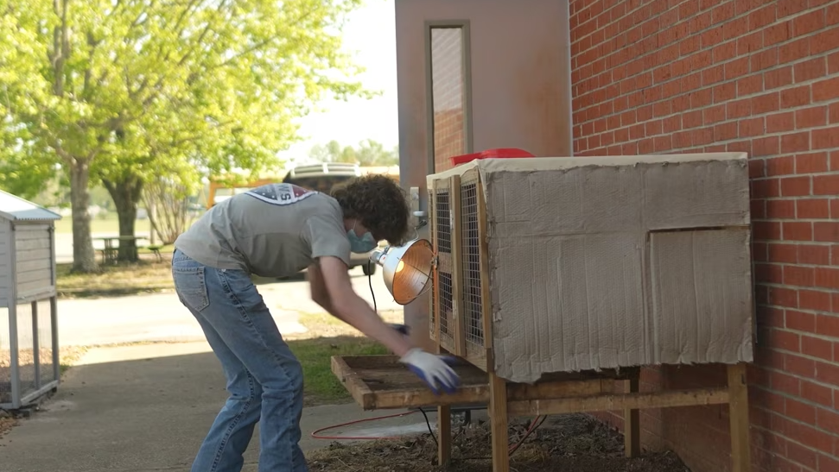
Tyler Hewitt – SAE – Turfgrass Management – Irrigation | Tyler’s SAE is turfgrass management and is in the plant systems career focus area. Tyler has learned about smart irrigation systems, technology and water conservation through his SAE. | 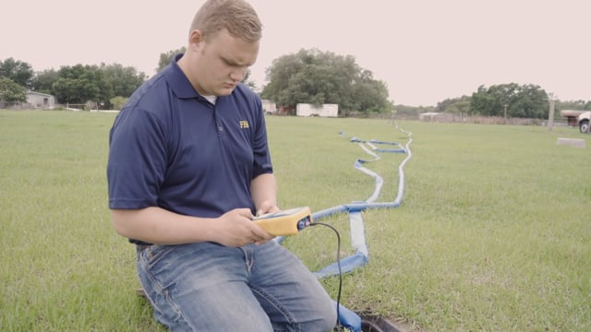
William Martin – Fruit Production SAE | This fruit production SAE introduces students to the basics of cultivating and managing fruit crops. | 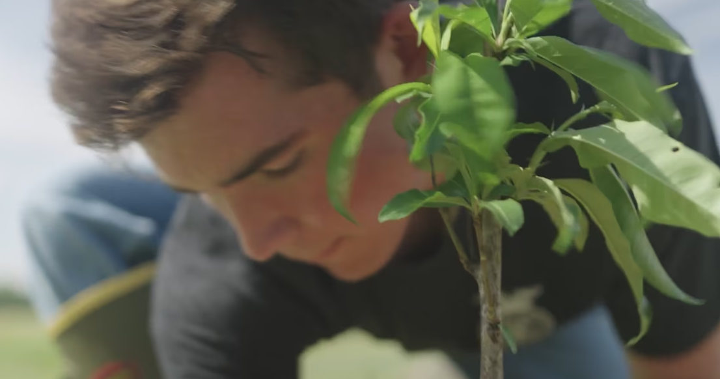

Full SAE Lesson Plans
Four Things to Consider for a Regenerative Agriculture SAE | Regenerative agriculture: What is it? What does it mean? In this lesson, students will learn what regenerative agriculture means and tips for considering it in their SAEs. Additionally, students will learn how one company is involved in regenerative agriculture. | 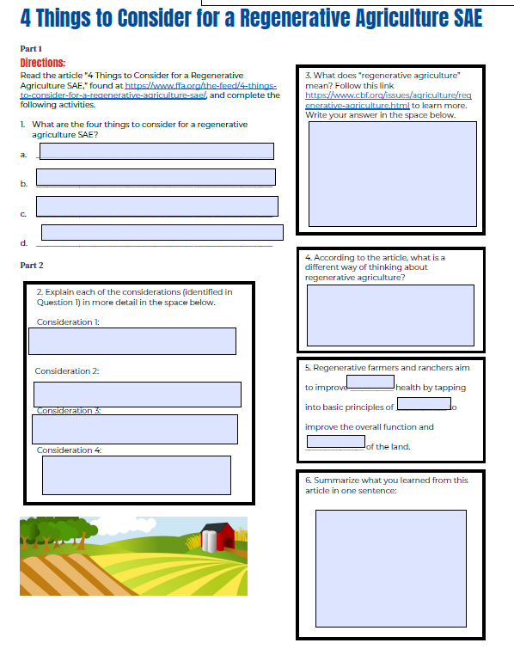
Get Started With an SAE | Supervised agricultural experiences (SAEs) allow students to apply what they have learned in the classroom in a real-world setting. Before getting to that step, students will first need to determine their SAE. This lesson will help introduce SAEs to students. | 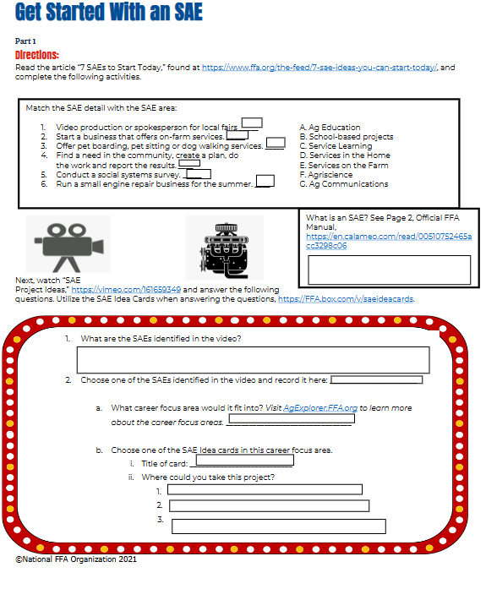
Rabo Agrifinance: Five Tips and Tricks to Build SAEs | Learn about five tips and tricks to help build your SAE from Rabo Agrifinance. | 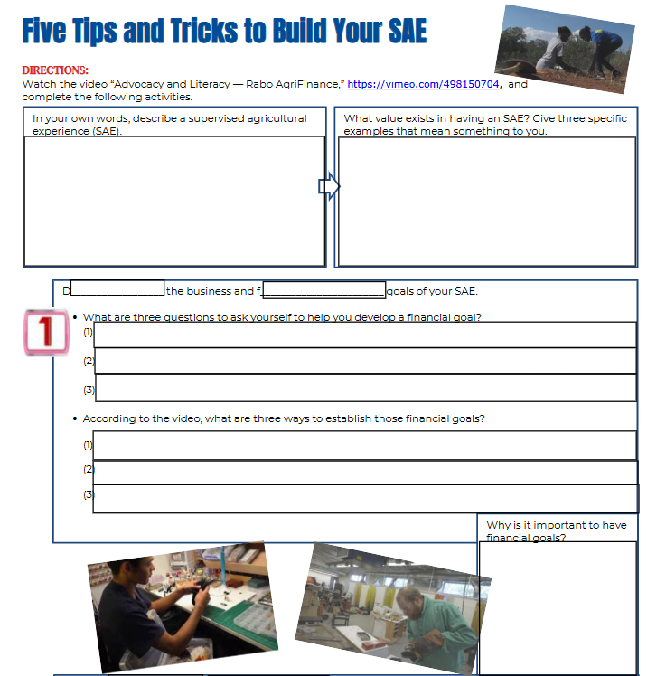
SAE Monopoly | Introduce students to the vast SAE opportunities available to them through playing SAE Monopoly, allowing them to think critically and brainstorm SAEs for themselves and their peers. | 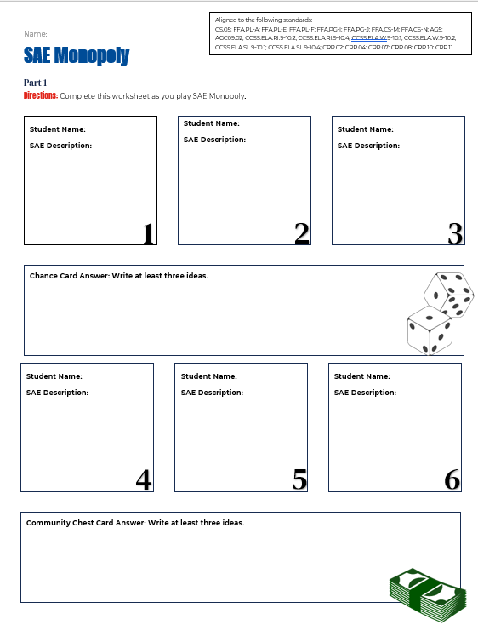
SAE Planning | Students will plan out their SAEs. | 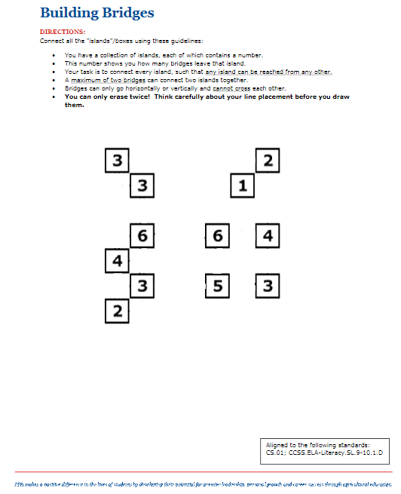
SAE: Start Small, Grow Big | Students explore how to grow their SAEs. | 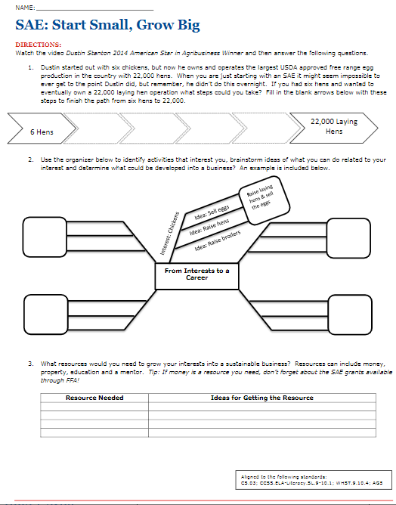
SAE: What Should I Do? | Students will learn about different SAEs and then develop SMART goals. | 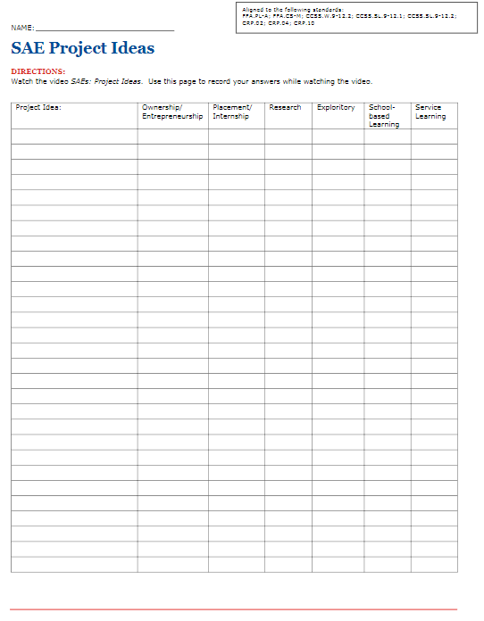
Teacher Created SAE Resources | These SAE resources were created by teachers across the country. | 