Pine Needles Everywhere
Aligned to the following standards:
PL-A.; PL-F.; PG-I.; PG-J.; CS-M.; CS.01; CS.02; CS.05; CS.06; CCSS.RI.9-10.1; CCSS.RI.9-10.4; CCSS.W.9-10.1; CCSS.W.9-10.2; CCSS.W.9-10.4; CCSS.W.9-10.9; CCSS.SL.9-10.1; CCSS.SL.9-10.4; CCSS.SL.9-10.6; CCSS.L.9-10.6; CRP.02; CRP.04; CRP.07; CRP.08
Directions:
Answer the questions below as you watch the video “Pine Straw SAE | Sam Mills,” available at https://vimeo.com/368437993.

What is Sam’s SAE?

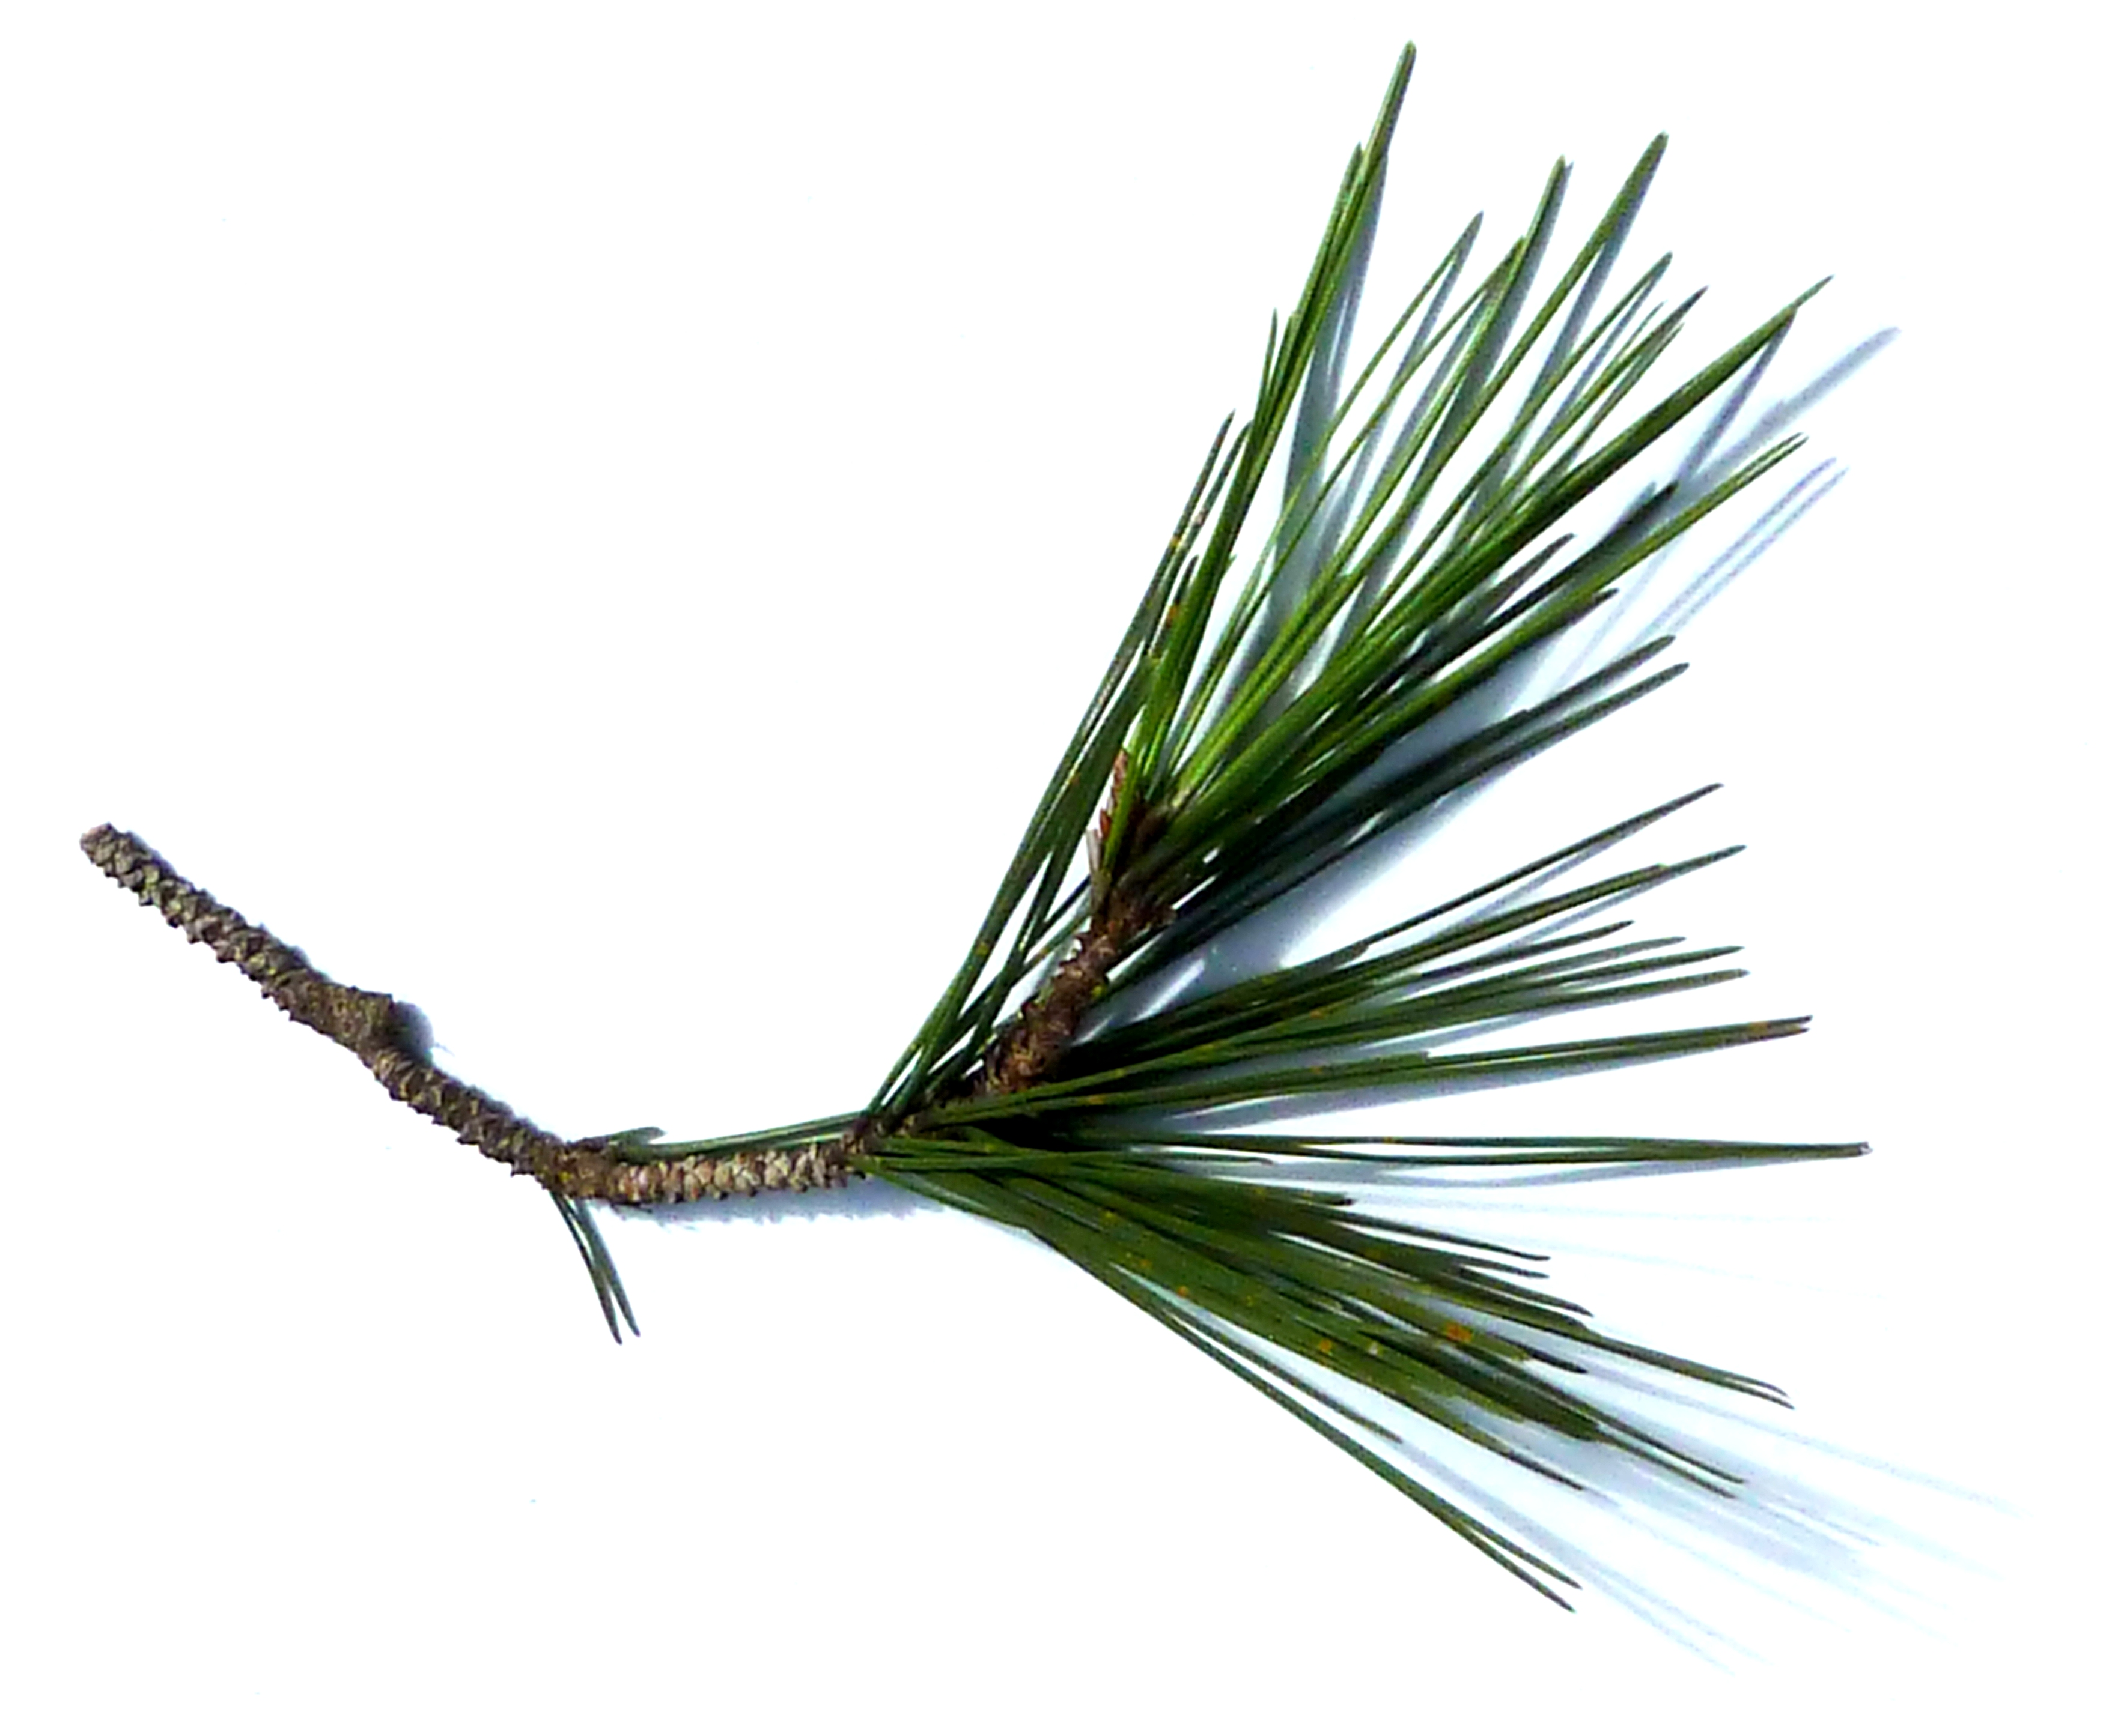
Where does pine straw come from?

Where is it used?

What does pine straw do?

How did Sam get started in his SAE?

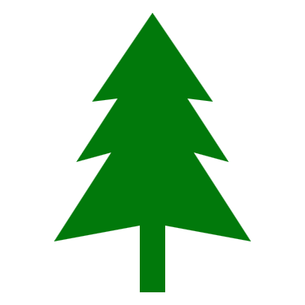
What are his daily tasks?

How have his agriculture classes helped him with his SAE?

What safety gear does Sam use when spraying pesticides?


What is special about the baler?

To Straw or To Mulch?
Aligned to the following standards:
PL-A.; PL-F.; PG-I.; PG-J.; CS-M.; CS.01; CS.02; CS.05; CS.06; CCSS.RI.9-10.1; CCSS.RI.9-10.4; CCSS.W.9-10.1; CCSS.W.9-10.2; CCSS.W.9-10.4; CCSS.W.9-10.9; CCSS.SL.9-10.1; CCSS.SL.9-10.4; CCSS.SL.9-10.6; CCSS.L.9-10.6; CRP.02; CRP.04; CRP.07; CRP.08
Directions:
There are numerous materials that are used in landscaping to control weeds and retain moisture. Two of the most common materials are pine straw and mulch. Which is better? Complete the charts below to examine the pros and cons of both pine straw and mulch. (Suggested Resource: “Should I Use Mulch or Pine Straw?,” https://www.canopylawncare.com/blog/should-i-use-mulch-or-pine-straw)

- Research the PROS of pine straw and mulch, and then use the questions below to compare those advantages.

Pros of _________________________________

and

Pros of _________________________________
What are similarities that EVERYONE would recognize?

What are similarities that NO ONE would recognize?

Similarities
What are differences that EVERYONE would recognize?

What are differences that NO ONE would recognize?

Differences

- Research the CONS of pine straw and mulch, and then use the questions below to compare those disadvantages.

Cons of _________________________________

and

Cons of _________________________________
What are similarities that EVERYONE would recognize?

What are similarities that NO ONE would recognize?

Similarities
What are differences that EVERYONE would recognize?

What are differences that NO ONE would recognize?

Differences

- Using specific examples from what you learned about the pros and cons of pine straw and mulch, write one paragraph explaining which you would use and why. Do this on a separate piece of paper.

