Pine Straw
Created: 07/2020 by the National FFA Organization

Sam Mills’ supervised agricultural experience (SAE) program is a baled pine straw business. Discover how his responsibilities and tasks change as the seasons change.

Student Learning Objectives:
After completing these activities, students will …
- Examine the work that goes into producing pine straw for landscaping.
- Compare and contrast the advantages and disadvantages of pine straw and mulch.
- Consider whether pine straw or mulch seems more advantageous.

Time Required: 90 minutes
Resources/References:
- Video: “Pine Straw SAE | Sam Mills,” https://vimeo.com/368437993
- Article: “Should I Use Mulch or Pine Straw?” https://www.canopylawncare.com/blog/should-i-use-mulch-or-pine-straw

Equipment and Supplies Needed:
- A copy of the “Pine Needles Everywhere” worksheet for each student
- A copy of the “To Straw or To Mulch” worksheet for each student
- Internet access to play the video in real time or embed it in a PowerPoint ahead of time

Student activity sheets:
Direct access to student activity sheets without lesson plan or answer key for easy upload to learning management system or printing for classwork.
https://ffa.box.com/s/sqe439u4yzv91qs931qysxs3v21o19bx (Word)
https://ffa.box.com/s/7v5f2xdggei4jr7sca81c7o05d78b9zs (PDF)

Cross-Curricular Connections:
English/Language Arts
Write a short assessment considering whether pine straw or mulch seems more advantageous.

These activities are aligned to the following standards:
FFA Precept
- FFA.PL-A.Action: Assume responsibility and take the necessary steps to achieve the desired results, no matter what the goal or task at hand.
- FFA.PL-F.Continuous Improvement: Accept responsibility for learning and personal growth.
- FFA.PG-I.Professional Growth: Assume responsibility for attaining and improving upon the skills needed for career success.
- FFA.PG-J.Mental Growth: Embrace cognitive and intellectual development relative to reasoning, thinking and coping.
- FFA.CS-M.Communication: Effectively interact with others in personal and professional settings.
AFNR Cluster Skills
- CS.01. Analyze how issues, trends, technologies and public policies impact systems in the Agriculture, Food & Natural Resources Career Cluster.
- CS.02. Evaluate the nature and scope of the Agriculture, Food, and Natural Resources Career Cluster and the role of agriculture, food, and natural resources (AFNR) in society and the economy.
- CS.05. Describe career opportunities and means to achieve those opportunities in each of the Agriculture, Food & Natural Resources career pathways.
- CS.06. Analyze the interaction among AFNR system in the production, processing and management of food, fiber and fuel and the sustainable use of natural resources.
Common Core – Reading: Informational Text
- CCSS.ELA-LITERACY.RI.9-10.1 Cite strong and thorough textual evidence to support analysis of what the text says explicitly as well as inferences drawn from the text.
- CCSS.ELA-LITERACY.RI.9-10.4 Determine the meaning of words and phrases as they are used in a text, including figurative, connotative, and technical meanings; analyze the cumulative impact of specific word choices on meaning and tone (e.g., how the language of a court opinion differs from that of a newspaper).
Common Core – Writing
- CCSS.ELA-LITERACY.W.9-10.1 Write arguments to support claims in an analysis of substantive topics or texts, using valid reasoning and relevant and sufficient evidence.
- CCSS.ELA-LITERACY.W.9-10.2 Write informative/explanatory texts to examine and convey complex ideas, concepts, and information clearly and accurately through the effective selection, organization, and analysis of content.
- CCSS.ELA-LITERACY.W.9-10.4 Produce clear and coherent writing in which the development, organization, and style are appropriate to task, purpose, and audience.
- CCSS.ELA-LITERACY.W.9-12.9 Draw evidence from literary or informational texts to support analysis, reflection, and research.
Common Core – Speaking and Listening
- CCSS.ELA-LITERACY.SL.9-10.1 Initiate and participate effectively in a range of collaborative discussions (one-on-one, in groups, and teacher-led) with diverse partners on grades 9-10 topics, texts, and issues, building on others' ideas and expressing their own clearly and persuasively.
- CCSS.ELA-LITERACY.SL.9-10.4 Present information, findings, and supporting evidence clearly, concisely, and logically such that listeners can follow the line of reasoning and the organization, development, substance, and style are appropriate to purpose, audience, and task.
- CCSS.ELA-LITERACY.SL.9-10.6 Adapt speech to a variety of contexts and tasks, demonstrating command of formal English when indicated or appropriate. (See grades 9-10 Language standards 1 and 3 here for specific expectations.)
Common Core – Language
- CCSS.ELA-LITERACY.L.9-10.6 Acquire and use accurately general academic and domain-specific words and phrases, sufficient for reading, writing, speaking, and listening at the college and career readiness level; demonstrate independence in gathering vocabulary knowledge when considering a word or phrase important to comprehension or expression.
AFNR Career Ready Practices
- CRP.02. Apply appropriate academic and technical skills. Career-ready individuals readily access and use the knowledge and skills acquired through experience and education to be more productive.
- CRP.04. Communicate clearly, effectively, and with reason. Career-ready individuals communicate thoughts, ideas and action plans with clarity, whether using written, verbal and/or visual methods.
- CRP.07. Employ valid and reliable research strategies. Career-ready individuals are discerning in accepting and using new information to make decisions, change practices or inform strategies.
- CRP.08. Utilize critical thinking to make sense of problems and persevere in solving them. Career-ready individuals readily recognize problems in the workplace, understand the nature of the problem, and devise effective plans to solve the problem.
Partnership for 21st Century Skills
- Communication
- Critical Thinking and Problem Solving
- Environmental Literacy
- Information Literacy
- Initiative and Self-Direction
- Productivity and Accountability

Lesson Plan:
- Bell Ringer: List three things you can do with pine needles. (Get creative if you need to!)

- Introduction: When we typically think of landscaping and the work involved, we usually think about the people who work directly in landscape management. It is easy to overlook the role individuals and businesses play in providing the materials, both man-made and from nature, that are used in a landscape. Today, we will learn how one FFA member’s family business is providing one of the common materials used in landscaping — pine straw.

- Activity: Each student needs a copy of the worksheet “Pine Needles Everywhere.” Have students complete the activities as they watch the video “Pine Straw SAE | Sam Mills,” available at https://vimeo.com/368437993. When students have completed the questions, give each student a copy of the worksheet “To Straw or To Mulch.” In this worksheet, students will use a compare and contrast strategy called “Everyone and No One.” This works on the concept that some similarities and differences are easily recognizable and some are not. This helps students approach a comparison from a different perspective and allows for different connections to be made that are sometimes overlooked in a typical Venn diagram activity. Once students have made their comparisons, they will write a one-paragraph assessment considering whether pine straw or mulch seems more advantageous.

- Follow-up: To incorporate some public speaking practice into class, have students share their paragraphs with the class in the form of a speech. Don’t grade them on their speaking ability (and be sure to tell them this), but encourage students to practice speaking in a safe environment. When speeches are done, tally how many students chose mulch and how many chose pine straw. Have a class discussion about the differences in numbers and opinions.

- Optional — Extended Learning Opportunities (Not factored into time requirement):
  - In groups, have students research other business opportunities that provide materials like straw, mulch, stone, river rocks, etc. for landscaping purposes. Rearrange the groups so that new groups have one “expert” from each of the original groups, so they can share their knowledge of the businesses that provide the materials.

- Exit Ticket: Was pine straw one of the things you listed as a use for pine needles? Why or why not?

Pine Needles Everywhere
Aligned to the following standards:
PL-A.; PL-F.; PG-I.; PG-J.; CS-M.; CS.01; CS.02; CS.05; CS.06; CCSS.RI.9-10.1; CCSS.RI.9-10.4; CCSS.W.9-10.1; CCSS.W.9-10.2; CCSS.W.9-10.4; CCSS.W.9-10.9; CCSS.SL.9-10.1; CCSS.SL.9-10.4; CCSS.SL.9-10.6; CCSS.L.9-10.6; CRP.02; CRP.04; CRP.07; CRP.08
Directions:
Answer the questions below as you watch the video “Pine Straw SAE | Sam Mills,” available at https://vimeo.com/368437993.

What is Sam’s SAE?

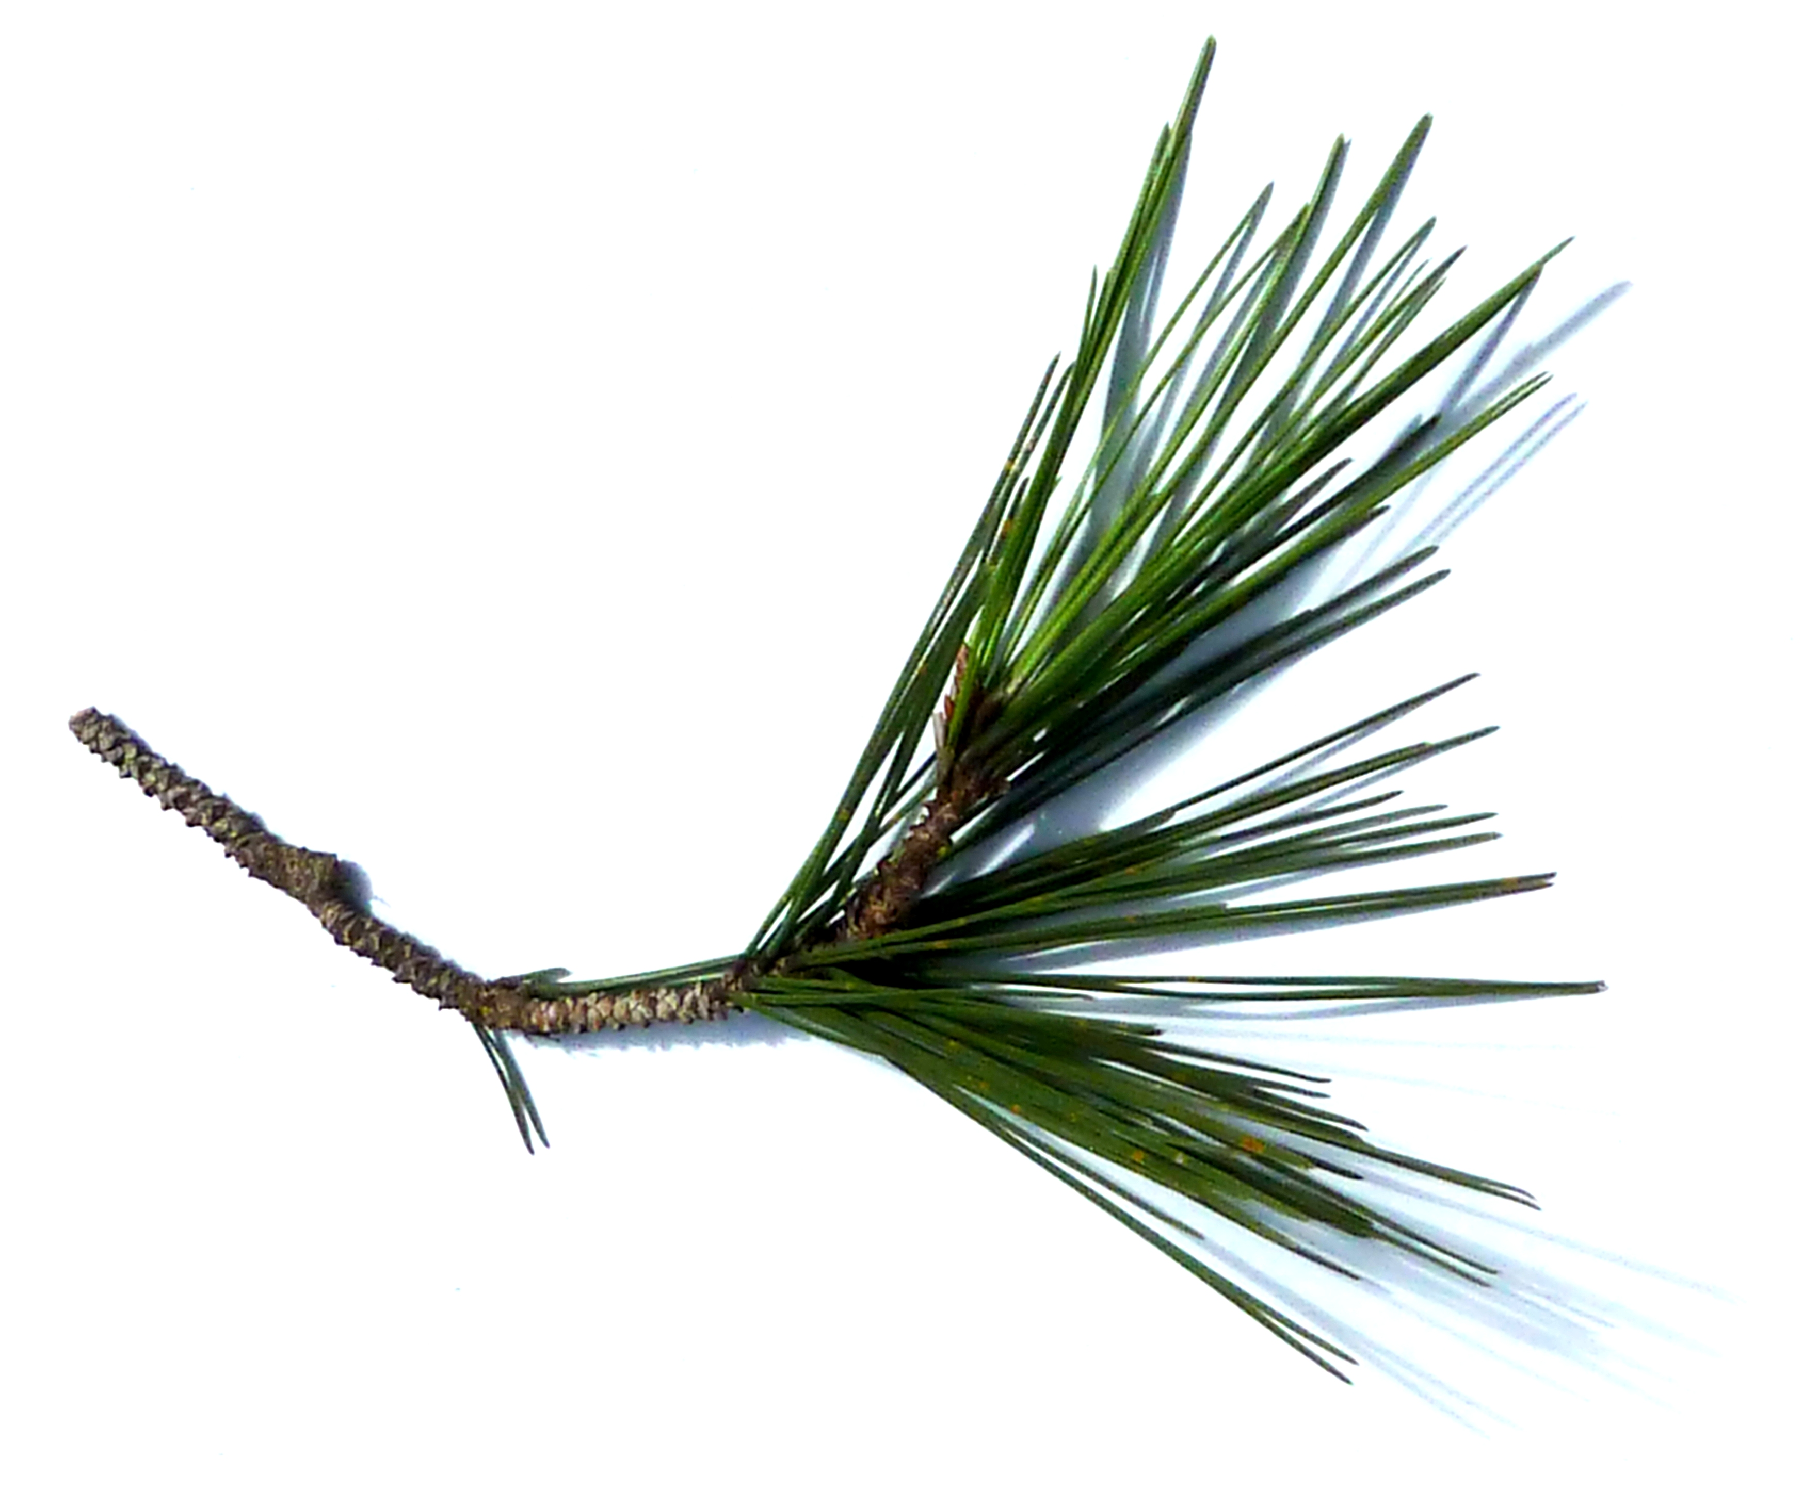
Where does pine straw come from?

Where is it used?

What does pine straw do?

How did Sam get started in his SAE?


What are his daily tasks?

How have his agriculture classes helped him with his SAE?

What safety gear does Sam use when spraying pesticides?


What is special about the baler?

To Straw or To Mulch?
Aligned to the following standards:
PL-A.; PL-F.; PG-I.; PG-J.; CS-M.; CS.01; CS.02; CS.05; CS.06; CCSS.RI.9-10.1; CCSS.RI.9-10.4; CCSS.W.9-10.1; CCSS.W.9-10.2; CCSS.W.9-10.4; CCSS.W.9-10.9; CCSS.SL.9-10.1; CCSS.SL.9-10.4; CCSS.SL.9-10.6; CCSS.L.9-10.6; CRP.02; CRP.04; CRP.07; CRP.08
Directions:
There are numerous materials that are used in landscaping to control weeds and retain moisture. Two of the most common materials are pine straw and mulch. Which is better? Complete the charts below to examine the pros and cons of both pine straw and mulch. (Suggested Resource: “Should I Use Mulch or Pine Straw?,” https://www.canopylawncare.com/blog/should-i-use-mulch-or-pine-straw)

- Research the PROS of pine straw and mulch, and then use the questions below to compare those advantages.

Pros of _________________________________

and

Pros of _________________________________
What are similarities that EVERYONE would recognize?

What are similarities that NO ONE would recognize?

Similarities
What are differences that EVERYONE would recognize?

What are differences that NO ONE would recognize?

Differences

- Research the CONS of pine straw and mulch, and then use the questions below to compare those disadvantages.

Cons of _________________________________

and

Cons of _________________________________
What are similarities that EVERYONE would recognize?

What are similarities that NO ONE would recognize?

Similarities
What are differences that EVERYONE would recognize?

What are differences that NO ONE would recognize?

Differences

- Using specific examples from what you learned about the pros and cons of pine straw and mulch, write one paragraph explaining which you would use and why. Do this on a separate piece of paper.

KEY: Pine Needles Everywhere
Aligned to the following standards:
PL-A.; PL-F.; PG-I.; PG-J.; CS-M.; CS.01; CS.02; CS.05; CS.06; CCSS.RI.9-10.1; CCSS.RI.9-10.4; CCSS.W.9-10.1; CCSS.W.9-10.2; CCSS.W.9-10.4; CCSS.W.9-10.9; CCSS.SL.9-10.1; CCSS.SL.9-10.4; CCSS.SL.9-10.6; CCSS.L.9-10.6; CRP.02; CRP.04; CRP.07; CRP.08
Directions:
Answer the questions below as you watch the video “Pine Straw SAE | Sam Mills,” available at https://vimeo.com/368437993.

What is Sam’s SAE?

Baled pine straw
Where does pine straw come from?
From pine trees
Where is it used?
Landscaping and mulching
What does pine straw do?
Reduces growth of weeds and helps prevent soil erosion and water evaporation

How did Sam get started in his SAE?

When he was in middle school, he rode with his father to check on their baling crews, and he also helped with maintenance.

What are his daily tasks?

In the fall and winter, he rakes and plows the fire lines.

In the summer, he sprays vegetation and mows after it has died, then the crews come in and bale and rake.

How have his agriculture classes helped him with his SAE?
The classes have helped him understand plant functions, which helps him when he sprays the pine tree rows so it is as clean as possible.

What safety gear does Sam use when spraying pesticides?

Lab coat
What is special about the baler?

It is handmade, and his grandfather invented it in 1976.
Mixing gloves

Eye protection

Ear protection

Long sleeve shirt

KEY: To Straw or To Mulch?
Aligned to the following standards:
PL-A.; PL-F.; PG-I.; PG-J.; CS-M.; CS.01; CS.02; CS.05; CS.06; CCSS.RI.9-10.1; CCSS.RI.9-10.4; CCSS.W.9-10.1; CCSS.W.9-10.2; CCSS.W.9-10.4; CCSS.W.9-10.9; CCSS.SL.9-10.1; CCSS.SL.9-10.4; CCSS.SL.9-10.6; CCSS.L.9-10.6; CRP.02; CRP.04; CRP.07; CRP.08
Directions:
There are numerous materials that are used in landscaping to control weeds and retain moisture. Two of the most common materials are pine straw and mulch. Which is better? Complete the charts below to examine the pros and cons of both pine straw and mulch. (Suggested Resource: “Should I Use Mulch or Pine Straw?,” https://www.canopylawncare.com/blog/should-i-use-mulch-or-pine-straw)

- Research the PROS of pine straw and mulch, and then use the questions below to compare those advantages.

Pros of ______Pine Straw____________

and

Pros of _______Mulch__________
What are similarities that EVERYONE would recognize?
How students arrange the pros in this chart will vary since this is just a method to get them to compare and contrast in a different way. However, the following pros should be included somewhere: less expensive than mulch in the short term, easy to spread and easy to rearrange.
What are similarities that NO ONE would recognize?
How students arrange the pros in this chart will vary since this is just a method to get them to compare and contrast in a different way. However, the following pros should be included somewhere: provides a better moisture barrier for plants, can help add extra nutrients to soil and stays in place longer than pine straw.

Similarities
What are differences that EVERYONE would recognize?

What are differences that NO ONE would recognize?

Differences

- Research the CONS of pine straw and mulch, and then use the questions below to compare those disadvantages.

Cons of ____Pine Straw____________

and

Cons of _________Mulch_____________
What are similarities that EVERYONE would recognize?
How students arrange the cons in this chart will vary. However, the following cons should be included somewhere: has to be refreshed more often than mulch, can add too much acid to your soil and can easily blow into your yard and need frequent clean-up.

What are similarities that NO ONE would recognize?
How students arrange the cons in this chart will vary. However, the following cons should be included somewhere: more expensive than pine straw, harder to spread, you may need to spend a whole morning spreading mulch depending on square footage and sometime a yard of mulch doesn’t go as far as you thought.
Similarities
What are differences that EVERYONE would recognize?

What are differences that NO ONE would recognize?

Differences

- Using specific examples from what you learned about the pros and cons of pine straw and mulch, write one paragraph explaining which you would use and why. Do this on a separate piece of paper.
Responses will vary.

