Sap Happy
Created: 01/2016 by the National FFA Organization

Student Learning Objectives
After completing these activities students will…
- Identify the parts of the vascular system of a tree.
- Explain how maple syrup is made from tree sap.
- Describe how sap rises in a tree.

Time Required: 60 minutes
Resources:
- FFA.org
- “Sap Happy” (https://www.saphappy.com/how-to.html#/)
Equipment and Supplies Needed:
- A copy of the “From Sap to Syrup” worksheet for each student.
- A copy of the “Sap on the Rise” worksheet for each student.
- Internet access for students.

This quick lesson plan would work well as:
- An introduction to tree anatomy.
- Part of an agricultural production unit.
- Part of a food science unit.

These activities are aligned to the following standards:

AFNR Performance Element
- FPP.04. Explain the scope of the food industry and the historical and current developments of food products and processing.
- PS.02. Apply principles of classification, plant anatomy and plant physiology to plant production and management.
FFA Precept
- FFA.PL-A.Action: Assume responsibility and take the necessary steps to achieve the desired results, no matter what the goal or task at hand.
- FFA.PG-J.Mental Growth: Embrace cognitive and intellectual development relative to reasoning, thinking and coping.
Common Career Technical Core
- AG-FD4 Explain the scope of the food industry and the historical and current developments of food products and processing.
- AG-PL2 Apply the principles of classification, plant anatomy and plant physiology to plant production and management.
NASDCTEc
- AGPB01.02 Examine and explain basic plant anatomy and physiology using taxonomic and other classifications to build a working understanding of functional differences among plant structures.
AFNR Cluster Skills
- CS.02. Evaluate the nature and scope of the Agriculture, Food, and Natural Resources Career Cluster and the role of agriculture, food, and natural resources (AFNR) in society and the economy.
Common Core- Reading: Informational Text
- CCSS.ELA-Literacy.RI.9-10.3 Analyze how the author unfolds an analysis or series of ideas or events, including the order in which the points are made, how they are introduced and developed, and the connections that are drawn between them.
Common Core- Speaking and Listening
- CCSS.ELA-Literacy.SL.9-10.1.A Come to discussions prepared, having read and researched material under study; explicitly draw on that preparation by referring to evidence from texts and other research on the topic or issue to stimulate a thoughtful, well-reasoned exchange of ideas.
Common Core- Science & Technical Subjects
- CCSS.ELA-Literacy.RST.9-10.4 Determine the meaning of symbols, key terms, and other domain-specific words and phrases as they are used in a specific scientific or technical context relevant to grades 9-10 texts and topics.
- CCSS.ELA-Literacy.RST.9-10.9 Compare and contrast findings presented in a text to those from other sources (including their own experiments), noting when the findings support or contradict previous explanations or accounts.
Common Core- Literacy in Science & Technical Subjects: Writing
- CCSS.ELA-Literacy.WHST.9-10.2 Write informative/explanatory texts, including the narration of historical events, scientific procedures/ experiments, or technical processes.
- CCSS.ELA-Literacy.WHST.9-10.4 Produce clear and coherent writing in which the development, organization, and style are appropriate to task, purpose, and audience.
- CCSS.ELA-Literacy.WHST.9-10.7 Conduct short as well as more sustained research projects to answer a question (including a self-generated question) or solve a problem; narrow or broaden the inquiry when appropriate; synthesize multiple sources on the subject, demonstrating understanding of the subject under investigation.
- CCSS.ELA-Literacy.WHST.9-10.8 Gather relevant information from multiple authoritative print and digital sources, using advanced searches effectively; assess the usefulness of each source in answering the research question; integrate information into the text selectively to maintain the flow of ideas, avoiding plagiarism and following a standard format for citation.
- CCSS.ELA-Literacy.WHST.9-10.9 Draw evidence from informational texts to support analysis, reflection, and research.
Common Core- Math Practices
- CCSS.MP2 Reason abstractly and quantitatively.
- CCSS.MP3: Construct viable arguments and critique the reasoning of others.
- CCSS.MP6: Attend to precision.
AFNR Career Ready Practices
- CRP.02. Apply appropriate academic and technical skills. Career-ready individuals readily access and use the knowledge and skills acquired through experience and education to be more productive.
- CRP.04. Communicate clearly, effectively, and with reason. Career-ready individuals communicate thoughts, ideas and action plans with clarity, whether using written, verbal and/or visual methods.
- CRP.07. Employ valid and reliable research strategies. Career-ready individuals are discerning in accepting and using new information to make decisions, change practices or inform strategies.
Partnership for 21st Century Skills
- Communication
- Information Literacy
- Productivity and Accountability

Lesson Plan:
- Introduction: Ask students, where does maple syrup come from? If students know the source of maple syrup ask them, how is maple syrup made? As a class discuss what is known about maple syrup production.
- Activity:
  - Each student should read “Sap Happy”. The direct URL is https://www.saphappy.com/how-to.html#/ As students read have them complete the “From Sap to Syrup” worksheet.
    - Discuss the article as a class and have students share what they learned about the process of making maple syrup.
  - Each student needs a copy of the “Sap on the Rise” worksheet. Either individually or in small groups have students use the internet and other resources available to complete. When students are done discuss what they learned as a class.
- Follow-up: When students have completed both worksheets discuss what they learned as a class.

From Sap to Syrup
Directions:
Read the article “Sap Happy.” Using information from the article describe (in words or pictures) the steps involved in making maple syrup.

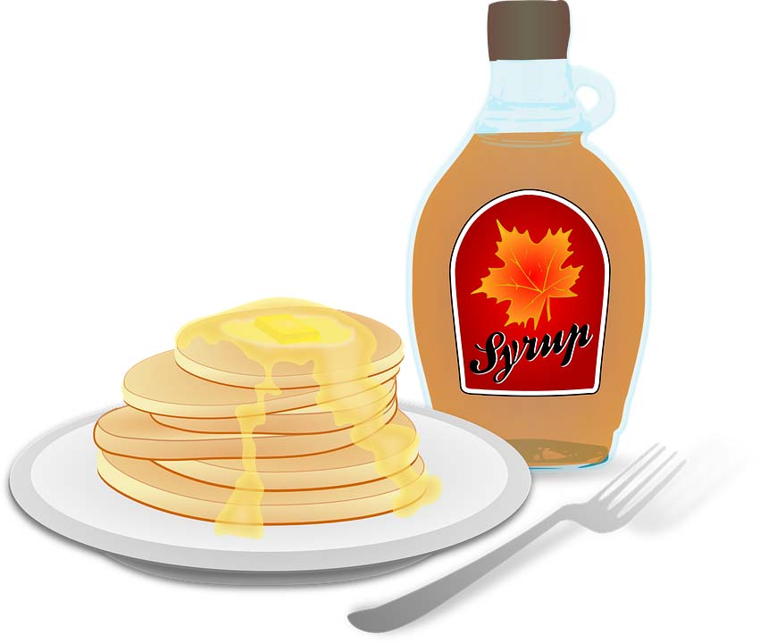
Step 3:
Step 1:
Step 2:
Step 4:
Step 5:

Aligned to the following standards:
FPP.04;PS.02;FFA.PL-A;FFA.PG-J;AG-FD4;AG-PL2; AGPB01.01; CS.02; CCSS.RI.9-10.3; CCSS.SL.9-10.1.A; CCSS.RST.9-10.4; CCSS.RST.9-10.9; CCSS.WHST.9-10.2; CCSS.WHST.9-10.4; CCSS.WHST.9-10.7; CCSS.WHST.9-10.8; CCSS.WHST.9-10.9; CCSS.MP2; CCSS.MP3; CCSS.MP6; CRP.02; CRP.04; CRP.07

Sap on the Rise
Aligned to the following standards:
FPP.04;PS.02;FFA.PL-A;FFA.PG-J;AG-FD4;AG-PL2; AGPB01.01; CS.02; CCSS.RI.9-10.3; CCSS.SL.9-10.1.A; CCSS.RST.9-10.4; CCSS.RST.9-10.9; CCSS.WHST.9-10.2; CCSS.WHST.9-10.4; CCSS.WHST.9-10.7; CCSS.WHST.9-10.8; CCSS.WHST.9-10.9; CCSS.MP2; CCSS.MP3; CCSS.MP6; CRP.02; CRP.04; CRP.07
Directions:
Using the internet and other resources available to you, complete the following activities.

Peel It Apart
Part 1:
Identify the different parts of the vascular system of a tree by writing the correct term on the appropriate blank. Put a star beside the part that is tapped when it is time to collect sap for syrup.

Terms:
Bark Phloem
Cambium Xylem
Heartwood

Part 2:
Color the different parts of the vascular system to match this key:

Bark: brown
Cambium: green
Heartwood: yellow
Phloem: red
Xylem: blue

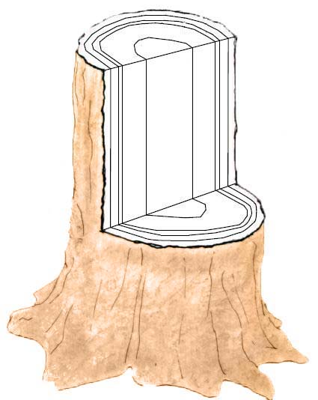

Soaking It Up

Using the resources available to you, research how sap rises in the late winter and early spring so it can be harvested to make syrup. Explain the process in the space below.

____________________________________________________________________________________________________________________________________________________________________________________________________________________________________________________________________________________________________________________________________________________________________________________________________________________________________________________________________________________________________________________________________________________________________________________________________________________________________________________________________________________________________________________________________________________________________________________________________________________________________________________________________________________________________________________________________

Terminology Corner
Define each term in the space provided.
Bark
Cambium
Heartwood
Phloem
Sapwood
Xylem

KEY: From Sap to Syrup
Directions:
Read the article “Sap Happy.” Using information from the article describe (in words or pictures) the steps involved in making maple syrup.

Step 3:
Step 1:
Step 2:
Step 4:
Step 5:

Pick a tree, minimum of 12” diameter.
Measure 2-3 feet up tree and dill a hole.

Attach tubing to short end of spout. Lightly tap the spout into the hole.

Insert tubing into a food safe container. Collect sap.

Filter and boil down sap.

Bottle the syrup.

Aligned to the following standards:
FPP.04;PS.02;FFA.PL-A;FFA.PG-J;AG-FD4;AG-PL2; AGPB01.01; CS.02; CCSS.RI.9-10.3; CCSS.SL.9-10.1.A; CCSS.RST.9-10.4; CCSS.RST.9-10.9; CCSS.WHST.9-10.2; CCSS.WHST.9-10.4; CCSS.WHST.9-10.7; CCSS.WHST.9-10.8; CCSS.WHST.9-10.9; CCSS.MP2; CCSS.MP3; CCSS.MP6; CRP.02; CRP.04; CRP.07

KEY: Sap on the Rise
Aligned to the following standards:
FPP.04;PS.02;FFA.PL-A;FFA.PG-J;AG-FD4;AG-PL2; AGPB01.01; CS.02; CCSS.RI.9-10.3; CCSS.SL.9-10.1.A; CCSS.RST.9-10.4; CCSS.RST.9-10.9; CCSS.WHST.9-10.2; CCSS.WHST.9-10.4; CCSS.WHST.9-10.7; CCSS.WHST.9-10.8; CCSS.WHST.9-10.9; CCSS.MP2; CCSS.MP3; CCSS.MP6; CRP.02; CRP.04; CRP.07
Directions:
Using the internet and other resources available to you, complete the following activities.

Peel It Apart
Part 1:
Identify the different parts of the vascular system of a tree by writing the correct term on the appropriate blank. Put a star beside the part that is tapped when it is time to collect sap for syrup.

Terms:
Bark Phloem
Cambium Xylem
Heartwood

Part 2:
Color the different parts of the vascular system to match this key:

Bark: brown
Cambium: green
Heartwood: yellow
Phloem: red
Xylem: blue

Phloem
Bark

Xylem

Cambium
Heartwoood

Soaking It Up

Using the resources available to you, research how sap rises in the late winter and early spring so it can be harvested to make syrup. Explain the process in the space below.

Source: Cornell Sugar Maple Research & Extension Program (http://maple.dnr.cornell.edu/produc/sapflow.htm)
“During warm periods when temperatures rise above freezing, pressure (also called positive pressure) develops in the tree. This pressure causes the sap to flow out of the tree through a wound or tap hole. During cooler periods when temperatures fall below freezing, suction (also called negative pressure) develops, drawing water into the tree through the roots. This replenishes the sap in the tree, allowing it to flow again during the next warm period. Although sap generally flows during the day when temperatures are warm, it has been known to flow at night if temperatures remain above freezing.”

Terminology Corner
Define each term in the space provided.
Bark | the tough exterior covering of a woody root or stem
Cambium | a cellular plant tissue from which phloem and xylem develop
Heartwood | the dense inner part of a tree trunk, yielding the hardest timber.
Phloem | pipeline through which food is passed to the rest of the tree (It lives for only a short time, then dies and turns to cork to become part of the protective outer bark.)
Sapwood | another name for the xylem
Xylem | network of thick-walled cells brings water and some nutrients up from the roots (Dead xylem cells form the tree’s heartwood.

