Sense of Belonging Celebration Lesson
Created: 07/2024 by the National FFA Organization
Description of Lesson: Introduce diverse fall and winter celebrations to students by having students research different celebrations, what foods are eaten during those celebrations and what agricultural products are needed to make those foods.

Student Learning Objectives:
After completing these activities, students will …
- Research different fall and winter celebrations.
- Evaluate how agriculture plays a crucial role in celebrations around the world.
Suggested Grade Level:
Grades 9 and 10 (This lesson is written so instructors can scale up or down based on class needs.)

Suggested Time: 100 minutes (*Time requirements may vary based upon student understanding and class schedule.)
Resources/References:
- Website: https://www.canva.com/
- Website: https://piktochart.com/blog/infographic-examples/
Related Resources:
- New Horizons Teaching Guide, Spring/Summer 2024, Appendix 2: Paving a Path Forward, https://FFA.box.com/s/5okgqkzgmawvqf0j9gs95gj4lwjllpkq
- New Horizons Teaching Guide, Fall 2022, Appendix 3: Rich in Tradition https://FFA.box.com/s/79yqh7jemfsoyylwetls8o9vnhfwdfep

Equipment and Supplies Needed:
- A copy of the “Celebrations Around the World” worksheet for each student
- Student devices with internet access
- Blank paper
- Markers
Vocabulary:
- Bodhi Day
- Chinese New Year
- Christmas
- Collard greens
- Diwali
- Eid Al-Fitr
- Hannukah
- Kwanzaa
- Las Posadas
- Latkes
- Matzo ball soup
- Ōmisoka
- Rosh Hashana
- Samosa
- Sheer khurma
- Soyal
- Tamales
- Thanksgiving
- Toshikoshi Soba
- Yom Kippur
Cross-Curricular Connections:
English/Language Arts | Technology | Geography
Synthesize information about global celebrations and explain how agriculture plays a role. | Use the internet to aid in research about celebrations, food and agricultural products. | Sketch states and countries producing agricultural products.

Student Activity Sheets:
Direct access to student activity sheets without lesson plan or answer key for easy upload to a learning management system or printing for classwork.

https://ffa.box.com/s/3n84nnfq6mscu64ex5d0surkssfnyb4s (Word)
https://ffa.box.com/s/ekhqq1c1tn4l7h4jptprn0lm0973o67y (PDF)
https://docs.google.com/document/d/1F3KfJSEoUcc9qY9QW6gQf-ukc3GqvTPWudUN1IBXOas/copy (Google)

These Activities Are Aligned to the Following Standards:
AFNR Performance Element
- CS.01. Analyze how issues, trends, technologies and public policies impact systems in the Agriculture, Food & Natural Resources Career Cluster
FFA Precept
- FFA.PL-A.Action: Assume responsibility and take the necessary steps to achieve the desired results, no matter what the goal or task at hand.
- FFA.PL-E. Awareness: Understand personal vision, mission and goals.
- FFA.PG-J. Mental Growth: Embrace cognitive and intellectual development relative to reasoning, thinking and coping.
- FFA.CS-M. Communication: Effectively interact with others in personal and professional settings.
- FFA.CS-N. Decision Making: Analyze a situation and execute an appropriate course of action.
Common Career Technical Core
- AG1 Analyze how issues, trends, technologies and public policies impact systems in the Agriculture, Food & Natural Resources Career Cluster.
NASDCTEc
- AGC02.02 Employ the use of technical information effectively to maintain and communicate records and reporting procedures commonly used in the AFNR cluster.
- AGC10.03 Compare and contrast issues affecting the AFNR industry including biotechnology, employment, safety, environmental and animal welfare to demonstrate an understanding of the trends and issues important to careers in this industry.
- AGC10.04 Envision emerging technology and globalization and project its influence on widespread markets to demonstrate an understanding of technologies and trends that will impact the AFNR industry.
Common Core – Reading: Informational Text
- CCSS.ELA-Literacy.RI.9-10.1 Cite strong and thorough textual evidence to support analysis of what the text says explicitly as well as inferences drawn from the text.
- CCSS.ELA-Literacy.RI.9-10.2 Determine a central idea of a text and analyze its development over the course of the text, including how it emerges and is shaped and refined by specific details; provide an objective summary of the text.
- CCSS.ELA-Literacy.RI.9-10.3 Analyze how the author unfolds an analysis or series of ideas or events, including the order in which the points are made, how they are introduced and developed, and the connections that are drawn between them.
- CCSS.ELA-Literacy.RI.9-10.4 Determine the meaning of words and phrases as they are used in a text, including figurative, connotative, and technical meanings; analyze the cumulative impact of specific word choices on meaning and tone (e.g., how the language of a court opinion differs from that of a newspaper).
- CCSS.ELA-Literacy.RI.9-10.8 Delineate and evaluate the argument and specific claims in a text, assessing whether the reasoning is valid and the evidence is relevant and sufficient; identify false statements and fallacious reasoning.
Common Core – Writing
- CCSS.ELA-Literacy.W.9-10.1 Write arguments to support claims in an analysis of substantive topics or texts, using valid reasoning and relevant and sufficient evidence.
- CCSS.ELA-Literacy.W.9-10.2 Write informative/explanatory texts to examine and convey complex ideas, concepts, and information clearly and accurately through the effective selection, organization, and analysis of content.
Common Core – Speaking and Listening
- CCSS.ELA-Literacy.SL.9-10.2 Integrate multiple sources of information presented in diverse media or formats (e.g., visually, quantitatively, orally) evaluating the credibility and accuracy of each source.
- CCSS.ELA-Literacy.SL.9-10.4 Present information, findings, and supporting evidence clearly, concisely, and logically such that listeners can follow the line of reasoning and the organization, development, substance, and style are appropriate to purpose, audience, and task.
Common Core – Science & Technical Subjects
- CCSS.ELA-Literacy.RST.9-10.7 Translate quantitative or technical information expressed in words in a text into visual form (e.g., a table or chart) and translate information expressed visually or mathematically (e.g., in an equation) into words.
- CCSS.ELA-Literacy.RST.9-10.9 Compare and contrast findings presented in a text to those from other sources (including their own experiments), noting when the findings support or contradict previous explanations or accounts.
Common Core – Literacy in Science & Technical Subjects: Writing
- CCSS.ELA-Literacy.WHST.9.10.6 Use technology, including the Internet, to produce, publish, and update individual or shared writing products, taking advantage of technology’s capacity to link to other information and to display information flexibly and dynamically.
Common Core – Math Practices
- MP2 Reason abstractly and quantitatively.
- MP3 Construct viable arguments and critique the reasoning of others.
- MP5 Use appropriate tools strategically.
- MP6 Attend to precision.

AFNR Career Ready Practices
- CRP.02. Apply appropriate academic and technical skills. Career-ready individuals readily access and use the knowledge and skills acquired through experience and education
to be more productive.
- CRP.04. Communicate clearly, effectively, and with reason. Career-ready individuals communicate thoughts, ideas and action plans with clarity, whether using written, verbal and/or visual methods.
- CRP.05. Consider the environmental, social and economic impact of decisions. Career-ready individuals understand the interrelated nature of their actions and regularly make decisions that positively impact and/or mitigate negative impact on other people, organizations and the environment.
- CRP.06. Demonstrate creativity and innovation. Career-ready individuals regularly think of ideas that solve problems in new and different ways, and they contribute those ideas in a useful and productive manner to improve their organization.
- CRP.07. Employ valid and reliable research strategies. Career-ready individuals are discerning in accepting and using new information to make decisions, change practices or inform strategies.
- CRP.08. Utilize critical thinking to make sense of problems and persevere in solving them. Career-ready individuals readily recognize problems in the workplace, understand the nature of the problem, and
devise effective plans to solve the problem.
- CRP.11. Use technology to enhance productivity. Career-ready individuals find and maximize the productive value of existing and new technology to accomplish workplace tasks and solve workplace problems.
Partnership for 21st Century Skills
- Financial, Economic, Business, and Entrepreneurial Literacy
- Information, Communications, and Technology Literacy
- Global Awareness
- Think Creatively

Lesson:
- Bell Ringer: What favorite foods do you eat for celebrations during the fall and winter?

- Introduction: There are many diverse celebrations around the country and world during the fall and winter seasons. We may not be familiar with many of these celebrations if we do not celebrate them. Today, we are going to learn about these exciting celebrations, the foods that are eaten during them and how agriculture plays a vital role in getting these foods to the celebrations.

- Activity: Each student needs a copy of the worksheet “Celebrations Around the World.”
  - Part 1: Students will match the foods to the celebration during which that food is commonly eaten. They will write the letter of the food item next to the celebration. Students will then use the internet to research each celebration and fill in the third column with that information. Upon completion, they will answer the two discussion questions.
  - Part 2: Students will research three different fall/winter celebrations and answer the questions.
    - At least one must be a celebration that they do not celebrate.
    - Students can use the list from Part 1 or research other celebrations they might know about.
  - Part 3: Students will use a blank sheet of paper to create an eye-catching infographic about one celebration researched in Part 2.
    - Students should put pictures on their infographics and include all the information listed on the assignment sheet.
  - Part 4: Students will complete a gallery walk to learn about different celebrations around the world and complete the table for 10 different celebrations as they walk around the room.
    - The chart can be scaled up or down depending on your class size.
  - Part 5: Now that students have learned about different celebrations around the world, they will create their “perfect plate” of foods.
    - Have them start by dividing the plate into sections.
    - On each section they should include the following:
      - Name of the food.
      - A sketch of the food.
      - The agricultural product that food is made from.
      - Where that agricultural product comes from.
      - What celebration(s) that food is connected to.
    - Students must include at least five food items, and two of those should be food items they have not tried before.

- Follow-up: Have a class discussion about what each student chose to put on their “perfect plate.”

- Optional – Extended Learning Opportunities (Not factored into time requirement): Divide students into groups and have each group create one of the food products they learned about to create a diverse celebration table.

- Exit Ticket: What role does agriculture play in making celebrations possible?

Celebrations Around the World
Aligned to the following standards: CS.01., AG1, AGC02.02, AGC10.03, AGC10.04, CCSS.RI.9-10.1, CCSS.RI.9-10.2, CCSS.RI.9-10.3, CCSS.RI.9-10.4, CCSS.RI.9-10.8, CCSS.RI.9-10.8, CCSS.W.9-10.2, CCSS.RST.9-10.7, CCSS.RST.9-10.9, CCSS.WHST.9.10.6, MP2, MP3, MP5, MP6, CRP.02., CRP.04., CRP.06., CRP.07., CRP.08., CRP.11
Part 1
Directions:
Match the foods to the celebration during which that food is commonly eaten by writing the letter of the food item next to the celebration. Then, use the internet to research the purpose of each celebration and fill in the third column with that information.
Food | Celebration | Purpose of Celebration
- Latkes  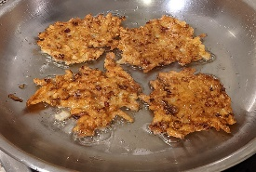 | Christmas
- Sheer khurma  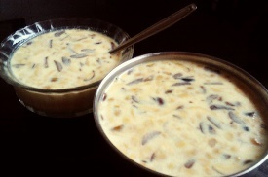 | Hannukah
- Samosa  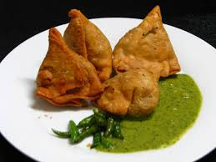 | Kwanzaa
- Toshikoshi Soba  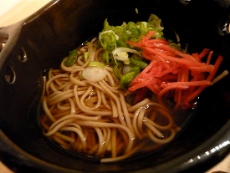 | Las Posadas
- Collard Greens  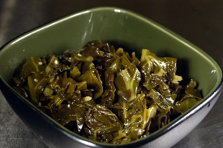 | Soyal
- Tamales  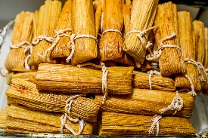 | Eid al-Fitr
- Squash  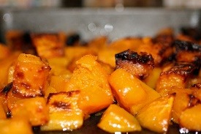 | Diwali

- Fish  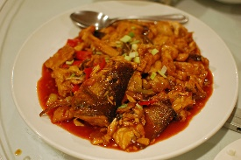 | Thanksgiving
- Ham  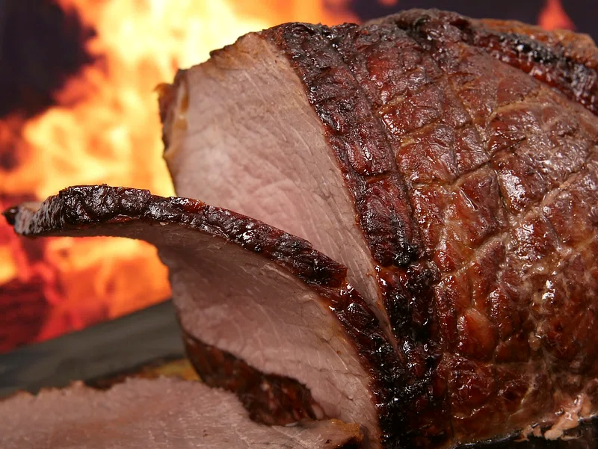 | Omisoka
J. Matzo Ball Soup  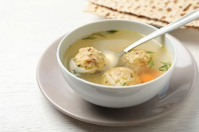 | Chinese New Year
K. Apples and Honey  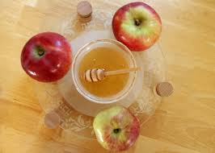 | Rosh Hashana
L. Rice  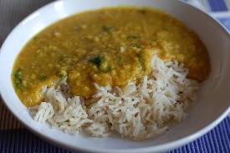 | Yom Kippur
M. Turkey  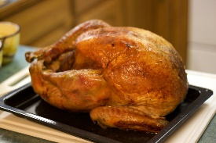 | Bohdi Day

- Which of these celebrations were unfamiliar to you?

- Which of these food items were unfamiliar to you and why?

Celebrations Around the World
Aligned to the following standards: CS.01., AG1, AGC02.02, AGC10.03, AGC10.04, CCSS.RI.9-10.1, CCSS.RI.9-10.2, CCSS.RI.9-10.3, CCSS.RI.9-10.4, CCSS.RI.9-10.8, CCSS.RI.9-10.8, CCSS.W.9-10.2, CCSS.RST.9-10.7, CCSS.RST.9-10.9, CCSS.WHST.9.10.6, MP2, MP3, MP5, MP6, CRP.02., CRP.04., CRP.06., CRP.07., CRP.08., CRP.11
Part 2
Directions:
- Research three different fall/winter celebrations and answer the questions below.
- At least one must be a celebration you do not celebrate.
- You can use the list from Part 1 or research other celebrations you might be interested in learning about.

- What is the name of the first celebration you are going to learn about?

- In what culture is this celebration primarily celebrated?

- Name three foods that are commonly eaten during this celebration, the agricultural product they come from and where that product is primarily produced.
Food Product | Agricultural Product | Area of Production
- Sketch the state or country that produces the most of each food product.

- What is the name of the second celebration you are going to learn about?

- In what culture is this celebration primarily celebrated?

- Name three foods that are commonly eaten during this celebration, the agricultural product they come from and where that product is primarily produced.
Food Product | Agricultural Product | Area of Production
- Sketch the state or country that produces the most of each food product.

- What is the name of the third celebration you are going to learn about?

- In what culture is this celebration primarily celebrated?

- Name three foods that are commonly eaten during this celebration, the agricultural product they come from and where that product is primarily produced.
Food Product | Agricultural Product | Area of Production

- Sketch the state or country that produces the most of each food product.

Celebrations Around the World
Aligned to the following standards: CS.01., AG1, AGC02.02, AGC10.03, AGC10.04, CCSS.RI.9-10.1, CCSS.RI.9-10.2, CCSS.RI.9-10.3, CCSS.RI.9-10.4, CCSS.RI.9-10.8, CCSS.RI.9-10.8, CCSS.W.9-10.2, CCSS.RST.9-10.7, CCSS.RST.9-10.9, CCSS.WHST.9.10.6, MP2, MP3, MP5, MP6, CRP.02., CRP.04., CRP.06., CRP.07., CRP.08., CRP.11
Part 3
Directions:
- Use the space below or a blank sheet of paper to create an eye-catching infographic about one celebration researched in Part 2 that you do not currently celebrate. Examples of infographics can be found at https://piktochart.com/blog/infographic-examples/. The infographic must be created with color and include the following:
  - Name of celebration.
  - The purpose of the celebration.
  - Culture this celebration is most commonly a part of.
  - Area of the country/world where the celebration primarily happens.
  - Main foods eaten during this celebration.
  - Agricultural products needed to produce foods eaten during this celebration.
  - Areas of the country/world where these agricultural products are produced.
  - A minimum of four pictures.

Celebrations Around the World
Aligned to the following standards: CS.01., AG1, AGC02.02, AGC10.03, AGC10.04, CCSS.RI.9-10.1, CCSS.RI.9-10.2, CCSS.RI.9-10.3, CCSS.RI.9-10.4, CCSS.RI.9-10.8, CCSS.RI.9-10.8, CCSS.W.9-10.2, CCSS.RST.9-10.7, CCSS.RST.9-10.9, CCSS.WHST.9.10.6, MP2, MP3, MP5, MP6, CRP.02., CRP.04., CRP.06., CRP.07., CRP.08., CRP.11
Part 4
Directions:
Complete a gallery walk to learn about different celebrations around the world and complete the table for ___ different celebrations.

Celebration | Purpose | One Food Eaten | Agricultural Product Needed for That Food | Area Where That Product Is Produced

Celebrations Around the World
Aligned to the following standards: CS.01., AG1, AGC02.02, AGC10.03, AGC10.04, CCSS.RI.9-10.1, CCSS.RI.9-10.2, CCSS.RI.9-10.3, CCSS.RI.9-10.4, CCSS.RI.9-10.8, CCSS.RI.9-10.8, CCSS.W.9-10.2, CCSS.RST.9-10.7, CCSS.RST.9-10.9, CCSS.WHST.9.10.6, MP2, MP3, MP5, MP6, CRP.02., CRP.04., CRP.06., CRP.07., CRP.08., CRP.11
Part 5
Directions:
Now that you have learned about different celebrations around the world, create your “perfect plate” of foods.
- Divide the plate into sections.
- On each section include the following:
  - Name of the food.
  - A sketch of the food.
  - The agricultural product that food is made from.
  - Where that agricultural product comes from.
  - What celebration(s) that food is connected to.
- You must include at least five food items, and two of those should be food items you have not tried before.

- What food item are you most excited to try and why?

- Pretend you are a reporter for your local newspaper, write an article in the space below about one of the celebrations you learned about today. Include the following information:
  - Title of the celebration.
  - Picture of the celebration.
  - Information about the celebration using at least four sentences.

KEY: Celebrations Around the World
Aligned to the following standards: CS.01., AG1, AGC02.02, AGC10.03, AGC10.04, CCSS.RI.9-10.1, CCSS.RI.9-10.2, CCSS.RI.9-10.3, CCSS.RI.9-10.4, CCSS.RI.9-10.8, CCSS.RI.9-10.8, CCSS.W.9-10.2, CCSS.RST.9-10.7, CCSS.RST.9-10.9, CCSS.WHST.9.10.6, MP2, MP3, MP5, MP6, CRP.02., CRP.04., CRP.06., CRP.07., CRP.08., CRP.11
Part 1
Directions:
Match the foods to the celebration during which that food is commonly eaten by writing the letter of the food item next to the celebration. Then, use the internet to research the purpose of each celebration and fill in the third column with that information.
Food | Celebration | Purpose of Celebration
- Latkes | I. Christmas | Christmas celebrates the birth of Jesus Christ and is observed with religious reverence as well as cultural traditions of gift-giving and family gatherings.
- Sheer khurma | A. Hannukah | Hanukkah commemorates the rededication of the Holy Temple in Jerusalem and is celebrated with the lighting of the menorah, traditional foods and prayers over eight days.
- Samosa | E. Kwanzaa | Kwanzaa is a week-long celebration honoring African-American heritage, unity and culture through rituals that include lighting the kinara, feasting, storytelling and artistic expression.
- Toshikoshi Soba | F. Las Posadas | Las Posadas is a Mexican Christmas tradition reenacting Mary and Joseph’s search for lodging, celebrated with processions, prayers, piñatas and community feasting.
- Collard Greens | G. Soyal | Soyal is a winter solstice ceremony observed by Hopi and Zuni tribes, marking the new year with rituals symbolizing purification, renewal and the return of the sun.
- Tamales | B. Eid al-Fitr | Eid al-Fitr is an Islamic festival marking the end of Ramadan, the holy month of fasting. It celebrates spiritual renewal, gratitude and communal unity through prayers, feasting and charitable acts.
- Squash | C. Diwali | Diwali, also known as the Festival of Lights, is a Hindu festival symbolizing the victory of light over darkness and good over evil. It is celebrated with the lighting of lamps, fireworks, feasting and sharing sweets, promoting family bonding and spiritual reflection.

Food | Celebration | Purpose of Celebration
- Fish | M. Thanksgiving | Thanksgiving is a North American holiday observed as a day of giving thanks for the blessings of the harvest and the preceding year. It is marked by family gatherings, feasting on traditional foods like turkey and expressing gratitude.
- Ham | D. Omisoka | Omisoka is the Japanese New Year’s Eve celebration where families gather to clean their homes, prepare traditional foods and welcome Toshigami (the deity of the New Year). It includes ringing bells at midnight and eating special foods like soba noodles for longevity.
- Matzo Ball Soup | H. Chinese New Year | Chinese New Year, also known as Lunar New Year or Spring Festival, marks the beginning of the lunar calendar. It is celebrated with family reunions, festive decorations, dragon and lion dances, fireworks and the giving of red envelopes (hongbao) containing money for luck.
- Apples and Honey | K. Rosh Hashana | Rosh Hashanah is the Jewish New Year, a time of reflection and repentance. It is observed with synagogue services, the sounding of the shofar (ram’s horn) and special meals featuring symbolic foods like apples dipped in honey for a sweet year ahead.
- Rice | J. Yom Kippur | Yom Kippur, also known as the Day of Atonement, is the holiest day in Judaism. It is a time for fasting, prayer and repentance for sins committed in the past year. Observances include synagogue services and seeking forgiveness from others.
- Turkey | L. Bohdi Day | Bodhi Day commemorates the day when Siddhartha Gautama, the historical Buddha, attained enlightenment under the Bodhi tree. It is observed with meditation, chanting and acts of kindness, reflecting on the teachings of Buddhism and the path to enlightenment.

- Which of these celebrations were unfamiliar to you?

Answers will vary.

- Which of these food items were unfamiliar to you and why?

Answers will vary.

KEY: Celebrations Around the World
Aligned to the following standards: CS.01., AG1, AGC02.02, AGC10.03, AGC10.04, CCSS.RI.9-10.1, CCSS.RI.9-10.2, CCSS.RI.9-10.3, CCSS.RI.9-10.4, CCSS.RI.9-10.8, CCSS.RI.9-10.8, CCSS.W.9-10.2, CCSS.RST.9-10.7, CCSS.RST.9-10.9, CCSS.WHST.9.10.6, MP2, MP3, MP5, MP6, CRP.02., CRP.04., CRP.06., CRP.07., CRP.08., CRP.11
Part 2
Directions:
- Research three different fall/winter celebrations and answer the questions below.
- At least one must be a celebration you do not celebrate.
- You can use the list from Part 1 or research other celebrations you might be interested in learning about.

- What is the name of the first celebration you are going to learn about?
Answers will vary.

- In what culture is this celebration primarily celebrated?
Answers will vary.

- Name three foods that are commonly eaten during this celebration, the agricultural product they come from and where that product is primarily produced.
Food Product | Agricultural Product | Area of Production
Answers will vary. | Answers will vary. | Answers will vary.
Answers will vary. | Answers will vary. | Answers will vary.
Answers will vary. | Answers will vary. | Answers will vary.

- Sketch the state or country that produces the most of each food product.
Answers will vary.

- What is the name of the second celebration you are going to learn about?
Answers will vary.

- In what culture is this celebration primarily celebrated ?
Answers will vary.

- Name three foods that are commonly eaten during this celebration, the agricultural product they come from and where that product is primarily produced.
Food Product | Agricultural Product | Area of Production
Answers will vary. | Answers will vary. | Answers will vary.
Answers will vary. | Answers will vary. | Answers will vary.
Answers will vary. | Answers will vary. | Answers will vary.
- Sketch the state or country that produces the most of each food product.
Answers will vary.

- What is the name of the third celebration you are going to learn about?
Answers will vary.

- In what culture is this celebration primarily celebrated?
Answers will vary.

- Name three foods that are commonly eaten during this celebration, the agricultural product they come from and where that product is primarily produced.
Food Product | Agricultural Product | Area of Production
Answers will vary. | Answers will vary. | Answers will vary.
Answers will vary. | Answers will vary. | Answers will vary.
Answers will vary. | Answers will vary. | Answers will vary.

- Sketch the state or country that produces the most of each food product.
Answers will vary.

KEY: Celebrations Around the World
Aligned to the following standards: CS.01., AG1, AGC02.02, AGC10.03, AGC10.04, CCSS.RI.9-10.1, CCSS.RI.9-10.2, CCSS.RI.9-10.3, CCSS.RI.9-10.4, CCSS.RI.9-10.8, CCSS.RI.9-10.8, CCSS.W.9-10.2, CCSS.RST.9-10.7, CCSS.RST.9-10.9, CCSS.WHST.9.10.6, MP2, MP3, MP5, MP6, CRP.02., CRP.04., CRP.06., CRP.07., CRP.08., CRP.11
Part 3
Directions:
- Use the space below or a blank sheet of paper to create an eye-catching infographic about one celebration researched in Part 2 that you do not currently celebrate. Examples of infographics can be found at https://piktochart.com/blog/infographic-examples/. The infographic must be created with color and include the following:
  - Name of celebration.
  - The purpose of the celebration.
  - Culture this celebration is most commonly a part of.
  - Area of the country/world where the celebration primarily happens.
  - Main foods eaten during this celebration.
  - Agricultural products needed to produce foods eaten during this celebration.
  - Areas of the country/world where these agricultural products are produced.
  - A minimum of four pictures.

Answers will vary.

KEY: Celebrations Around the World
Aligned to the following standards: CS.01., AG1, AGC02.02, AGC10.03, AGC10.04, CCSS.RI.9-10.1, CCSS.RI.9-10.2, CCSS.RI.9-10.3, CCSS.RI.9-10.4, CCSS.RI.9-10.8, CCSS.RI.9-10.8, CCSS.W.9-10.2, CCSS.RST.9-10.7, CCSS.RST.9-10.9, CCSS.WHST.9.10.6, MP2, MP3, MP5, MP6, CRP.02., CRP.04., CRP.06., CRP.07., CRP.08., CRP.11
Part 4
Directions:
Complete a gallery walk to learn about different celebrations around the world and complete the table for ___ different celebrations.

Celebration | Purpose | One Food Eaten | Agricultural Product Needed for Fhat Food | Area Where That Product Is Produced
Answers will vary. | Answers will vary. | Answers will vary. | Answers will vary. | Answers will vary.
Answers will vary. | Answers will vary. | Answers will vary. | Answers will vary. | Answers will vary.
Answers will vary. | Answers will vary. | Answers will vary. | Answers will vary. | Answers will vary.
Answers will vary. | Answers will vary. | Answers will vary. | Answers will vary. | Answers will vary.
Answers will vary. | Answers will vary. | Answers will vary. | Answers will vary. | Answers will vary.
Answers will vary. | Answers will vary. | Answers will vary. | Answers will vary. | Answers will vary.
Answers will vary. | Answers will vary. | Answers will vary. | Answers will vary. | Answers will vary.
Answers will vary. | Answers will vary. | Answers will vary. | Answers will vary. | Answers will vary.

KEY: Celebrations Around the World
Aligned to the following standards: CS.01., AG1, AGC02.02, AGC10.03, AGC10.04, CCSS.RI.9-10.1, CCSS.RI.9-10.2, CCSS.RI.9-10.3, CCSS.RI.9-10.4, CCSS.RI.9-10.8, CCSS.RI.9-10.8, CCSS.W.9-10.2, CCSS.RST.9-10.7, CCSS.RST.9-10.9, CCSS.WHST.9.10.6, MP2, MP3, MP5, MP6, CRP.02., CRP.04., CRP.06., CRP.07., CRP.08., CRP.11
Part 5
Directions:
Now that you have learned about different celebrations around the world, create your “perfect plate” of foods below.
- Divide the plate into sections.
- On each section include the following:
  - Name of the food.
  - A sketch of the food.
  - The agricultural product that food is made from.
  - Where that agricultural product comes from.
  - What celebration(s) that food is connected to.
- You must include at least five food items, and two of those should be food items you have not tried before.

Answers will vary.

- What food item are you most excited to try and why?

Answers will vary.

- Pretend you are a reporter for your local newspaper, write an article in the space below about one of the celebrations you learned about today. Include the following information:
- Title of the celebration.
- Picture of the celebration.
- Information about the celebration using at least four sentences.

Answers will vary.

