Succulents
Aligned to the following standards:
FFA.PL-A.; FFA.PL-B.; FFA.PL-D.; FFA. PL-F.; FFA.PG-H.; FFA.CS-M.; FFA.CS-N.; FFA.CS-O; CCSS.ELA-RI.9-10.4; CCSS.ELA-W.9-10.2; CCSS.W.9-10.4; CCSS.ELA-W.9-10.6; CCSS.ELA-SL.9-10.4; CCSS.ELA-WHST.9.10.2; CCSS.ELA-WHST.9.10.4; CCSS.ELA-WHST.9.10.6; MP1; MP2; MP6; CRP.04; CRP.06; CRP.08; CRP.11
directions:
Answer the questions below as you watch the video “Silvio Barnes – SAE – Succulents,” available at https://vimeo.com/300298447.

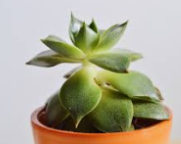
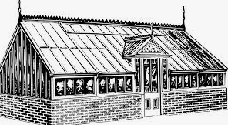
1) How did Silvio get started with his SAE?

2) What were two main challenges he faced with his SAE?

3) Who has helped him the most with his SAE?

4) What has he learned from his SAE?

5) What are two skills he has learned from this SAE?

6) What is the classroom activity that helped him the most with his SAE?

7) What advice does Silvio give to other students who want to start their SAEs?

8) How can you apply the information you learned from this SAE to your current SAE or to your future career?

Succulent vs. Other Plants
Aligned to the following standards:
FFA.PL-A.; FFA.PL-B.; FFA.PL-D.; FFA. PL-F.; FFA.PG-H.; FFA.CS-M.; FFA.CS-N.; FFA.CS-O; CCSS.ELA-RI.9-10.4; CCSS.ELA-W.9-10.2; CCSS.W.9-10.4; CCSS.ELA-W.9-10.6; CCSS.ELA-SL.9-10.4; CCSS.ELA-WHST.9.10.2; CCSS.ELA-WHST.9.10.4; CCSS.ELA-WHST.9.10.6; MP1; MP2; MP6; CRP.04; CRP.06; CRP.08; CRP.11
Directions
Research the growing requirements for succulents and other types of plants and record the information in the corresponding flower pots below. If additional space is needed, record responses in the boxes under each flower pot. Suggested website for succulent growth requirements: https://simplysucculents.com/plant-care-information/. Suggested websites for other plant growth requirements: https://www.gardeners.com/how-to/growing-annual-flowers/5070.html, https://extension.umn.edu/flowers/growing-petunias, https://www.merriam-webster.com/dictionary/succulent.
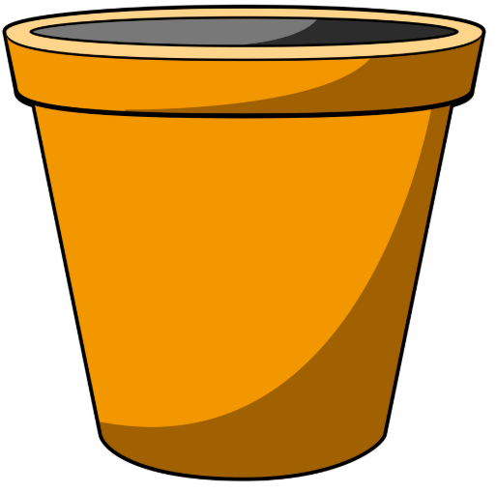
vs.
Additional Space – Succulents:
Additional Space – Other plant:
What are two differences in growing requirements?

Succulent:
Non-Succulent Plant of Your Choice:
What is a succulent plant?

Plant Propagation
Aligned to the following standards:
FFA.PL-A.; FFA.PL-B.; FFA.PL-D.; FFA. PL-F.; FFA.PG-H.; FFA.CS-M.; FFA.CS-N.; FFA.CS-O; CCSS.ELA-RI.9-10.4; CCSS.ELA-W.9-10.2; CCSS.W.9-10.4; CCSS.ELA-W.9-10.6; CCSS.ELA-SL.9-10.4; CCSS.ELA-WHST.9.10.2; CCSS.ELA-WHST.9.10.4; CCSS.ELA-WHST.9.10.6; MP1; MP2; MP6; CRP.04; CRP.06; CRP.08; CRP.11
Directions:
Research the different types of plant propagation and answer the questions below. A Suggested website to use for research is https://extension.umaine.edu/gardening/manual/propagation/plant-propagation/.

1) What are the two different types of plant propagation?

Type 1: ______________________

Type 2: ______________________

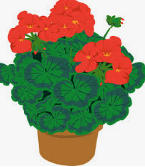
2a) Steps to perform this type of propagation:

2b)
Steps to perform this type of propagation:

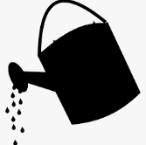

3) What are the advantages of asexual plant propagation for a home owner?

Teach Elementary Students or Classmates!
Aligned to the following standards:
FFA.PL-A.; FFA.PL-B.; FFA.PL-D.; FFA. PL-F.; FFA.PG-H.; FFA.CS-M.; FFA.CS-N.; FFA.CS-O; CCSS.ELA-RI.9-10.4; CCSS.ELA-W.9-10.2; CCSS.W.9-10.4; CCSS.ELA-W.9-10.6; CCSS.ELA-SL.9-10.4; CCSS.ELA-WHST.9.10.2; CCSS.ELA-WHST.9.10.4; CCSS.ELA-WHST.9.10.6; MP1; MP2; MP6; CRP.04; CRP.06; CRP.08; CRP.11
Directions:
Create a plan for a plant propagation demonstration for elementary-age students or fellow classmates. A suggested website to use for research is https://extension.umaine.edu/gardening/manual/propagation/plant-propagation/.


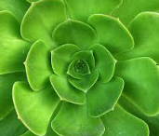
1) What supplies will you need for this demonstration?

2) Introduction for the demonstration (How would you introduce this to the students?):

3) Write a step-by-step plan on how to perform the plant propagation method you chose.

What type of plant propagation will you choose for this demonstration?

4) What you will say during the demonstration? Write it here.





