Social Media Challenge
Directions: Use the template on the following page to create your social media plan for convention and get approval from the chapter advisor and school administration. As you post, take pictures and share with your chapter/class and advisor. See below for examples.
Use #FFA23 when posting on social media about the national convention and expo.
Examples:
Facebook: “I’m pumped for this year’s 96th National FFA Convention & Expo. What are you most excited about? Comment below! #FFA23”

Instagram Story: “Wearing my new convention tee for #FFA23. Who else is wearing theirs?”

Snapchat: Share a picture of you participating in a student workshop. Caption: “Love learning with members across the country!”

Other Examples:

- During convention, post a picture of yourself watching a student workshop or main live session, experiencing the expo hall or repping in your FFA gear!
- Counting down the days to convention? Post a countdown and what you are looking forward to.
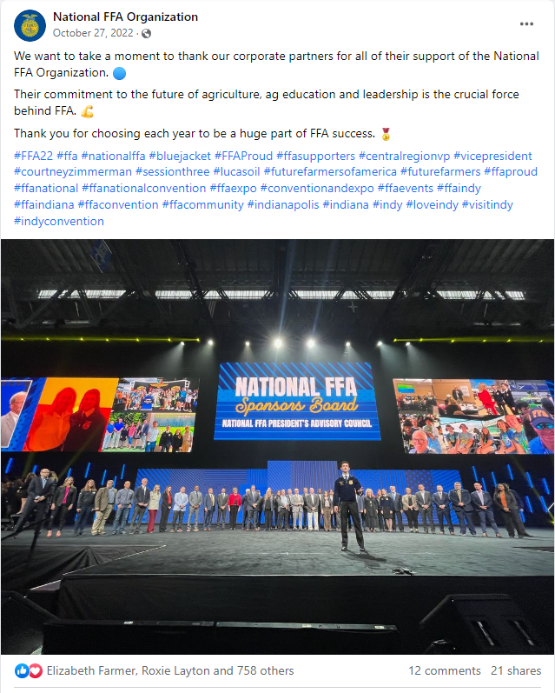
- After convention, post a reflection about your experience.

Wed.
01
Thurs.02
_______________________________________________________________________________________________________________________________________________________________________________________________________________________________________________________________________________________________________________________________________________________________________________________________________

Fri.
03
Post-Convention
Pre- Convention
_______________________________________________________________________________________________________________________________________________________________________________________________________________________________________________________________________________________________________________________________________________________________________________________________________

_______________________________________________________________________________________________________________________________________________________________________________________________________________________________________________________________________________________________________________________________________________________________________________________________________

_______________________________________________________________________________________________________________________________________________________________________________________________________________________________________________________________________________________________________________________________________________________________________________________________________

Sat.
04
_______________________________________________________________________________________________________________________________________________________________________________________________________________________________________________________________________________________________________________________________________________________________________________________________________

_______________________________________________________________________________________________________________________________________________________________________________________________________________________________________________________________________________________________________________________________________________________________________________________________________

