Social Media Challenge
Directions: Use the template on the following page to create your social media plan for convention, and get approval from the chapter advisor and school administration. As you post, take pictures and share with your chapter/class and advisor. See below for examples.
Use #FFA20 when posting on social media about the national convention and expo.
Examples:
Twitter: “Can’t wait to participate in this year’s virtual convention! #FFA20”
Facebook: “I’m pumped for this year’s 93rd National FFA Convention & Expo. Even though convention
looks different this year, what are you most excited for? Comment below! #FFA20”

Instagram Story: “Wearing my new convention tee for #FFA20. Who else is wearing theirs?”

Snapchat: Share a picture of you participating in a student connection room. Caption: “Love meeting new FFA members from across the country!”

Other Examples:

- During convention, post a picture of yourself watching a student workshop or main live session, experiencing the FFA Blue room or repping in your FFA gear!
- Counting down the days to convention? Post a countdown and what you are looking forward to.
- After convention, post a reflection about your experience.

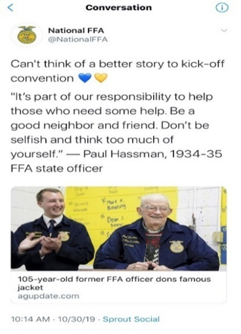
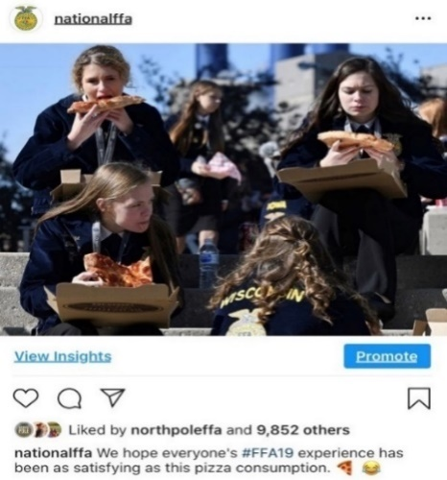

Tues.
27
Wed.
28
_______________________________________________________________________________________________________________________________________________________________________________________________________________________________________________________________________________________________________________________________________________________________________________________________________

Thurs.29
_______________________________________________________________________________________________________________________________________________________________________________________________________________________________________________________________________________________________________________________________________________________________________________________________________

_______________________________________________________________________________________________________________________________________________________________________________________________________________________________________________________________________________________________________________________________________________________________________________________________________

Post-Convention
Pre- Convention
_______________________________________________________________________________________________________________________________________________________________________________________________________________________________________________________________________________________________________________________________________________________________________________________________________

_______________________________________________________________________________________________________________________________________________________________________________________________________________________________________________________________________________________________________________________________________________________________________________________________________

