Social Media Tips and Tricks Guide 
Our shared goal during National FFA Week is to tell the world about FFA! Thousands of voices spreading the FFA message across social media elevates awareness of FFA, and that’s where you come in. Your chapter’s story is important in helping others learn who we are, what we do and the diversity of FFA across the country. Here are our top tips on using your voice on social media to elevate your chapter and FFA during FFA Week!
Pick one or two social platforms to concentrate on. Don’t spread yourself too thin. It’s better to be in one place with great stories than everywhere with mediocre stories.
Which social platforms will you concentrate on?
- _______________________________
- _______________________________



Tip 5:
Try ending your social post with a question or ask others to share their stories in the comments. This will help create engagement and conversation amongst your followers.
Tip 4:
Use Instagram/Facebook stories to tell stories. For instance, your story could be an ongoing “scrapbook” of that day’s FFA Week activities or video interviews.
Tip 3:
Remember your FFA voice — a positive, respectful and inspirational tone. If individuals comment on your posts with unkind words, resist the urge to argue with negative comments. You won’t change any minds, and it will just ruin your day. We like to say, “Hug Your Haters.”
Tip 2:
Share what you and your chapter are doing during FFA Week, but don’t forget the rest of the year. Does someone in your chapter have an interesting or unique SAE? Share it! Does your chapter have a Living to Serve project? Share it! And of course, share your FFA Week activities too!
Tip 1:
Use #FFAWeek and tag @NationalFFA on all your social posts so people can find them and National FFA can share the amazing stories you’re telling.
Social platform 1: __________________________________

1.

2.
Social platform 2: _________________________________

1.

2.
Before FFA week, plan your posts. You can even write some of them ahead of time. Planning ahead will save time during FFA Week so you can enjoy the celebration too! Just leave some room for spontaneity. In the boxes below, compose two posts for each social platform you selected above. Read the tips below to help you plan! Need to see some examples? Click here!

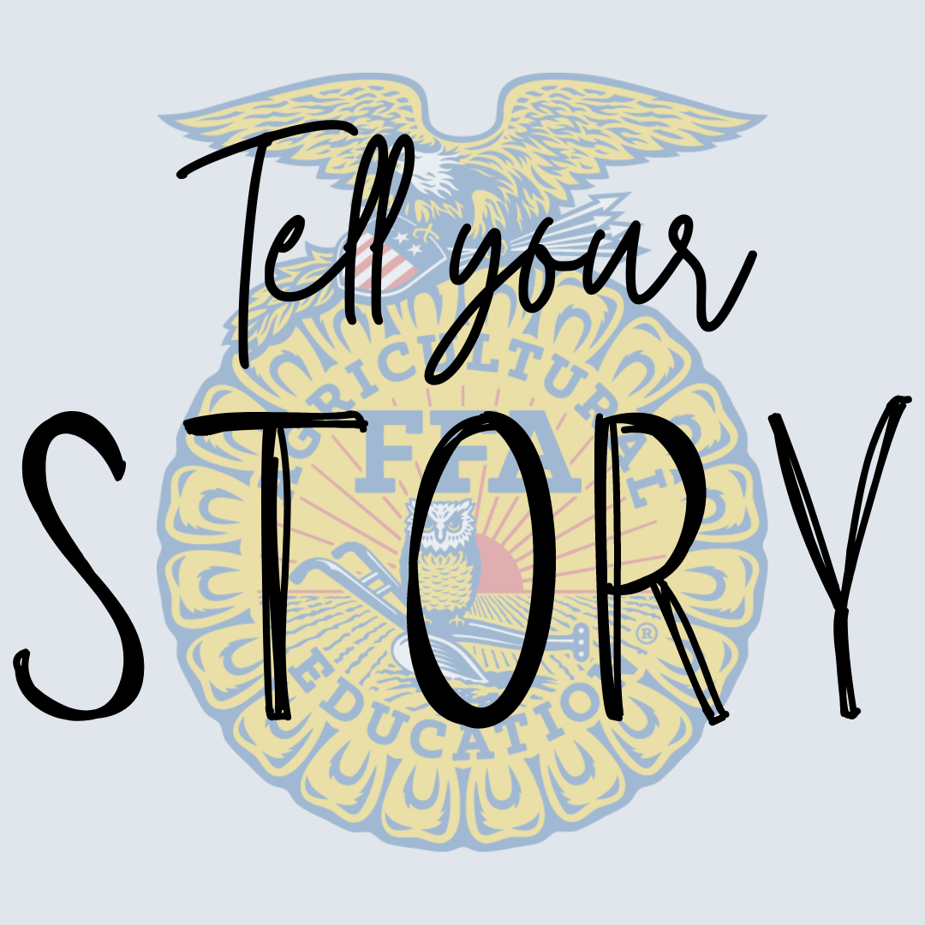


MOST importantly, every member and every chapter have an important FFA story. Don’t be afraid to share yours — we know it will be interesting!
If someone is being vulgar, bullying or posting unrelated comments on your posts, hide them. It’s good practice to have user guidelines on your page in the About section. Ours is on the National FFA website: FFA.org/social-media-user-policy/
Compose some guidelines that you could include to help avoid vulgarity, bullying or posting of unrelated comments.
In your posts, use the highest-quality photos and videos you have access to. These tell the best stories and generate the most engagement.
Use this space to brainstorm a list of photos and videos that could be used. Don’t have any that will work? Brainstorm pictures and videos that can be taken!
Ready to plan your whole week of social media posts? Use the National FFA Week on Social Media 2026 planning guide!

