A Vineyard for a Classroom
Aligned to the following standards:
PS.03; PL-A.; PG-J.; CS-M.; AG-PL3; AGPB01.03; CCSS.RI.9-10.1; CCSS.SL.9-10.4; CCSS.RST.9.10.4; CCSS.WHST.9.10.4; CCSS.WHST.9.10.7; WHST.9.10.9; CRP.02; CRP.04; CRP.07; CRP.08
Part 1
Directions:
Read the article “A Vineyard for a Classroom,” available at FFA.org/news/a-vineyard-for-a-classroom/, and answer the following questions.
What four tasks do students complete in their vineyard?

- _________________________________
- _________________________________
- _________________________________
- _________________________________

What does viticulture mean?

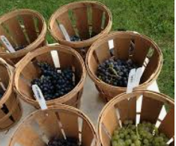
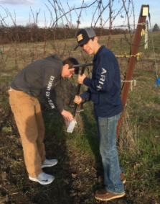
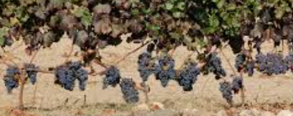
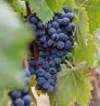
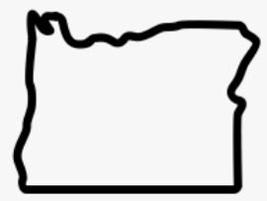
Part 2
Using AgExplorer.FFA.org, identify three careers you could have if you want to enter the viticulture industry and how that career fits.

- _____________________________________
  - How:

- _____________________________________
  - How:

- _____________________________________
  - How:
Think of a program you are currently a part of or have been in the past that has had a similar impact on you. Why did it impact you?

What impact has this program had on students who go through the Yamhill-Carlton agriculture program?

What role does the viticulture program play in the Yamhill-Carlton FFA?

How many bottles of wine are produced each year from the grapes the chapter produces?

- 120
- 976
- 1,440
- 1,468
What do students test to determine when they should harvest the grapes?

- ___________________
- ___________________

How large is the chapter’s vineyard?

- 1 acre
- 2 acres
- 3 acres
- 4 acres

The Yamhill-Carlton FFA chapter is in what state?

- Oregon
- Washington
- Maine
- California

Directions:
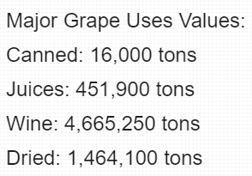
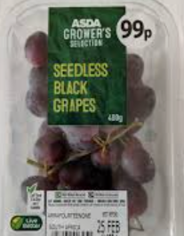
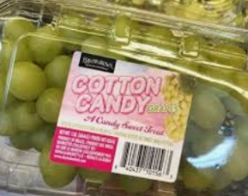
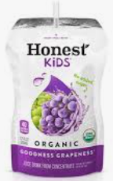
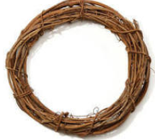
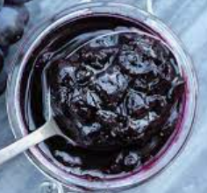
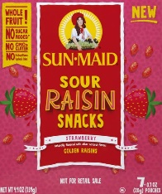
Grape production is a large component of the agriculture industry. Complete the following activities to learn more about grape production and the industry.
What surprises you about the use of grapes, as represented in your graph? Why?
The USDA National Agricultural Statistics Service (NASS) reported that the U.S. had 1,000,700 acres of grapes. Using the information below, develop a bar graph to visually represent the value of the most common grape uses. Be sure to label each axis.
Title: _____________________________________________
What impact do you think grape production has on the agriculture industry?
Circle the products below that come from the grape industry.
Part 3
Directions:
Table-grape production is a unique process with many steps required to ensure a useable product. Using the resource from Grapes from California (History), https://www.grapesfromcalifornia.com/community-outreach/grapes-in-the-classroom/#lesson-plans, study the steps in the production process and, in the space below, place them in the correct order to reflect the production process. Sketch a picture to represent each step.
Prune the vines

Buds swell and green leaves appear

Mean temperature rises

Sugar accumulation

Pick grape bunches

Shoots begin growing one or more inches per day.

Flowers bloom

Color change/translucency begins

Shipped
Flowers shatter

Tiny green grapes ripen into clusters

Ripening grapes begin to soften

Inspection

Placed in a cooled environment

Packed by hand
Do You Have Any Grapes?
Aligned to the following standards:
PS.03; PL-A.; PG-J.; CS-M.; AG-PL3; AGPB01.03; CCSS.RI.9-10.1; CCSS.SL.9-10.4; CCSS.RST.9.10.4; CCSS.WHST.9.10.4; CCSS.WHST.9.10.7; WHST.9.10.9; CRP.02; CRP.04; CRP.07; CRP.08
Directions:
To grow her SAE, Chloe had to learn how to grow, care for, and harvest grapes and grapevines. Complete the worksheet by examining the suggested resource and answering the questions below.
Suggested Resource:
- Growing Grapes in the Home Garden, https://extension.umn.edu/fruit/growing-grapes-home-garden

- List five facts about grapes.



- What should you consider when choosing what grape variety to grow?

- How much water do young grapes require? How do water needs change as the plants mature?

- Why should you reduce watering young grapes in the fall?
  - They are not growing so they do not need water.
  - It encourages the plant to harden-off.
  - It prevents the roots from freezing during the winter.
  - You should not reduce watering in the fall.

- What are the fertilizer needs of grape vines?

- True or False. Mulching around the base of the vine is beneficial. (If false, explain why.)

- Why is weeding around grape vines so important?

- What steps should you follow to harvest grapes?
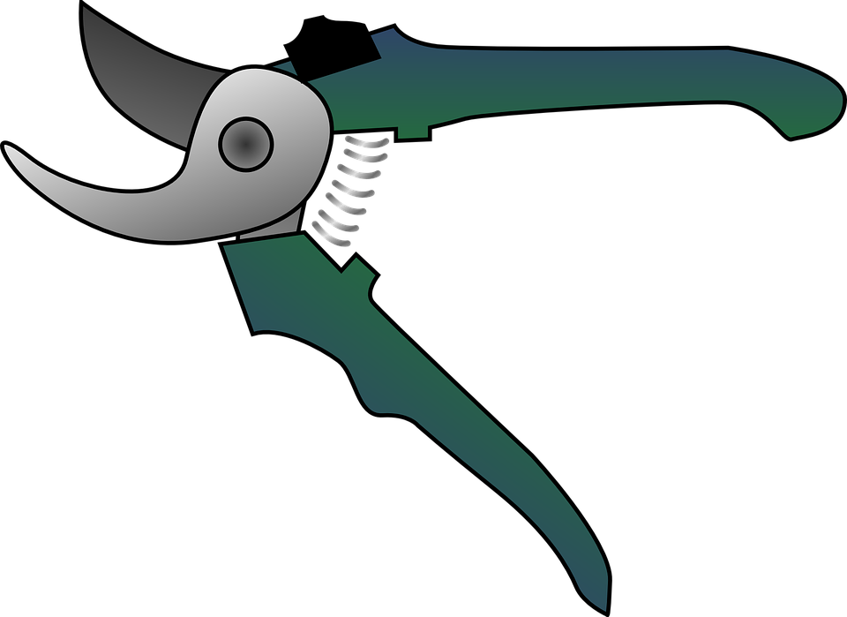

- How do you properly store grapes?

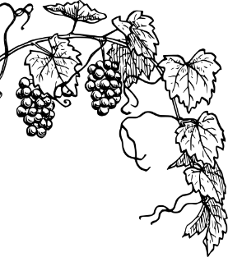

- Grape vines require care throughout the year. Complete the task chart below.

Month | Tasks
March
April, May
April – June
April – August
April – October
May, June
September, October
September, October
October, November

All About the Vine
Aligned to the following standards:
PS.03; PL-A.; PG-J.; CS-M.; AG-PL3; AGPB01.03; CCSS.RI.9-10.1; CCSS.SL.9-10.4; CCSS.RST.9.10.4; CCSS.WHST.9.10.4; CCSS.WHST.9.10.7; WHST.9.10.9; CRP.02; CRP.04; CRP.07; CRP.08
Part 1
Directions:
Answer the questions below as you watch the video “Grapevine Wreaths SAE | Chloe Jones,” available at https://vimeo.com/377181367.

What is a supervised agricultural experience?

What does Chloe do in the summer and in the winter to create her grapevine wreaths?
How does Chloe’s SAE impact her community?



What daily tasks is she responsible for?


How has Chloe’s SAE grown?

What did she have to learn so she could grow her SAE?

What things must be considered when decorating the wreath?

How do you make a grapevine wreath?

Part 2
Directions:
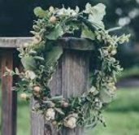
Now that you know how a grapevine wreath is made, let’s make our own wreath to take home! Watch the video “How to Make a Wreath – The Home Depot” found at https://youtu.be/V-7QVb3T-jI. During and after the video, complete the following activity sheet to plan out your wreath.
What would you do differently if you made a second wreath?
What did you enjoy about making your wreath?
What was the biggest challenge you experienced? Why?
Draw an image to help plan out your wreath. Be sure to include all the flowers, greenery and other supplies you listed in your Supplies list.
Supplies:

Tools/supplies:
- Grapevine wreath

Fresh Materials:
- Flowers:

- Greenery:

Develop a numbered procedure list to follow.

