
Advocacy Chat: Growth Energy
Directions:
Watch the video “Advocacy Chat: Growth Energy” at https://vimeo.com/522381211. Complete the following activities.
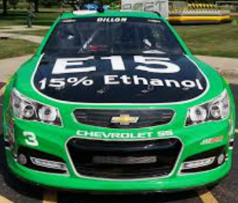
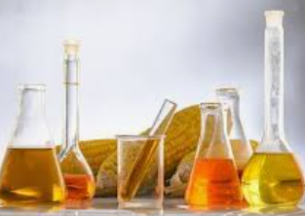

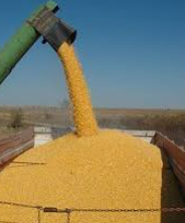
Describe what Growth Energy does.
Where is Growth Energy located?
- San Francisco
- Seattle
- West Palm Beach
- Washington D.C.
What are two items that are represented by Growth Energy?

What agricultural commodity is used for ethanol?
_______________________________
How do biofuels link to agriculture?
Classify each statement by circling fact or fiction.
- Ethanol demand helps corn farmers. Fact Fiction

- Ethanol does not have a role in COVID-19. Fact Fiction

- Ethanol is better for the environment than gasoline.
Fact Fiction

- Ethanol is bad for my vehicle’s engine. Fact Fiction
Identify three ways you have used corn today. Note: No more than one item can be food.

In detail, describe the role that agriculture will play in the biofuels industry in the future. Provide an example to aid in your explanation.

