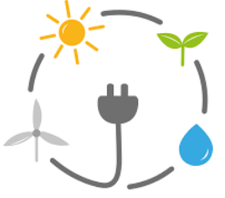
Advocacy Chat with Invenergy
Directions:
Watch the video “Advocacy Chat with Invenergy,” available at https://vimeo.com/522381211/190e926853, and complete the following activities.
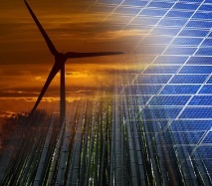
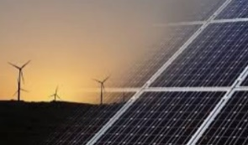

Draw a picture that depicts the height of a wind turbine in comparison to another well-known structure (Ex. a wind turbine next to the St. Louis Gateway Arch).
The height of the wind turbine should come from the video and your answer in Question 2.
What did you find most interesting about solar panels and wind turbines? Why?
What do you think the future is for wind and solar energy?
It was mentioned that one turbine provides 1.5 megawatts of energy. What can that amount of energy power? Be specific.
What benefits do wind and solar energy bring to farming communities?
How would solar or wind energy impact the community you live in? If you have wind and solar energy, how has it impacted your community?
Where in your community could a wind and/or solar energy device be placed? Be specific, taking into consideration the sizes of solar panels and wind turbines.
In the video, which state houses the wind turbines and solar panels we see?

- Ohio
- Oklahoma
- Texas
- Illinois
Who manufactures the turbines shown?

What other types of items does this company produce?
________________________________________________________________________
- How long is each turbine blade?
  - 80 ft.
  - 100 ft.
  - 120 ft.
  - 140 ft.

- How tall is this specific brand of wind turbine?
  - 40 ft.
  - 120 ft.
  - 164 ft.
  - 265 ft.

