What Question Do I Have?
Aligned to the following standards:
CS.01; FFA.PL-A; FFA.PL_C; FFA.PL-E; FFA.PL-F; FFA. PG-J; FFA.CS-N; AG1; CCSS.ELA.RI.9-10.1; CCSS.ELA.RI.9-10.2; CCSS.ELA.RI.9-10.3; CCSS.ELA.RI.9-10.4; CCSS.ELA.RI.9-10.8; CCSS.ELA.RST.9-10.1; CCSS.RST.9.10.4; CCSS.ELA.RST.9-10.8; CCSS.ELA.RST.9-10.9; CCSS.ELA.WHST.9.10.1; CCSS.ELA.WHST.9.10.4; CRP.02; CRP.04; CRP.05; CRP.06; CRP.07; CRP.08

Part 1
Directions:
Having an effective research question is important for being able to complete an effective research study. Learn how to develop proper research questions through the activities below.
What is a research question?

Using the resource https://writingcenter.gmu.edu/guides/how-to-write-a-research-question, summarize, in your own words, the five words you should consider when writing an appropriate research question.

- Word: ___________________: __________________________________________________________________________________________________________________________________________________________________________________________________________________________

- Word: ___________________: __________________________________________________________________________________________________________________________________________________________________________________________________________________________

- Word: ___________________: __________________________________________________________________________________________________________________________________________________________________________________________________________________________

- Word: ___________________: __________________________________________________________________________________________________________________________________________________________________________________________________________________________

- Word: ___________________: __________________________________________________________________________________________________________________________________________________________________________________________________________________________


Take one minute and brainstorm a minimum of three of your greatest interests, both in the classroom and out. For example, do you like working on trucks, raising goats, playing soccer? Go!
- Circle three interests on your list.
In one sentence, how would you summarize for a classmate these five needs for a perfect research question?
Interest/topic selected:
- Transfer one to the box.

Part 2
In your own words, using the George Mason University Writing Lab, identify the six steps you should take to write an appropriate research question.

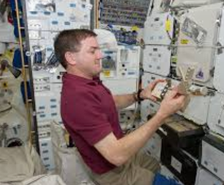

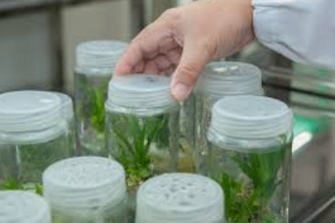
Think about your interests, and then consider what related needs there are in your community that you could research. Identify three.

1.

2.

3.
Think about the needs you just identified and your interests, then develop a well-written research question that can serve as the foundation of your research.
Watch the video “What Is Aquaculture?”, and write two well-formed research questions you could investigate.

Thinking about the five words and the steps needed to write an effective research question, read through each of the research questions below and circle the question(s) that are well-written and could be used for a research study.

- How are doctors addressing heart disease in the United States?

- Do cats prefer wet food or dry food?

- Do carnations or daisies transport water throughout their stems more efficiently?

- Should high schoolers exercise regularly to impact mental health?

- Do corgi dogs have a greater number of surgery complications as compared to large breed dogs?

What Do We Already Know?
Aligned to the following standards:
CS.01; FFA.PL-A; FFA.PL_C; FFA.PL-E; FFA.PL-F; FFA. PG-J; FFA.CS-N; AG1; CCSS.ELA.RI.9-10.1; CCSS.ELA.RI.9-10.2; CCSS.ELA.RI.9-10.3; CCSS.ELA.RI.9-10.4; CCSS.ELA.RI.9-10.8; CCSS.ELA.RST.9-10.1; CCSS.RST.9.10.4; CCSS.ELA.RST.9-10.8; CCSS.ELA.RST.9-10.9; CCSS.ELA.WHST.9.10.1; CCSS.ELA.WHST.9.10.4; CRP.02; CRP.04; CRP.05; CRP.06; CRP.07; CRP.08

Part 1
Directions:
Literature Review!
Complete the following activities to learn about literature reviews.
What would happen if scientists completed research without ever looking at research that had already been completed?



Watch the video “What Is a Literature Review?” and answer the questions below.

What is a literature review?

Identify the purpose behind a literature review.



1.

2.

3.

In your own words, describe what a literature review is and why it is important for research.
Give an example of a study that would require a literature review.

Watch the video “How to Write a Literature Review: Three-Minute Step-by-Step Guide” and answer the following questions:
- Which of the following would NOT be considered an acceptable source for a literature review?
  - Google Scholar
  - A school textbook
  - The Huffington Post
  - A scientific journal (Ex. Journal of Agricultural Education)
- Which of the following should you look at to evaluate if the resource is trustworthy?
  - Abstract
  - References
  - Authors
  - All of the above
- As you read through the resource, what should you pay attention to and take note of?
  - Trends
  - Themes
  - Debates or contradictions
  - Influential studies
  - Gaps
  - All of the above

How will completing a literature review help you in your research?
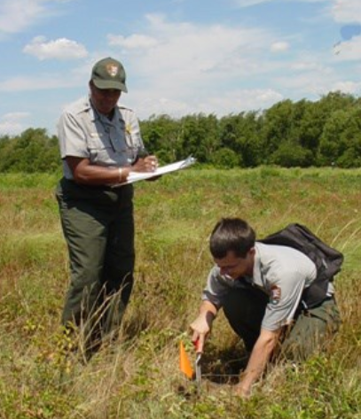
Part 2
Utilizing a valid research method (ex. Google Scholar), find three sources that will help inform your research question. List the titles of each resource below.

1.

2.

3.

What gaps, trends or themes do you see in the resources you found? Identify a minimum of three.

1.

2.

3.

Based on what you have learned in your literature review, how will or can you change your research question (developed previously) to use what you have just learned?

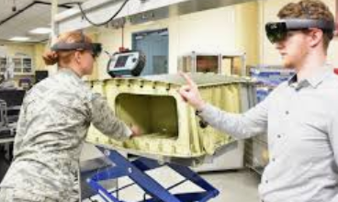

Let’s Sum it Up!
In your own words, describe the following as if you were talking to a grandparent, best friend, sibling or parent:
- How do you write an effective research question?
- Why are well-written research questions so important to produce effective research?
- What is a literature review?
- Why is it important to conduct a literature review?
- How do well-written research questions and your literature review relate?

Giving Credit
Aligned to the following standards:
CS.01; FFA.PL-A; FFA.PL_C; FFA.PL-E; FFA.PL-F; FFA. PG-J; FFA.CS-N; AG1; CCSS.ELA.RI.9-10.1; CCSS.ELA.RI.9-10.2; CCSS.ELA.RI.9-10.3; CCSS.ELA.RI.9-10.4; CCSS.ELA.RI.9-10.8; CCSS.ELA.RST.9-10.1; CCSS.RST.9.10.4; CCSS.ELA.RST.9-10.8; CCSS.ELA.RST.9-10.9; CCSS.ELA.WHST.9.10.1; CCSS.ELA.WHST.9.10.4; CRP.02; CRP.04; CRP.05; CRP.06; CRP.07; CRP.08

Directions:
Giving credit is very important when credit is due. In research, it is always important to give credit to other researchers as well as yourself. Complete the following activities to learn how to properly cite sources.
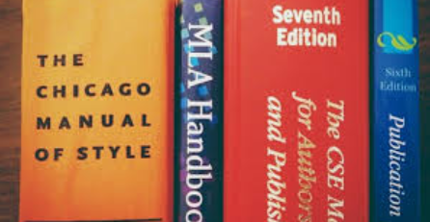
Use the Purdue University Online Writing Lab to help you cite the three resources you identified in the previous activity.
- ________________________________________________________________________________________________________________________________________________________________________________________________________________________

- ________________________________________________________________________________________________________________________________________________________________________________________________________________________

- ________________________________________________________________________________________________________________________________________________________________________________________________________________________
When completing research, it is always important to cite your sources. (If you score the winning goal in your soccer game you want the credit, right?) Utilizing APA formatting is a commonly accepted method for giving credit when conducting scientific research. Using the Purdue University Online Writing Lab, practice citing the resources shown below.
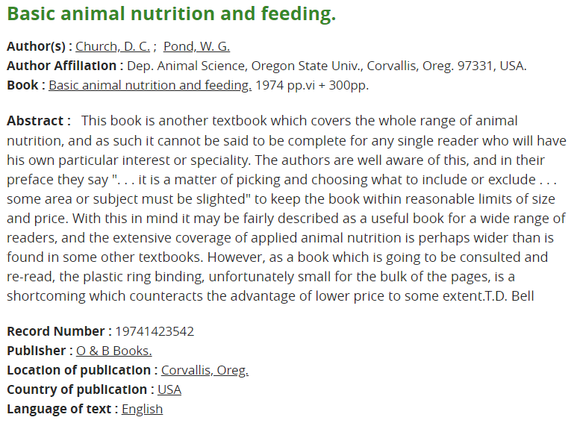
Citation:
Citation:
Did you know that if you have completed previous research you still have to cite yourself? Why do you think this is necessary?
When is the best time to complete your Works Cited page for your final research report?

- Before you start constructing your report
- While you are writing your report
- After you complete your report
When using information from a resource you must also include an in-text citation to let a reader know exactly what resource is being given credit. Using the Purdue University Online Writing Lab, develop an in-text citation for each of your three resources.

1.

2.

3.
Why is it important to use citations in research?



