Fact or Fiction?
Aligned to the following standards:
FFA.PL-A; FFA.PL-E; FFA.PL-F; FFA.PG-I; FFA.PG-J; FFA.CS-N; CCSS.ELA.RI.9-10.3; CCSS.ELA.RI.9-10.4; CCSS.ELA.SL.9-10.1; CCSS.ELA.WHST.9.10.4; CRP.02; CRP.04; CRP.06; CRP.07; CRP.08

Part 1
Directions:
Below is a list of statements. Circle “fact” if you believe the statement is true or “fiction” if you believe the statement is false. Do not look anything up; complete this to the best of your ability independently.
- Lightening never strikes the same place twice.
Fact Fiction

- Bananas grow on trees.
Fact Fiction

- Pigs don’t sweat.
Fact Fiction

- Hair and fingernails continue to grow after a person dies.
Fact Fiction

- Soil is alive.
Fact Fiction

- A penny dropped from the empire state building can kill a person on the sidewalk. Fact Fiction

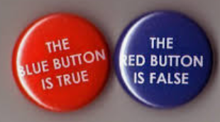

Watch the following episode of MythBusters: https://youtu.be/WpTSA_25wGEg

Why do you think the MythBusters crew tries to determine if something is a myth?

Check your answers below. How many did you get right and wrong?
# correct: ___/6
# incorrect: ___/6

Why do you think it is important to know the facts behind the things that impact us every day?

Research why the statements are considered fiction. How do you feel after finding out the truth?

What impact do you think myths can have on society and different industries? Why?

Part 2
Directions:
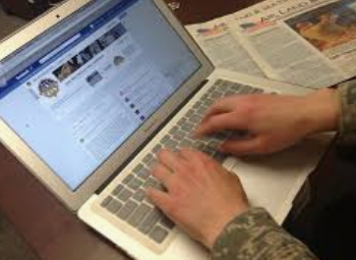


Watch the video “Why Research Is So Important,” https://youtu.be/FuVGo3AJhqA, and answer the questions below. Some questions may be answered after the video has ended
______________ is made through research.
Research gathers ________________ and investigates phenomena, allowing us to test _______________ and make _________________.
Research creates new knowledge and understanding. Give an example of new knowledge that may be gained from research.
Research is the force behind everything we do.
Identify three specific times in your life where research informed what you did. These should be different than the ones listed in the video.

1.

2.

3.
Research reduces the chances of making poor, or _______________, choices, ______________ us from ____________ ideas and ______________ beliefs. Give an example of when research may have helped you in these potential situations.
It’s time for us all to ________________ research to find the ________________ to back up beliefs, to test out ______________ and to _________________ better ways of doing things.
Eli Lilly is a major company that works in the field of science and medicine. Watch the video “Clinical Trials,” https://www.lilly.com/clinical-research/clinical-trials.While you watch the video record four words, thoughts or reactions you have.

- 2.
3. 4.

Using those four words, thoughts or reactions, summarize why research is important in our world and society. Why do we need research?
Summarize your thoughts about the video in one sentence.

