Let Your Research Be Seen
Aligned to the following standards:
FFA.PL-A; FFA.PL-C; FFA.PL-E; FFA.PL-F; FFA.PG-J; FFA.CS_N; CCSS.ELA.SL.9.10.1; CCSS.ELA.RST.9-10.7; CCSS.ELA.WHST.9.10.4; CCSS.ELA.RST.9.10.7; CRP.02; CRP.04; CRP.06; CRP.07; CRP.08
Directions:
Look at the two research posters below and answer the questions. Critique the visual aspects of the poster, not the content.
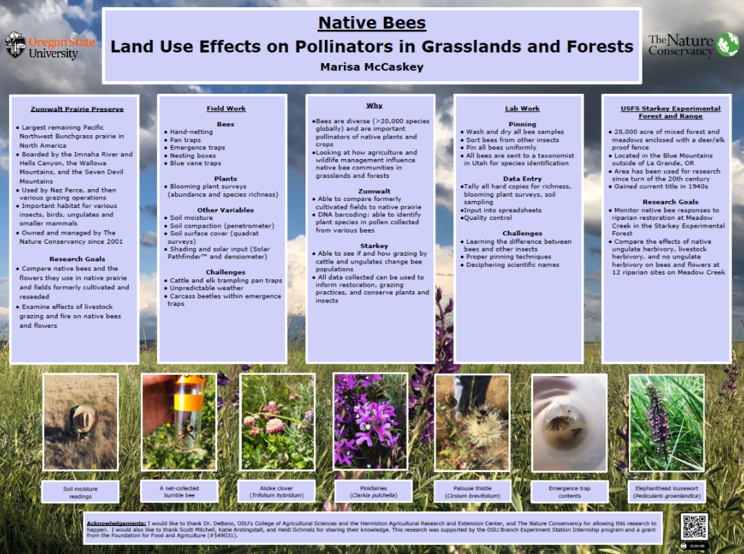
What do you like about this poster? What makes it catch your eye?

What about this poster do you not like, and what could be improved?

What do these posters have in common? Why do you think they have these items in common?

What do you like about this poster? What makes it catch your eye?

What about this poster do you not like, and what could be improved?



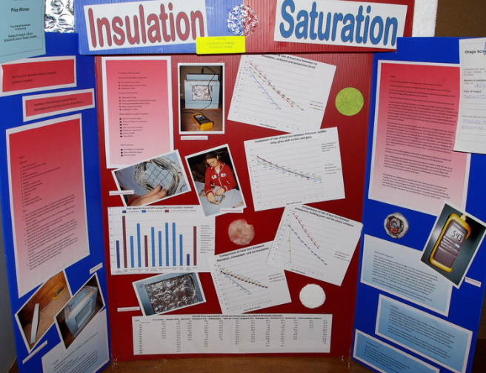
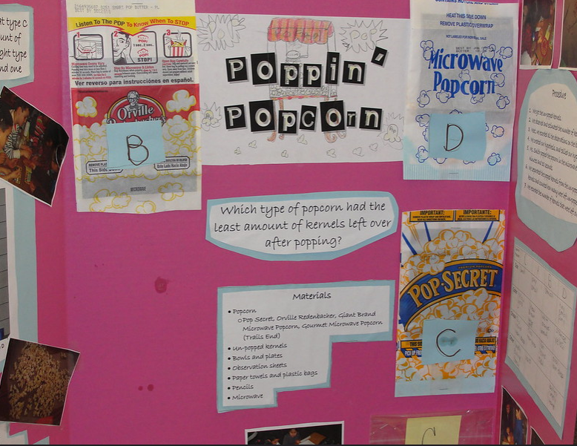
- Circle the poster that you think is the best.

- Why did you select this poster? What makes it the best option for a research poster?
What do you think is the purpose of a research poster?
What about this poster do you not like, and could be improved?
What do you like about this poster? What makes it catch your eye?
What about this poster do you not like, and what could be improved?
What do you like about this poster? What makes it catch your eye?
How Will You Show What You Know?
Aligned to the following standards:
FFA.PL-A; FFA.PL-C; FFA.PL-E; FFA.PL-F; FFA.PG-J; FFA.CS_N; CCSS.ELA.SL.9.10.1; CCSS.ELA.RST.9-10.7; CCSS.ELA.WHST.9.10.4; CCSS.ELA.RST.9.10.7; CRP.02; CRP.04; CRP.06; CRP.07; CRP.08
Directions:
Research posters are a great way to share your research in a concise and visual manner. Watch the video “Making a Better Research Poster,” available at https://youtu.be/AwMFhyH7_5g, and answer the questions below.
Why do you think this mistake is made so often?

What is the number one mistake people make when developing their research posters?

How will you avoid this mistake for your poster?



Full sentences can be used, but you should also try to use what?

- Bullet points
- Fragments
- Clips directly from your paper
Figures and graphs are important for your poster. But what should you be cautious of doing with your graphs and figures?

B________________ them in t__________

How many colors are recommended when designing your poster?
- 1-2
- 3-5
- 6-7
- 8-9
How do people naturally read?

Why is it important to think about this when designing your poster?




At what distance should all content be viewable?

- Two feet
- Three feet
- Six feet
- Seven feet

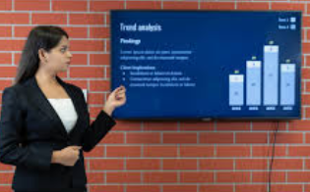

Lastly, describe how you will present your poster.

Let’s Brainstorm
Directions:
Now that you understand how a research poster should be constructed, use the space below to plan your poster. Be sure to consider all the elements we have learned, such as flow of the content, bullet points, colors, concise title, and labels, figures and charts to be included as well as the images you will include.
Note: Do NOT just copy and paste sentences and information from your paper! You should always think about your audience and how to display content concisely and in a readable format.

Poster Rubric
Area | 4 points | 3 points | 2 points | 1 point
Overall Appearance | - Well organized  - Bullet points used  - Not text heavy  - Draws attention | - Some organization is present.  - Text is somewhat heavy.  - Draws attention | Some organization is present. However, readability is still difficult. | Organization is poor with lots of text.  Does not capture your attention
Color | Only three to four colors were used. | More than four colors were used or colors do not work or dark background was used. | Colors are not cohesive. | Color was not well considered in the development of the poster.
Graphics/tables | Two to three graphics/tables were used in the correct places and enhanced the overall poster flow and readability. | Less than two graphics/tables were used. | One or less graphics/tables were included. | No graphics/tables incorporated
Text | Text and images are well balanced. Bullet points were used to help break up information. | Text heavy, with 20% or more of the poster having text directly copied and pasted from the paper | Very text heavy, with over 50% of the poster text having been copied directly from the paper | Paragraphs of text were copied and pasted to the poster.
Readability | Text and images can be read from 6 feet away. | ________________ | __________________ | Text and images are not able to be read from 6 feet away.
Total |  |  |  | ________/20

