What’s Next?
Aligned to the following standards:
FFA.PL-A; FFA.PL-C; FFA.PL-E; FFA.PG-I; FFA.PG-J; FFA.CS-N; CCSS.ELA.RI.9-10.4; CCSS.SL.9-10.2; CCSS.SL.9-10.4; CCSS.ELA.WHST.9.10.4; CRP.02; CRP.04; CRP.06; CRP.07; CRP.08; CRP.11
Directions:
Watch the video “Ctenophore SAE – Grace Ramcke and Hannah Colonese,” https://vimeo.com/300298552, and complete the following activities.
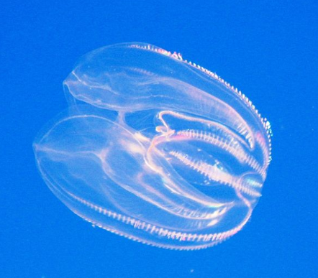


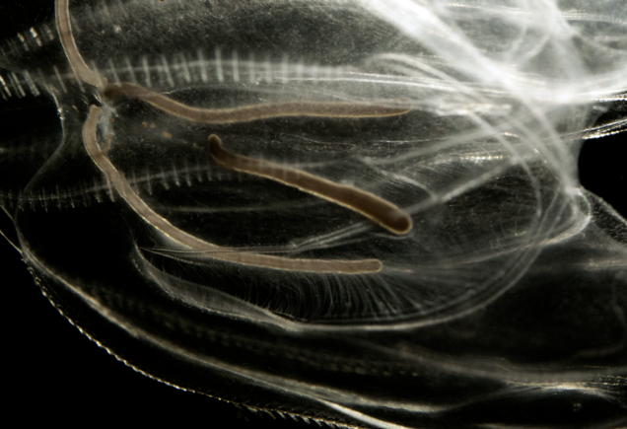
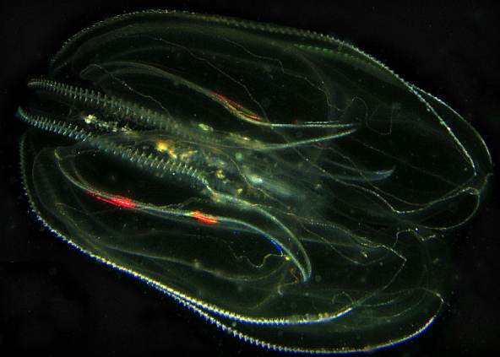
Say What???
Ctenophore = ten-uh-fawr
What is a supervised agricultural experience (SAE)?

In Grace and Hannah’s opinion, what can an SAE include?
- Working in a lab
- Research and a presentation
- Working at a local fast food restaurant
How are they hoping their research will be used?
What was the first step Hannah and Grace had to take for their SAE?
What was the first major challenge encountered in this SAE?
How did they work to solve the problem? ________________________________________________________________________________________________________________
What was the outcome?
Identify three skills that can be gained through an SAE.

1.
2.
3.

What role does research have in the agriculture industry? Give an example.

How is agriscience research an SAE?

Apply With What You Have Learned
Aligned to the following standards:
FFA.PL-A; FFA.PL-C; FFA.PL-E; FFA.PG-I; FFA.PG-J; FFA.CS-N; CCSS.ELA.RI.9-10.4; CCSS.SL.9-10.2; CCSS.SL.9-10.4; CCSS.ELA.WHST.9.10.4; CRP.02; CRP.04; CRP.06; CRP.07; CRP.08; CRP.11
Directions:
Now that you understand what an SAE is and how it relates to your agriscience research, let’s take it to the next level and collect all of your thoughts that could then be utilized to apply for an agriculture research proficiency award, which provides recognition through FFA for your hard work in your research. *Tip: Use the content you have already developed in the previous lessons to write your responses for the proficiency application.
Experimental Research SAE:

Involves the application of the scientific method to control certain variables while manipulating others to observe the outcome
Give a specific example of a research project that could fit in this SAE category.
What type of research SAE do you have? What, specifically, classifies your research this type of SAE?

Give a specific example of a research project that could fit in this SAE category.
Analytical Research SAE:

Often begins with a question that asks why or how something occurs, followed by a period of data collection using qualitative and/or quantitative methodologies that are then analyzed for results

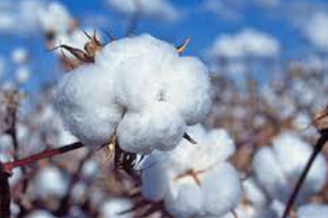
Agriscience Animal Systems Research - Research in the life processes, health, nutrition, genetics, management and processing of animal systems related to small animals, aquaculture, livestock, dairy, horses and/or poultry.

Agriscience Plant Systems Research - Research in the life cycles, classifications, functions, practices of plant systems related to crops, turf grass, trees and shrubs and/or ornamental plants.

Diversified Research - Research in two or more of the agriscience research areas.

Environmental Service Systems/Natural Resources Systems Research - Research in the systems, instruments and technology used in waste management and their influence on the environment.

Food Products and Processing Systems Research - Research in the product development, quality assurance, food safety, production, sales and service, regulation and compliance, and food service practices within the food industry.

Power, Structural and Technical Systems Research – Research in the agricultural equipment, power systems, alternative fuel sources and precision technology, as well as woodworking, metalworking, welding and project planning for agricultural structures.

Social Sciences Research - Research of leadership, personal growth and career success skills necessary for a chosen profession that effectively contributes to society.
In green, highlight the description that best fits your agriscience research pathway.
Give a specific example of a research project that could fit in this SAE category.
Invention Research SAE:

Applies the engineering design process to create a new product or service

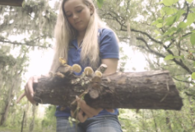
In orange, circle the career pathway that best fits your agriscience research.
What specifically about your research makes the pathway you circled in orange fit?
Briefly explain your SAE or research.
  - What interested and motivated you to begin?
  - What situations existed that relate to your SAE or research area?
  - Did any particular person, situation or event create your interest?
- Agribusiness Systems: The study of business principles, including management, marketing and finance, and their application to enterprises in agriculture, food and natural resources
- Animal Systems: The study of animal systems, including life processes, health, nutrition, genetics, management and processing, through the study of small animals, aquaculture, livestock, dairy, horses and/or poultry
- Biotechnology Systems: The study of data and techniques of applied science for the solution to problems concerning living organisms
- Environmental Service Systems: The study of systems, instruments and technology used in waste management and their influence on the environment
- Food Products and Processing Systems: The study of product development, quality assurance, food safety, production, sales and service, regulation and compliance and food service within the food science industry
- Natural Resources Systems: The study of the management of soil, water, wildlife, forests and air as natural resources
- Plant Systems: The study of plant life cycles, classifications, functions, practices, through the study of crops, turf grass, trees and shrubs and/or ornamental plants
- Power, Structural and Technical Systems: The study of agricultural equipment, power systems, alternative fuel sources and precision technology, as well as woodworking, metalworking, welding and project planning for agricultural structures
Briefly explain how your roles and responsibilities related to this area of research have changed.
- How have you increased your knowledge or skill related to this area?
- How have your roles and responsibilities increased over the life of you SAE or research?
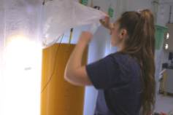
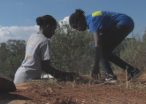


Briefly explain the single greatest challenge you had with your SAE or research and how you overcame that challenge.
*Tip: Be specific and provide insight into your management and performance skills.
Briefly explain your three greatest accomplishments/findings in your SAE or research? Examples: Has your research produced findings that support or reject your hypothesis? Did research lead to a new patent or method?

1)

2)

3)
What are three ways your experiences or opportunities through your SAE or research will impact your future?

1)

2)

3)
Describe how you handled the funding of your research.
Identify five skills you learned during your research.

1)

2)

3)

4)

5)
Agriscience Research Assessment
Directions:
Answer the questions below to the best of your ability by circling the most correct answer.

- When is the best time to complete your Works Cited page for your final research report?
  - Before you start constructing your report
  - While you are writing your report
  - After you complete your report
  - You don’t need a Works Cited page.
- What is the purpose of the literature review?
- To learn something new
- Determine what research has already been completed
- I am required to have citations.
- To increase my reading comprehension
- How many words should be used in an abstract?
- 100
- 200
- 300
- 400
- None of the above
- Which of the following best describes the purpose of agriscience research?
- Research gathers information and investigates phenomena.
- Research allows us to test theories and make predictions.
- Progress is made through research.
- All of the above
- None of the above
2. Which of the following should NOT be included in the introduction of your research report?
- Citations
- Purpose
- Data tables
- Objectives
- Which of the following is important when developing the methods section of your research report?
- References
- Accurate experimental design
- Method modifications
- All of the above
- None of the above
- Which if the following is NOT a recommendation when developing your record section?
- Use ink
- Umber the pages
- Include citations
- Date your entries
- All of the above
- None of the above
- What is the purpose of the results section of an agriscience research report?
- Explain what you found
- Report the results
- Identify what went wrong
- All of the above
- None of the above
- What should be included in a conclusion section?
- Restate the hypothesis/research question
- Restate major findings
- Tell the reader about the contribution your study has made to the literature
- Future recommendations
- All of the above
- What is a hypothesis?
- An educated guess
- A statement of what happened in your research
- A statement that explains why your research is important
- A statement of what you think you will find through your research
- What can you do to be recognized through FFA for your research?
- Proficiency award application
- Have an SAE
- Write a paper
- State degree application
- Why should a student complete an agriscience research project?
- To learn more about a pathway
- To gain and refine skills in research
- To add to the literature
- All of the above
- None of the above

