To Chew or Not to Chew
Aligned to the following standards:
FFA.PL-A; FFA.PL-C; FFA.PL-E; FFA.PL-F; FFA.PG-J; FFA.CS_N; CCSS.ELA.SL.9.10.1; CCSS.ELA.RST.9-10.7; CCSS.ELA.WHST.9.10.4; CCSS.ELA.RST.9.10.7; CRP.02; CRP.04; CRP.06; CRP.07; CRP.08
Directions:
Gum is a very popular option for many people for many reasons, but what are the differences between different types of gum? Work through the following lab activity to determine the answer.

Title: _________________________________________

Purpose: ____________________________________________________________________________________________________________________________________________________________________________________________________________________________________________________________________________________________________________________________________________________________

Hypothesis (What do you think will happen?): ____________________________________________________________________________________________________________________________________________________________________________________________________________________________________________________________________________________________________________________________________________________________

Materials (bulleted list):

Methods (numbered list):

Data:

Results:

Conclusion:

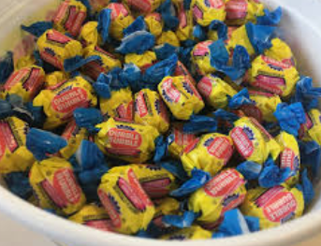
Thinking back through this activity, how do you think the overall process went? Why?


What Is a Hypothesis?
Aligned to the following standards:
FFA.PL-A; FFA.PL-C; FFA.PL-E; FFA.PL-F; FFA.PG-J; FFA.CS_N; CCSS.ELA.SL.9.10.1; CCSS.ELA.RST.9-10.7; CCSS.ELA.WHST.9.10.4; CCSS.ELA.RST.9.10.7; CRP.02; CRP.04; CRP.06; CRP.07; CRP.08
Part 1
Directions:
In the previous activity, you were asked to develop a hypothesis for your Bubble Gum Lab based on what you already knew about a hypothesis. However, let’s take a closer look at how to develop a well-written hypothesis. Watch the video “Six Steps to Formulate a STRONG Hypothesis,” https://youtu.be/PCgLjDDD4ek (stop at 2:43), to learn about constructing a hypothesis for research studies.

What is a hypothesis?







Ask a ______________________.

Complete _________________ research.

Formulate your __________________.

It should be ______________ and _____________.

R____________.

_______________ and ______________ with relevant variables.

______________ outcome ____________ being ____________________

Phrasing of your hypothesis
- ______ … ___________

- C__________________ and/or E____________

- C__________________

Think back to your hypothesis from the Bubble Gum Lab. Did you write your hypothesis correctly? Circle your answer.

Yes No

If no, re-write your Bubble Gum Lab hypothesis here. If yes, record your hypothesis here.

Which type of phrasing (one of the three from the video) did you use for your hypothesis?
Why is developing a well-written hypothesis so important for a research study?
What could be the result of completing a study with a poorly written hypothesis?

Part 2
Directions:
Complete the following activities to practice what we just learned about formulating a well-written hypothesis. You will need to reference the information you learned from the video for this part of the activity.

Read the following hypotheses and determine the type of phrasing being used.

- If I walk my Berkshire three times a week in the evening, then my animal will be ready for show by September 1.

Answer: ___________________________________________

- By eating three carrots per day men, over the age of 50 will have improved vision as compared to those that only eat two carrots per day.

Answer: ___________________________________________

- The number of cigarettes smoked in one day will directly impact cardiovascular health in women of all ages.

Answer: ___________________________________________




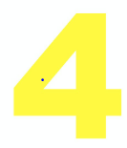
Think about the study you have been preparing, then go through the steps below:

What is your research question? (HINT: You already wrote this in a previous lesson: record it here.)

Identify three key facts you learned in your literature review that helped to inform your research question.

(1)

(2)

(3)

Being clear and concise, draft your hypothesis based on Steps 1 and 2.

Refine and rewrite your hypothesis.
What type of phrasing did you use for your hypothesis?

