
Camping
Aligned to the following standards:
FFA.PL-A; FFA.PL-C; FFA.PL-E; FFA.PL-F; FFA.PG-J; FFA.CS_N; CCSS.ELA.SL.9.10.1; CCSS.ELA.RST.9-10.7; CCSS.ELA.WHST.9.10.4; CCSS.ELA.RST.9.10.7; CRP.02; CRP.04; CRP.06; CRP.07; CRP.08
Directions:
Read the following scenario and record your responses below.

“You and your family are celebrating the end of the school year by going on a camping trip out of town. You have been given the task to create the supply list for the weekend. Think about what you will need for the weekend and create a list. Remember, you will be camping with a tent and need a fire to keep warm and make your meals.” Record thoughts in Step 1.

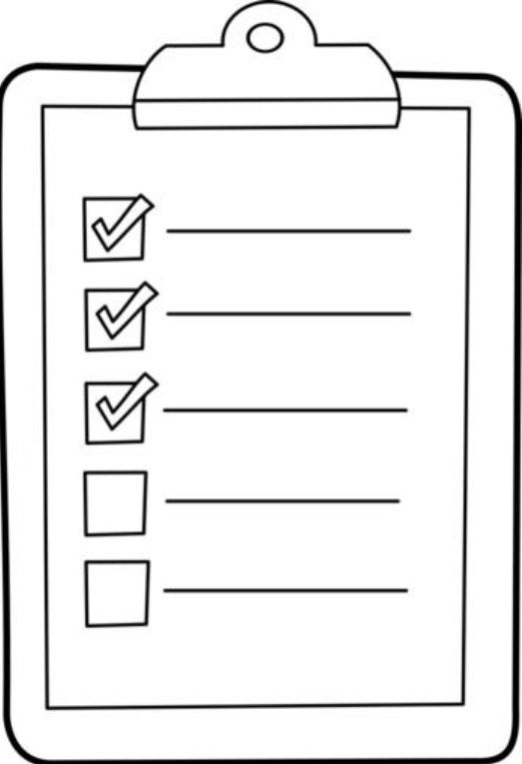



“Develop the detailed procedure you will need to put up your tent, start your fire and prepare your first meal. You can only use the items on your supply list.”
*If you need more space just extend your list to the back of this paper.
Pair up with your neighbor. On the back of their paper your neighbor is going draw as you read your procedure. Do not deviate from the procedure that you created.

- How did the final picture look? Does it match the one you created in Step 3?

- What changes would you make to your procedure?

- Why is it important to have a very detailed procedure?
“Now that you have created your list, packed all the items on your list and arrived at your destination (with very little family drama), you need to put together your campsite. Draw a picture, in the space provided, of the campsite that you will build. You can only include the items on your packing list. Remember that you must have a tent and a fire pit to prepare dinner. As you draw your campsite, develop a procedures list in the box below. This procedure list should be very detailed.”
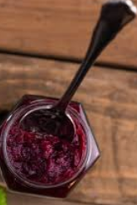
You Are the Peanut Butter to My Jelly
Aligned to the following standards:
FFA.PL-A; FFA.PL-C; FFA.PL-E; FFA.PL-F; FFA.PG-J; FFA.CS_N; CCSS.ELA.SL.9.10.1; CCSS.ELA.RST.9-10.7; CCSS.ELA.WHST.9.10.4; CCSS.ELA.RST.9.10.7; CRP.02; CRP.04; CRP.06; CRP.07; CRP.08
Directions:
You will work with two teammates to make a peanut butter and jelly sandwich. One of you will be responsible for giving instructions to your partner on how to create a peanut butter and jelly sandwich while your third teammate will be recording the instructions given.
Procedure
**This should be a numbered list of the exact instructions given to the sandwich maker.
Materials

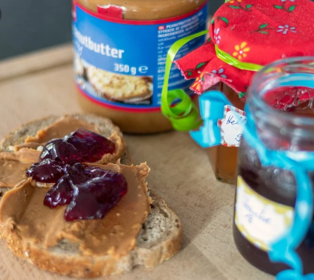

How did you feel during this process? Why?
How did your sandwich turn out? Why do you think it turned out the way that it did?

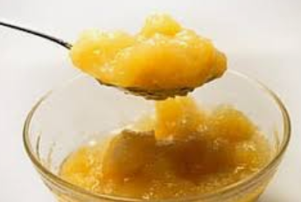

What happened when the instructions were not specific enough or a step was “missed”?
What would you do differently if you were to go through this process again? Why?

What would you tell someone else about the importance of a very specific, well-planned lab procedure?

Let’s Plan and Prepare
Aligned to the following standards:
FFA.PL-A; FFA.PL-C; FFA.PL-E; FFA.PL-F; FFA.PG-J; FFA.CS_N; CCSS.ELA.SL.9.10.1; CCSS.ELA.RST.9-10.7; CCSS.ELA.WHST.9.10.4; CCSS.ELA.RST.9.10.7; CRP.02; CRP.04; CRP.06; CRP.07; CRP.08
Directions:
Having a well-developed materials and methods section is very important for a study for many reasons. Using the resource from “How to Write Materials and Method Section in Scientific Writing,” let us learn some specifics about developing a materials and methods section for a research project.


Identify three key words for why a materials and methods section is important.

1.

2.

3.
In one sentence, describe what a materials and methods section is AND its purpose.
What tense should you write your methods section in?

_______________________
Using what has been learned, develop a detailed procedure for your research study.
Using the reference above, match the step with the correct description about developing a methods section by drawing a line.

- Organization

- Provide References

- Correct Experimental Design

- Effective Abbreviations

- Method Modifications

- Provide Details

Be specific in methodology modifications and the reason why these were made.

Providing credit to others’ research is crucial. Be sure to include in-text citations as well as a works cited page.

The order in which you present the results should match the methodology.

Ensure that your abbreviations are succinct and easily distinguishable.

Always be specific when writing your methodology.

Ensure that you have a control for your experiment as well as have your methodology checked by your teacher.

Create a materials list for your study.

