Explain It to Me
Aligned to the following standards:
FFA.PL-A; FFA.PL-C; FFA.PL-E; FFA.PL-F; FFA.PG-J; FFA.CS_N; CCSS.ELA.SL.9.10.1; CCSS.ELA.RST.9-10.7; CCSS.ELA.WHST.9.10.4; CCSS.ELA.RST.9.10.7; MP1; MP5; MP6; CRP.02; CRP.04; CRP.06; CRP.07; CRP.08
Part 1
Directions:
Read the following passages about the purpose of a research results section and complete the activities.
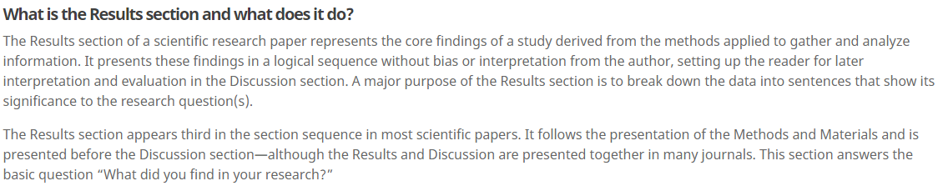
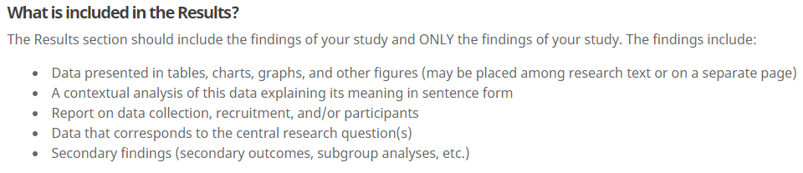


- In your own words, describe the results section of a scientific research study.
3. In purple, circle where the results section is located in a scientific paper.
2. According to the passage, how should the findings be presented? Underline the answer in red.
4. In yellow, highlight the basic question that the results section answers.
Finish the sentence: The results section should include …
- Who/what will you be reporting on?

- Give two examples of how you will visually represent your data for your study.
Helpful Tip: It is a good habit to discuss the results of each research question by itself.
Passages sourced from Wordvice at https://wordvice.com/writing-the-results-section-for-a-research-paper/


Part 2
Aligned to the following standards:
FFA.PL-A; FFA.PL-C; FFA.PL-E; FFA.PL-F; FFA.PG-J; FFA.CS_N; CCSS.ELA.SL.9.10.1; CCSS.ELA.RST.9-10.7; CCSS.ELA.WHST.9.10.4; CCSS.ELA.RST.9.10.7; MP1; MP5; MP6; CRP.02; CRP.04; CRP.06; CRP.07; CRP.08
Directions:
Now that we have discovered what a results section is and how it should be constructed, we are going to start laying out our own results section.
Record your research questions here so that you can reference them.
How can you visually represent your data? (Ex. bar graph, pie chart, etc.)
Select one research question to focus on for this activity.

When adding text to your results section, always be sure to describe what you found. Now that you have created your visual representation for your selected research question, use the space provided to describe exactly what your results are. Tip: Remember, we should not use personal opinion in the results section.
Using this space, develop a visual representation of your data. It can be in any format that will accurately represent your results.
Skiing to the Result
Aligned to the following standards:
FFA.PL-A; FFA.PL-C; FFA.PL-E; FFA.PL-F; FFA.PG-J; FFA.CS_N; CCSS.ELA.SL.9.10.1; CCSS.ELA.RST.9-10.7; CCSS.ELA.WHST.9.10.4; CCSS.ELA.RST.9.10.7; MP1; MP5; MP6; CRP.02; CRP.04; CRP.06; CRP.07; CRP.08
Directions:
Watch the video “The Last Run Is All David Wise Needed to Defend Freestyle Skiing Halfpipe Gold – PyeongChang 2018,” available at https://youtu.be/VZSzNx1ND9w. While watching the video, complete the following activity.



What is the Result?
How long ago did he win the X Games? _____________________________

When the announcers were reviewing the run, were they using personal opinion in their results? Circle your answer.

Yes No

When giving the results in a scientific paper, should personal opinion be given? How do the results of an athletic event differ from a scientific paper? Explain and give an example.




Why should we not give personal opinion in a results section?
What might happen if researchers give their personal opinions?
What is the purpose of a results section?

