Make It Short and Say Thank You
Aligned to the following standards:
FFA.PL-A; FFA.PL-C; FFA.PL-E; FFA.PL-F; FFA.PG-J; FFA.CS_N; CCSS.ELA.SL.9.10.1; CCSS.ELA.WHST.9.10.4; CCSS.ELA.RST.9.10.7; CRP.02; CRP.04; CRP.06; CRP.07; CRP.08
Part 1
Directions:
Read the following movie description and answer the questions.

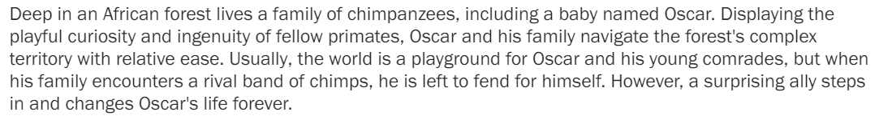
Sourced from: https://www.rottentomatoes.com/m/disneynature_chimpanzee

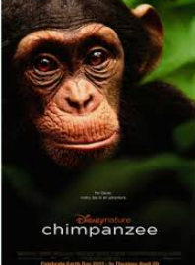
Image sourced from wired.com
What did you learn about this movie from the description?

Do you feel confident you know what the movie is about and can decide if you want to see it?

Yes No (circle one)

Why?

Why do you think the movie creators provide a short description of the movie?



Do you think it would be beneficial for a research paper to have a short summary for the reader? Why or why not?

Using your brainstorming skills, what do you think should be included in an abstract for a research study? Identify a minimum of four items.

1.

2.

3.

4.



Note: When writing an abstract, “spoilers” about the results are OK to include, unlike in movies.

Part 2
Directions:
Abstracts play an important role in allowing a reader to gain an understanding of what they are about to read, allowing the reader to decide if they would like to read the entire study. So, what makes an effective research abstract? Using the following resource from USC Libraries, https://libguides.usc.edu/writingguide/abstract, complete the activities below.

- How many words should be used in an abstract?
- Under 200 words
- Under 300 words
- Under 400 words
- Under 500 words

- Which of the following should not be included in the abstract?
- Citations
- Tables/graphics
- Abbreviations
- Incomplete sentences
- All of the above

- In your own words, what are the four components that should be included in an abstract?

(1)

(2)

(3)

(4)

In this space, use the four components you just identified to begin building your abstract. Each number represents a component. Add information from your research study that you can use in your abstract.

(1)

(2)

(3)

(4)

Part 3
Directions:
Let’s put it all together. Take what you have learned and drafted and, in the space provided, create your final abstract for your research study.
NOTE: It should be no longer than 300 words!

Part 4
Directions:


Watch the video “Lupita Nyong’o Winning Best Supporting Actress,” available at https://youtu.be/73fz_uK-vhs, and complete the activities below.
Acknowledging those that have helped you reach a goal and accomplishment is important for many reasons. When completing a formal research paper, an acknowledgement section should be added. In the space provided, develop an acknowledgement that will be placed in your research paper.
NOTE: It should be no longer than one page!
What was Lupita doing in the video you just watched?
Why do you think this step is so important?
Develop a list of people who have supported and helped you throughout this research process. Include how each person has helped you.

