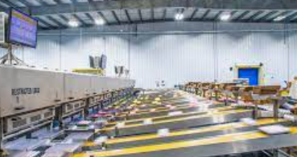
Appendix 1: Automation in Agriculture
Aligned to the following standards: FFA.PL-A; FFA.PL-C; FFA.PL-F; FFA.PG-I; FFA.CS-M; FFA.CS-N; FFA.CS-O; FFA.CS-P; CS.02; AG2; CCSS.ELA.RI.9-10.2; CCSS.ELA.RI.9-10.4; CCSS.ELA.W.9-10.4; CCSS.ELA.W.9-10.5; CCSS.ELA.SL.9-10.4; CCSS.ELA..L.9-10.6; CRP.02; CRP.04; CRP.06; CRP.07; CRP.08
Bell Ringer
Draw a picture of what automation looks like to you.

Part 1

Directions: Read the article “Automation in Agriculture” in the fall 2022 issue of FFA New Horizons and complete the activities below.
- What does automation mean?

- How does automation currently impact agriculture? Give two specific examples.
(1)

(2)

- Based on the reading, what are two pros and cons that can be seen for those involved with automation in agriculture?
Pros | Cons

  - How do these pros and cons impact implementation of automation throughout the agriculture industry?

- Select an agriculture automation that caught your interest the most. ______________________________________
  - What about this caught your attention?
Did the image you drew at the beginning of this activity accurately reflect what automation is? Why or why not?

  - How does this agriculture automation impact you?

Part 2
Directions:
The Agriculture, Food and Natural Resources (AFNR)Value Chain shows the stages agricultural products take from research and development all the way to the consumer. During this process, many steps take place to ensure a safe product. Using the AFNR Value Chain below, identify and describe an automation practice that occurs at each step along the way (answers should be written above or below each icon step in the image). Use the article and your own research to determine and describe the automation practices you are highlighting. An example is a robot being used to target and eliminate weeds in a garden (Production).
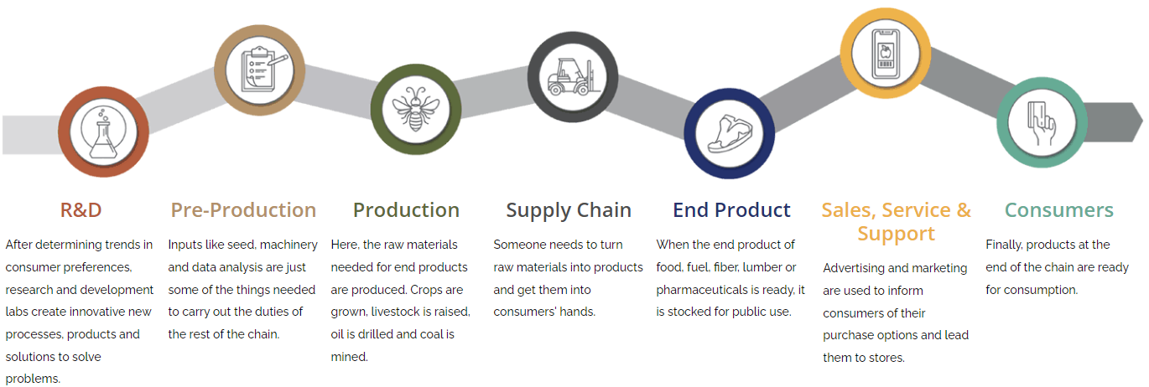
What surprised you most about the automation that exists in the agriculture industry? Why?
Part 3
Directions:
Research an agricultural problem and develop an idea for a machine or other piece of technology that would help solve this problem. Use the space below and the rubric from your teacher to brainstorm and guide your research and idea development.

How has your idea of what automation is and how it is implemented in the industry been impacted?

Criteria | Excellent  20–16 points | Above Average  15–11 points | Average  10–6 points | Below Average  5–0 points | Points Earned
Identification of the Problem | The problem has been clearly shown to exist with supporting factual evidence. | A problem is stated but has weak supporting evidence. | A problem is stated but lacks supporting evidence. | A problem is not stated.
Research and Information Gathering | Existing solutions to the problem, including their good and bad points, have been stated. | Existing solutions have been stated, but those solutions are not evaluated for effectiveness. | A review of existing solutions is stated, but it is not complete and/or related research is not shared. | Little to no research was completed.
Brainstorming Ideas | At least three possible technological solutions were generated. The most appropriate solution was selected, and the reason for the choice was clearly explained. | Three possible technological solutions were generated. An appropriate solution was selected, and the choice is somewhat explained. | Two possible technological solutions were generated. A solution was selected, but no explanation is provided. | On possible technological solution was generated.
Design | A clear description of the proposed technological solution is provided, including an explanation of how it works and how it will help solve the problem. If applicable, rough sketches of the design are provided. | A clear description of the proposed technological solution, including an explanation of how it works, is provided, but the explanation of how it will help the problem is limited. If applicable, rough sketches of the design are provided. | A vague description of the proposed technological solution is provided, but the explanation of how it works and how it will help the problem is limited. | A vague description of the proposed technological solution is provided, and no explanation is provided.
Teamwork | Team members worked well together and settled differences in a positive manner. Each member contributed in a valuable way to the project. | The majority of the team demonstrated good team-working skills. Most members contributed in a valuable way to the project. | The team demonstrated good team-working skills only part of the time, and some members did not contribute to the project. | The team demonstrated few team-working skills, and the majority of the assignment was completed by only one or two members of the group.
Total Points:

