Aligned to the following standards:
CS.02; FFA.CS-O; FFA.CS-P; FFA.PL-A; FFA.CS-N; AG2; CCSS.ELA.RI.9-10.2; CCSS.ELA.W.9-10.2; CCSS.ELA.WHST.9.10.4; MP1; MP6; CRP.02; CRP.04; CRP.08
Appendix 2: Beefing Up Community Service
Check with your teacher to see if you circled the correct item(s)!
Bell Ringer
Directions:
In purple, circle the everyday product(s) produced from beef cattle.
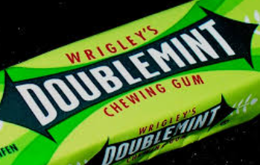

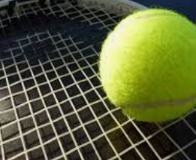
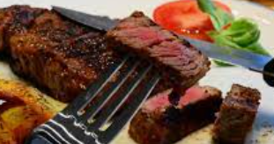
Chewing Gum
Chalk
Tennis Racquet Strings
Steak

Why did you choose the item(s) above that you did? What surprised you about this activity?

In three to five images, depict your knowledge of the beef production industry.

Do you feel that beef cattle impact you every day? Why or why not?
Part 1
Directions:
Read the article “Beefing Up Community Service” in the fall 2022 issue of FFA New Horizons and complete the following activities.

Name and draw the state the Rio Rico FFA is in.
In your own words, why do you think this project was beneficial to students regardless of their interests or future career aspirations?
What breed of cattle did the chapter start with?

What does this breed look like?

How many head of cattle did the chapter start with?
- 7
- 10
- 12
- 20
According to the chapter’s advisor, what is the biggest gain from completing this project?

About how long does it take for the students to raise a calf to market weight?
- 7 months
- 7 years
- 8 months
- 12 months

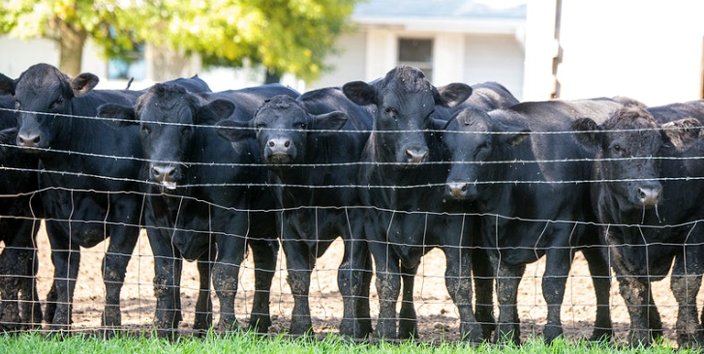

Part 2
Directions:
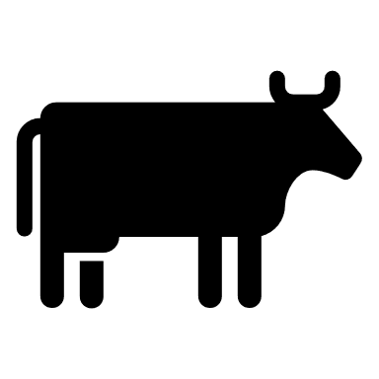
Using the Farm Credit Knowledge Center, https://www.farmcreditofvirginias.com/knowledge-center/blog/beef-cattle-production-and-lifecycle, complete the following activities.
If you had to draw a picture to describe each of these three categories for someone that is unfamiliar with the beef cattle industry, what would that look like? Draw your thoughts and label them in the space below.
What are the three categories of beef cattle production?
(1)

(2)

(3)

How does understanding the different categories of cattle production impact you and your perception of the industry?
In your own words, what is the purpose of each of these categories of beef cattle production?
(1)

(2)

(3)

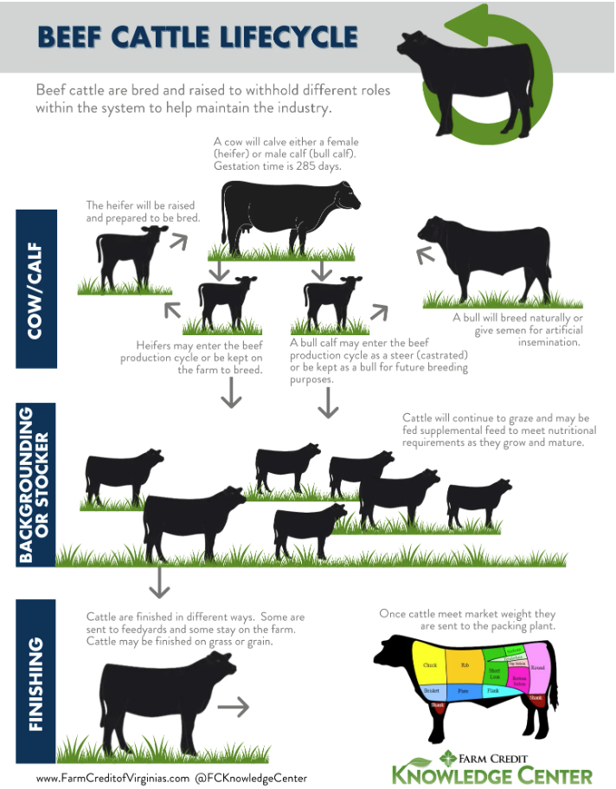
Directions:
Cow/Calf: In your own words, describe a cow/calf operation in a way that someone unfamiliar with agriculture would understand.

Purpose:

Impact on the agriculture industry:

Impact for the consumer:
Backgrounding or Stocker: In your own words, describe a backgrounding or stocker operation in a way that someone unfamiliar with agriculture would understand.

Purpose:

Impact on the agriculture industry:

Impact for the consumer:
Finishing: In your own words, describe a finishing operation in a way that someone unfamiliar with agriculture would understand.

Purpose:

Impact on the agriculture industry:

Impact for the consumer:
Using the image below, complete the activities.
Part 3
Directions:
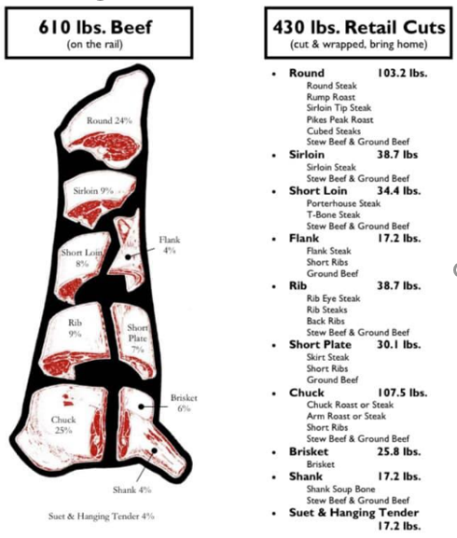
Now that you understand the on-farm production process, let’s take a look at the products that come from the finished market-weight beef animal.
When a beef animal is processed, the live weight does not correspond to the final hanging weight. A processor can expect weight loss due to loss of hide, hooves, head, organs, etc. The hanging weight will be approximately 61% of the live weight.

Using that percentage, calculate the hanging weight of the following steers.

- Live weight: 1,234 lbs Hanging weight: ____________lbs
- Live weight: 1,421 lbs Hanging weight: _____________lbs
- Live weight: 1,287 lbs Hanging weight: _____________lbs

Study the image to the left. Why do you think the total retail cut weight is lower?

Identify three cuts that you are familiar with or have heard of and identify how that cut could be prepared for a meal (Ex. grill, fry, bake, etc.).

- Cut: _____________________ Preparation: ___________________________________
- Cut: _____________________ Preparation: ___________________________________
- Cut: _____________________ Preparation: ___________________________________

How does understanding where meat cuts come from and how to prepare them help you to become a better consumer?
Image sourced from: Ag 101-National Agricultural Institute, www.national-ag-institute.org.

Part 4
Directions:
Once we have the meat products that we can consume, what happens to all the other parts of the beef animal that we do not directly consume as meat? Using the image below, identify a product that you have in your home, school or backpack that fits into each category in the table. Draw a picture of what the product looks like.
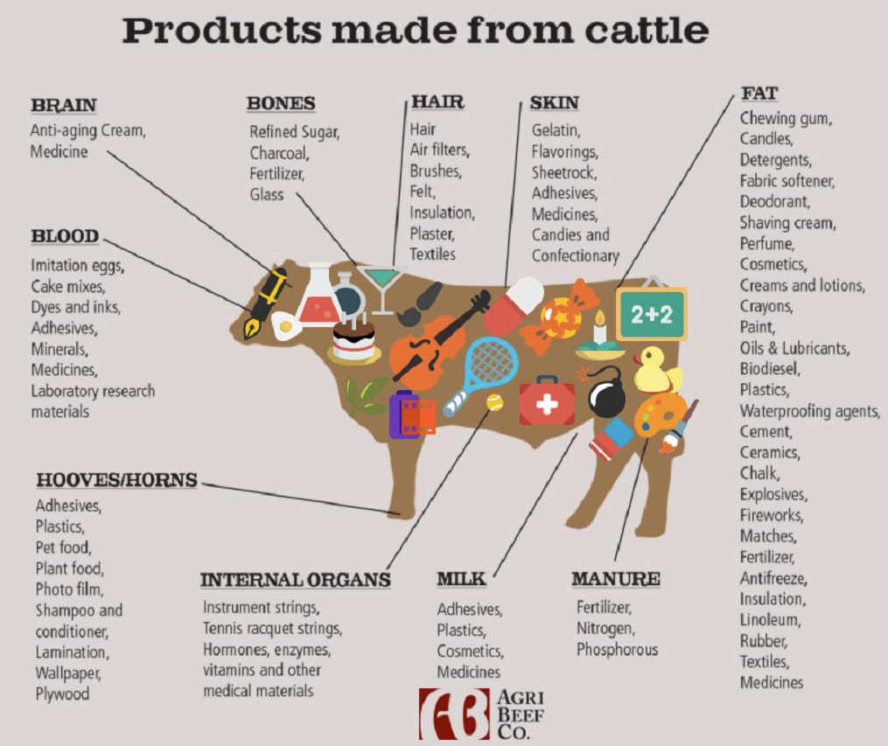
Brain

Name of Product: _________________________________________

Image:

Bones

Name of Product: _________________________________________

Hair

Name of Product: _________________________________________

Skin

Name of Product: _________________________________________

Fat

Name of Product: _________________________________________

Internal Organs

Name of Product: _________________________________________

Hooves/Horns

Name of Product: _________________________________________

Image:

Image:

Image:

Image:

Image:

Image:

Considering what you now know about cattle production, what would you say to someone who says the livestock industry is wasteful?
Could you go a day without using and/or consuming products that come from the beef cattle industry? Why or why not?
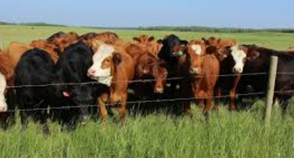
Using one emoji, how do you feel about the beef cattle industry?

Explain why you chose the emoji you did.
In a minimum of three sentences, write a blog post about the beef cattle industry based on what you have learned through this lesson.

________________________________________________________________________________________________________________________________________________________________________________________________________________________________________________________________________________________________________________________________________________________________________________________________________________________________________________________________________________________________________________________________________________________________________________________________________________________________________________________________________________________________________________________________________________________________________________________________________________________________________________________________________________________________________________________________________________________________________________________________________________________________________________________________________________________________________________________________________________________________________________________________________________________________________________
________________________________________________________________________________________________________________________________________________________________________________________________________________________________________________________________________________________________________________________________________________________________________________________________________________________________________________________________________________________________________________________________________________________________________________________________________________________________________________________________________________________________________________________________________________________________________________________________________________________________________________________________________________________________________________________________________________________________________________________________________________________________________________________________________________________________________________________________________________________________________________________________________________________________________________________________________________________________________________________________________________________________________________________________________________________________________________________________________________________________________________________________________________________________________________________________________________________________________________________________________________________________________________________________________________

