Appendix 2: The Corn Maze Craze
Aligned to the following standards:
CS.02; CS.05; FFA.PL-A; FFA.PG-J; FFA.CS-N; AG1; AG5; CCSS.ELA.RI.9-10.2; CCSS.ELA.RI.9-10.3; CCSS.ELA.RI.9-10.4; CCSS.WHST.9.10.4; CRP.02; CRP.04; CRP.06; CRP.08

Created: Fall 2020 by the National FFA Organization
Part 1
Directions:
Read the article “The Corn Maze Craze” in the fall 2020 issue of FFA New Horizons and complete the activities below.
Thinking about what you just read, define agritourism.
What FFA conference did McCall attend in 2019 that made a large impact on his future career goals and objectives?
According to the article, what does McCall say is his reason for advocating for agriculture?
What is the topic of McCall’s supervised agricultural experience (SAE)?
What does the McCall family grow?

- Corn
- Hay
- Honey
- Pumpkins

How many different attractions has the McCall farm grown to?

- 5
- 10
- 30
- 50

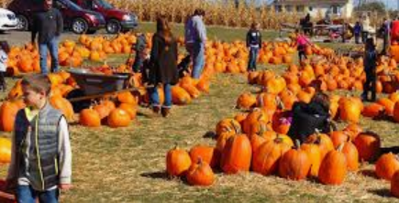

What is the theme for the 2020 corn maze on the McCall farm?

- Drones
- “God Made a Farmer”
- Tractor and American Flag
- “Land of the Lost”
How tall does the corn tend to be when the maze is flagged for the selected design?

Why do you think agritourism is so important? Give two reasons.

1.

2.

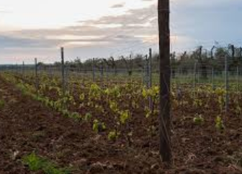

Using AgExplorer.com and what you have learned about agritourism, identify two careers that would be needed to run/work at an agritourism site.
(1)

(2)

Part 2
Directions:
Agritourism is a very important component in every state. Complete the following activities to learn about agritourism in your state and to plan your own operation.
Thinking about your state, identify an agritourism destination that already exists.

Name: ______________________________________________________

What makes this an agritourism location?

Which agricultural commodity do you think your state needs to learn more about?

_______________________________________

Why?
What are the top 5 agricultural commodities in your state?

1.

2.

3.

4.

5.

Part 3
Directions:
Today you are going to design your own agritourism site for your county. Follow the steps below to help guide you through the process.

- What will be your theme for your agritourism site this year? _________________________________________
(Tip: Think about the commodities that you identified above, hot topics in the industry, etc.)

- Why did you select the theme that you did? What is the significance in educating the public?

- Identify three attractions that you could offer at your agritourism site that would help to educate the general public about agriculture in your state. Describe and draw a picture of each.

(2) Name: _________________________

- Name: ________________________

(1) Name: _______________________
Description:

Picture:

- Name: _______________________
Description:

Picture:

- Name: _______________________
Description:

Picture:

Part 4
How will each of the activities you identified above impact those visiting your agritourism site?
Directions:
One of the fun and major attractions at many
agritourism sites is a corn maze. Each year lots of
planning goes into mapping out the design as well as
ensuring the maze matches the theme selected. Using
the graph below, use your theme to map out your own
corn maze for your agritourism site. The following
guidelines need to be kept in mind:
- The maze should follow the theme selected
above.
- Identify the graph measurements to ensure
your maze will make sense when made into a large scale. Example,
one square is one foot.
- The maze should have a clear entrance and exit, and they should be labeled.
Theme:
1 square =



