Aligned to the following standards:
CS.02; CS.03, FFA.PL-A, FFA.PL-E, FFA.PL-F, FFA.PG-G, FFA.PG-I; FFA.PG-J, FFA.CS-M, FFA.CS-N, CCSS.RI.9-10.2, CCSS.RI.9-10.4, CCSS.WHST.9.10.4, CCSS.W.9-10.2, CCSS.W.9-10.4, CCSS.SL.9-10.2, AG2; AG3, CRP.02, CRP.03, CRP.04, CRP.07, CRP.08

Appendix 5: What’s Up With Almond Girl Jenny?
Directions:
Read the article “What’s Up With Almond Girl Jenny?” in the fall 2021 issue of FFA New Horizons and answer the following questions.

Part 1
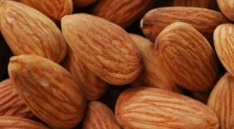

What state is the family farm located in? ________________________
Growing up on the family farm, what were some of Jenny’s responsibilities? Identify 4.

What FFA chapter did she join in high school? ________________________
What was her SAE? ________________________
What does she consider the “icing on the cake” for her FFA career?
________________________
What is the title of her blog?
Why did she start a blog?

How does the blog help her farm today?
What advice does she feel she can offer to anyone? Explain how she came to that conclusion.
How can you apply her advice in your own life?

Directions:
Answer the following questions and complete the activities to learn about the growth cycle and requirements for almonds.

Part 2
Use this website, https://www.almonds.com/why-almonds/almond-lifecycle, to fill in the month/time period and a description of what occurs during that period in the chart below. Additionally, this website can be used to answer questions about the Agriculture, Food and Natural Resources (AFNR) Value Chain: FFA.org/value-chain-lessons/.
Month | What occurs during this time?
November to January
Mid-February to Mid-March
March to June
July
August to October | What step is this in the AFNR Value Chain?  What step is November to July in the AFNR Value Chain?
- Draw the state that produces the most almond trees. Use this link to answer: https://www.fas.usda.gov/newsroom/cracking-open-new-markets-california-almonds
2. What happens to the almonds after harvest?

What step is this in the AFNR Value Chain?

4. What is the next step after harvest?

What step is this in the AFNR Value Chain?
3. Almond farmers have a zero-waste approach. Explain what this means.

5. After sizing, what happens next?

What step is this in the AFNR Value Chain?

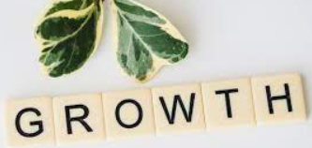

Now that we have talked about production of almonds, let’s discuss and learn about the growth requirements for almonds. Utilize this website to answer the questions below, https://www.gardeningknowhow.com/edible/nut-trees/almonds/growing-almond-nut-trees.htm.

- List the conditions in which almond trees like to grow. Identify 5 conditions.

Directions:
Utilize these websites, https://www.almonds.com/why-almonds/health-and-nutrition/nutritional-value and https://www.healthline.com/health/balanced-diet to answer the following questions and complete the activities to learn about the nutritional aspects of almonds.

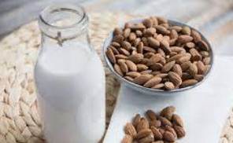
Part 3
What is a balanced diet? How can almonds fit into a balanced diet?

Match the nutritional benefit with the amount per serving (1 oz).

- Protein _______ 9 g

- Fiber _______ 1 mg (4% daily rec. intake)

- Calcium _______7.3 mg

- Iron _______0.3 mg

- Vitamin E _______ 210 mg

- Riboflavin _______6 g

- Potassium _______ 4 g

- Niacin _______ 75 mg

- “Good” monounsaturated fats _______1 mg

Describe the nutritional benefit of each of the components as identified above utilizing websites such as https://medlineplus.gov/definitions/nutritiondefinitions.html.

Protein:

Fiber:

Calcium:

Iron:

Vitamin E:

Riboflavin:

Potassium:

Niacin:

“Good” monounsaturated fats:

Almonds contain 50% of the daily value for vitamin E. What does vitamin E help the body do?

Now that we have learned about the nutritional facts, let’s compare the different types of milks. Utilize this website, https://www.healthline.com/health/milk-almond-cow-soy-rice, to answer the questions below.

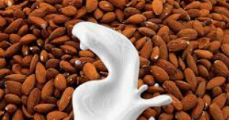
What is one fact that stood out to you?
Let’s review! We have learned about the production, growth requirements, nutritional facts and different types of alternative milks. Complete the activities below to review what you have learned.

- Summarize, in one sentence, the production timetable for producing almonds. ______________________

______________________________________________________________________________________________________________

- Summarize, in one sentence, the methods for producing almonds. ___________________________________
______________________________________________________________________________________________________________
- Create a hashtag to summarize the nutritional values of almonds. ____________________________________

- Summarize, in one sentence, the growth requirements for almonds. ______________________________

__________________________________________________________________________________________________________
Type of Milk: | Nutritional Facts:

