Aligned to the following standards:
FFA.PL-A, FFA.PL-E, FFA.PL-F, FFA.PG-G, FFA.PG-I; FFA.PG-J, FFA.CS-M, FFA.CS-N, CCSS.RI.9-10.2, CCSS.RI.9-10.4, CCSS.WHST.9.10.4, CCSS.W.9-10.2, CCSS.ELA.W.9-10.4, CCSS.SL.9-10.2, AG2; AG3, CRP.02, CRP.03, CRP.04, CRP.07, CRP.08

Appendix 6: Curiosity Amid Chemotherapy
Directions:
Read the article “Curiosity Amid Chemotherapy” in the fall 2021 issue of FFA New Horizons and answer the following questions.
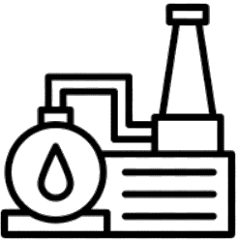

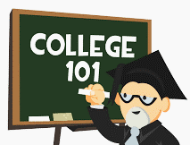
Part 1
- Draw the state where Austin Hooten is from.
- What is the port that is used to deliver his chemotherapy medications made of?

3. Learning what the port was made of inspired him to do what in FFA?
6. What FFA office does Austin hold?
5. Austin used the research from

his ____________ ____________

project for his _______________

_________________ experience and

as the basis for exploring

____________________ agriculture.
7. Where did he receive a grant
from?
8. What did he use the grant for?
9. What proficiency area did he compete in on the national level?
10. Where does he plan to attend college?

What does he plan to major in?
11. Overall, how did this experience have an impact on him?

4. What awards did he win?

Directions:
Learn about where our natural gas comes from and about the industry. Utilize these websites to answer the questions below: https://www.eia.gov/energyexplained/natural-gas/where-our-natural-gas-comes-from.php and https://www.eia.gov/energyexplained/natural-gas/. Additionally, you’ll answer questions to learn where our oil comes from. Utilize this site to answer the questions: https://www.eia.gov/energyexplained/oil-and-petroleum-products/where-our-oil-comes-from.php.
Part 2
What is natural gas?
How did natural gas form?

= _______
= _______
= _______
= _______
= _______
In the blank space below, draw each of the top five natural gas–producing states and write its share of total U.S. natural gas production in 2019 in the box.


2. What does “crude” mean?
- What country is one of the largest crude oil producers?

How long has that country held that position?

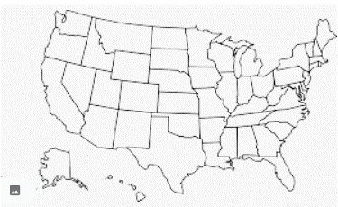
4. List the top five crude oil–producing states and their percentage shares in the space below:
Color in on the U.S. map the top five crude oil–producing states.
3. How many U.S. states produce crude oil?

5. Color in the top five crude oil–producing countries.
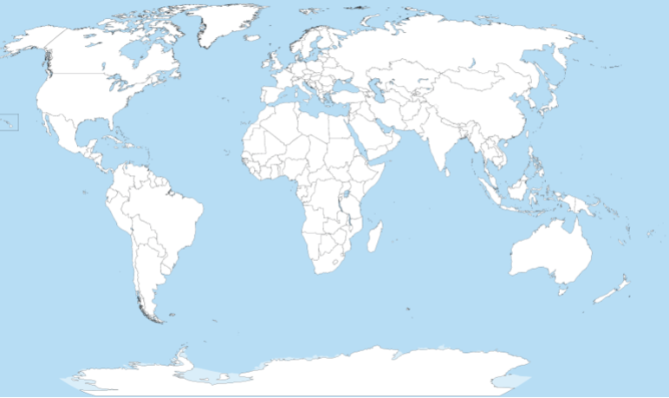

6. Conduct research to determine one similarity and one difference between the top crude oil-producing states and the top crude oil-producing countries.

Directions:
Answer the questions below and complete the activities to learn how plastics are made. Utilize these websites to answer the questions below: https://plastics.americanchemistry.com/How-Plastics-Are-Made/ and https://homeguides.sfgate.com/renewable-plastics-79403.html.

Part 3

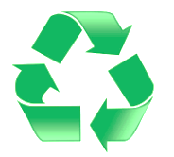

- What does the term “plastics” include?

2. What is another name for plastics?
3. What is another term for renewable plastics?
4. What are renewable plastics made from?
5. List seven uses of renewable plastic.
6. Identify at least one renewable plastic in your life (at home, school, etc.).

Directions:
Let’s make soy plastic. Utilize this website, https://agclassroom.org/matrix/lesson/740/, to aid in the activity below. *Note: This activity is from National Agriculture in the Classroom. Have students make soy plastic (Activity 2 in the lesson).

Part 4

Step 2: Follow these steps:
- Part 1:
- Place 1 tablespoon of cornstarch into the plastic bag. (Figure 1)
- Add 2 drops of soybean oil. (Figure 2)
- Add 1 tablespoon of water. (Figure 3)
- Close the bag and knead it with your fingers, mixing the contents. (Figure 4)
- Add 2 drops of food coloring. (Figure 5)
- Seal the bag and mix remaining contents.
- Open the bag slightly so it can vent.
- Weigh the contents of the bag on a kitchen scale. (Figure 6)
- Part 2:
- Heat the bag in the microwave for 20 to 25 seconds. (Figure 7)
- Remove the bag from the microwave and let the plastic cool. Caution: The bag and contents will be hot!
- Weigh the contents of the bag again. (Figure 8) Compare the weight measurements from before and after microwaving.

Step 1: Collect the items needed for this activity:

- Measuring spoon
- 1 tablespoon cornstarch
- 2 drops (about 1/8 teaspoon) of soybean oil
- 1 tablespoon water
- 2 drops food coloring
- Resealable sandwich-sized bag
- Microwave
- Kitchen scale

Answer the following questions as you are completing the activity (Part 1):

- How many grams does your bag of contents weigh before microwaving?

- Describe the mixture in your plastic bag.

- How does it feel when you squish the bag?

- Is your mixture a solid or a liquid?

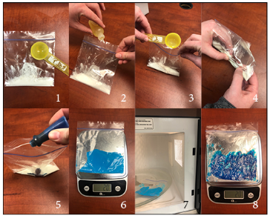

Answer the following questions as you are completing the activity (Part 2):
5. What does your new substance look like?

6. How many grams does your bioplastic weigh? Is it the same weight as before? Why or why not?

8. What products can be made with bioplastic?

