Appendix 7: More Than a Jacket
Aligned to the following standards:
CS.02; CS. 03, FFA.PL-A, FFA.PL-E, FFA.PL-F, FFA.PG-G, FFA.PG-I; FFA.PG-J, FFA.CS-M, FFA.CS-N, CCSS.RI.9-10.2, CCSS.RI.9-10.4, CCSS.WHST.9.10.4, CCSS.W.9-10.2, CCSS.W.9-10.4, CCSS.SL.9-10.2, AG2; AG3, CRP.02, CRP.03, CRP.04, CRP.07, CRP.08

Directions:
Read the article “More Than a Jacket” in the fall 2021 issue of FFA New Horizons. Answer the questions below.

Part 1

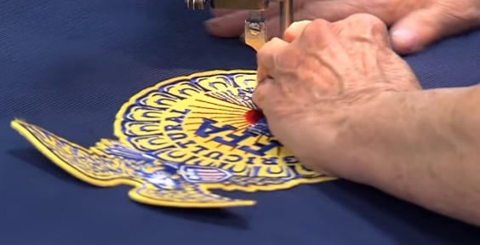
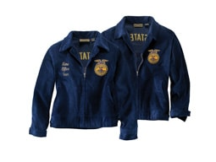
- What year did the blue jacket originate?
- How did the idea for the FFA jacket come about?
- What was the result for the FFA advisor?
- What happened at the 1933 National FFA Convention?
- What milestone occurred in 1964?
- How many jackets are sold today, annually?
- How much corduroy does it take to create one FFA jacket?
- What is one main difference from the original style of the jacket to today’s jacket?
- What program is available that gives jackets to members who wouldn’t otherwise be able to own an FFA jacket?
- What company sponsors this program?

Directions:
Read the article “The FFA Jacket: A Global Effect,” available at https://www.ffa.org/the-feed/the-ffa-jacket-a-global-effort/. Complete the questions below. Additionally, use this website, FFA.org/value-chain/, to answer the questions about the AFNR Food Value Chain.

Part 2

- a. Identify, color in with yellow and label on the map below where the cotton is woven and dyed.
b. Identify, color in with blue and label on the map below where the FFA Jackets are manufactured.

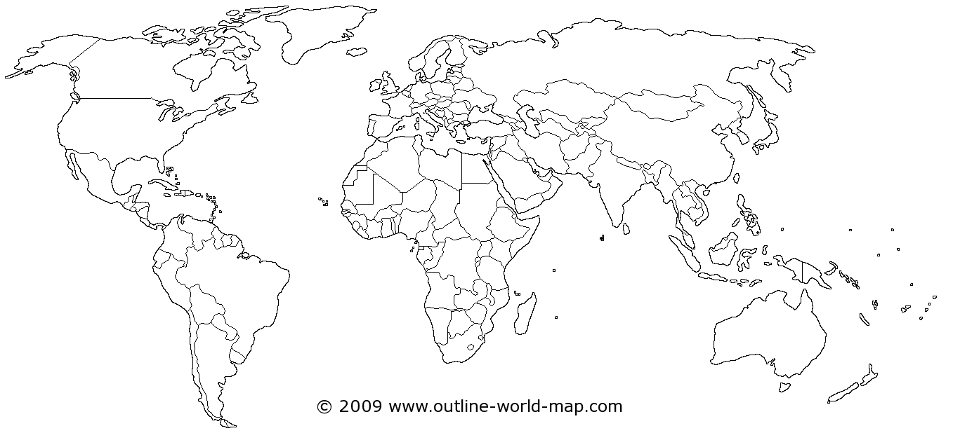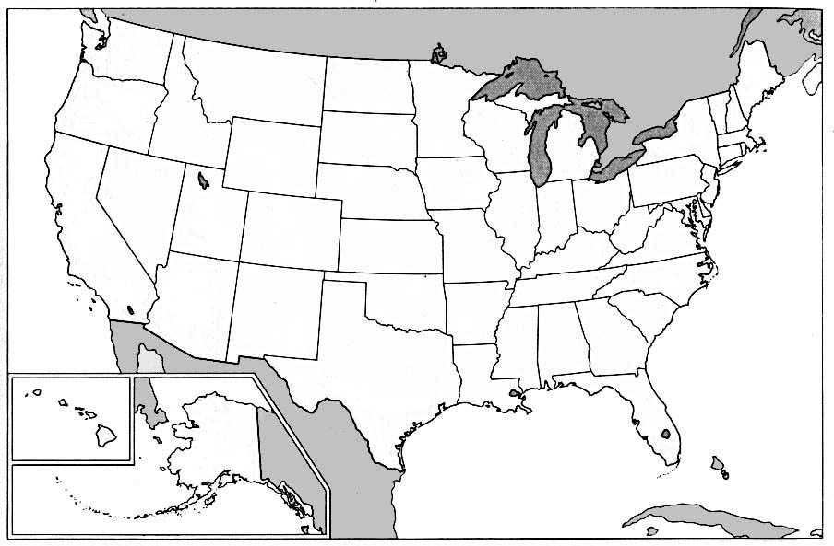
3. a. You learned where the cotton for the jacket is woven and dyed. What step is this in the AFNR Value Chain?

b. You learned where FFA jackets are manufactured. What step is this in the AFNR Value Chain?
- What company embroiders jackets with the names of states, chapters and FFA members? Where is this company located?

- Utilizing the maps below and this website, https://www.ffa.org/the-feed/the-ffa-jacket-a-global-effort/, illustrate the entire production process of the FFA jacket from start to finish.
Why do we source products globally? What would happen if we didn’t?
5. What is global sourcing?
Use this space to explain the process and identify the step in the AFNR Value Chain where it would fit.

